INTERVIEW MANAGER
Application (IMapp)

LIST OF IMPROVMENTS

Sept 2013

SUMMARY:

- URGENT POINTS 1
- GENERAL COMMENTS 1
- FOLDER MANAGEMENT screen 2
- UPLOAD INTERVIEW screen 3
- IMPORT INTERVIEW screen 4
- SUBJECT MANAGEMENT screen 5
- NOTE MANAGEMENT screen 8
- VIEW/EXPORT screen 8
- OBSOLETE INTERVIEW screen 8
- Download screen 8
- DATABASE MODELS 9
Annex 1: SUMMARY of points with Higher IMPACTS 10
Annex 2: ADDITIONAL points with lower IMPACTS 11

- URGENT POINTS

  - Performance : PRIORITY=1
Response times too long for:
- display 1 page in Note screen
- display 1 page in View/export screen (See e-SMP-3716)
Scratch during the:
- export a big interview set (~600) in Note & View/export screens
- import a big interview set (~600)

  - IMapp can be used by different users in the same time. In order to avoid confusion during update, an approach with lock-unlock function is needed. PRIORITY=1

- GENERAL COMMENTS:

  - Perimeter - Language: as a default language is assign to each project/country, this language should be proposed first to the user (e.g. PILOT-PANEU – Bulgaria with Bulgarian Language and not English). PRIORITY=1

  - Export of the notes: - this went OK but we could not read the csv-file in Excel, because for every 'enter/return' he created a new line.

  - Filters and pop-up title: PRIORITY=1
In the filter pop-up, display as title, the name of the selected column. In the following example, replace:
- “Filter column name” by “First name”
- “Filter values” by “Values”
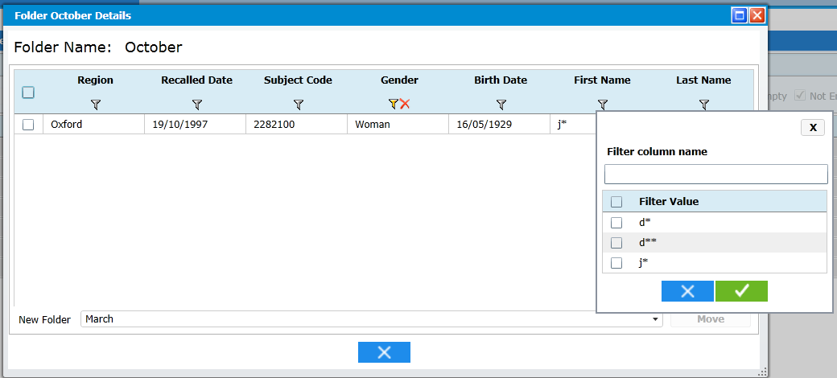
This general rules has to be followed in the following screen:
- Folder management & “Folder details” fiche
- Notes screen
- View/Export screen
- Obsolete interviews screen

  - The column “subject code” has to be placed before the column “Recall date” in all screens (view/export, Note, Obsolete, Folder) PRIORITY=1

  - Icon for Sort and Filter function: Please increase the size of the funnel and the size of the white triangle PRIORITY=1
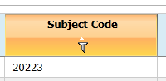

  - Refresh screen icon: Please change the refresh screen icon in the menu, it is not visible: PRIORITY=1


  - Menu: regarding the returns from PILOT-PANEU, we have seen that the process was not strongly followed. For example, they have exported interviews for update and then they have updated the subject codes that had stopped the possibility to re-import the exported interviews… It is for this reason, that we would like to change the menu in order to well display the steps to be followed: PRIORITY=1
Old menu:
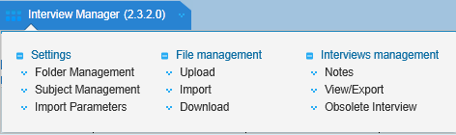

New Menu:
Settings: Interview Management:
Folder Management Upload
Obsolete Interviews Import
Import Parameters Subject Update
Note review
Interview View / Export
Downloaded Interviews

- FOLDER MANAGEMENT screen:

  - Liste – problem of sort order after a creation: When we create a new folder and returned to the list of folder, this new folder is always available at the top of the list. The sort on Folder name in alphabetical order is not done after a creation:
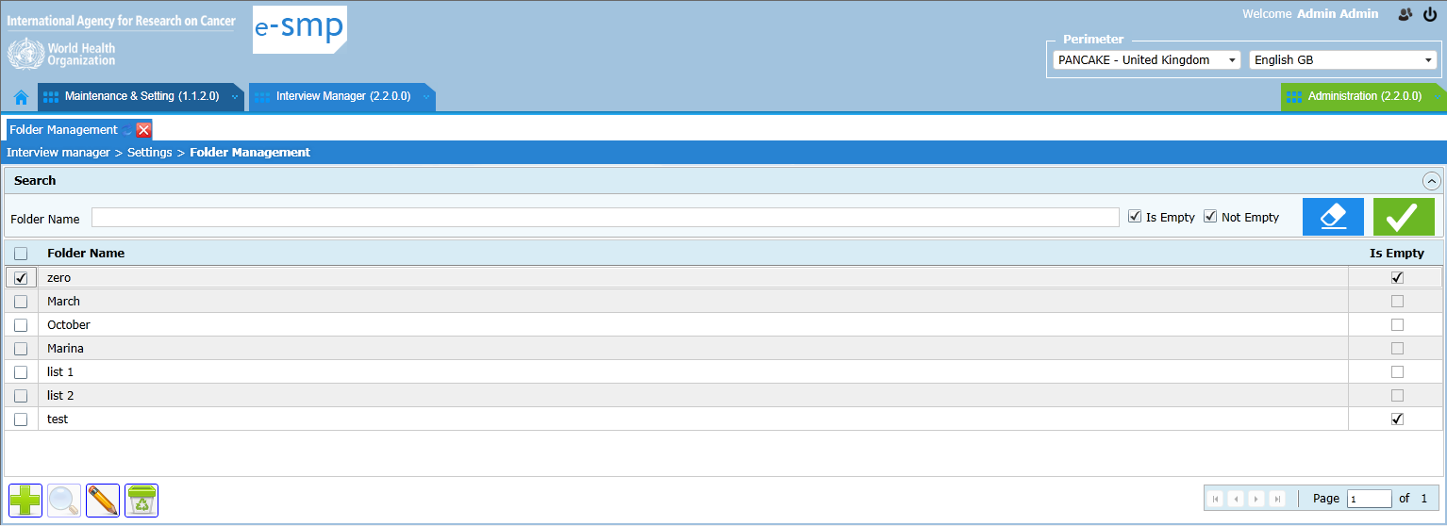

  - Fiche Details – sort order problem: PRIORITY=1
- The list of interviews is not sorted on region + subject_code + recalled date.
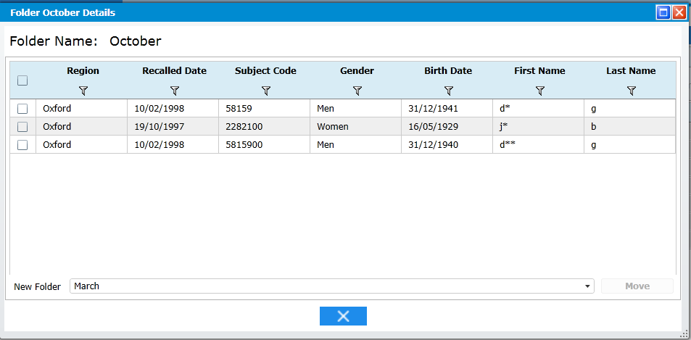

  - Fiche Details – column order The Subject code should be displayed before the recall date. Column order is Region, Subject code, Recall date, Gender, Birth Date, First Name and Last Name

- UPLOAD INTERVIEW screen

  - View Errors –
    - In case of errors occurred during the upload, the user has to click on the view error button to see what’s happened. A non-informed user can miss this step and when the pop-up is closed, it is impossible to have again the error list. PRIORITY=1
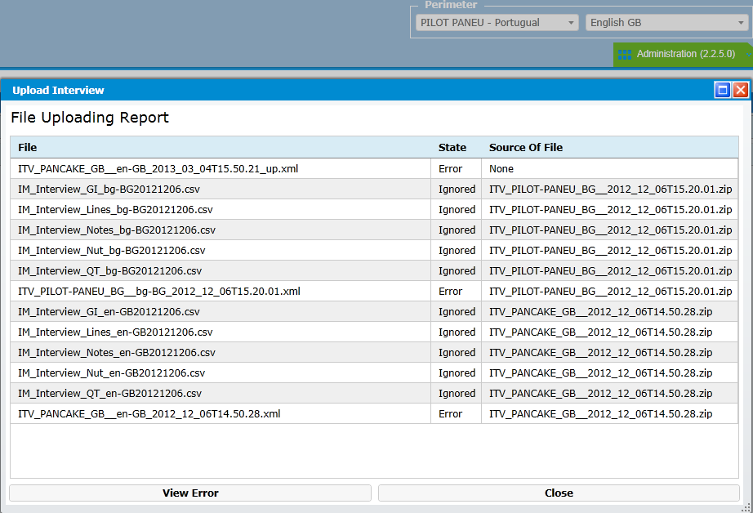
Solution:
Once the upload is finished and in case of errors, then the error list is automatically displayed.
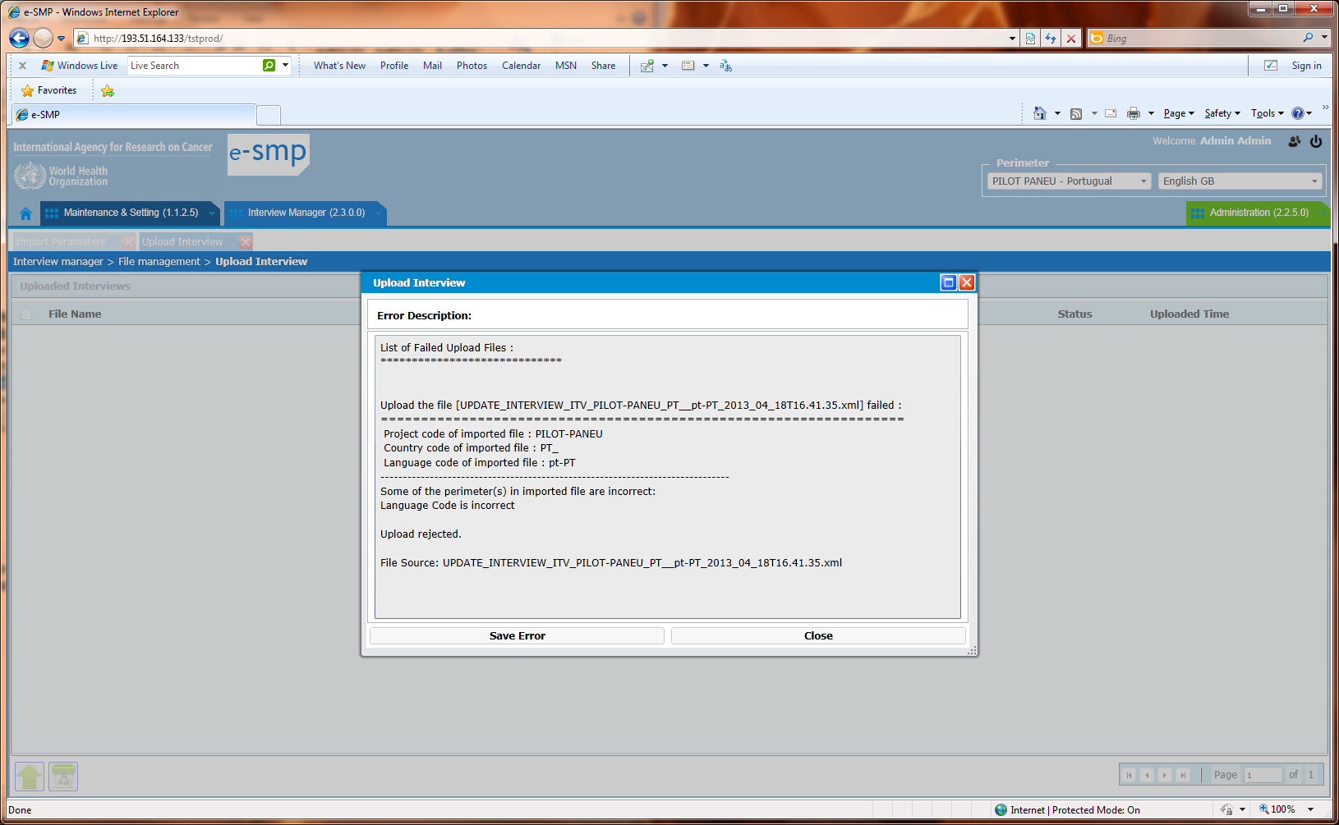
Then when the user closes this “error description” pop-up, the previous pop-up “file uploading Report” is displayed instead of returning in the main upload screen.

  - The following message displayed when the upload run well has to be changed by “Upload file completed successfully. Do not forget to archive this xml- (& bak) files provided by EPIC-Soft application.” PRIORITY=1
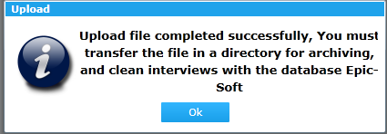

- IMPORT INTERVIEW screen

  - An xml-file has been imported but error occurred. The xml-file with error is visible on screen but when we try to download it, we have error message. PRIORITY=1

After a problem of import, an error file is generated and the xml-file is visible as below:
Then I select the error file and when I use the download function, I have the following error message. Why, the error file is there and can be visible? Is this question asked because the xml-file is not there? Why it is visible but not downloaded?
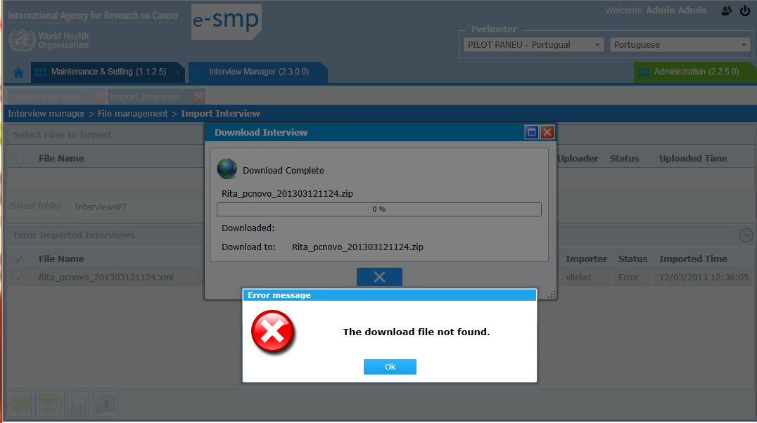

  - Name of error file has to be changed: The name of the generated error file has to follow the same rules as for the xml-file with started with “Import_” then “Error_Log_File_” then the date and the hours “2013_04_18T18.30.04” PRIORITY=1
In this example: Import_Error_log_file_2013_04_26T12.15.10.txt
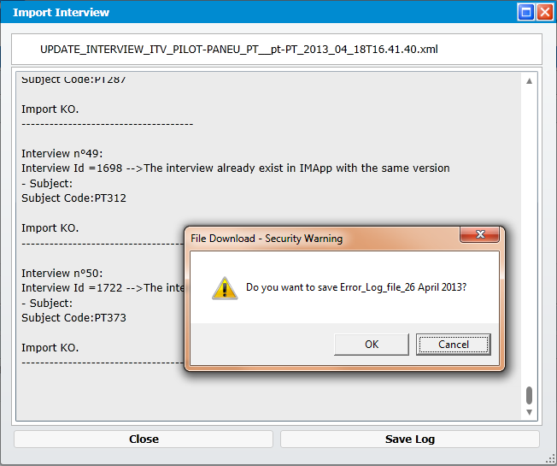

  - When the import is not well proceed, an error file is generated (txt-file) but an xml-file has also to be generated containing only the non-imported interviews in order to be updated and re-imported if necessary.
When the import runs with errors due to a problem (e.g. format error with coma instead of point…), the application is imported some interviews (e.g. interviews with correct format) and some not (e.g. interviews with wrong format). The application is generated:
  - The error-file that lists all the interviews with attached a status OK or KO.
  - The imported xml-file is available on screen with all interviews (OK and KO ones).
  - A new xml-file has to be generated containing only the non-imported interviews in order to allow the user to correct it, or to import it in ESapp to correct the interviews with problems.

- SUBJECT MANAGEMENT screen

  - Liste screen:
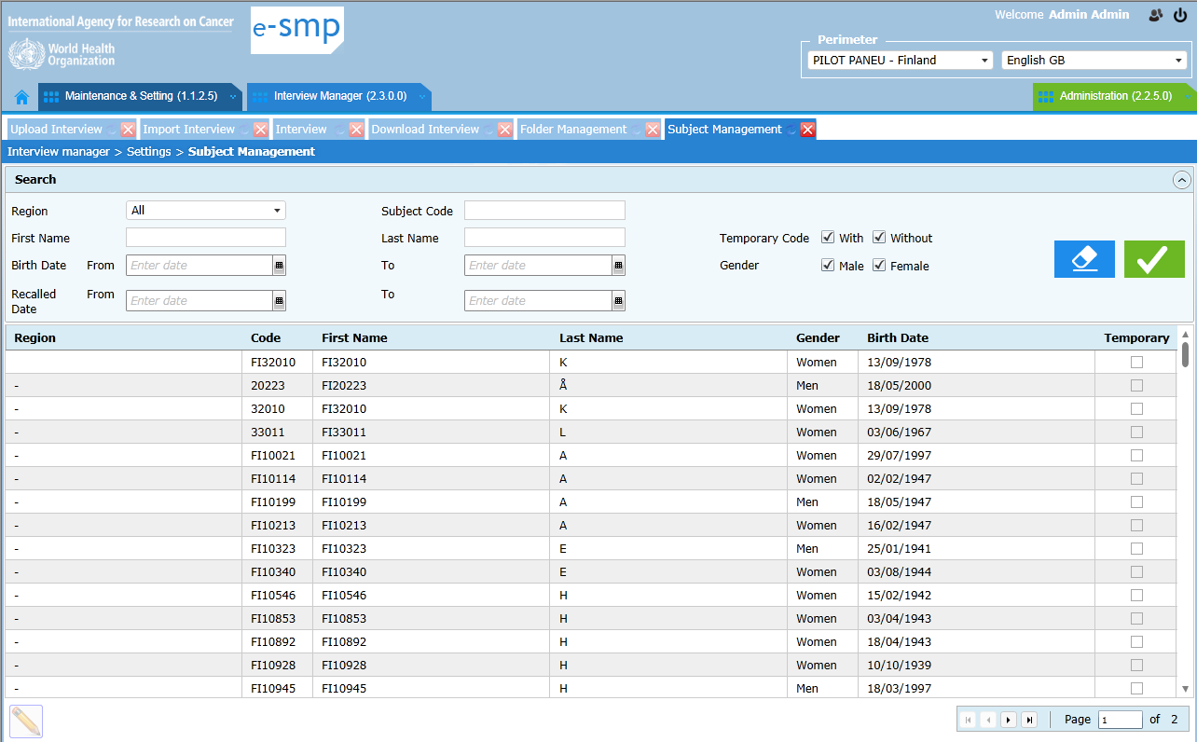

    - Sort order should be done on Region name + subject code PRIORITY=1

    - Change the name of ‘temporary’ column by ‘To be reviewed’ and this also in the fiche PRIORITY=1

    - In the search part, add the ‘Folder’ field, in order to have the list of subjects available in a selected folder (e.g. subject from ‘Delete’ folder are not interesting). PRIORITY=2

  - Fiche screen:
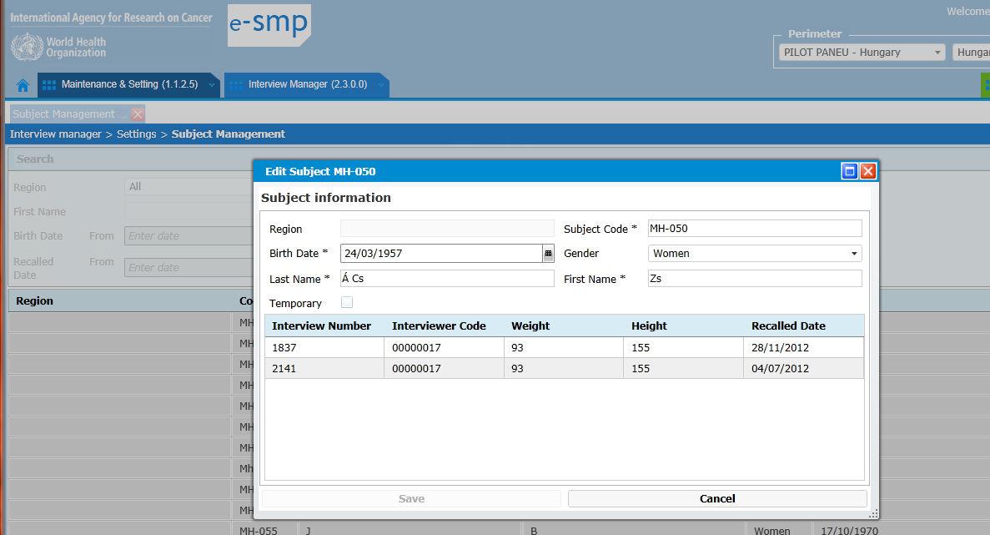
    - The sort order in the interview list has to be done on recalled date PRIORITY=1

    - Addition of the following business rules: PRIORITY=1
  - A subject cannot be updated if at least one of its interviews has the status exported.
  - An interview general information (weight, height…) cannot be updated if its status=exported.
These 2 rules are necessary in order to avoid this special situation:
      - Import of a subject/interview with status=temporary
      - Export of this temporary subject/interview
      - Update of this subject/interview
      - Import again this subject/interview as the application cannot find an exported interview (status=exported) with the key information, the import is KO…

    - Column order has to be changed in order to have the same approach as in EPIC-Soft application and some column has to be added. New order: PRIORITY=1
  - Recall date as first column,
  - Interview number (column ITG_num of Interview_gi table and not ITV_id)
  - Folder name to be added
  - Weight,
  - Height
  - Energy intake to be added
  - Interviewer code and add the interviewer region code in from of (1 column).
  - Status ‘exported’/’accessible’ to be added

    - Fields that can be updated in subject information pop-up: PRIORITY=1
  - At subject level:
    - Code
    - Birth date
    - Gender
    - Last name
    - First name
    - Region (Y/N)?
  - At interview level:
    - Recall date (Y/N)?
    - Interview number
    - Weight
    - Height
Note: no update for folder value because already possible in folder management (not in both place)

    - When several interviews are attached to one subject, we cannot attribute one of these interviews to another subject. PRIORITY=1
To implement this new function, we can have 2 different approaches by:

      - Adding button in the fiche pop-up: we need a button “move interview” that allows attributing a selected interview to another subject:
When the move button is selected, a pop-up displaying the list of available subject codes is displayed and the user can select one or can also enter a new one by selecting a region and taping the new code. In this pop-up, we can also image a possible search.
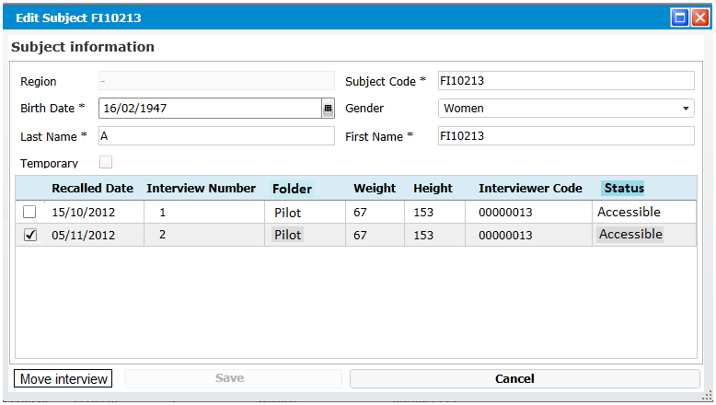

OR

      - Changing the list by adding the column Recall date and having several lines per subject (1 per interview) in this list as:
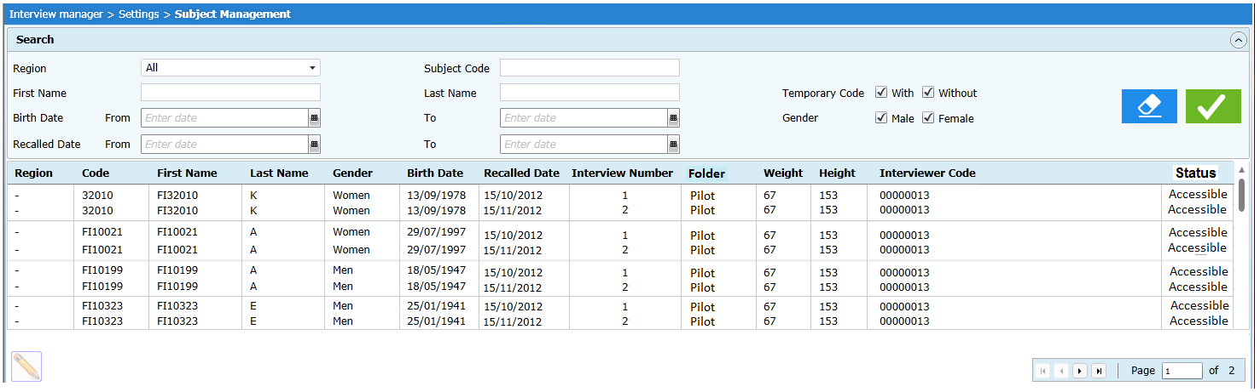
When the user edits a line, the fiche is displayed with 1 interview. If a modification is done on subject Code then, the user has to confirm that it is for all the interview attached to this subject or only to the selected one. In this last case, the interview is allocated to another user.
For the subject general information, the update is automatically applied to all the attached interview.

Conclusion: As we expect that this function will not be used so much/frequently, the solution a. seems to be the better approach

    - Page to be displayed: We select a subject in the page 2 or 3, we update it and we save the record. After this save, the first page of subject list is displayed and not the second/third one. PRIORITY=1

- NOTE MANAGEMENT screen

  - Column order: Subject code should be moved before the Recall date column. . PRIORITY=1

  - Funnel selection and display data: Do not run the record display if time a selection is done (selection with funnel) but only when the user decides to do it by adding a button ‘Run filter’ (a kind of refresh that takes into account the done selections) if we still have a performance problem. . PRIORITY=2

  - Move the button “Clear all filter values” to pop-up “Filter management” PRIORITY=2

  - Move the button “Save filter” to pop-up “Filter management” PRIORITY=2

- VIEW/EXPORT screen
  - Same points as in screen Note management (chapter 7.)

- OBSOLETE INTERVIEW screen

  - Liste – sort order not correct. The sort has to be done on region, subject code, recall date and interview version.

  - Column order: Subject code should be moved before the Recall date column. PRIORITY=1

  - Fiche - “interview details”: the note records are displayed instead of interview records (as in view/export screen). PRIORITY=1
This was specified in the “general specifications” document page 52

  - Delete old interviews: the interview with version 1 cannot be deleted as specified in general specification document (p52). PRIORITY=1
This function has been strongly requested by the TFG and users.

- Download screen
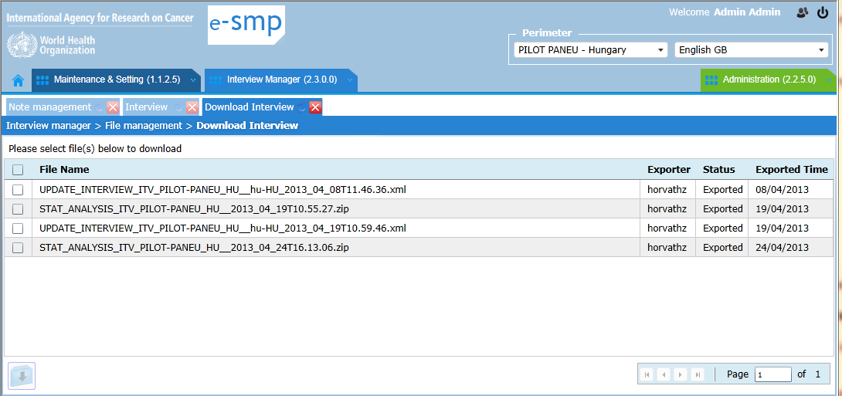

  - Add a delete button in order to allow coordinators to suppress the files already exported and to not overcharge our server space. PRIORITY=1

  - When an export is running (not finished), a record should be displayed with the file name and the status=running. PRIORITY=1

  - All the generated files have to be available in zip-files in order to win space PRIORITY=2.

- DATABASE MODELS:

  - The management of the interview versions has to be reviewed in order to can easily attend to the data. The previous interview versions are only used in obsolete screen so we can:
  - Put them in different tables that also allow to have less data in current table and to go faster
  - Attribute an indicator to each interview to know if it is the last version or not (new variable)
The response time will be much better if the current interview access is simplest (Note, View/export & Subject screen). PRIORITY=1

  - In the table Subject, the Region/Centre_id has to be added and the Country_id can be deleted PRIORITY=1

Annex 1: SUMMARY of points with Higher IMPACTS

1.1 Performance: Response times too long for some screens & Scratch during the Import and Export of big interview set (~600 interviews).
1.2 IMapp can be used by different users in the same time. In order to avoid confusion during update, an approach with lock-unlock function is needed.

  - The column “subject code” has to be placed before the column “Recall date” in all screens (view/export, Note, Obsolete, Folder)
  - Refresh screen icon: Please change the refresh screen icon in the menu, it is not visible:

  - Menu: regarding the returns from PILOT-PANEU, we have seen that the process was not strongly followed.. New Menu:
Settings: Interview Management:
Folder Management Upload
Obsolete Interviews Import
Import Parameters Subject Update
Note review
Interview View / Export
Downloaded Interviews

  - Import screen: When the import is not well proceed, an error file is generated (txt-file) but an xml-file has also to be generated containing only the non-imported interviews in order to be updated and re-imported if necessary. The application is generated a) The error-file that lists all the interviews with attached a status OK or KO, b) The imported xml-file is available on screen, c) A new xml-file has to be generated containing only the non-imported

    - Subject: Change the name of ‘temporary’ column by ‘To be reviewed’ and this also in the fiche
6.2.2 Subject: Addition of the following business rules:
  - A subject cannot be updated if at least one of its interviews has the status exported.
  - An interview general information (weight, height…) cannot be updated if its status=exported.
6.2.3 Subject: Column order has to be changed in order to have the same approach as in EPIC-Soft application and some column has to be added. New order:
  - Recall date as first column,
  - Interview number (first, second… column ITG_num)
  - Folder name to be added
  - Weight
  - Height
  - Energy intake to be added
  - Interviewer code and add the interviewer region code in from of (1 column).
  - Status ‘exported’/’accessible’ to be added
    - Subject: When several interviews are attached to one subject, we cannot attribute one of these interviews to another subject.

9.3 Obsolete interview screen - Fiche - “interview details”: the note records are displayed instead of interview records (as in view/export screen). . This was specified in the “general specifications” document page 52
9.4 Obsolete interview screen - Delete old interviews: the interview with version 1 cannot be deleted as specified in general specification document (p52).

  - Export function: When an export is running (not finished), a record should be displayed with the file name and the status=running.
Annex 2: ADDITIONAL points with lower IMPACTS

- GENERAL COMMENTS:

  - - I have to use the mouse very often and I would be very happy if you add some key combinations to make the work quicker and less 'mousy'. So arrow keys and enters to open a note.

  - Removal of interviews in IMapp
We wonder if it is possible to completely remove an interview from the database (e.g. is it possible to remove test interviews from IM-app).?
Presently we did some testing steps, so before uploading and importing our real data we prefer to start with an completely empty database in e-SMP. Do you think this will be possible?

  - Obsolete interviews
Is there an easy way to list or report the differences between different versions of the same interview? + export raw interviews

  - It is very good to be able to see all notes and their status, I am still in doubt whether I want to see also the notes with status '99 action done, and 999 deleted and 02- no action needed'?

  - Filters and proposed values: When we enter a second filter, the proposed values should take into account the selection previously done. The rule is the filter proposed values should take into account the selections previously done.
This general rules has to be followed in the following screens:
- Folder management & “Folder details” fiche
- Notes screen
- View/Export screen
- Obsolete interviews screen
Alternative approach:
- The filters propose all the possible values whatever the previous selection and only when the user select a new button called “Run filter/selection”, the screen is refresh taking into account the selection done.

  - It is very good to be able to see all notes and their status, I am still in doubt whether I want to see also the notes with status '99 action done, and 999 deleted and 02- no action needed'?

- FOLDER MANAGEMENT screen

  - Liste – the “is empty” columns can be replaced by the number of interviews available in the folder (e-SMP-2635 part 1)
List: replace the “is Empty” column with a 'Number of interviews' indicating the number of interviews contained in each folder.
By numbers of interviews, we means the number of “project + Country + Centre + Subject code + Recall date”

  - Fiche detail– number of interviews in the pop-up title
Fiche detail: include the number of interviews in the title of the popup
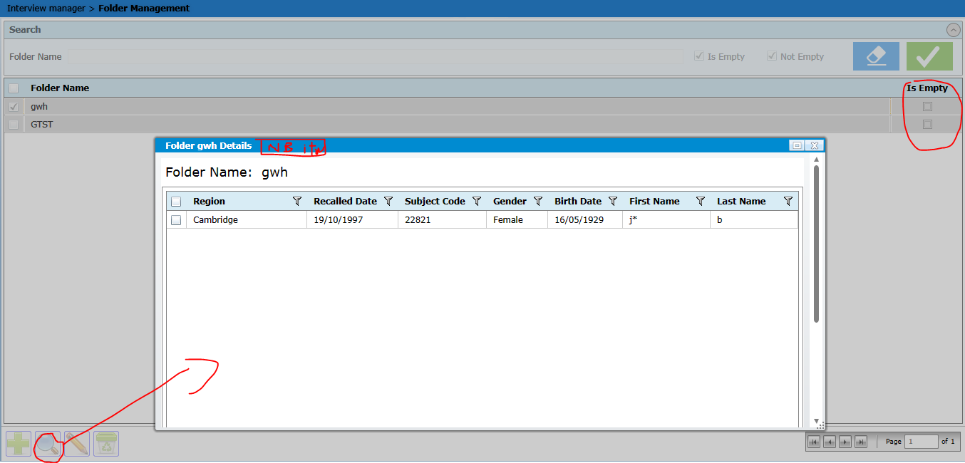

- IMPORT INTERVIEW screen

  - When an import data is run, a log-file is generated but its format has to be reviewed in order to be readable by other applications (as Excel) in order to be more practical for users. Today an error file is generated only when errors occurred during the import. We have to generate it for each import in order to give to the user a list of treated interviews.
The format of the this generated log-file is defined below:
- At the top of the log file, we have general information on the xml-file (in italic information to be filled):
File: Yhd_FI_2013_02_05.xml
Data import done by: hyvarinenh (user’s login)
Data import status: Error or uploaded
Imported interviews for:
Project code: PILOT-PANEU
Country code: FI_
Centre code: 001
Project Langage code: fi-FI
Date of import: 20130520
- For interviews imported with or without problem, we can use pipe as delimiter (|) (in italic information to be filled)
Subject Code | 33011 | Recall date | 20130510 | Import OK
Subject Code | 33011 | Recall date | 20130512 | Import KO | Text on why import not done
In the Text, we can have for example:
The UPDATE statement conflicted with the FOREIGN KEY constraint "SBT_Id". The conflict occurred in database "esmp_im", table "dbo.Subject", column 'SBT_Id'

- SUBJECT MANAGEMENT screen

  - Liste screen: Add a column “number of interview” OR a column with the different recall dates attached to the subject (e.g. 05/12/2012 – 15/12/2012)

- NOTE MANAGEMENT screen:

  - Facet string: using a bubble, add the possibility to view the labels attached to this long list of codes. This label is available in ITL_Text column of table interview_Li

  - Add the subject Total energy intake in a column after the special diet one

