

CHECK LIST

The check list is a list of foods often eaten at each food consumption occasion. During the quick list step, this list will appear as a reminder or a help to the interviewer when a food consumption occasion (FCO) is proposed (before choosing a FCO and after filling in a FCO quick list).

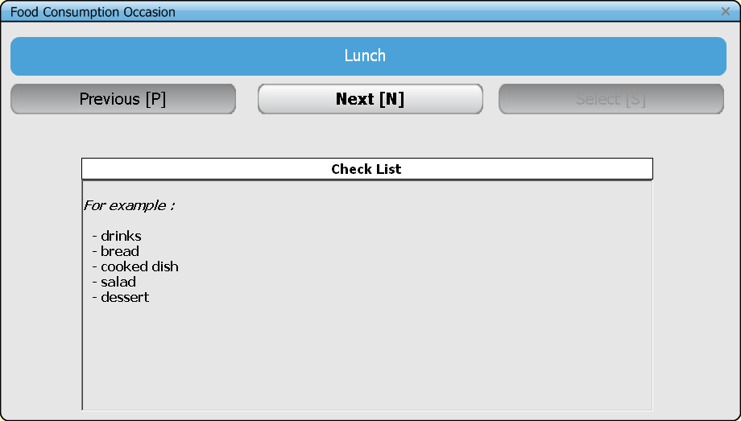

Note that during the description/quantification step, probing questions will be proposed with the same purpose, i.e. to avoid omitting food items. For example, for the quick list item “tea” containing tea and milk, the probing “sugar” will be proposed – if entered in the FDPROBING file.

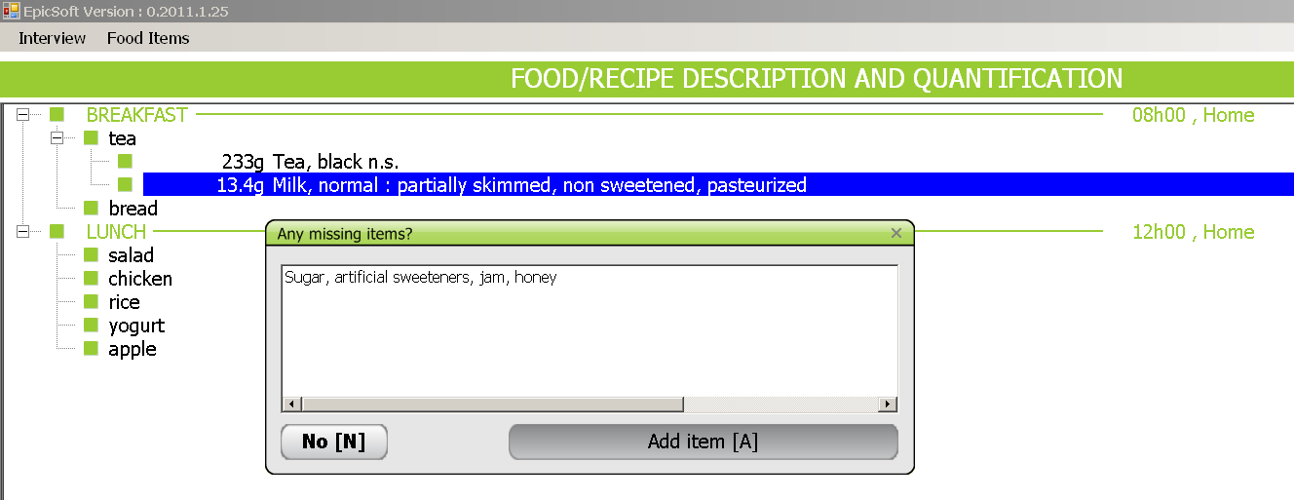

I- PROPOSITION

In the following list, examples are given for each food consumption occasion of foods which might be forgotten (this is not an exhaustive list):

01Before Breakfast (Wake Up)
- Beverage

02Breakfast
- Beverage
- Fruit
- Bread
- Ice cream, water ice
- Breakfast cereals
- Confectionary

03During the Morning
- Beverage
- Confectionary (chocolate and non chocolate)
- Cake and biscuit
- Fruit
- Salty biscuits
- Snack
- Ice cream, water ice
- Nuts and seeds

04Before Lunch (Aperitif)
- Beverage
- Salty biscuits
- Nuts and seeds
- Confectionary (chocolate and non chocolate)
- Fruit
- Ice cream, water ice

05Lunch
- Beverage
- Bread
- Hors d'oeuvre
- Main dish
- Cheese
- Yogurt
- Dessert
- Fruit
- Cake
- Ice cream, water ice
- Confectionary (chocolate and non chocolate)

06After Lunch
- Beverage
- Confectionary (chocolate and non chocolate)
- Cake and biscuit
- Nuts and seeds
- Ice cream, water ice
- Fruit
- Snack

07During Afternoon
- Beverage
- Confectionary (chocolate and non chocolate)
- Cake and biscuit
- Fruit
- Nuts and seeds
- Ice cream, water ice

08Before Dinner (Aperitif)
- Beverage
- Nuts and seeds
- Confectionary (chocolate and non chocolate)
- Ice cream, water ice
- Cake and biscuit
- Fruit

09Dinner
- Beverage
- Bread
- Soup
- Hors d'oeuvre
- Main dish
- Cheese
- Yogurt
- Dessert
- Fruit
- Ice cream, water ice
- Cake
- Confectionary (chocolate and non chocolate)

10After Dinner (Digestif)
- Beverage
- Confectionary (chocolate and non chocolate)
- Cake and biscuit
- Nuts and seeds
- Ice cream, water ice
- Fruit
- Salty biscuit

11During the Evening / At Night
- Beverage
- Salty biscuits
- Snack
- Nuts and seeds
- Confectionary (chocolate and non chocolate)
- Cake and biscuit
- Fruit
- Ice cream, water ice
- Bread

2- WORK TO BE DONE :

- First of all, the list of FCO must be agreed on at the project level.
- For each FCO, use the proposition list to build your local checklist. List foods which are VERY commonly eaten at each FCO, based on local dietary pattern(s).

- The items to be reported in the check list per FCO can either refer to GENERIC ITEMS (e.g. beverages, cheese, ...) or to a COMPONENT OF THE MEAL (e.g. first dish, dessert…).

- Because fats, sauces and sweeteners should NOT be listed in the quick list step – that will be instructed during the training course, those items should not appear (not be reminded of) in the check list either.

