Globodiet Parameter Database

Run Of Automatic Controls & File Preparation

SUMMARY:

- Preparation of EPIC-Soft doc-files: procedure task 2

- Installation 2

- Conversion of doc-files 3

- Run of controls for Foods and Supplements 4

- Run of controls for Recipes 6

- Used of FUF to generate food new-files 7

- Used of RUF to generate recipe new-files 9

- Generation of db3-files when 1 language is used in the Country 11

- Generation of db3-files when several languages are used in the Country 14

ANNEX 1: LIST OF END-FILES 17

ANNEX 2: LIST OF END-FILES INVOLVED FOR EACH CONTROL 18

ANNEX 3: COMMENTS AVAILABLE IN THE DIFFERENT OUT-FILES 19

- Preparation of EPIC-Soft doc-files: procedure task

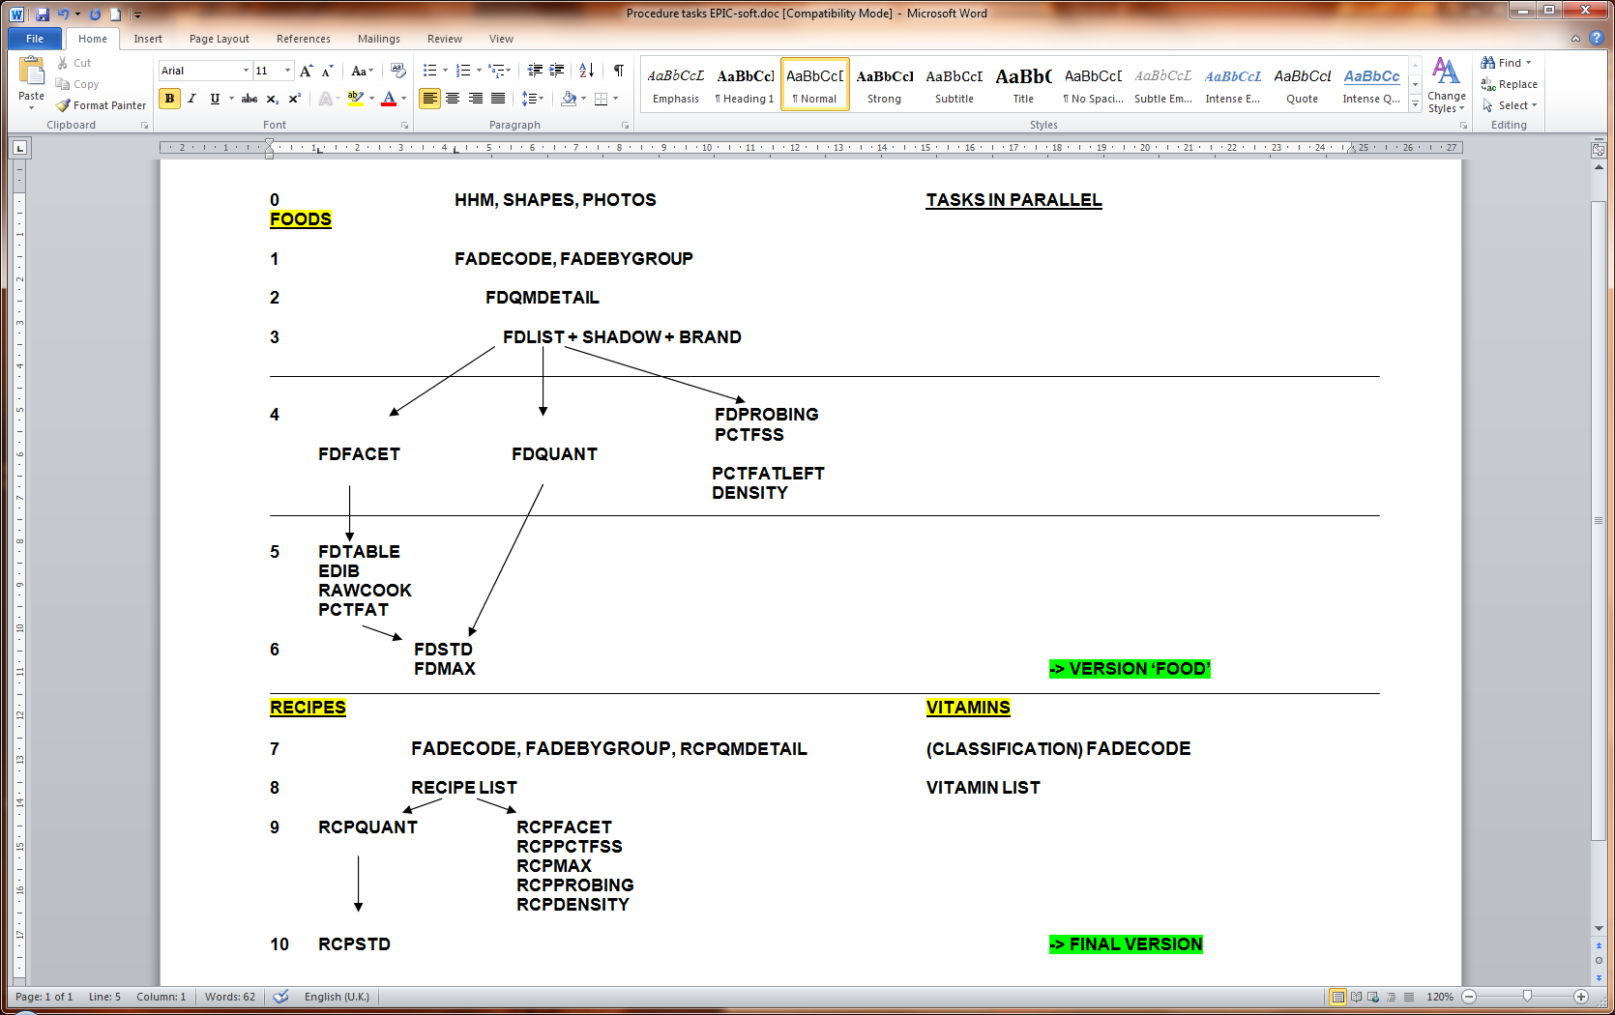

- Installation

- Extract on your PC on D:, all the files and folders available in the zip-file called Episoft_DB_preparation_20121012.zip keeping the same folder names.

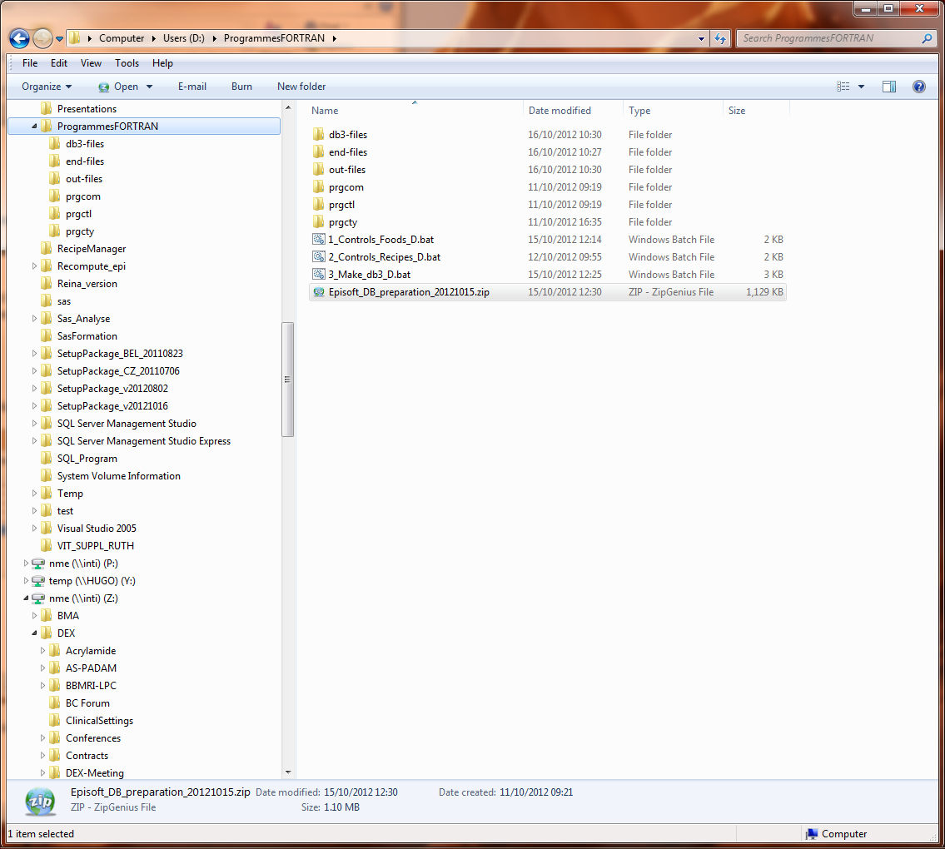

- Conversion of doc-files

- All the doc-files have to be converted in plain text as txt-files with the “windows (default)”
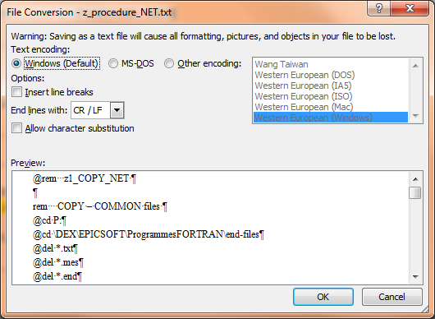

- The generated txt-files have to be moved in the folder called:
D:\programmesFORTRAN\end-files

- The txt-files have to be renamed in end-files with the fixed names defined in Annexe 1

- Country language constraints:
  - For some files, the used languages can be in English or in Country language depending of the used.
    - For controls, generally, the English language is used
    - For generation db3-files, the Country language is used

  - It is for this reason; we have the File_EN.end and File_cty.end.available (e.g FDCLASS_EN.end and FDCLASS_DE.end).

  - The files impacted by the language constraint are:
FDCLASS.end FCLASS_EN.end FDCLASS_cty.end
FADECODE.end FADECODE_EN.end FADECODE_cty.end
RCPCLASS.end RCPCLASS_EN.end RCPCLASS_cty.end
RCPFADECODE.end RCPFADECODE_EN.end RCPFADECODE_cty.end

- Run of controls for Foods and Supplements

- Once the Food end-files are available in the folder D:\programmesFORTRAN, you have to open the file called 1_Controls_Foods_D.bat (e.g. using notepad) to run all the checks in several steps as described below.
Then you have to check the following point:

  - Fdclass_EN.end file should be available in the folder D:\programmesFORTRAN\end-files

  - If the non-specified mark (in the food list) is not “n.s.”, replace all “n.s.” by the correct one (e.g. “n.s.” by “n.e.”)

  - You can save and exit the file as the txt-file “windows (default)” but the file name should be kept as 1_Controls_Foods_D.bat

- Run the food controls by double clicking on this file called:
1_Controls_Foods_D.bat in several steps as described below

  - A “cmd” window is opened displaying the detail of the run of the Fortran programs.

  - Returned messages are displayed after each exe-files. Some are “normal” (e.g. “Number Foods: 1879 Last Food: 2922”) and some are “problematic” messages as “file not found” or “runtime error” or an error message specific to the program or no attached message at all.
  - If you have this kind of problematic message, you will have to open the attached out-file to see why the problem occurs and if it is not clear, do not hesitate to ask to Corinne

  - Here an example on displayed messages when the procedure runs well:
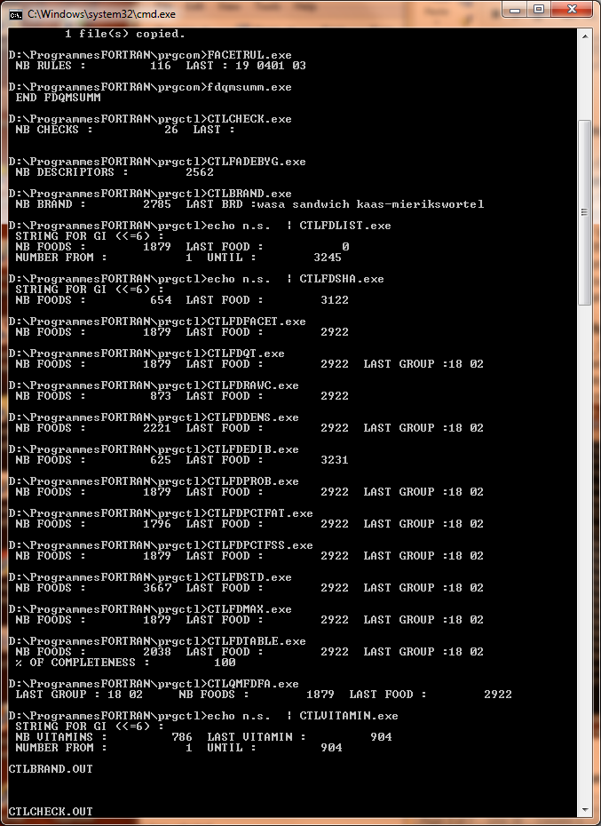
- Details on followed Procedure:

  - Step 1: Preparation of common files by:
    - Copying some main files as txt-files
    - Run some programs to generate txt and dat-files that will be used for other controls (e.g. generation of Facgroup.txt)
Groupfac.txt : If this file contains only 1 line for group 18, this line has to be copied for all sub-groups :
Example:
18 06 12 08 becomes:

18 00 06 12 08
18 01 06 12 08
18 02 06 12 08

Grfac.dat : the sub- (sub-) groups 00 of this file have to be checked against the FADEBYGROUP.end file because the programme automatically generates the list of facets and descriptors for the “undefined” sub- (sub-) groups by proposing all facets and descriptors available for the specific sub- (sub-) groups. Extra lines have to be removed.

  - Step 2: Run of controls on country-specific files.
    - The following end-files are checked and the results are available in the attached out-files.
    - All the out-files are available in the folder D:\programmesFORTRAN\out-files
    - In the file called a_CTLfd.out, you can find the combination of all generated food out-files. Here the file list:
END-files Attached OUT-files
Brandname.end CTLbrand.out
Checklist.end CTLcheck.out
Fadebygroup.end CTLfadebyg.out

Fdlist.end CTLfdlist.out
Shadowlist.end CTLfdsha.out

Fdfacet.end CTLfdfacet.out
Fdfacet & fdqmdetail.end CTLqmfdfa.out

Fdquant.end CTLfdqt.out
Fdstd.end CTLfdstd1.out

Density.end CTLfddens.out
Edib.end CTLfdedib.out
Rawcook.end CTLfdrawc.out

Fdprobing.end CTLfdprob.out
Fdmax.end CTLfdmax.out

Pctfat.end CTLfdpctfat.out
Pctfss.end CTLfdpctfss.out
Fdtable.end CTLfdtable.out
Vitamins.end CTLvitamin.out

- List of end-files involved for each control: see ANNEX 2

- Comments available in the different out-files: see ANNEX 3

- Run of controls for Recipes

- Before running the Recipe controls, you have to check that the Recipe end-files are well available in the folder D:\programmesFORTRAN\end-files.
- Do not forget Rcpclass_EN.end and rcpfadecode_EN.end files

- Run the recipe controls by double clicking on this file called:
2_Controls_Recipes_D.bat

  - A “cmd” window is opened displaying the detail of the run of the Fortran programs.

  - Returned messages are displayed after each exe-files. Some are “normal” (e.g. “Number recipe 302 Last recipe 5397”) and some are “problematic” messages as “file not found” or “runtime error” or an error message specific to the program or no attached message at all.

  - If you have this kind of problematic message, you will have to open the attached out-file to see why the problem occurs and if it is not clear, do not hesitate to ask to Corinne

  - Here an example on displayed messages when the procedure runs well:
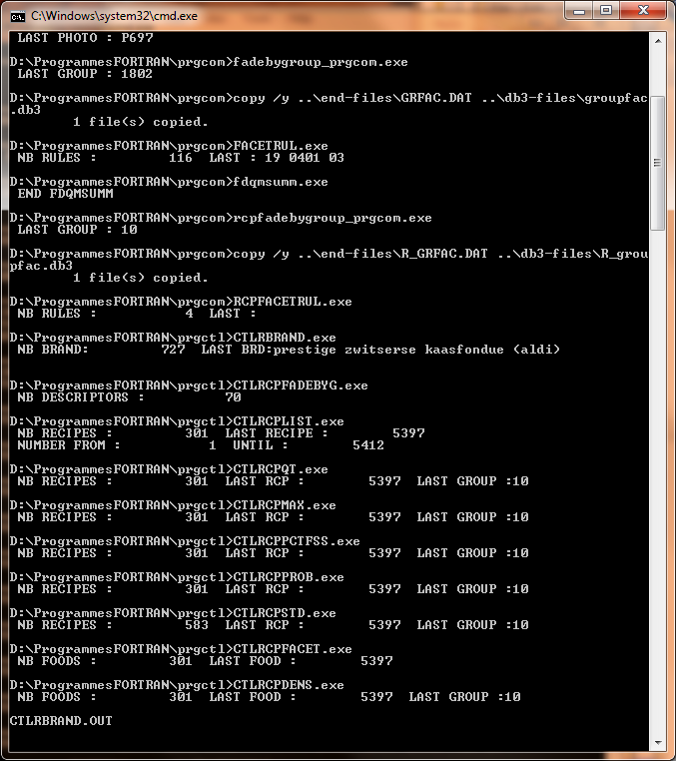

- Details on followed Procedure:

  - Step 1: Preparation of common files by:
    - Copying some main files as txt-files
    - Run some programs to generate txt and dat-files that will be used for other controls (e.g. generation of R_Facgroup.txt)

  - Step 2: Run of controls.
    - The following end-files are checked and the results are available in the attached out-files.
    - All the out-files are available in the folder D:\programmesFORTRAN\out-files
    - In the file called a_CTLrcp.out, you can find the combination of all generated recipe out-files. Here the file list:
END-files Attached OUT-files
Rcpbrand.end CTLrcpbrand.out
Rcpfadebygroup.end CTLrcpfadebyg.out
Mixedrec.end CTLrcplist.out
Rcpfacet.end CTLrcpfacet.out
Rcpquant.end CTLrcpqt.out
Rcpstdu.end CTLrcpstd.out
Rcpmax.end CTLrcpmax.out
Rcpdensity.end CTLrcpden.out
Rcpprobing.end CTLrcpprob.out
Rcppctfss.end CTLrcppctfss.out

- List of end-files involved for each control: see ANNEX 2

- Comments available in the different out-files: see ANNEX 3

- Used of FUF to generate food new-files

- Before running the FUF program, you have to check that the FUF txt-file is well available in the folder D:\programmesFORTRAN\end-files.

- Run the FUF program by double clicking on this file called:
  - 4_maj_FUF_D.bat

  - A “cmd” window is opened displaying the detail of the run of the Fortran programs.

  - Returned messages are displayed listed the new added foods:
    - For example ‘UPDATING : 0 legumes tests n.s.’
    - The used food files are all first copying as sav-files (in case of problem) in \end-files folder.
  - A file called MAJFUF.OUT is generated in D:\ProgrammesFORTRAN\out-files folder. This file contains the new codes of the added foods and sometimes, some problematic messages and in this case do not hesitate to ask to Corinne how to proceed.
  - A maximum of 13 food files (new-files) are generated in D:\ProgrammesFORTRAN\out-files folder. You will have to rename these new-files to end-files and copy them to \end-files folder.

  - Here an example on displayed messages when the procedure runs well:
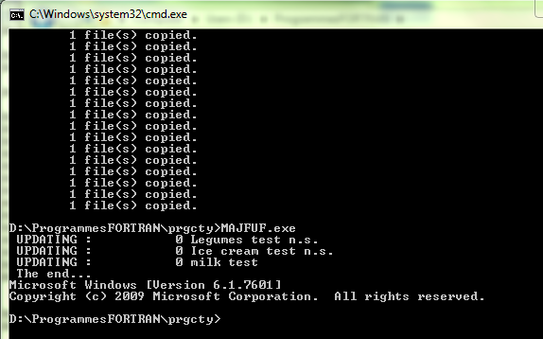

- Details on followed Procedure:

  - Step 1: Preparation of files:
    - Visual checks of FUF file
    - Run the program to generate new-files and Majfuf.out file

  - Step 2: Run of program (4.maj_FUF_D.bat)
    - The involved end-files are duplicated in sav-files
    - Majfuf.out file is available in the folder D:\programmesFORTRAN\out-files
    - New-files are available in the folder D:\programmesFORTRAN\out-files
    - Here the file list:
END-files Attached sav-files Attached new-files
FDLIST.end FDLIST.sav FDLIST.new
SHADOWLIST.end SHADOWLIST.new SHADOWLIST.new
BRANDNAME.end BRANDNAME.new BRANDNAME.new
FDFACET.end FDFACET.new FDFACET.new
FDQUANT.end FDQUANT.new FDQUANT.new
FDSTD.end FDSTD.new FDSTD.new
FDMAX.end FDMAX.new FDMAX.new
FDPROBING.end FDPROBING.new FDPROBING.new
FDTABLE.end FDTABLE.new FDTABLE.new
DENSITY.end DENSITY.new DENSITY.new
EDIB.end EDIB.new EDIB.new
RAWCOOK.end RAWCOOK.new RAWCOOK.new
PCTFAT.end PCTFAT.new PCTFAT.new
PCTFSS.end PCTFSS.new PCTFSS.new

  - Step 3: Rename all the new-files to end-files and copy them in \end-files folder by replacing the previous ones. In case of problems, the sav-files can always be re-used.

  - Step 4: Run of controls for Foods and Supplements (see previous point 4)

- Used of RUF to generate recipe new-files

- Before running the RUF program, you have to:

  - check that the RUF txt-file is well available in the folder D:\programmesFORTRAN\end-files.

  - Prepare the Mixedrec.end files according to the file called mixedrec.xls received from the Country and generated with the Recipe Manager application.
    - The format of this file is:
Recipe code 4 characters
Classification code 4 characters (2 for group & 2 for subgroup)
Recipe name 50 characters
Recipe type 2 characters (11=not commercial, 22=commercial)
Recipe brand 50 characters
    - Example:
00230101Vleesbrood, met brood 11
02140101Stoofvlees, frituur 22-Commercieel n.s.-

    - Important Notes on the construction of Mixedrec.end:
      - You can prepare this file based on the received Mixedrec.xls file & using Excel:
        - Keeping only 4 characters for the recipe code (#R_IDNUM)
        - Truncating the R_NAME to 50 characters
        - Recoding the R_TYPE to 11 or 22
        - Deleting the shadow (SH) lines
        - Deleting the 3 last columns TYPE, R_SUB & STATUS
        - Sorting the list of R_GROUP, R_SUBGROUP & R_IDNUM
        - Saving the file as a prn-file and then renaming it as end-file
      - In Mixedrec.end, the recipe list has to be sorted by R_GROUP, R_SUBGROUP & R_IDNUM

- Run the RUF program by double clicking on this file called:
  - 5_maj_RUF_D.bat

  - A “cmd” window is opened displaying the detail of the run of the Fortran programs.

  - Returned messages are displayed listed the new added foods:
    - For example ‘UPDATING : 5415 kapsalon’
    - The used recipe files are all first copying as sav-files (in case of problem) in \end-files folder.

  - A file called MAJRUF.OUT is generated in D:\ProgrammesFORTRAN\out-files folder. This file contains the new codes of the added recipes and sometimes, some problematic messages and in this case do not hesitate to ask to Corinne how to proceed.
  - A maximum of 7 recipe files (new-files) are generated in D:\ProgrammesFORTRAN\out-files folder. You will have to rename these new-files to end-files and copy them to \end-files folder.

  - Here an example on displayed messages when the procedure runs well:
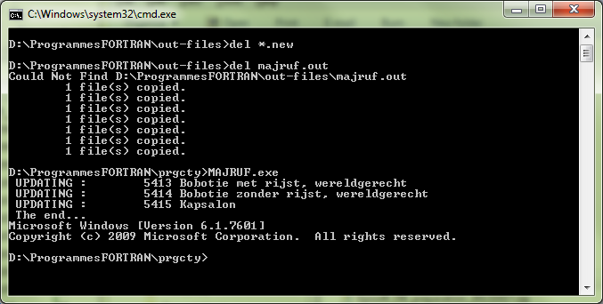

- Details on followed Procedure:

  - Step 1: Preparation of files:
    - Visual checks of RUF file
    - Preparation of the MIXEDREC.end file based on the received mixedrec.xls from the Country
    - Run the program to generate new-files and MAJFUF.out file

  - Step 2: Run of program (4.maj_FUF_D.bat)
    - The involved end-files are duplicated in sav-files
    - Majfuf.out file is available in the folder D:\programmesFORTRAN\out-files
    - New-files are available in the folder D:\programmesFORTRAN\out-files
    - Here the file list:
END-files Attached sav-files Attached new-files
RCPDENSITY.end RCPDENSITY.sav RCPDENSITY.new
RCPFACET.end RCPFACET.new RCPFACET.new
RCPMAX.end RCPMAX.new RCPMAX.new
RCPPCTFSS.end RCPPCTFSS.new RCPPCTFSS.new
RCPPROBING.end RCPPROBING.new RCPPROBING.new
RCPQUANT.end RCPQUANT.new RCPQUANT.new
RCPSTDU.end RCPSTDU.new RCPSTDU.new

  - Step 3: Rename all the new-files to end-files and copy them in \end-files folder by replacing the previous ones. In case of problems, the sav-files can always be re-used.

  - Step 4: Run of controls for Recipes (see previous point 5)

- Generation of db3-files when 1 language is used in the Country

- The generated DB3-files are for foods and recipes.

- Before running the program generating DB3-files, you have to:
  - Check that all the needed end-files are available in the folder D:\programmesFORTRAN\end-files. All the used end-files have to be in Country language (e.g. FDCLASS_DE have to be copied in FDCLASS.end).
See the list below.

  - Open the program called 3_Make_db3_D_1_language.bat to:
    - Replace the acronym of the Country language (e.g. change _DE by _FR)
    - If needed, change the non-specified code ‘n.s.’ by the one needed for the Country language (e.g. replacing by ‘n.e.’)

  - Please find below the list of the 49 end-files involved to generate the db3-files.

BRANDNAME.end
CHECKLIST.END
COMPRCP.END
DENSITY.end
EDIB.end
FACETRUL.END
FADEBYGROUP.end
FADECODE_EN.end
FADECODE_DE.end
FCO.END
FDCLASS_EN.end
FDCLASS_DE.end
FDFACET.end
FDLIST.end
FDMAX.end
FDPROBING.end
M_SHAPES.end
FDQMDETAIL.end
FDQUANT.end
FDSTD.end
FDTABLE.end
HHM.end
MIXEDREC.END
PCTFAT.end
PCTFATLEFT.end
PCTFSS.end
PHOTO.END
POC.END
PROBING.end
RAWCOOK.end
RCPBRAND.END
RCPCLASS_EN.end
RCPCLASS_DE.end

RCPDENSITY.end
RCPFACET.end
RCPFACETRUL.end
RCPFADEBYGROUP.end
RCPFADECODE_EN.end
RCPFADECODE_DE.end
RCPMAX.end
RCPPCTFSS.end
RCPPROBING.end
RCPQMDETAIL.end
RCPQUANT.end
RCPSTDU.end
SHADOWLIST.end
SPECDAY.END
SPECDIET.end
VITADESC.END
VITAMINS.end

    - In this list, some end-files are available in both languages English and in Country language that is always the case for the classification of foods & recipes and for the list of facets/descriptors of foods & recipes.

    - If you have some other examples of files with both languages you will have to adapt the 3_Make_db3_D_1_language.bat program by deleting the ‘rem’ in the following lines for:

      - FCO, POC, SPECDAY, SPECDIET
@rem copy /y FCO_DE.end ..\db3-files\FCO.db3
@rem copy /y POC_DE.end ..\db3-files\POC.db3
@rem copy /y SPECDAY_DE.end ..\db3-files\SPECDAY.db3
@rem copy /y SPECDIET_DE.end ..\db3-files\SPECDIET.db3
      - DAYOWEEK, FDQMDETAIL, FDSTD, PROBING and FDLIST
@rem copy /y DAYOWEEK_DE.END DAYOWEEK.end
@rem copy /y FDQMDETAIL_DE.END FDQMDETAIL.END
@rem copy /y FDSTD_DE.END FDSTD.end
@rem copy /y PROBING_DE.END PROBING.end
@rem copy /y FDLIST_DE.end FDLIST.end

    - If you have other files in both languages, do not hesitate to ask Corinne to help you to modify your bat-file.

- Run the generation of DB3 program by double clicking on this file called:
  - 3_Make_db3_D_1_language.bat in several steps as described below

  - A “cmd” window is opened displaying the detail of the run of the Fortran programs.

  - Returned messages are displayed after each exe-files. Some are “normal” (e.g. “NB FOODS: 1873 Last Food: 2216”) and some are “problematic” messages as “file not found” or “runtime error” or an error message specific to the program or no attached message at all (Read Error).

  - If you have this kind of problematic message, you will have to open the attached db3-file to see on which item the problem occurs and if it is not clear, do not hesitate to ask to Corinne

  - Here an example on displayed messages when the procedure runs well:
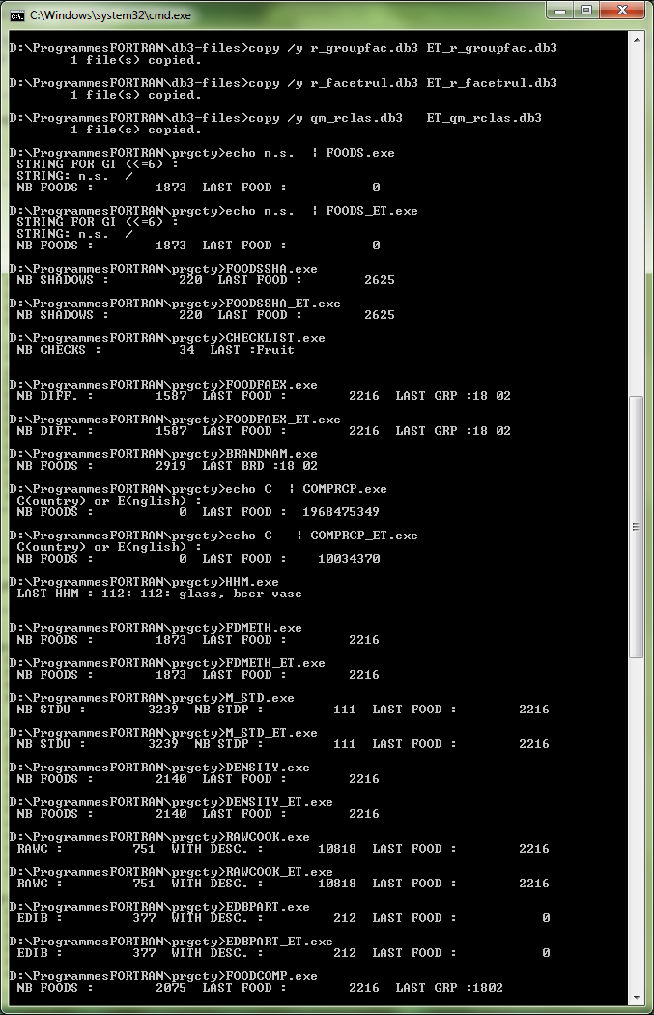

- Details on followed Procedure:

  - Step 1: Open the file 3_Make_db3_D_1_language.bat and update by:
    - Checking that all the needed end-files are available in the folder D:\programmesFORTRAN\end-files. See the list above.
    - Replacing all the acronym ‘_DE’ by the current used language (e.g. ‘_FR’)
    - Changing the non-specified code ‘n.s.’ by the one needed for the Country language (e.g. replacing by ‘n.e.’)
    - Changing the copy command lines in the Copy part, if needed.

  - Step 2: Run of common files using program (3_Make_db3_D_1_language.bat)
Generated ET_groupfac.db3 has to be adapted:

    - Remove the extra lines created by the programme for sub (sub-) groups 00 by comparing with the FADEBYGROUP.end (work in Notepad)
    - Be sure to list the facets and descriptors for 1800, 1801 and 1802 subgroups.
  - Step 3: Run of country-specific files using program (3_Make_db3_D_1_language.bat)

    - In the folder D:\programmesFORTRAN\db3-files, 96 db3-files will be generated
      - 50 started with ‘ET_’ to build the ExternalTable

ET_brandnam.db3
ET_chklist.db3
ET_cring.db3
ET_density.db3
ET_descface.db3
ET_ediblep.db3
ET_facetrul.db3
ET_facets.db3
ET_fatlefto.db3
ET_FCO.db3
ET_foodcomp.db3
ET_foodfaex.db3
ET_FOODS.db3
ET_foodscrp.db3
ET_foodssha.db3
ET_groupfac.db3
ET_groups.db3
ET_maxrval.db3
ET_maxval.db3
ET_POC.db3
ET_m_hhm.db3
ET_m_photos.db3
ET_m_rcpu.db3
ET_m_stdpor.db3
ET_m_stduts.db3
ET_pqpath.db3
ET_probque.db3
ET_qm_foods.db3
ET_qm_group.db3
ET_qm_rclas.db3
ET_qm_recip.db3
ET_r_density.db3
ET_r_descface.db3
ET_r_facetrul.db3
ET_r_facets.db3
ET_r_groupfac.db3
ET_r_rcpfaex.db3
ET_rawcook.db3
ET_rbrand.db3
ET_rgroups.db3
ET_rpqpath.db3
ET_rsubgr.db3
ET_SPECDAY.db3
ET_SPECDIET.db3
ET_spfacook.db3
ET_spfacore.db3
ET_spfdcook.db3
ET_subgroup.db3
ET_vitadesc.db3
ET_vitamins.db3

      - 46 not started with ‘ET_’ to be used on the Migration process done by Corinne and using DBASE & Migration

brandnam.db3
chklist.db3
cring.db3
density.db3
descface.db3
ediblep.db3
facetrul.db3
facets.db3
fatlefto.db3
foodcomp.db3
foodfaex.db3
foods.db3
foodscrp.db3
foodssha.db3
groupfac.db3
groups.db3
maxrval.db3
maxval.db3
m_hhm.db3
m_photos.db3
m_rcpu.db3
m_stdpor.db3
m_stduts.db3
pqpath.db3
probque.db3
qm_foods.db3
qm_group.db3
qm_rclas.db3
qm_recip.db3
rawcook.db3
rbrand.db3

rgroups.db3
rpqpath.db3
rsubgr.db3
r_density.db3
r_descface.db3
r_facetrul.db3
r_facets.db3
r_groupfac.db3
r_rcpfaex.db3
spfacook.db3
spfacore.db3
spfdcook.db3
subgroup.db3
vitadesc.db3
vitamins.db3

  - Step 3: Copy these db3-files on Inti in the Country folder. Example: Z:\DEX\GLOBODIET_DB\Ger\TMP_Window-version\z_End-files\db3-files

  - Step 4: Prepare the Country ExternalTable_xxx.xls using the ET_xxx.db3 files. Please use the function “Data” & “From text” of Excel.

- Go to Migration_users_manual to automatically generate ExternalTable

- Generation of db3-files when several languages are used in the Country

- The generated DB3-files are for foods and recipes.

- Before running the program generating DB3-files, you have to:
  - Check that all the needed end-files are available in the folder D:\programmesFORTRAN\end-files. All the used end-files have to be in Country language (e.g. FDCLASS_DE have to be copied in FDCLASS.end).
See the list below.

  - Open the program called 3_Make_db3_D_n_languages.bat.bat to:
    - Replace the acronym of the Country language (e.g. change _DE by _FR)
    - If needed, change the non-specified code ‘n.s.’ by the one needed for the Country language (e.g. replacing by ‘n.e.’)

  - Please find below the list of the 63 end-files involved to generate the db3-files.

BRANDNAME.end
CHECKLIST_FR.END
CHECKLIST_NL.END
COMPRCP.END
DENSITY.end
EDIB.end
FACETRUL.END
FADEBYGROUP_NL.end
FADEBYGROUP_FR.end
FADECODE_FR.end
FADECODE_NL.end
FCO.END
FDCLASS_FR.end
FDCLASS_NL.end
FDFACET.end
FDLIST_FR.end
FDLIST_NL.end
FDMAX.end
FDPROBING.end
FDQMDETAIL_FR.end
FDQMDETAIL_NL.end
FDQUANT.end
FDSTD_FR.end
FDSTD_NL.end
FDTABLE.end
HHM_FR.end
HHM_NL.end
MIXEDREC.END
PCTFAT.end
PCTFATLEFT.end
PCTFSS.end
PHOTO.END
POC_FR.END
POC_NL.END
PROBING_FR.end
PROBING_NL.end
RAWCOOK.end
RCPBRAND.END
RCPCLASS_FR.end
RCPCLASS_NL.end
RCPDENSITY.end
RCPFACET.end
RCPFACETRUL.end
RCPFADEBYGROUP_FR.end
RCPFADEBYGROUP_NL.end
RCPFADECODE_FR.end
RCPFADECODE_NL.end
RCPMAX.end
RCPPCTFSS.end
RCPPROBING.end
RCPQMDETAIL_FR.end
RCPQMDETAIL_NL.end
RCPQUANT.end
RCPSTDU_FR.end
RCPSTDU_NL.end
SHADOWLIST_FR.end
SHADOWLIST_NL.end
SPECDAY_FR.END
SPECDAY_NL.END
SPECDIET_FR.end
SPECDIET_NL.end
VITADESC.END
VITAMINS.end

    - In this list, some end-files are available in 3 or 4 different languages English and in 2 or 3 Country languages that is always the case for the classification of foods & recipes and for the list of facets/descriptors of foods & recipes.

    - If you have some other examples of files with both languages you will have to check and adapt the 3_Make_db3_D_n_languages.bat program by checking and creating new copy commands (see point --> Predefined COPY in the bat-file)

    - If you have other files in both languages, do not hesitate to ask Corinne to help you to modify your bat-file.

- Run the generation of DB3 program by double clicking on this file called:
  - the 3_Make_db3_D_n_languages.bat (see section 8 to proceed in several steps: common then country-specific files)

  - A “cmd” window is opened displaying the detail of the run of the Fortran programs.

  - Returned messages are displayed after each exe-files. Some are “normal” (e.g. “NB FOODS: 1873 Last Food: 2216”) and some are “problematic” messages as “file not found” or “runtime error” or an error message specific to the program or no attached message at all (Read Error).

  - If you have this kind of problematic message, you will have to open the attached db3-file to see on which item the problem occurs and if it is not clear, do not hesitate to ask to Corinne

  - Here an example on displayed messages when the procedure runs well:


- Details on followed Procedure:

  - Step 1: Open the file the 3_Make_db3_D_n_languages.bat and update by:
    - Checking that all the needed end-files are available in the folder D:\programmesFORTRAN\end-files. See the list above.
    - Replacing all the acronym ‘_DE’ by the current used language (e.g. ‘_FR’)
    - Changing the non-specified code ‘n.s.’ by the one needed for the Country language (e.g. replacing by ‘n.e.’)
    - Checking and creating new copy commands (see point --> Predefined COPY in the bat-file), if needed.

  - Step 2: Run of program (3_Make_db3_D_n_languages.bat) – part common files
  - ET_groupfac.db3 has to be adapted:

    - Remove the extra lines created by the programme for sub (sub-) groups 00 by comparing with the FADEBYGROUP.end (work in Notepad)
    - Be sure to list the facets and descriptors for 1800, 1801 and 1802 subgroups.
  - Step 3: Run of program (3_Make_db3_D_n_languages.bat) – part country-specific files

    - In the folder D:\programmesFORTRAN\db3-files, 96 db3-files will be generated
      - 50 started with ‘ET_’ to build the ExternalTable

ET_brandnam.db3
ET_chklist.db3
ET_cring.db3
ET_density.db3
ET_descface.db3
ET_ediblep.db3
ET_facetrul.db3
ET_facets.db3
ET_fatlefto.db3
ET_FCO.db3
ET_foodcomp.db3
ET_foodfaex.db3
ET_FOODS.db3
ET_foodscrp.db3
ET_foodssha.db3
ET_groupfac.db3
ET_groups.db3
ET_maxrval.db3
ET_maxval.db3
ET_POC.db3
ET_m_hhm.db3
ET_m_photos.db3
ET_m_rcpu.db3
ET_m_stdpor.db3
ET_m_stduts.db3
ET_pqpath.db3
ET_probque.db3
ET_qm_foods.db3
ET_qm_group.db3
ET_qm_rclas.db3
ET_qm_recip.db3
ET_r_density.db3
ET_r_descface.db3
ET_r_facetrul.db3
ET_r_facets.db3
ET_r_groupfac.db3
ET_r_rcpfaex.db3
ET_rawcook.db3
ET_rbrand.db3
ET_rgroups.db3
ET_rpqpath.db3
ET_rsubgr.db3
ET_SPECDAY.db3
ET_SPECDIET.db3
ET_spfacook.db3
ET_spfacore.db3
ET_spfdcook.db3
ET_subgroup.db3
ET_vitadesc.db3
ET_vitamins.db3

      - 46 not started with ‘ET_’ to be used on the Migration process done by Corinne and using DBASE & Migration

brandnam.db3
chklist.db3
cring.db3
density.db3
descface.db3
ediblep.db3
facetrul.db3
facets.db3
fatlefto.db3
foodcomp.db3
foodfaex.db3
foods.db3
foodscrp.db3
foodssha.db3
groupfac.db3
groups.db3
maxrval.db3
maxval.db3
m_hhm.db3
m_photos.db3
m_rcpu.db3
m_stdpor.db3
m_stduts.db3
pqpath.db3
probque.db3
qm_foods.db3
qm_group.db3
qm_rclas.db3
qm_recip.db3
rawcook.db3
rbrand.db3

rgroups.db3
rpqpath.db3
rsubgr.db3
r_density.db3
r_descface.db3
r_facetrul.db3
r_facets.db3
r_groupfac.db3
r_rcpfaex.db3
spfacook.db3
spfacore.db3
spfdcook.db3
subgroup.db3
vitadesc.db3
vitamins.db3

  - Step 3: Copy these db3-files on Inti in the Country folder. Example: Z:\DEX\GLOBODIET_DB\Ger\TMP_Window-version\z_End-files\db3-files

  - Step 4: Prepare the Country ExternalTable_xxx.xls using the ET_xxx.db3 files. Please use the function “Data” & “From text” of Excel.

- Go to Migration_users_manual to automatically generate ExternalTable

- Preparation of GloboDiet parameter database in SQL format

- For the moment, Corinne is running these Migration process.

- A Country GloboDiet parameter database car be generated:
  - using the prepared db3-files
  - using the prepared ExternalTable_CTY_xxxx.xls file
  - Running the Migration program
- Once the GloboDiet_cty_date.bak file is generated, some addition controls on shapes have to be run using SQL server management studio. The commands for these checks are:

  - For Shapes

          - Foods
-- Dans QM_Foods mais pas Dans QM_Group
SELECT distinct [GROUP], [subgroup1], [METHOD]
FROM [MGEpicSoft].[dbo].[QM_FOODS], [MGEpicSoft].[dbo].[FOODS]
where [id_num]=[foodnum]
and METHOD='A'
EXCEPT
Select distinct [group], [subgroup1], METHOD
from [MGEpicSoft].[dbo].[QM_GROUP] where [method]='A'

SELECT distinct [group], [subgroup1], [subgroup2], METHOD
from [MGEpicSoft].[dbo].[QM_GROUP] where [method]='A'
order by 1,2,3,4

SELECT distinct [METHOD], [GROUP], [subgroup1], [subgroup2]
FROM [MGEpicSoft].[dbo].[QM_FOODS], [MGEpicSoft].[dbo].[FOODS]
where [id_num]=[foodnum]
and METHOD='A'
order by 1,2,3,4

SELECT distinct [GROUP], [subgroup1], [subgroup2], [name], [ID_NUM], [METHOD]
FROM [MGEpicSoft].[dbo].[QM_FOODS], [MGEpicSoft].[dbo].[FOODS]
where [id_num]=[foodnum]
and METHOD='A'
order by 1,2,3,5,6

-- Thickness list
SELECT distinct [TH_FDCLASS]
FROM [MGEpicSoft].[dbo].[THICKNESS]

-- Method code not in M_Shape table
SELECT distinct [METH_CODE]
from [MGEpicSoft].[dbo].[QM_GROUP]
where [METHOD]='A'
and [METH_CODE] not in (select SH_CODE from [MGEpicSoft].[dbo].[M_shapes])

          - Recipes

SELECT distinct [r_group], METHOD
from [MGEpicSoft].[dbo].[QM_RCLAS] where [method]='A'
order by 1,2

SELECT distinct [r_GROUP], [r_subgroup], [r_name], [ID_NUM], [METHOD], [TYPE]
FROM [MGEpicSoft].[dbo].[QM_RECIP], [MGEpicSoft].[dbo].[MIXEDREC]
where [id_num]=[R_IDNUM]
and METHOD='A'
order by 1,2,3

SELECT distinct [METH_CODE]
from [MGEpicSoft].[dbo].[QM_RCLAS]
where [METHOD]='A'
and [METH_CODE] not in (select SH_CODE from [MGEpicSoft].[dbo].[M_shapes])

-- Thickness list
SELECT distinct [TH_RCPCLASS]
FROM [MGEpicSoft].[dbo].[THICKNESS]

-- Recipe Facet 00 for closed and commercial recipes
SELECT a.[R_IDNUM],b.[R_TYPE],[R_NAME],[RFACET_CODE],[ORDER_FAC]
FROM [MGEpicSoft].[dbo].[R_RCPFAEX] A,
[MGEpicSoft].[dbo].[MIXEDREC] B
where a.R_IDNUM = b.R_IDNUM and [R_TYPE]<>'1.2' and [RFACET_CODE]='00'
order by 2

-- Recipe: ingredient available in Mixeding but not in Foods table
SELECT [R_IDNUM],[IDNUM],[NAME] from [MGEpicSoft].[dbo].[MIXEDING]
where [IDNUM] not in (select foodnum from [MGEpicSoft].[dbo].[FOODS])
order by 1,2

  - For Food Descriptors
crun very fatty , fatty , low fatty
DATA CKDESC / '10','08','07',
, '18','09','16',
, '20','11','27',
, '24','95','28',
, '25',' ','29',
, '26',' ','30',
, '52',' ','31',
, '53',' ','36',
, '56',' ','54',
, '57',' ','59' /
-- Very fatty Desc_cook=3
SELECT * from [MGEpicSoft].[dbo].[DESCFACE]
where [FACET_CODE]='03' and [DESCR_CODE] in ('10','24','52','56')

-- Very fatty Desc_cook=2
SELECT * from [MGEpicSoft].[dbo].[DESCFACE]
where [FACET_CODE]='03' and [DESCR_CODE] in ('18','20','25','26','53','57')
-- Fatty Desc_cook=2
SELECT * from [MGEpicSoft].[dbo].[DESCFACE]
where [FACET_CODE]='03' and [DESCR_CODE] in ('08','09','11','95')
order by [DESCR_CODE]
-- Low fatty Desc_cook=2
SELECT * from [MGEpicSoft].[dbo].[DESCFACE]
where [FACET_CODE]='03' and [DESCR_CODE] in ('07','16','27','28','29','30','31','36','54','59')
order by [DESCR_CODE]

-- RAW Desc_cook=1
SELECT * from [MGEpicSoft].[dbo].[DESCFACE]
where [FACET_CODE]='03' and [DESCR_CODE] in ('99')
order by [DESCR_CODE]

-- No fatty Desc_cook=0
SELECT * from [MGEpicSoft].[dbo].[DESCFACE]
where [FACET_CODE]='03' and [DESCR_CODE] not in
('10','24','52','56','18','20','25','26','53','57','08','09','11','95','07','16','27',
'28','29','30','31','36','54','59','99')
order by [DESCR_CODE]
-- Descriptor Other
SELECT * from [MGEpicSoft].[dbo].[DESCFACE]
where [DESC_OTHER]=1 order by 1,2

-- Single descriptor
SELECT * from [MGEpicSoft].[dbo].[DESCFACE]
where [DESC_SINGLE]=1 order by 1,2

  - For Recipe Descriptors

-- Descriptor Other
SELECT * from [MGEpicSoft].[dbo].[R_DESCFACE]
where [RDESCR_OTHER]=1 order by 1,2

-- Single descriptor
SELECT * from [MGEpicSoft].[dbo].[R_DESCFACE]
where [RDESCR_SINGLE]=1 order by 1,2

  - For Recipe Ingredients

-- Check on ingredients not available in Foods table
SELECT [R_IDNUM],[IDNUM],[name] from [MGEpicSoft].[dbo].[MIXEDING]
where [IDNUM] not in (select [FOODNUM] from [MGEpicSoft].[dbo].[FOODS])
order by 1,2

-- Check on recipes available in Mixeding but not in Mixedrec table
SELECT * FROM [MGEpicSoft].[dbo].[MIXEDING]
where [R_IDNUM] not in (select [R_IDNUM] FROM [MGEpicSoft].[dbo].[MIXEDREC])

-- Check on recipes available in Mixedrec but not in Mixeding table
SELECT * FROM [MGEpicSoft].[dbo].[MIXEDREC]
where [R_IDNUM] not in (select [R_IDNUM] FROM [MGEpicSoft].[dbo].[MIXEDING])

ANNEX 1 : LIST OF END-FILES

FOOD COMMON data
FACETRUL.end
FADEBYGROUP.end
FADECODE.end
FADECODE_EN.end
FADECODE_NL.end
FDCLASS.end
FDCLASS_EN.end
FDCLASS_NL.end
FDQMDETAIL.end

FOOD COUNTRY data
BRANDNAME.end
CHECKLIST.end
DENSITY.end
EDIB.end
FDFACET.end
FDLIST.end
FDMAX.END
FDPROBING.END
FDQUANT.END
FDSTD.end
FDTABLE.end
PCTFAT.END
PCTFATLEFT.END
PCTFSS.END
RAWCOOK.END
SHADOWLIST.end

RECIPE COMMON data
RCPCLASS.END
RCPCLASS_EN.END
RCPCLASS_DE.end
RCPFACETRUL.end
RCPFADEBYGROUP.end
RCPFADECODE.end
RCPFADECODE_EN.end

RECIPE COUNTRY data
MIXEDING.end
MIXEDREC.end
RCPBRAND.end
RCPDENSITY.end
RCPFACET.end
RCPMAX.end
RCPPCTFSS.end
RCPPROBING.end
RCPQMDETAIL.end
RCPQUANT.end
RCPSTDU.end

DIETARY SUPPLEMENT data
VITAMINS.end

SETTING data:
HHM.end
PHOTO.end
PROBING.END
FCO.END
POC.END
SPECDAY.END
SPECDIET.END
INTVIEWR.END

ANNEX 2: LIST OF END-FILES INVOLVED FOR EACH CONTROL

CONTROL & OUT-FILE | MAIN END-FILE | OTHER INVOLVED END-FILES
FOODS
ctlbrand.out | brandname | facgroup.txt / fdclass.end
ctlcheck.out | checklist | fco.end
ctlfadebyg.out | fadebygroup | fdclass.end / fadecode.end
ctlfdlist.out | fdlist | fdclass.end
ctlfdsha.out | shadowlist | fdclass.end / fdlist.end
ctlfdfacet.out | fdfacet | fdclass.end / fadecode.end / facgroup.txt / fdlist.end
ctlqmfdfa.out | fdqmdetail | fdfacet
ctlfdqt.out | fdquant | fdclass.end / photo.end / fdqmsumm.txt / fdlist.end / fdstd.end /
ctlfdstd1.out | fdstd | fdclass.end / fdlist.end / fdfacet.end / fdquant.end / edib.end / rawcook.end
ctlfddens.out | density | fdclass.end / fadebygroup.end / fdlist.end / fdfacet.end / fdquant.end
ctlfdedib.out | edib | fdclass.end / fdlist.end
ctlfdrawc.out | rawcook | fdclass.end / fadebygroup.end / fdlist.end / fdfacet.end
ctlfdprob.out | fdprobing | fdclass.end / fdlist.end / probing.end
ctlfdmax.out | fdmax | fdclass.end / fdlist.end
ctlfdpctfat.out | pctfat | fdclass.end / fdlist.end / fdfacet.end
ctlfdpctfss.out | pctfss | fdclass.end / fdlist.end
ctlfdtable.out | fdtable | fdclass.end / fadebygroup.end / fdlist.end / fdfacet.end
SUPPLEMENTS
ctlvitamin.out | vitamins | -
RECIPES
ctlrcpbrand.out | rcpbrand | rcpclass.end
ctlrcpfadebyg.out | rcpfadebygroup | rcpclass.end / rcpfadecode.end
ctlrcplist.out | mixedrec | rcpclass.end
ctlrcpfacet.out | rcpfacet | rcpclass.end / rcpfadecode.end / r_facgroup.txt / mixedrec.end
ctlrcpqt.out | rcpquant | rcpclass.end / photo.end / rcpqmdetail.end / mixedrec.end / rcpstdu.end
ctlrcpstd.out | rcpstdu | rcpclass.end / mixedrec.end / rcpquant.end
ctlrcpmax.out | rcpmax | rcpclass.end / mixedrec.end
ctlrcpprob.out | rcpprobing | rcpclass.end / probing.end / mixedrec.end / rcppctfss.end
ctlrcpden.out | rcpdensity | rcpclass.end / rcpfadebygroup.end / mixedrec.end / rcpfacet.end
ctlrcppctfss.out | rcppctfss | rcpclass.end / mixedrec.end

ANNEX 3: COMMENTS AVAILABLE IN THE DIFFERENT OUT-FILES

The returned messages available in out-file, can be classified as warning or as ‘error with actions needed’. Please find below a list of the most common ones with the attached possible actions:

Control | Message | Type | Comment | Action
general | Read error | Error | The format of the end-file is not valid | Find where this problem occurred and check if values are in the correct column, no tab…
general | Nbgrpmax limit | Error | Fortran program problem (list too long) | Contact Corinne
general | Group not in classif | Error | Group code not available in fdclass/rcpclass | Classification in End-file to be checked
general | Group not in fdlist | Error | Group code not available in fdlist | Classification in End-file to be checked
general | Facet not in fadebyg | Error | Problem on a facet code | Facet codes in End-file to be checked
general | Facet not in fdfacet : xx for food : xxxx | Error | Problem on a facet not available in fadebygroup | Check end-file or facdebygroup or fdfacet
general | Fade not in fadebyg : xxxx for food xxxx | Error | Problem on a descriptor not available in fadebygroup | Check end-file or facdebygroup or fdfacet
general | Numfood not found in food list | Error | Food available in the food list but not in the checked end-file | Check the end-file
general | Numfood not in same group | Error | Food available in the food list in a attached group/subgroup but not in the same group/subgroup in the checked end-file | Check the end-file
general | Food not found in nnnn file | Error | Food available in fdlist but missing in checked file | Check both files
general | Recipe not found in recipe list | Error | Recipe available in mixedrec but missing in checked file | Check both files
general | Unequal name | Warning | Food/recipe Name not the same as in Fdlist/Mixedrec
FOODS
brand | Brandname too long | Error | Label too long | Modify in end-file
brand | No brandname for | Warning | For a (sub-)group, brand are not available | Check the end-file or fadebygroup

Control | Message | Type | Comment | Action
checklist | Fco not found in fco list | Error | FCO code available in checklist but not in FCO file | Check the end-file or FCO
checklist | Text too long | Error | Label too long | Check the end-file
fadebygroup | Facet not found in fadecode | Error | Facet used in fadebygroup but not available in fadecode | Check both end-files
fadebygroup | Desc not found in fadecode t | Error | Descriptor used in fadebygroup but not available in fadecode | Check both end-files
fadebygroup | Order of facets, Grp: xxx facet: xx | Error | Problem on the facet order. | Modify in end-file
fadebygroup | Descrip. 00 in the name for grp | Warning | Label of descriptors coded 00 is kept in the item description label.
fadebygroup | Facet/desc. Not used | Warning | List of facets/descriptors not used in fadebygroup
fadebygroup | Label <GRP> label | Warning | Group Label in fadebygroup not the same as in fdclass
fadebygroup | Label <FACET> label | Warning | Facet Label in fadebygroup not the same as in fadecode
fadebygroup | Label <FADE> label | Warning | Descriptor Label in fadebygroup not the same as in fadecode
fdlist | Invalid GI | Error | The generic item is not correctly marked (e.g. not ‘n.s.’ but ‘n.s’) | Check the reported item
fdlist | Name already used | Error | Food name already used | Check it
fdlist | Numfood already used | Error | Food code already used | Check it
fdlist | Invalid first letter | Warning | Strange first letter for a food
shadowlist | Same name without group | Error | Identical Food and shadow name and group/subgroup not available | Check shadowlist
fdfacet | Facet not in fadebygroup or bad order | Error | Facet order not correct or Facet not available in fadebygroup for this food group/subgroup | Check both files
fdfacet | Facet not in fadecode | Error | Facet available in fdfacet but not in fadecode | Check both files
fdfacet | Group : xx facets not used | Warning | Specified facets not used in the specified group
fdfacet | Label <GRP> label | Warning | Group Label in fdfacet not the same as in fdclass
Control | Message | Type | Comment | Action
Fdqmdetail | Physical needed for food: xxxx | Error | Check on Physical state defined in fdqmdetail and available or not in fdfacet | Check both files
fdqmdetail | Rawcook needed for food: xxxx | Error | Check on Rawcook defined in fdqmdetail and available or not in fdfacet | Check both files
fdquant | Photo not found : xxx for food : xxxx | Error | Photo code available in fdquant but not in photo list | Check both files
fdquant | Photo not in qmsumm file : | Error | Photo code available in fdquant but not in fdqmdetail | Check both files
fdquant | HHM not found in qmsumm file : | Error | HHM code available in fdquant but not in fdqmdetail | Check both files
fdquant | StdU not found in qmsumm file | Error | StdU code available in fdquant but not in fdqmdetail | Check both files
fdquant | StdP not found in qmsumm file | Error | StdP code available in fdquant but not in fdqmdetail | Check both files
fdstd | For food : xxxx std type invalid | Error | Invalid standard code (not U nhot P) | Check in fdstd
fdstd | For food : xxxx comment stdu invalid | Error | Invalid/missing comment for standard Unit | Check in fdstd
fdstd | For food : xxxx comment stdp invalid | Error | Invalid/missing comment for standard Portion | Check in fdstd
fdstd | Stdu not found in fdquant. File | Error | Standard Unit defined but not available in fdquant | Check both files
fdstd | For food : xxxx stdu number | Error | Code of standard Unit not correct | Check in fdstd
fdstd | Stdp not found in fdquant. File | Error | Std Portion defined but not available in fdquant | Check both files
fdstd | For food : xxxx stdp number | Error | Code of standard Portion not correct | Check in fdstd
fdstd | For food : xxxx rawcook invalid | Error | Rawcook type not correct | Check in fdstd
fdstd | For food : xxxx edible invalid | Error | Edib type not correct | Check in fdstd
fdstd | Coeff not found in rawc. File | Error | Raw standard but no coefficient in rawcook | Check both files
Control | Message | Type | Comment | Action
fdstd | No cook. Facet in fdfacet for food | Error | Raw standard but facet cooking method not available in fdfacet | Check both files
fdstd | Coeff not found in edib. File : | Error | With inedible but no coefficient in Edib | Check both files
fdstd | For food : xxx quant. Invalid | Error | Invalid standard quantity | Check in fdstd
fdstd | Std with same quantity | Warning | Standards of the same food with the same quantity
fdstd | Std with same comment | Warning | Standards of the same food with the same comment
density | Estimate invalid | Error | Coefficient not relevant | Check the coefficient
density | Food : xxxx coeff =xx | Warning | High coefficient value
edib | Nb food for : xxxx EDIB LIST xxx | Warning
edib | Food : xxxx coeff = xx | Warning | High value of coefficient
rawcook | No cook. Facet in fdfacet for food xxxx | Error | Coefficient available in rawcook but facet cooking method not available for this food | Check both files
rawcook | No preservation facet in fdfacet xx or dried desc. for food : xxxx | Error | Facet preservation method not available for this food in fdfacet | Check both files
rawcook | No cooking method facet in fdfacet xx or not applicable desc. for food xxxx | Error | Facet cooking method not available in fdfacet but rawcook coefficient exist | Check both files
rawcook | Cooked food not found in rawcook file | Error | Facet cooking method available in fdfacet but rawcook coefficient missing | Check both files
rawcook | Nb food for : xxxx RAWC LIST xxx | Warning
rawcook | Food : xxxx coeff = xx | Warning | High value of coefficient
fdprobing | Probing not found : xxx for food : xxx | Error | Probing code not exists in probing file | Check both files
Control | Message | Type | Comment | Action
fdmax | Max for food | Error | The maximum value is > 10000 | Modify in end-file
pctfat | No cook. Facet in fdfacet for food | Error | Facet cooking method not available for this food in fdfacet | Check both files
pctfat | Food with cook. Facet not in pct file | Error | Facet cooking method available for this food but no value in pctfat | Check both files
pctfss | Label <GRP> label | Warning | Group label in pctfss not the same as in fdclass | Check both files
fdtable | Same priority twice for food | Error | Same priority defined twice for the same food | Check fdtable
SUPPLEMENTS
vitamins | Name already used | Error | Food name already used | Check vitamins
vitamins | Invalid first letter | Warning | Strange first letter for a supplement
RECIPES
rcpbrand | Brandname too long | Error | Label too long | Modify in end-file
rcpfadebygroup | Facet not found in fadecode | Error | Facet used in fadebygroup but not available in fadecode | Check both end-files
rcpfadebygroup | Desc not found in fadecode t | Error | Descriptor used in rcpfadebygroup but not available in rcpfadecode | Check both end-files
rcpfadebygroup | Order of facets, grp: xxx facet: xx | Error | Problem on the facet order. | Modify in end-file
rcpfadebygroup | Descrip. 00 in the name for grp | Warning | Label of descriptors coded 00 is kept in the item description label.
rcpfadebygroup | Facet/desc. Not used | Warning | List of facets/descriptors not used in rcpfadebygroup
rcpfadebygroup | Label <grp> label | Warning | Group Label in rcpfadebygroup not the same as in rcpclass
rcpfadebygroup | Label <facet> label | Warning | Facet Label in rcpfadebygroup not the same as in rcpfadecode
rcpfadebygroup | Label <fade> label | Warning | Descriptor Label in rcpfadebygroup not the same as in rcpfadecode

Control | Message | Type | Comment | Action
mixedrec | Name already used | Error | Recipe name already used | Check it
mixedrec | Numrcp already used | Error | Recipe code already used | Check it
mixedrec | Invalid first letter | Warning | Strange first letter for a Recipe
rcpfacet | Facet not in fadebygroup or bad order | Error | Facet order not correct or Facet not available in rcpfadebygroup for this food group/subgroup | Check both files
rcpfacet | Facet not in fadecode | Error | Facet available in rcpfacet but not in rcpfadecode | Check both files
rcpfacet | Group : xx facets not used | Warning | Specified facets not used in the specified group
rcpfacet | Label <GRP> label | Warning | Group Label in rcpfacet not the same as in rcpclass
rcpquant | Recipe not found in recipe list | Error | Recipe available in rcpquant but not in mixedrec | Check both files
rcpquant | Recipe not found in quant file | Error | Recipe available in mixedrec but not in rcpquant | Check both files
rcpquant | Recipe not in same group | Error | Recipe defined in one subgroup in rcpquant and another in mixedrec | Check both files
rcpquant | Photo not found : xxx for recipe : xxxx | Error | Photo code available in rcpquant but not in photo list | Check both files
rcpquant | Photo not in rcpqm file : | Error | Photo code available in rcpquant but not in rcpqmdetail | Check both files
rcpquant | HHM not found in rcpqm file : | Error | HHM code available in rcpquant but not in rcpqmdetail | Check both files
rcpquant | StdU not found in std file | Error | StdU code available in rcpquant but not in rcpstdu | Check both files
rcpquant | StdU not found in rcpqm file | Error | StdP code available in rcpquant but not in rcpqmdetail | Check both files
rcpquant | Label <GRP> label | Warning | Group Label in rcpquant not the same as in rcpclass

Control | Message | Type | Comment | Action
rcpstdu | For recipe : xxxx std type invalid | Error | Invalid standard code (not U nhot P) | Check in rcpstdu
rcpstdu | For recipe : xxxx comment invalid | Error | Invalid/missing comment for standard Unit | Check in rcpdstdu
rcpstdu | Stdu not found in rcpquant File | Error | Standard Unit defined but not available in rcpquant | Check both files
rcpstdu | For recipe : xxxx stdu number | Error | Code of standard Unit not correct | Check in rcpstdu
rcpstdu | For recipe : xxx quant. Invalid | Error | Invalid standard quantity | Check in rcpstdu
rcpmax | Max for recipe | Error | The maximum value is > 10000 | Modify in end-file
rcpmax | Label <GRP> label | Warning | Group Label in rcpmax not the same as in rcpclass
rcpprobing | Probing not found : xxx for recipe : xxx | Error | Probing code not exists in probing file | Check both files
rcpdensity | Fade not in fadebyg: xx for recipe xxxx | Error | Descriptor not in rcpfadebygroup | Check both files
rcpdensity | Facet not in rcpfacet xx for recipe xxxx | Error | Facet not in rcpfadebygroup | Check both files
rcpdensity | Estimate invalid | Error | Coefficient not relevant | Check the coefficient
rcpdensity | Food : xxxx coeff =xx | Warning | High coefficient value
rcppctfss | Label <GRP> label | Warning | Group label in rcppctfss not the same as in rcpclass | Check both files

