Migration Procedure

Dietary Exposure Assessment Group (DEX)
International Agency for Research on Cancer (IARC)

- Preparation of end-files and Generation of db3-files
  - Process to prepare a SQL GloboDiet database
  - Check that all the needed end-files are available in your PC folder
  - Adaptation of the bat-file used to generate the db3-files:

- Migration Procedure
  - Read of db3-files and import in Migration Access database:
  - Export a temporary ExternalTables file
  - Preparation of Final ExternalTables file
  - Import the final ExternalTables file
  - Generation of GloboDiet parameter database in SQL format

- MIGRATION application: requirement, installation/un-installation
  - Requirements to install Migration
  - How to install Migration program
  - How to uninstall Migration program:

ANNEX 1: BAT-Program to be adapted and then, run to generate the db3-files
ANNEX 2: List of the 63 generated db3-files:

- Preparation of end-files and Generation of db3-files

Most of the working files exchanged with the collaborators are .docx/.txt/.end files. This format enables automatic controls to be run on them to check consistency between files.
Due to new specifications and needs for more flexibility, extra variables are added to some .txt/.end files.
Some new files – created for the Windows application – are Excel files.

  - Process to prepare a SQL GloboDiet database

- Case A: language with no special characters

- Prepare the z-end\ .end files in ANSI format
- Prepare the z-end\db3\.db3 files
- Prepare the additional files saved under Final\.doc or .txt
  - FDLIST_complete names
  - FDMAX_with facetstring
  - EDIB_with facetstring
  - FDQUANT_withshapes
  - PCTFSS_special rules
- Using Migration application, import the generated db3-files and generate the temporary ExternalTables.xls file
- Prepare the Final.xls\.xls files
- Open an ExternalTables of the same project which is recent (and close) OR if it is a new project, open the temporary ExternalTables.xls file
- Update the ExternalTables (see section dedicated to explain in details)
- Using Migration application, import the updated ExternalTables and prepare the GloboDiet database in SQL format (bak-file)
- Run some checks on the generated GloboDiet bak-file (SQL checks done by Corinne)

- Case B: language with special characters

Same as above except for point 3- Have some files and additional saved under Final\.doc or .txt UNICODE format
  - Setting files: CHECKLIST, FCO, SPECDAY, SPECDIET, POC, DAYWEEK, MONTHS, PROBING
  - Common files: FDCLASS, RCPCLASS, FADECODE, RCPFADECODE (or xls), FDQMDETAIL, RCPQMDETAIL, HHM (or xls)
  - FDLIST or FDLIST_complete names
  - SHADOWLIST
  - BRANDNAME
  - FDSTD
  - FDMAX_with facetstring
  - EDIB_with facetstring
  - FDQUANT_withshapes
  - PCTFSS_special rules
  - RCPSTDU

- Case C: several languages
An ExternalTables file has to be created per language.

  - Check that all the needed end-files are available in your PC folder

- List of mandatory end-files in Alphabetical order (1 language in the Country):

BRANDNAME.end
CHECKLIST.end
COMPRCP.end (*)
DAYOWEEK.end
DENSITY.end
EDIB.end
FACETRUL.end
FADEBYGROUP.end
FADECODE_EN.end
FADECODE_cty.end
FCO.end
FDCLASS_EN.end
FDCLASS_cty.end
FDFACET.end
FDLIST.end
FDMAX.end
FDPROBING.end
FDQMDETAIL.end
FDQUANT.end
FDSTD.end
FDTABLE.end
HHM.end
M_SHAPES.end
MIXEDREC.end
MONTHS.end
PCTFAT.end
PCTFATLEFT.end
PCTFSS.end
PHOTO.end
POC.end
PROBING.end
RAWCOOK.end
RCPBRAND.end
RCPCLASS_EN.end
RCPCLASS_cty.end
RCPDENSITY.end
RCPFACET.end
RCPFACETRUL.end
RCPFADEBYGROUP.end
RCPFADECODE.end
RCPFADECODE_EN.end
RCPFADECODE_cty.end
RCPMAX.end
RCPPCTFSS.end
RCPPROBING.end
RCPQMDETAIL.end
RCPQUANT.end
RCPSTDU.end
SHADOWLIST.end
SPECDAY.end
SPECDIET.end
VITAMINS.end

(*) empty file generally

- If several languages are available in the Country (e.g. Belgium, Switzerland), the list is increased with:

CHECKLIST_cty.END
DAYOWEEK_cty.END
FADEBYGROUP_cty.end
FCO_cty.END
FDLIST_cty.end
FDQMDETAIL_cty.END
FDSTD_cty.END
HHM_cty.END
M_SHAPES.end MIXEDREC_cty.end
MONTHS_cty.END
POC_cty.END
PROBING_cty.END
RCPFADEBYGROUP_cty.end
RCPQMDETAIL_cty.end
RCPSTDU_cty.END
SHADOWLIST_cty.end
SPECDAY_cty.END
SPECDIET_cty.END

  - Adaptation of the bat-file used to generate the db3-files:

- Bat-file to be used:
  - if 1 language used in the Country: 3_Make_db3_D_1_Langague.bat
  - if several languages used in the Country: 3_Make_db3_D_n_Langague.bat
      - see Annex 1

- Replace the country extension (e.g. _FR by _DE)

- Replace the non-specify abbreviation (e.g. n.s. by n.e. for Spain)

- Run the needed & adapted bat-file by double clicking on it

- Migration Procedure

To open the application, you can double click on the following icon available on your desk


The main Migration window is then displayed:
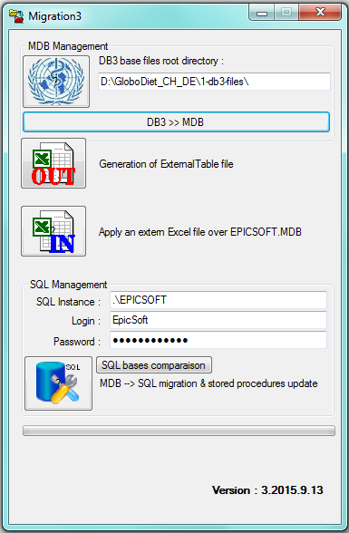

  - Read of db3-files and import in Migration Access database:

- Before running the import of the db3-files in the Migration Access database with Migration application, you have to Copy all the available db3-files in a country-specific folder.

- For example, for Austria you can use D:\GloboDiet_AUT\1_db3-files. Starting with ’1_’ allows to display it on the top of the sub-folder GloboDiet_AUT).

- By clicking on the following Migration icon,


- You have to enter the folder where the db3-files are available:
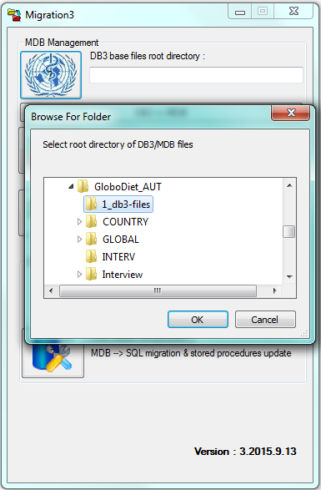

- You can then run the import of the db3-files by clicking on the long button ‘DB3 >> MDB’
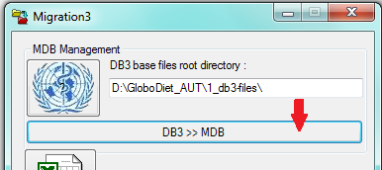

- If an Access database is already available on the predefined folder, the application will ask you if you want to replace it displaying the following message.
Select the Yes button to continue:

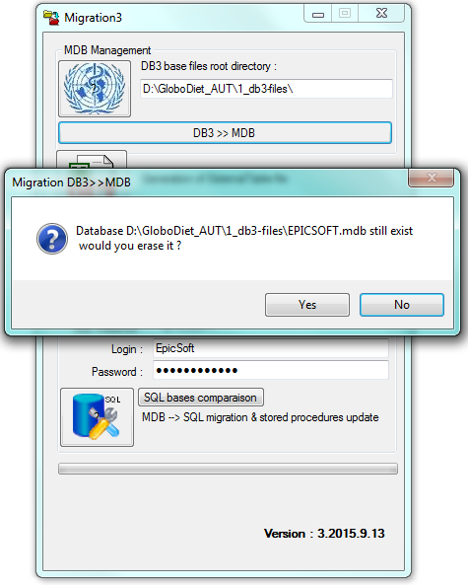

- Once the import is finished, a green message is displayed at the bottom of the window saying that the import is well done:
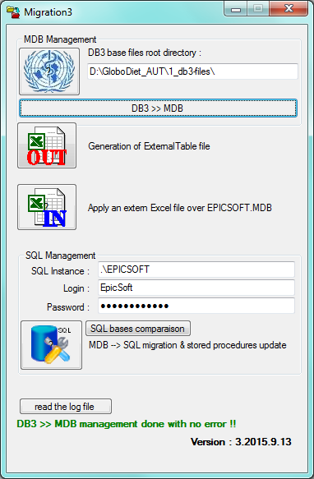

- By clicking on the button, it is possible to open the log file generated during the import. This file gives details on the generation of the Access database. Example of message for a well done import:
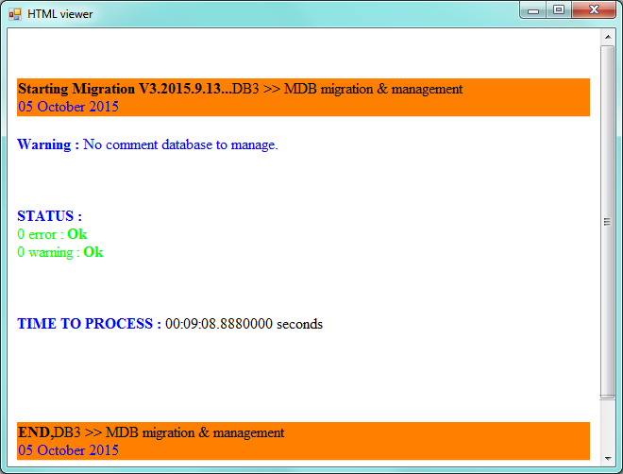

  - Export a temporary ExternalTables file

- You can generate the Excel file called ExternalTables_date that contains the db3-files in Excel format with 1 sheet per db3-files by clicking on the following button,
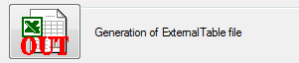
- Once the ExternalTables file is ready, the following message is displayed giving its name and the folder to find it; same folder as the one predefined above (e.g. D:\GloboDiet_Aut\1_db3-files)
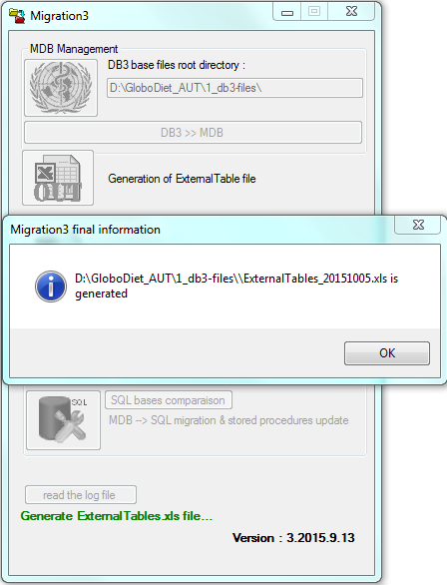

- By clicking on the ‘Read the log file’ button,
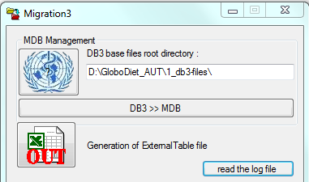

- You can open the log file generated during the generation of this file that gives details (e.g. empty file or number of loaded records) for each generated Excel sheet:

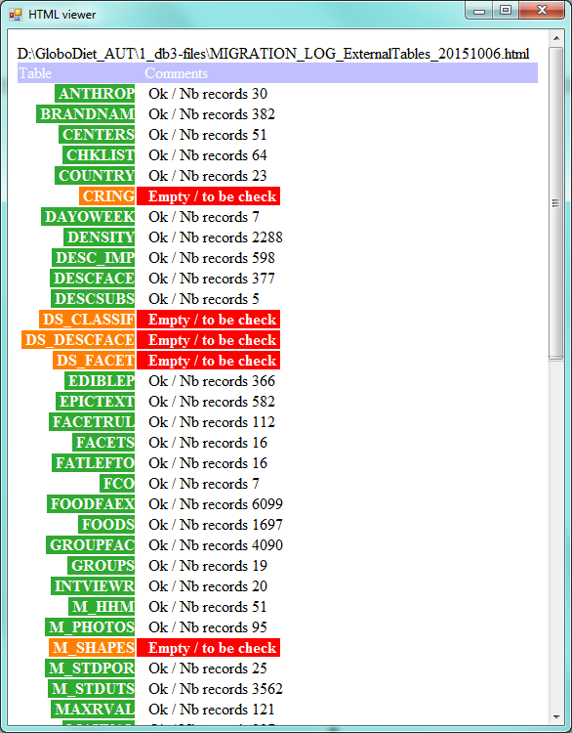

  - Preparation of Final ExternalTables file

    - Procedure

The update of the ExternalTables file can be done according to 2 different pathways:
- If the project is started, you can directly use the temporary ExternalTables.
- If you have to update an existed project, you can:
  - Take the last update of ExternalTables attached to this project
  - Put all the worksheet tabs in “no color”: Right click of the tab, choose “Tab color” in the menu, then “no color”.
  - Save it with a new attached date.
  - The sheet update can be done by copying the sheets from to temporary external table to the current one, or updating directly the sheet, depending of worksheet.

As you go along filling the worksheet, put the worksheet tabs in green when finished, in red with comments in the worksheet to know this is not finalised.

Note 1: The format of the columns Comment, Label, Name is defined with 100 characters unless otherwise specified in the document.

Note 2: if you need to load .db3 files into Excel sheet, the procedure to be followed is:
- Open a new temporary Excel file and place it so that you can view the column headings of the ExternalTables to fill in
- Choose Data > From txt >
- Select the country folder z_end\db3-files, view “All files” (bottom right menu), select the corresponding ET_xxx.db3 file and click on” Import”
- On the Text Import Wizard, choose “Fixed width”, File origin =MS-DOS(PC-8) if numbers, fine, else ANSI for regular characters or xxx, then click on “Next”
- Set the column breaks according to the ExternalTables column headings and info from another project, then click on “next”
- Select all columns (first column, shift, last column) and choose Text format, , then click on “Finish”
- Enter the data in =$A$1
- Copy the row with column headings from ExternalTables into the new temporary file using “Insert copied cells”

    - Tables/worksheet Description

- ANTHROP
Copy the ANTHROP worksheet from the temporary ExternalTables to the final ExternalTable. A priori no change needed except if this is a special population.
An ANTHROP file called ET_ANTHROP_xxxx.db3 is available in the folder \DEX\GLOBODIET_DB\3_COMMON\LIBRARY e-SMP\db3-files.

- BRANDNAME
Copy the BRANDNAME worksheet from the temporary ExternalTables to the final ExternalTable.
- #NAME:
Brand names starting with numbers are entered starting with “ in BRANDNAME.end. With the db3 process, it is modified into ô. This has to be removed.

- CENTERS
The Centres depend on information provided by the coordinators.
Copy the CENTERS worksheet from the temporary ExternalTables to the final ExternalTable that contains all the existing Centres already defined for GloboDiet projects. This Center file is available in the folder \DEX\GLOBODIET_DB\3_COMMON\LIBRARY e-SMP\db3-files
You can use it to select the needed project centres or enter new ones.
Note: CNTR_Name 50 characters

- CHKLIST
Copy the CHKLIST worksheet from the temporary ExternalTables to the final ExternalTable

- COUNTRY
Copy the COUNTRY worksheet from the temporary ExternalTables to the final ExternalTable that contains all the existing Countries already defined for GloboDiet projects.
The Country codes are defined at IARC according the international standards that are available in the file called \DEX\GLOBODIET_DB\3_COMMON\LIBRARY e-SMP\Code_Country_ISO.doc. To be used for new added Countries.
Note: CNTY_Name 50 characters

- DAYOWEEK
Copy the DAYOWEEK worksheet from the temporary ExternalTables to the final ExternalTable
Note: DAY 20 characters

- DENSITY
Copy the Density worksheet from the temporary ExternalTables to the final ExternalTable

- DESC_IMP
Copy the DESC_IMP worksheet from the temporary ExternalTables to the final ExternalTable.
This table is common and maintained by IARC. It is also available in the folder \DEX\GLOBODIET_DB\3_COMMON\LIBRARY e-SMP\db3-files.

- DESCFACE
Copy the DESCFACE worksheet from the temporary ExternalTables to the final ExternalTable.
Fill in the columns:
- #DESCR_NAME
If special characters, copy the correct labels into the column according to the FADECODE file in word/Excel.
- #DESC_COOK:
Use the information of the original ExternalTables file for descriptors of facet 03 OR GLOBODIET_DB\common\library e-SMP\cooking methods.xls file column Group PCTFAT.
For cooking descriptor 99 (raw) assign “1”.
Assign “2” for the cooking descriptors having a designation of “LOW FAT” or “FATTY”.
Assign “3” for the descriptors having a designation of “VERY FATTY”., enter “0” for the rest of the descriptors containing a blank in the Group PCTFAT column and referring to a cooking method that doesn’t use any fat during cooking.
This column is used for the calculation of fat in recipes (i.e. when 3 then fat will be assigned by software and shouldn’t be accounted for as an ingredient).
- #DESC_SINGLE:
Idem: Based on the list of multiple choice facets (defined in the Ext Table sheet “FACETS” – found below- and column #FACET_TYPE_S) , identify the descriptors of those facets which cannot be combined with others with “1”, enter “0” for the other descriptors.
- #DESC_OTHER::
Identify the descriptors “other option” (filter on “other” in the country language) with “1”, enter “0” for the other descriptors

- DESCSUBS
Copy the DESCSUBS worksheet from the temporary ExternalTables to the final ExternalTable. This table is common and maintained by IARC. This table is common and maintained by IARC. It is also available in the folder \DEX\GLOBODIET_DB\3_COMMON\LIBRARY e-SMP\db3-files.
For information: Have 02-03, 02-24 and the descriptor(s) for dried 04-03, 04-12, 04-18 (check in DESCFACE)

- DS_CLASSIF
Optional, defined by the coordinators
Note:Name 50 characters

- DS_DESCFACE
Defined by the coordinators
Descriptors of Facet 99 ‘Physical state’ are mandatory

- DS_FACET
Defined by the coordinators
Facet 99 ‘Physical state’ is mandatory
Fill in the columns:
- #DSFACET_NAME
If special characters, copy the correct labels into the column according to the DS_FADECODE file in word/Excel.
- #DSFACET_QUANT
1 for facet 99 ‘Physical state’,
0 for the others
- #DSFACET_TYPE
1 to allow multiple choices (01 ‘source’)
0 for the others
- #DSFACET_MAIN
1 to identify the main facets to be attributed to all supplements (99 ‘physical state’)
0 for the others
- #DSFACET_ORDER
Order to ask the facets (1=first, 2=second...)
Note: DSFACET_QUEST 300 characters

- EDIBLEP
Copy the EDIBLEP worksheet from the temporary ExternalTables to the final ExternalTable.
Add the exceptions using EDIB_with$ file.
To help find the exception, first use conditional formatting function for column A to highlight duplicates.
Be careful with the #PRIORITY number: #1 is with facet string, #2 is the default (if two EDIB coefficients).

- EPICTEXT
Copy the EPICTEXT worksheet from a previous existing version of ExternalTables to the final ExternalTable. If this previous version not exists, copy it from the temporary ExternalTables and ask to collaborator to translate all the labels

- FACETRUL
Copy the FACETRUL worksheet from the temporary ExternalTables to the final ExternalTable.

- FACETS
Copy the FACETS worksheet from the temporary ExternalTables to the final ExternalTable.
Fill in the other columns:
- #FACET_NAME & #FACET_TEXT
If special characters, copy the correct labels into the column according to the word/Excel FADECODE file.
- #FACET_TYPE:
1 for brand (facet 12), 2 for type of fat (facet 15), 3 for type of liquid (facet 16),
else 0
- #FACET_TYPE_S:
1 to allow multiple choice.
Write 1 for facets 01, 04, 06, 07, 09, 11, 15 and 16 (if agreed by the coordinators), 0 for the other facets
- #FACET_GRP:
List the food subgroup to be viewed for facets 15 and 16 as defined by the coordinators.
- #FACET_QUEST:
Question to be asked by the interviewers.
If not provided, you can copy the text of #FACET_TEXT
Note: FACET_QUEST 300 characters

- FATLEFTO
Copy the FATLEFTO worksheet from the temporary ExternalTables to the final ExternalTable.

- FCO
Copy the FCO worksheet from the temporary ExternalTables to the final ExternalTable.
Fill in the column:
- #FCM_PRINCIPAL:
1 for Breakfast (02), Lunch (05), Dinner (09), else enter 0
Note: FCM_SNAME 50 characters

- FOODFAEX
Copy the FOODFAEX worksheet from the temporary ExternalTables to the final ExternalTable.

- FOODS
Copy the FOODS worksheet from the temporary ExternalTables to the final ExternalTable. The Shadows are already included in this worksheet.
Fill in the column:
- #SUPPL:
Enter 0 unless the food has to appear in the dietary supplement list
Open the FDLIST_longnames file to correct names that have been truncated.
100 characters max (convert in Courier New, add arrow to build a ruler of 100 characters).
Make sure that generic items (n.s.) that are not shadow names have #TYPE=GI and #ORDER=1.
If special characters, replace by correct names

- GROUPFAC
Copy the GROUPFAC worksheet from the temporary ExternalTables to the final ExternalTable.
The columns #ORDER_ FAC and #ORDER_DESC are filled. In case of problem, the instructions to fill them are:
- #ORDER_ FAC:
Enter 1 in row 2.
In the other row enter the formula:
=IF(AND(A2=A3,B2=B3,C2=C3,D2=D3),H2, IF( AND(A2=A3,B2=B3,C2=C3),H2+1,1) )
- #ORDER_DESC:
Enter 1 in row 2.
In the other row enter the formula:
=IF(AND(A2=A3,B2=B3,C2=C3,H2=H3),I2+1,1)

- GROUPS
Copy the GROUPS worksheet from the temporary ExternalTables to the final ExternalTable.
Fill in the column:
- #NAMES_SHORT:
Fill with Name limited to 20 characters

- INTERVIEWR
Defined by the coordinators
For the train the trainers’ course, you may enter
#INTV_CODE (8): 00000001…
#INTVFNAME: name (e.g. Elizabeth)
#INTVNAME: last name (e.g. Smith)
#COUNTRY: = CTRYCODE of sheet “Centers”
#CENTER: = CNTRCODE of sheet “Centers” (according to information provided by the coordinators)

- M_HHM
Copy the M_HHM worksheet from the temporary ExternalTables to the final ExternalTable.
Fill in the column:
- # D_ORDER:
Fill this column according to the order proposed in the temporary ExternalTable
OR use directly the M_HHM.xls.
N.B.: this will depend on how reliable the .end is

- M_PHOTOS
Copy the M_PHOTOS worksheet from the temporary ExternalTables to the final ExternalTable.
Fill in the column:
- #PH_UNIT:
G means “in grams”, V “in volume/ml”
Fill this column with G or V value
OR use the M_PHOTOS.xls directly
N.B.: this will depend on how reliable the .end is

- M_SHAPES
This table is defined by the coordinators. You can directly use the M_ SHAPES.xls

- M_STDUTS
Copy the M_STDUTS worksheet from the temporary ExternalTables to the final ExternalTable. Both recipe & food standard units are present in the worksheet.
Fill in the columns:
- #D_ORDER:
By default #UNIT_CODE=0001 gives # D_ORDER=1.01.
The formula =(1+F2/100) can be used.
If needed (for outdated or updated standard units) reorder the standard unit using the order indicated in the original Excel or doc FDSTD file. You have to put the NOT TO BE USED standard units (older ones) at the end of the list with higher D_ORDER value.
Since Dec 2015, change in the FDSTD file so volumes and decimals are handled automatically
- #STDU_UNIT:
Search on “$” in COMMENT to manage the volumes.
- #STDU_QUANT:
Search on “$” in COMMENT to manage decimal figures.
- #COMMENT:
Check if it is not truncated or if special characters are needed. If yes, retrieve the whole comments using the original Excel or doc FDSTD file.
Delete flags (e.g. $) from comments

- M_STDPOR
Copy the M_STDPOR worksheet from the temporary ExternalTables to the final ExternalTable.
Fill in the columns:
- #D_ORDER:
By default #PORT_CODE = 0001 gives # D_ORDER =1.01. The formula =(1+F2/100) can be used.
If needed (for outdated or updated standard portions) reorder the standard portion using the order indicated in the original Excel or doc FDSTD file. You have to put the NOT TO BE USED standard portions (older ones) at the end of the list with higher D_ORDER value.
Since Dec 2015, change in the FDSTD file so volumes and decimals are handled automatically
- #STDP_UNIT:
Add ‘G’ and Search on “$” in COMMENT to manage the volumes.
- #STDP_QUANT:
Search on “$” in COMMENT to manage decimal figures.
- #COMMENT:
Check if it is not truncated or if special characters are needed. If yes, retrieve the whole comments using the original Excel or doc FDSTD file.
Delete flags (e.g. $) from comments

- MAXRVAL
Copy the MAXRVAL worksheet from the temporary ExternalTables to the final ExternalTable.

- MAXVAL
Copy the MAXVAL worksheet from the temporary ExternalTables to the final ExternalTable.
Insert additional specific values for e.g. powdered milk and coffee

- MIXEDING
Copy the MIXEDING worksheet from the export of the Recipe Manager application

- MIXEDING_QT
If it exists, copy the MIXEDING_QT worksheet from the export of the Recipe Manager application

- MIXEDREC
Copy the MIXEDREC worksheet from the export of the Recipe Manager application

- MONTHS
Copy the MONTHS worksheet from the temporary ExternalTables to the final ExternalTable. A priori no change
Note: MONTH 20 characters

- NUTLIMIT
Copy the NUTLIMIT worksheet from the temporary ExternalTables to the final ExternalTable. A priori no change.
It is also available in the folder \DEX\GLOBODIET_DB\3_COMMON\LIBRARY e-SMP\db3-files
Notes: NAME & UNIT 50 characters

- NUTRIENT
Copy the NUTRIENT worksheet from the temporary ExternalTables to the final ExternalTable. A priori no change
Note: NTR_UNIT 20 characters

- PARAM
Handled by Corinne

- PARAMDE
Handled by Corinne

- POC
Copy the POC worksheet from the temporary ExternalTables to the final ExternalTable.
Fill in the column:
- #POC_OTHER:
Fill in 1 if “other” (e.g. coded 99), else Fill 0

- PROBQUE
Copy the PROBQUE worksheet from the temporary ExternalTables to the final ExternalTable. A priori no change

- QM_FOODS
Copy the QM_FOODS worksheet from the temporary ExternalTables to the final ExternalTable.
Delete Shape rows:
- Delete of Shape lines:
Filter on #METHOD =A Shape, delete the shapes that are not needed according to the selection in FDQUANT_withShapes

- QM_GROUP
Copy the QM_GROUP worksheet from the temporary ExternalTables to the final ExternalTable.
Fill in the columns/delete rows:
- #COMMENT:
- Filter on #METHOD =P & #METH_CODE, fill in the missing #COMMENT using the FDQMDETAIL file
- Filter on #METHOD =H, fill in the missing #COMMENT in the local language
- Filter on #METHOD =S, fill in the missing #COMMENT using the FDQMDETAIL file if it exists.
- Filter on #METHOD =U, fill in the missing #COMMENT using the FDQMDETAIL file if it exists
- Be sure the truncated comments are fixed using the FDQMDETAIL file
- Delete Shape rows:
- Filter on #METHOD =A Shape, delete the shapes that are not needed according to the selection in FDQMDETAIL file
Note: COMMENT 200 characters

- QM_RCLASS
Copy the QM_RCLASS worksheet from the temporary ExternalTables to the final ExternalTable.
Fill in the columns/delete rows:
- #COMMENT:
- Filter on #METHOD =P & #METH_CODE, fill in the missing #COMMENT using the RCPQMDETAIL file
- Filter on #METHOD =H, fill in the missing #COMMENT in the local language
- Filter on #METHOD =U, fill in the missing #COMMENT using the RCPQMDETAIL file if it exists
- Be sure the truncated comments are fixed using the FDQMDETAIL file
- Delete Shape rows:
- Filter on #METHOD =A Shape, delete the shapes that are not needed according to the selection in RCPQMDETAIL file
Note: COMMENT 200 characters

- QM_RECIP
Copy the QM_RECIP worksheet from the temporary ExternalTables to the final ExternalTable.
Delete Shape rows:
- Delete of Shape lines:
Filter on #METHOD =A Shape, delete the shapes that are not needed according to the selection in RCPQUANT_withShapes

- R_BRAND
Copy the R_BRAND worksheet from the temporary ExternalTables to the final ExternalTable. Can be empty and only column titles are available.

- R_DESCFACE
Copy the R_DESCFACE worksheet from the temporary ExternalTables to the final ExternalTable.
Fill in the columns:
- #RDESCR_NAME:
If special characters, copy the correct labels according to RCPFADECODE file.
- #RDESCR_TYPE:
For the facet 01 Recipe production, identify the descriptors ‘prepared at home’ with others with “1”, enter “0” for the other descriptors whatever the facet.
- #RDESCR_KNOWN:
For the facet 00 ‘Known/Unknown’, identify the descriptors ‘known’ with “2”, the descriptor ‘unknown’ with “1” and enter “0” for the other descriptors whatever the facet.
- #RDESCR_OTHER:
Identify the descriptors “other option” (filter on “other” in the country language) with “1”, enter “0” for the other descriptors
- #RDESCR_SINGLE:
Identify the descriptors of those facets which cannot be combined with others with “1”, enter “0” for the other descriptors.

- R_FACET
Copy the R_FACET worksheet from the temporary ExternalTables to the final ExternalTable.
Fill in the columns:
- #RFACET_TYPE:
1 for brand (facet 02) else 0
- #RFACET_TYPE_S:
1 to allow multiple choices
Write 1 for facets 03 ‘Recipe preservation method’ if agreed by the coordinators,
0 for the other facets
- #RFACET_MAIN:
1 to identify the main facets with non-modified descriptor
Write 1 for facets 00 & 01 (‘Known/Unknown’ & ‘Recipe production’) if agreed by the coordinators,
0 for the other facets
- #RFACET_QUEST:
Question to be asked by the interviewers.
If not provided, you can copy the text of #RFACET_TEXT
Note: RFACET_QUEST 300 characters

- R_FACETRUL
Copy the R_FACETRUL worksheet from the temporary ExternalTables to the final ExternalTable.

- R_GROUPFAC
Copy the R_GROUPFAC worksheet from the temporary ExternalTables to the final ExternalTable.
The columns #ORDER_ FAC and #ORDER_DESC are filled whatever in case of problem, the instructions to fill them are:
- #ORDER_ FAC:
Enter 1 in row 2.
In the other row enter the formula:
=IF(AND(A2=A3,B2=B3,C2=C3),G2, IF( AND(A2=A3,B2=B3),G2+1,1) )
- #ORDER_DESC:
Enter 1 in row 2.
In the other row enter the formula:
=IF(AND(A2=A3,B2=B3,G2=G3),H2+1,1)

- R_RCPFAEX
Copy the RCPFAEX worksheet from the temporary ExternalTables to the final ExternalTable.

- RCP_PATH
Copy the RCP_PATH worksheet from the temporary ExternalTables to the final ExternalTable. A priori no change

- RGROUPS
Copy the RGROUPS worksheet from the temporary ExternalTables to the final ExternalTable.
Fill in the column:
- #NAMES_SHORT:
Fill with Name limited to 20 characters

- RSUBGR
Copy the RSUBGR worksheet from the temporary ExternalTables to the final ExternalTable.
Fill in the column:
- #NAMES_SHORT:
Fill with Name limited to 20 characters

- SPECDAY
Copy the SPECDAY worksheet from the temporary ExternalTables to the final ExternalTable. A priori no change

- SPECDIET
Copy the SPECDIET worksheet from the temporary ExternalTables to the final ExternalTable. A priori no change

- SPFACOOK
Copy the SPFACOOK worksheet from the temporary ExternalTables to the final ExternalTable.
Insert the special rules if applicable.

- SPFACORE
Copy the SPFACORE worksheet from the temporary ExternalTables to the final ExternalTable.
Insert the special rules if applicable.

- SPFDCOOK
Copy the SPFDCOOK worksheet from the temporary ExternalTables to the final ExternalTable.

- STATUS
This table is defined by the coordinators and use the local Excel file.
The following lines are mandatory:
00 New 0
99 Action done 0
999 Deleted 0
- #S_HIDE:
1 = the status is not displayed on screen (hidden) to lighten the viewing
0 = the status is display on screen (default)

- SUBGROUP
Copy the SUBGROUP worksheet from the temporary ExternalTables to the final ExternalTable.
Fill in the columns:
- #NAME:
Insert two blanks/spaces in front of labels of sub-sub-groups
- #NAME_SHORT:
Copy labels from #NAME, limit to 20 characters
- #SGRP_FSS:
1 for food sub-groups considered as fats, sauces or sweeteners added (e.g. 050700, 050701, 050702, 10, 1101, 110200, 110203 and 1501)
0 for the others
- #SGRP_FLO:
1 for sub-groups considered with possible fat-left-over percentage. Use the local PCTFATLEFT file (e.g. 050700, 050701, 050702, 10, 110105, 110200, 1501)
0 for the others
- #SGRP_FDC
1 for sub-groups considered as fats to be used during cooking (e.g. group 10)
0 for the others

- SUBSTIT
Copy the SUBSTIT worksheet from the temporary ExternalTables to the final ExternalTable. Table maintains by IARC, normally common to all projects.

- SUPPLEMENTS
Copy the SUPPLEMENT worksheet from the temporary ExternalTables to the final ExternalTable.
Fill in the columns:
- #NAME:
Correct names that have been truncated or with special characters using VITAMINS.end. 100 characters max (convert in Courier New, add arrow to build a ruler of 100 characters)
- #NAME_SHORT:
Copy labels from #NAME, limit to 20 characters
- #TYPE:
“GI” for generic items (n.s.), else blank
- #DS_CLASS:
If values are available in the DS_CLASSIF table, this column can be filled or not.
If no classification, this column is empty
- #DS_FACET:
To indicate in which order the facets have to be displayed, enter the facet codes separated with comma
Facet 99 is mandatory and has to be at the end of the list.
Example: “01,02,03,99”

- THICKNESS
Insert the local Excel file.

  - Import the final ExternalTables file

- Once the ExternalTables is ready, you can import it in the Access database by clicking on the following button:
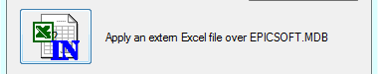

- You have to enter the final ExternalTables with xls as extension (not xlsx) in your folder and then select the Open button to import it:
Have ExternalTable in D:\ Programmes FORTRAN\db3-files
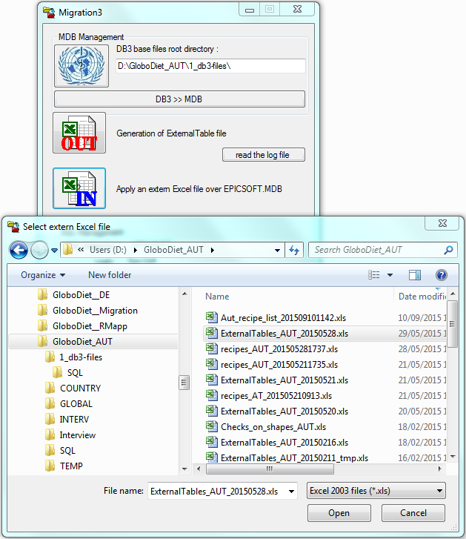

- The application is running displaying a green pipe and messages that give information on the table management:
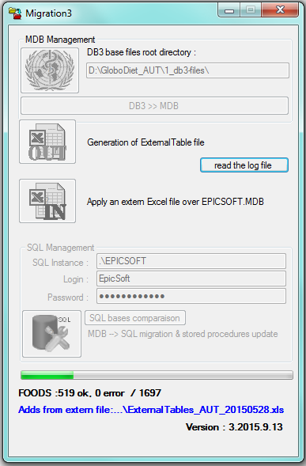

- Once the import is done, a message is displayed at the bottom of the window.
This message is green when the import is well done:
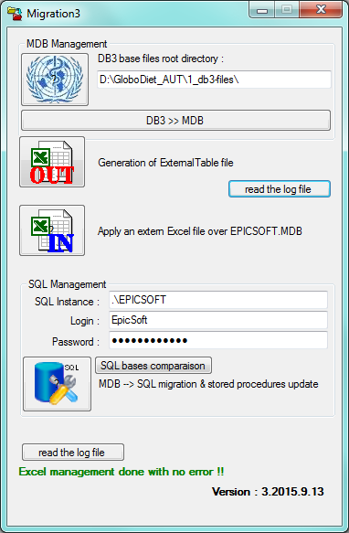

- This message is red when a mistake occurred:
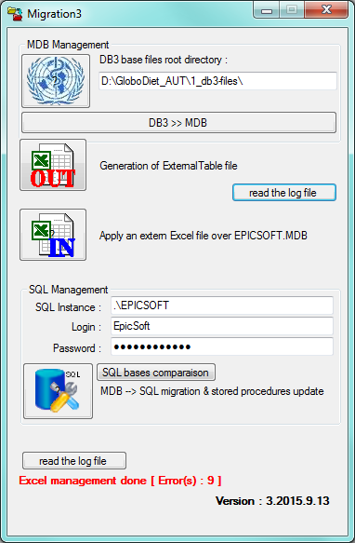

- By clicking on the button, it is possible to open the log file generated during the import of the External Table. This file gives details on this import in Access database.
Example of messages for a well done import:
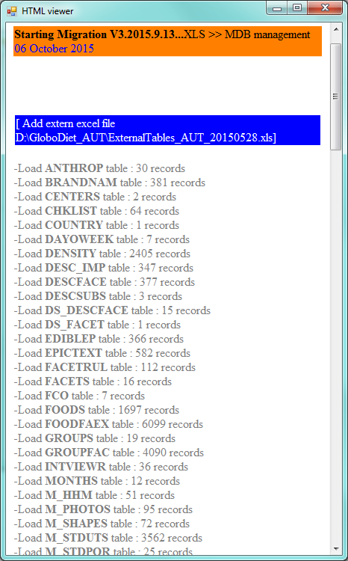

When problems occurred, the displayed messages give details on which sheet the problem occurred and on type of problem.
  - Example 1: A non-waited message “to be adapted” is still available in the FCO sheet:
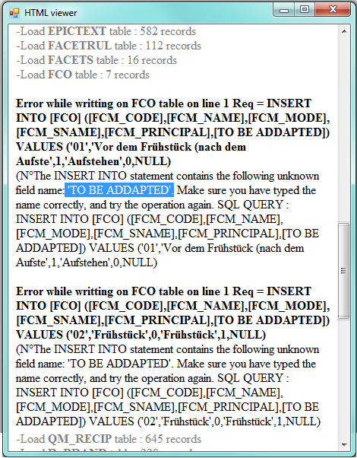
  - Example 2: In GROUPS table, the Name_Short label of is too long to be imported in the field of Access table:
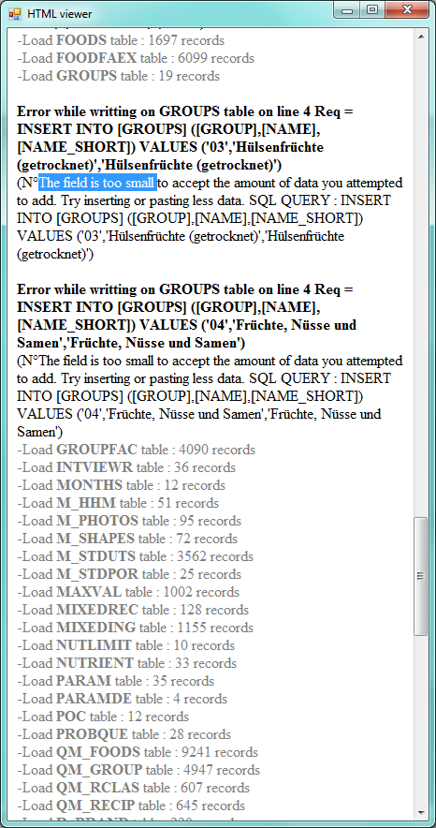

  - Generation of GloboDiet parameter database in SQL format

- Once you do not have error message during the import of the final ExternalTables, you can generate the SQL GloboDiet parameter database by clicking on the following button:
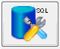

- The application is running displaying a green pipe:
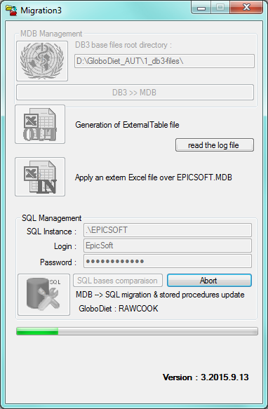
- At the end of the transformation, the following green message is displayed:
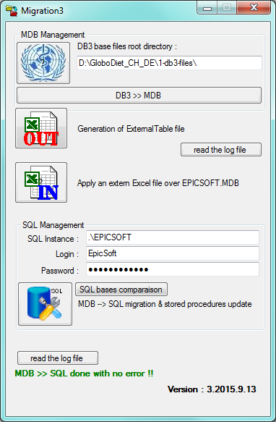

- Note: it is possible that instead of the previous green message, the following red message is displayed. In this case, you just have to click a second time on the SQL tools icon to re-run the generation of the SQL database:
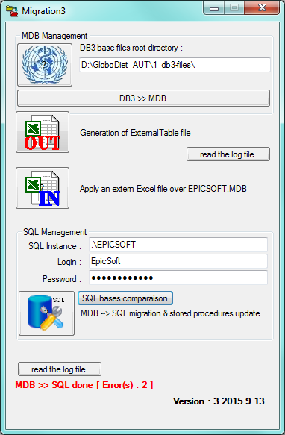

- At the end of this process, a GloboDiet parameter database has been generated.
The file called GloboDiet_date.bak is available in the folder displayed at the top of Migration window (in the example below D:\GloboDiet_AUT\1_db3-files).
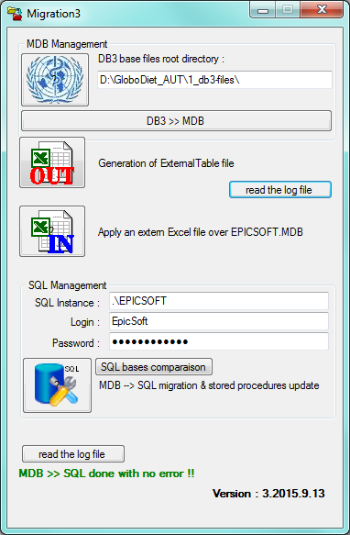

- To finish, you will have to:
  - Change the database mane by adding the country abbreviation (e.g. GloboDiet_AUT_20151005.bak)
  - Copy this file on the Version folder attached to the database Country (e.g. in \DEX\GLOBODIET_DB\AUT\VERSION

- MIGRATION application: requirement, installation/un-installation

  - Requirements to install Migration

- GloboDiet application has to be installed first
- See guidelines Appendix 3_How_to_install_GloboDiet_Application_20150122.doc
- Open the zip-file called Migration3Setup_2015_09_13.zip and available in the folder \DEX\e_SMP\GloboDiet_NEW_conception\Module_Migration\Version.
- Extract the 2 available files:
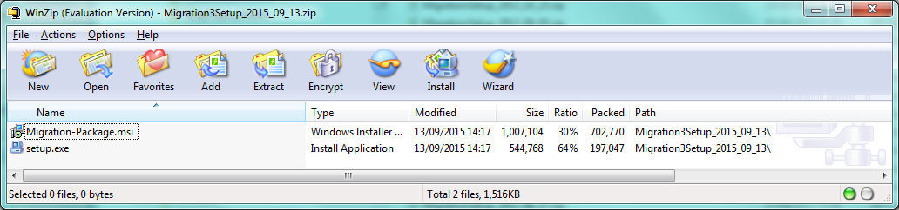

  - How to install Migration program

- Create a new folder called Migration for example
- Run the setup.exe program using the ‘Run as administrator’ function available by using the right click of the mouse:
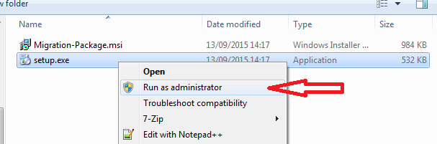

- Select ‘Yes’ to start the installation
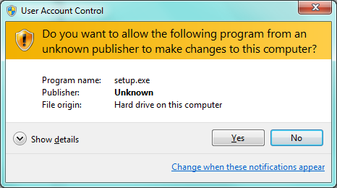

- Select ‘Accept’ and ‘Next’ to continue the installation
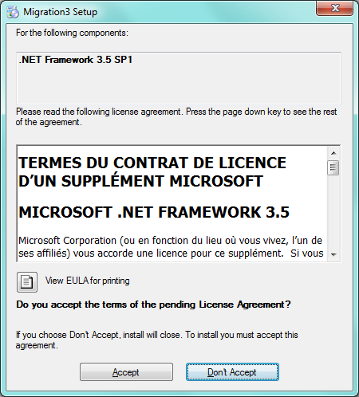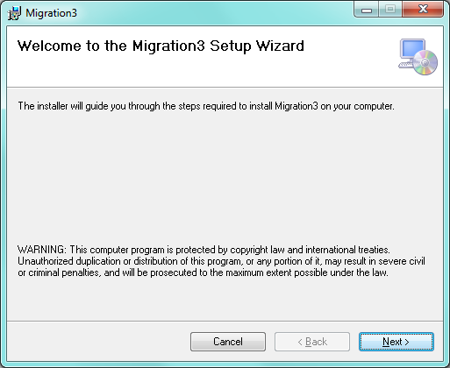

- Then select a folder to install Migration using the Browse button or type directly the Migration folder (e.g. D:\Migration).
Selecting the Next button, you can continue the installation
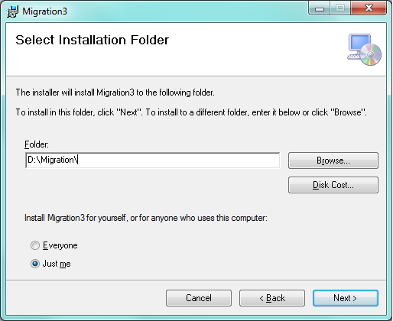

- Select again the Next button to confirm and continue the installation
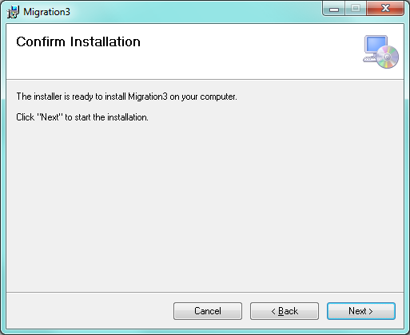

- Once the display of the pipe, a final window is displayed o confirm the installation. You can then Close the window.
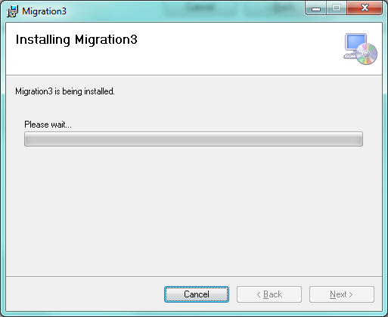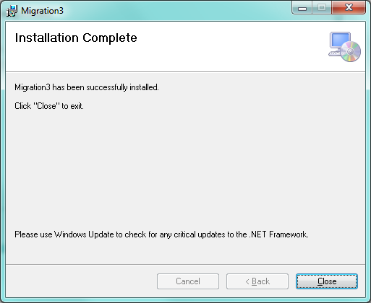

- Now, you can run Migration by selecting ‘All programs’ and ‘Migration’ on Windows menu
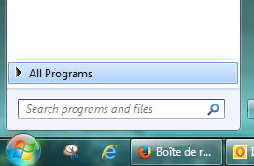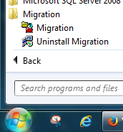

  - How to uninstall Migration program:

- Note: This uninstall has to be done before installing a new release of Migration
- Click on the Windows icon  and select the ‘All programs’ function


- Select the ‘Uninstall Migration’ function on the ‘Migration’ menu:
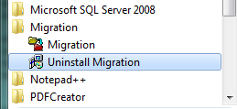

- Confirm the uninstallation of Migration by selecting the Yes button
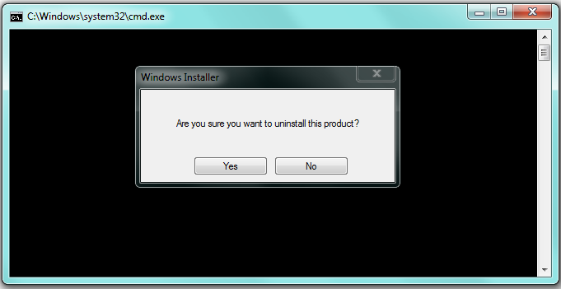

- After the display of the ‘pipe’ window, the Migration application is uninstalled.
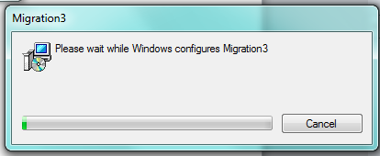

ANNEX 1: BAT-Program to be adapted and then, run to generate the db3-files

- If 1 language is used in the Country the following program called 3_Make_db3_D_1_Langague.bat has to be used.

- Before running it, it is necessary to adapt it as specified below

@rem ---------- NEEDED CHANGES TO BE DONE IN THE PROGRAM --------------------
@rem you have to replace:
@rem -> _FR to _DE (e.g. for Switzerlands to move from German to French)
@rem -> if needed 'n.s.' to 'n.e.' (here n.e. in Spanish)

@rem ------------------------------------------------------------------------
@rem ---------- COPY PART : For 1 used language ----------------------------
@rem all the used end-files have to be in Country language
@rem if needed do not hesitate to update this copy part
@rem ------------------------------------------------------------------------

@D:
@cd \ProgrammesFORTRAN\end-files
@copy /y FDCLASS_FR.end FDCLASS.end
@copy /y FADECODE_FR.end FADECODE.end
@copy /y RCPCLASS_FR.end RCPCLASS.end
@copy /y RCPFADECODE_FR.end RCPFADECODE.end

@REM copy of needed txt-files
@copy /y fdclass.end fdclass.txt
@copy /y photo.end photo.txt
@copy /y fadecode.end fadecode.txt
@copy /y fadebygroup.end fadebygroup.txt
@copy /y fadebygroup.end fdbyg.dat
@copy /y facetrul.end facetrul.txt
@copy /y fdqmdetail.end fdqmdetail.txt
@copy /y rcpclass.end rcpclass.txt
@copy /y rcpfadecode.end rcpfadecode.txt
@copy /y rcpfadebygroup.end rcpfadebygroup.txt
@copy /y rcpfacetrul.end rcpfacetrul.txt
@copy /y rcpqmdetail.end rcpqmdetail.txt

@REM copy of end files to folder to db3-files (no modification by program)
@copy /y DAYOWEEK.end ..\db3-files\ET_DAYOWEEK.db3
@copy /y FCO.end ..\db3-files\ET_FCO.db3
@copy /y POC.end ..\db3-files\ET_POC.db3
@copy /y MONTHS.end ..\db3-files\ET_MONTHS.db3
@copy /y SPECDAY.end ..\db3-files\ET_SPECDAY.db3
@copy /y SPECDIET.end ..\db3-files\ET_SPECDIET.db3

@rem ------------------------- Common db3 files -----------------------------

@cd \ProgrammesFORTRAN\prgcom
@rem ....... PHOTO...........: M_PHOTOS.DB3
PHOTO.exe
@rem ....... FDCLASS.........: GROUPS.DB3 & SUBGROUP.DB3
FDCLASS.exe
@rem ....... FADECODE........: FACETS.DB3 & DESCFACE.DB3
FADECODE.exe

@rem ....... FADEBYGROUP.....: GROUPFAC.DB3
FADEBYGROUP_PRGCOM.exe
FADEBYGROUP.exe
@rem ....... FACETRUL........: FACETRUL.DB3
FACETRUL.exe
@rem ....... PROBQUE.........: PROBQUE.DB3
PROBQUE.exe
@rem ....... QMETH...........: QM_GROUP.DB3
QMETH.exe

@cd \ProgrammesFORTRAN\prgcom
@rem ....... RCPCLASS........: RGROUPS.DB3 & RSUBGR.DB3
RCPCLASS.exe
@rem ....... RCP FADECODE....: R_FACETS.DB3 & R_DESCFACE.DB3
RCPFADECODE.exe
@rem ....... RCP FADEBYGROUP.: R_GROUPFAC.DB3
RCPFADEBYGROUP.exe
@rem ....... RCPFACETRUL.....: R_FACETRUL.DB3
RCPFACETRUL.exe
@rem ....... QMETHRCP........: QM_RCLAS.DB3
QMETHRCP.exe

@rem -------------------------- Country FOODS -------------------------------

@cd ..\prgcty
@rem ..... FOODS....... : FOODS.DB3
echo n.s.|FOODS.exe
@rem ..... SHADOWS..... : FOODSSHA.DB3
FOODSSHA.exe
@rem ..... CHECKLIST... : CHKLIST.DB3
CHECKLIST.exe
@rem ..... FDFACET..... : FOODFAEX.DB3
FOODFAEX.exe
@rem ..... BRANDNAM.... : BRANDNAM.DB3
BRANDNAM.exe
@rem ..... COMPRCP..... : FOODSCRP.DB3 & CRING.DB3
echo C | COMPRCP.exe
@rem ..... HHM......... : M_HHM.DB3
HHM.exe
@rem ..... FDQMDETAIL.. : QM_FOODS.DB3
FDMETH.exe
@rem ..... FDSTD....... : M_STDUTS.DB3 & M_STDPOR.DB3
M_STD.exe
@rem ..... DENSITY..... : DENSITY.DB3
DENSITY.exe
@rem ..... RAWCOOK..... : RAWCOOK.DB3
RAWCOOK.exe
@rem ..... EDIBL.T..... : EDIBLEP.DB3
EDBPART.exe
@rem ..... FDTABLE..... : FOODCOMP.DB3
FOODCOMP.exe
@rem ..... FDMAX....... : MAXVAL.DB3
MAXVAL.exe
@rem ..... PCTFAT...... : SPFDCOOK.DB3
PCTFAT.exe
@rem ..... PCTFATLEFT.. : FATLEFTO.DB3
PCTFATLEFT.exe
@rem ..... PCTFSS...... : SPFACOOK.DB3
PCTFSS.exe
@rem ..... FDPROBING... : PQPATH.DB3
PQPATH.exe
@rem ..... VITAMINS.... : VITAMINS.DB3
echo n.s.|VITAMINS.exe

@rem ------------------------- Country RECIPES ------------------------------

@cd ..\prgcty
@rem ..... RCPFACET..... : R_FAEX.DB3
RCPFAEX.exe
@rem ..... RCPBRAND..... : RBRAND.DB3
RBRAND.exe
@rem ..... RCPQUANT..... : QM_RECIP.DB3
RCPMETH.exe
@rem ..... MCPSTDU...... : M_RCPU.DB3
M_RCPU.exe
@rem ..... RCPMAX....... : MAXRVAL.DB3
MAXRVAL.exe
@rem ..... RCPDENSITY... : R_DENSITY.DB3
RCPDENSITY.exe
@rem ..... RCPPCTPFSS... : SPFACORE.DB3
RCPFSS.exe
@rem ..... RPQPROBING... : RPQPATH.DB3
RPQPATH.exe

@rem ------------- common db3-files to be retrieved ------------------------

@cd ..\db3-files
@copy /y ..\prgcom\*.db3 *.db3

@rem 12 Common Files copied:
@rem ET_ANTHROP_to_be_reviewed.DB3
@rem ET_CENTERS.DB3
@rem ET_COUNTRY.DB3
@rem ET_DESC_IMP.db3
@rem ET_DESCSUBS.DB3
@rem ET_EPICTEXT.db3
@rem ET_INTVIEWR_to_be_reviewed.DB3
@rem ET_NUTLIMIT.DB3
@REM ET_NUTRIENT.db3
@rem ET_PATIENTS.DB3
@rem ET_RCP_PATH.db3
@rem ET_SUBSTIT.DB3
@rem ------------------------------------------------------------------------
@cmd

      - 63 db3-files are generated including:
17 Setup files
17 Common files
20 Country Food files
8 Country Recipe files
1 Country Supplement files

- If several languages is used in the Country the following program called 3_Make_db3_D_n_Langague.bat has to be used.

- Before running it, it is necessary to adapt it as specified below

@rem ---------- NEEDED CHANGES TO BE DONE IN THE PROGRAM --------------------
@rem you have to replace:
@rem -> _FR to _DE (e.g. for Switzerland to move from German to French)
@rem -> if needed 'n.s.' to 'n.e.' (here n.e. in Spanish)
@rem ------------------------------------------------------------------------
@rem ---------- COPY PART : For several used languages ---------------------
@rem all the used end-files have to be in Country language
@rem if needed do not hesitate to update this copy part
@rem ------------------------------------------------------------------------

@D:
@REM --> Predefined COPY of end files in case of n languages used
@REM Check & add/delete copy lines before running the bat-file

@cd \ProgrammesFORTRAN\end-files
@copy /y FDCLASS_FR.end FDCLASS.end
@copy /y FADECODE_FR.end FADECODE.end
@copy /y RCPCLASS_FR.end RCPCLASS.end
@copy /y RCPFADECODE_FR.end RCPFADECODE.end

@copy /y CHECKLIST_FR.END CHECKLIST.end
@copy /y DAYOWEEK_FR.END DAYOWEEK.end
@copy /y FADEBYGROUP_FR.end FADEBYGROUP.end
@copy /y FCO_FR.END FCO.end
@copy /y FDLIST_FR.end FDLIST.end
@copy /y FDQMDETAIL_FR.END FDQMDETAIL.end
@copy /y FDSTD_FR.END FDSTD.end
@copy /y HHM_FR.END HHM.end
@copy /y MIXEDREC_FR.END MIXEDREC.end
@copy /y MONTHS_FR.END MONTHS.end
@copy /y POC_FR.END POC.end
@copy /y PROBING_FR.END PROBING.end
@copy /y RCPFADEBYGROUP_FR.end RCPFADEBYGROUP.end
@copy /y RCPQMDETAIL_FR.end RCPQMDETAIL.end
@copy /y RCPSTDU_FR.END RCPSTDU.end
@copy /y SHADOWLIST_FR.end SHADOWLIST.end
@copy /y SPECDAY_FR.END SPECDAY.end
@copy /y SPECDIET_FR.END SPECDIET.end

@REM copy of needed txt-files
@cd ..\end-files
@copy /y fdclass.end fdclass.txt
@copy /y photo.end photo.txt
@copy /y fadecode.end fadecode.txt
@copy /y fadebygroup.end fadebygroup.txt
@copy /y fadebygroup.end fdbyg.dat
@copy /y facetrul.end facetrul.txt
@copy /y fdqmdetail.end fdqmdetail.txt
@copy /y rcpclass.end rcpclass.txt
@copy /y rcpfadecode.end rcpfadecode.txt
@copy /y rcpfadebygroup.end rcpfadebygroup.txt
@copy /y rcpfacetrul.end rcpfacetrul.txt
@copy /y rcpqmdetail.end rcpqmdetail.txt

@REM copy of end files to folder to db3-files (no modification by program)
@copy /y DAYOWEEK.end ..\db3-files\ET_DAYOWEEK.db3
@copy /y FCO.end ..\db3-files\ET_FCO.db3
@copy /y POC.end ..\db3-files\ET_POC.db3
@copy /y MONTHS.end ..\db3-files\ET_MONTHS.db3
@copy /y SPECDAY.end ..\db3-files\ET_SPECDAY.db3
@copy /y SPECDIET.end ..\db3-files\ET_SPECDIET.db33
@rem ------------------------------------------------------------------------

@rem ----------------------- Common db3 files -------------------------------
@cd \ProgrammesFORTRAN\prgcom
@rem ....... PHOTO...........: M_PHOTOS.DB3
PHOTO.exe
@rem ....... FDCLASS.........: GROUPS.DB3 & SUBGROUP.DB3
FDCLASS.exe
@rem ....... FADECODE........: FACETS.DB3 & DESCFACE.DB3
FADECODE.exe
@rem ....... FADEBYGROUP.....: GROUPFAC.DB3
FADEBYGROUP_PRGCOM.exe
FADEBYGROUP.exe
@rem ....... FACETRUL........: FACETRUL.DB3
FACETRUL.exe
@rem ....... PROBQUE.........: PROBQUE.DB3
PROBQUE.exe
@rem ....... QMETH...........: QM_GROUP.DB3
QMETH.exe

@cd \ProgrammesFORTRAN\prgcom
@rem ....... RCPCLASS........: RGROUPS.DB3 & RSUBGR.DB3
RCPCLASS.exe
@rem ....... RCP FADECODE....: R_FACETS.DB3 & R_DESCFACE.DB3
RCPFADECODE.exe
@rem ....... RCP FADEBYGROUP.: R_GROUPFAC.DB3
RCPFADEBYGROUP.exe
@rem ....... RCPFACETRUL.....: R_FACETRUL.DB3
RCPFACETRUL.exe
@rem ....... QMETHRCP........: QM_RCLAS.DB3
QMETHRCP.exe

@rem ---------------------------- Country FOODS -----------------------------

@cd ..\prgcty
@rem ..... FOODS....... : FOODS.DB3
echo n.s.|FOODS.exe
@rem ..... SHADOWS..... : FOODSSHA.DB3
FOODSSHA.exe
@rem ..... CHECKLIST... : CHKLIST.DB3
CHECKLIST.exe
@rem ..... FDFACET..... : FOODFAEX.DB3
FOODFAEX.exe
@rem ..... BRANDNAM.... : BRANDNAM.DB3
BRANDNAM.exe
@rem ..... COMPRCP..... : FOODSCRP.DB3 & CRING.DB3
echo C | COMPRCP.exe
@rem ..... HHM......... : M_HHM.DB3
HHM.exe
@rem ..... FDQMDETAIL.. : QM_FOODS.DB3
FDMETH.exe
@rem ..... FDSTD....... : M_STDUTS.DB3 & M_STDPOR.DB3
M_STD.exe
@rem ..... DENSITY..... : DENSITY.DB3
DENSITY.exe
@rem ..... RAWCOOK..... : RAWCOOK.DB3
RAWCOOK.exe
@rem ..... EDIBL.T..... : EDIBLEP.DB3
EDBPART.exe
@rem ..... FDTABLE..... : FOODCOMP.DB3
FOODCOMP.exe
@rem ..... FDMAX....... : MAXVAL.DB3
MAXVAL.exe
@rem ..... PCTFAT...... : SPFDCOOK.DB3
PCTFAT.exe
@rem ..... PCTFATLEFT.. : FATLEFTO.DB3
PCTFATLEFT.exe
@rem ..... PCTFSS...... : SPFACOOK.DB3
PCTFSS.exe
@rem ..... FDPROBING... : PQPATH.DB3
PQPATH.exe
@rem ..... VITAMINS.... : VITAMINS.DB3
echo n.s.|VITAMINS.exe

@rem --------------------------- Country RECIPES -----------------------------

@cd ..\prgcty
@rem ..... RCPFACET..... : R_FAEX.DB3
RCPFAEX.exe
@rem ..... RCPBRAND..... : RBRAND.DB3
RBRAND.exe
@rem ..... RCPQUANT..... : QM_RECIP.DB3
RCPMETH.exe
@rem ..... MCPSTDU...... : M_RCPU.DB3
M_RCPU.exe
@rem ..... RCPMAX....... : MAXRVAL.DB3
MAXRVAL.exe
@rem ..... RCPDENSITY... : R_DENSITY.DB3
RCPDENSITY.exe
@rem ..... RCPPCTPFSS... : SPFACORE.DB3
RCPFSS.exe
@rem ..... RPQPROBING... : RPQPATH.DB3
RPQPATH.exe

@rem ------------- common db3-files to be retrieved ------------------------

@cd ..\db3-files
@copy /y ..\prgcom\*.db3 *.db3

@rem 12 Common Files copied:
@rem ET_ANTHROP_to_be_reviewed.DB3
@rem ET_CENTERS.DB3
@rem ET_COUNTRY.DB3
@rem ET_DESC_IMP.db3
@rem ET_DESCSUBS.DB3
@rem ET_EPICTEXT.db3
@rem ET_INTVIEWR_to_be_reviewed.DB3
@rem ET_NUTLIMIT.DB3
@REM ET_NUTRIENT.db3
@rem ET_PATIENTS.DB3
@rem ET_RCP_PATH.db3
@rem ET_SUBSTIT.DB3
@rem ------------------------------------------------------------------------

@cmd
ANNEX 2: List of the 63 generated db3-files:

- Alphabetical order

ET_ANTHROP.db3
ET_brandnam.db3
ET_CENTERS.DB3
ET_chklist.db3
ET_COUNTRY.DB3
ET_cring.db3
ET_DAYOWEEK.db3
ET_density.db3
ET_DESC_IMP.db3
ET_descface.db3
ET_DESCSUBS.DB3
ET_ediblep.db3
ET_EPICTEXT.db3
ET_facetrul.db3
ET_facets.db3
ET_fatlefto.db3
ET_FCO.db3
ET_foodcomp.db3
ET_foodfaex.db3
ET_FOODS.db3
ET_foodscrp.db3
ET_foodssha.db3
ET_groupfac.db3
ET_groups.db3
ET_INTVIEWR.DB3
ET_m_hhm.db3
ET_m_photos.db3
ET_m_rcpu.db3
ET_m_stdpor.db3
ET_m_stduts.db3
ET_maxrval.db3
ET_maxval.db3
ET_MONTHS.db3
ET_NUTLIMIT.DB3
ET_NUTRIENT.db3
ET_PATIENTS.DB3
ET_POC.db3
ET_pqpath.db3
ET_probque.db3
ET_qm_foods.db3
ET_qm_group.db3
ET_qm_rclas.db3
ET_qm_recip.db3
ET_r_density.db3
ET_r_descface.db3
ET_r_facetrul.db3
ET_r_facets.db3
ET_r_groupfac.db3
ET_r_rcpfaex.db3
ET_rawcook.db3
ET_rbrand.db3
ET_RCP_PATH.db3
ET_rgroups.db3
ET_rpqpath.db3
ET_rsubgr.db3
ET_SPECDAY.db3
ET_SPECDIET.db3
ET_spfacook.db3
ET_spfacore.db3
ET_spfdcook.db3
ET_subgroup.db3
ET_SUBSTIT.DB3
ET_vitamins.db3

- Managerial order

  - Setup

ET_anthrop.db3
ET_centers.db3
ET_country.db3
ET_cring.db3
ET_dayoweek.db3
ET_epictext.db3
ET_fco.db3
ET_intviewr.db3
ET_months.db3
ET_nutlimit.db3
ET_nutrient.db3
ET_patients.db3
ET_poc.db3
ET_rcp_path.db3
ET_specday.db3
ET_specdiet.db3
ET_substit.db3

  - Common

ET_descsubs.db3
ET_desc_imp.db3
ET_descface.db3
ET_facetrul.db3
ET_facets.db3
ET_groupfac.db3
ET_groups.db3
ET_probque.db3
ET_qm_group.db3
ET_qm_rclas.db3
ET_rgroups.db3
ET_rsubgr.db3
ET_r_facetrul.db3
ET_r_facets.db3
ET_r_groupfac.db3
ET_r_descface.db3
ET_subgroup.db3

  - Country

FOODS

ET_brandnam.db3
ET_chklist.db3
ET_density.db3
ET_ediblep.db3
ET_fatlefto.db3
ET_foodcomp.db3
ET_foodfaex.db3
ET_foods.db3
ET_foodscrp.db3
ET_foodssha.db3
ET_maxval.db3
ET_m_hhm.db3
ET_m_photos.db3
ET_m_stdpor.db3
ET_m_stduts.db3
ET_pqpath.db3
ET_qm_foods.db3
ET_rawcook.db3
ET_spfacook.db3
ET_spfdcook.db3

RECIPES

ET_maxrval.db3
ET_m_rcpu.db3
ET_qm_recip.db3
ET_rbrand.db3
ET_rpqpath.db3
ET_r_density.db3
ET_r_rcpfaex.db3
ET_spfacore.db3

SUPPLEMENTS
ET_vitamins.db3

