RECIPE MANAGER

USER MANUAL

Dietary Exposure Assessment Group (DEX)
International Agency for Research on Cancer

Lyon, France, May 2014

Any queries on the circulation, reproduction or other use of the material should be directed to:

Dietary Exposure Assessment Group
International Agency for Research on Cancer
150, cours Albert Thomas
69372 Lyon Cedex 08, France
slimanin@iarc.fr

This copy of the guidelines is part of the GloboDiet methodology and is protected as pre-existing know-how (PEKH) during and after the current project. Proper acknowledgement of the use of the GloboDiet methodology, including the GloboDiet guidelines, should be made in any document, report or scientific paper resulting from the use of this methodology. Like all IARC products disseminated for educational and research purposes, the entire GloboDiet methodology enjoys copyright protection in accordance with the provisions of Protocol 2 of the Universal Copyright Convention. All rights are therefore reserved.


We acknowledge the financial support of the European Community under the ‘Europe AgainstCancer’ Programme (Grant No. SOC 96 200416) and the FP6 EFCOVAL project (Contract number: FOOD-CT-2006-022895). The EC is not liable for any use of the information contained herein.
We also thank all the contributors to this manual.

THE MANAGEMENT OF RECIPE DATA THROUGH THE RECIPE MANAGER

There are two ways that recipes are entered and stored using the GloboDiet applications:
1) Prior to the start of their fieldwork and using the RECIPE MANAGER application for GloboDiet, standard recipes can be entered by the country coordinator/dietician, thus creating a country-specific recipe database. These recipes will then appear in the country version of the GloboDiet application available for all the interviewers in that country. Hence during the interview any recipe saved in this recipe database can be selected by an interviewer and, if permitted, ingredients modified according to the respondent’s answers.
2.) During the fieldwork and using the country-version of GloboDiet, new individual recipes are created choosing all the ingredients from the food list. Since these recipes are entered only during the interview they will be attached only to that individual’s interview and will not become part of the country-specific recipe database: they would not be visible/accessible to other interviewers during the fieldwork period.
The type of recipes entered during an interview are more likely to be composed recipes, but could be also mixed recipes (see below for definitions) if the respondent is able to provide the list of ingredients and their quantities, and given that no such recipe is already available in the country-specific recipe database of the GloboDiet.

This document provides guidelines on the management of the country-specific recipe database (standard recipe entry, modification, deletion) using the RECIPE MANAGER application developed by IARC specifically for the preparation/update of the full (i.e. including recipes) country-version of the GloboDiet application prior to the fieldwork (point 1 above). The recipes entered using this method will become part of the recipe database for that country and will be available to all the interviewers during the fieldwork period.

I. DEFINITIONS AND GUIDELINES CONCERNING RECIPES USED IN GloboDiet

During an interview with GloboDiet, items can be chosen out of two lists: from the food list (top of the screen) and the recipe list (bottom of the screen). The two alternatives are described below.

I.1. Food pathway

Simple and complex foods
In the food list of the GloboDiet application are listed food items. They are either ‘simple foods’ (e.g. fruits, meat cuts, fish) or ‘complex foods’ (e.g. cakes, biscuits, dough, desserts, sauces and some snacks). Complex foods contain several ingredients but are perceived (or defined) as food items, and are treated in the same way as simple foods. Food items in the food list (whether simple or complex) can be used as ingredients in a recipe. Ingredients are searched, described and quantified in the same way as foods in both, the RECIPE MANAGER and the GloboDiet applications (see section I.3 Ingredients).

‘Composed recipes’ follow the food pathway meaning that they are entered directly in the GloboDiet application during the interview by listing together the associated ingredients in the Quick List Item screen.
Definition: Recipes where the different ingredients can be identified and quantified separately after preparation (e.g. rice with sauce, mixed salad) or just before mixing (e.g. coffee with milk) are termed ‘composed’ recipes.
A composed recipe should be used even though the respondent cannot quantify all of its ingredients such as fat, sauce or sweetener. GloboDiet has indeed foreseen standard percentages for them, and standard portions (e.g. for cheese or tuna) to be used to compose a mixed salad (refer to country-specific files). All the ingredients of the composed recipe are described and quantified as stand-alone food items.
Since these recipes are NOT entered using the RECIPE MANAGER application prior to the interview, they are saved/attached only to that individual’s interview and will not become part of the recipe database for use during other interviews. Therefore, they will not be discussed further in this document.

I.2 Recipe pathway

‘Mixed recipes’ follow the recipe pathway and are relevant for the RECIPE MANAGER application guidelines herein. Mixed recipes are listed in the recipe list of GloboDiet.
Definition: Recipes where, after preparation, the different ingredients cannot be identified and quantified separately are termed ‘mixed’ recipes. The ingredients of mixed recipes are derived from cook books (for homemade and similar recipes), internet or are based on information received from the industry (for commercial recipes). They are entered as standard recipes with the RECIPE MANAGER and handled at the country level prior to the commencement of the interviews.
The mixed recipe database may contain three types of recipes: 1) ‘open recipes’, 2) ‘closed recipes’ and 3) ‘strictly commercial with brand recipes’.
For each mixed recipe, information on the expected variation of ingredients within the study population needs to be collected, too. If the variation is found to be great, the recipe should be treated as an open recipe. It is also possible to enter several standard variations of a recipe depending on regions. If no variations are expected, a recipe should be treated as a closed recipe or as a strictly commercial recipe. Furthermore, it has to be decided if each ingredient is fixed or substitutable (see definitions below). When entering the recipe ingredients with RECIPE MANAGER, the ingredients are described and quantified like in the food pathway. (see specific section I.4).

I.3. Ingredients
Ingredients will be chosen from the food list. In the RECIPE MANAGER, ingredients will be set as either ‘fixed’ or ‘substitutable’ when entering the recipes.
Fixed ingredients are those that cannot be replaced or re-described during the interview.

Substitutable ingredients are those that can be replaced or re-described during the interview. They have to be checked and adjusted to the respondent’s specific habits/answers during the interview. This makes the standard recipe, which is predefined prior to the interview, more flexible during the interview, e.g. ‘oil n.s.’ can be replaced by ‘margarine, vegetable’.

- Substitutable ingredient, marked ‘SUBST’, can be replaced or re-described using facets/descriptors during the interview. Ingredients set as substitutable may be:
- Ingredients which are likely to be replaced within the same food group/subgroup so that the recipe becomes more flexible.
- Generic ingredients, i.e. food items appearing with ‘n.s.’ in the food list
- All sauces, fats and dairy creams
- All ingredients with at least one ‘undefined’ descriptor (descriptor 00) and that would need to be re-described with the interviewee
- Ingredients with facets 12 Brandname, 13 Skin consumed, 14 Visible fat consumed, 15 Type of milk/liquid used or 16 Type of fat used as their descriptors are changed frequently. Note that the use of facets 15 and 16 is to be avoided.
Some restrictions apply to substitutions.
1.) The quantity of substitutable ingredients cannot be changed.
2.) The substitution is limited either to the group level whatever the subgroup, or to the sub-group level, or to the sub-sub-group level. For example, carrot can be substituted for cabbage because they are in the same food group (02) but not for potato, which is in a different food group (01). No substitution is allowed for some groups/subgroups. Substitution rules are decided for each study by the coordinator.
- Fixed ingredient, marked ‘FIXED’, cannot be replaced or re-described during the interview. Ingredients may be set as fixed:
- If there is no replacement foreseen, such as e.g. spices
- If the ingredient has low nutritional impact e.g. stock cubes
- If the descriptors of an ingredient are not likely to vary, e.g. egg
- Often, if ingredient appears in the name of the recipe
- All the ingredients in strictly commercial recipes

Special rule due to ingredient description:
Some ingredients cannot be entirely re-described because of their description which has a direct link with quantification. Indeed, the descriptors ‘powdered’, ‘concentrated’, ‘dried’, ‘semi-dried’ and ‘dried n.s.’ cannot be substituted in order to avoid quantification problems. For example, 5 gram of powdered milk does not correspond nutritionally to 5 gram of liquid milk thus the ingredient would be set as fixed. The inverse is also true: liquid milk cannot be re-described as powdered milk.

I.4. Types of mixed recipes to decide on in the RECIPE MANAGER

Prior to entering a mixed recipe in the RECIPE MANAGER, one must decide on a few aspects of that recipe, thus specifying for the interviewer during the interview how much flexibility he/she has with that given recipe, as briefly explained in I.2.
This consists of choosing the type for each mixed recipe. For GloboDiet there exist four major sets (see the scheme below):
- Open recipes (with or without brand name)
This is a type of mixed recipe where it is assumed that the ingredients reported within the study population can vary considerably. A maximum of flexibility is required.
They still may be with or without brand. If with brand, the commercial source (supermarket, restaurant,…) as well as the brand name of the recipe will be asked during the interview.
Within open recipes, three types of recipes exist:

1/ INDIVIDUAL RECIPE: the recipe is homemade and the subject knows the recipe (ingredients AND quantities). The respondent would indicate all the ingredients with their description and quantification (in the Recipe Ingredient manager window/pop-up). The pre-entered recipe ingredients are displayed as a guide, without any ingredient description, nor quantification; any ingredient can be added, deleted or substituted. As a visual help, the standard recipe can be displayed with the % as estimated and as consumed.
2/ ADAPTABLE RECIPES:
2a/ The recipe is prepared at home and the subject does not know the recipe. If such a recipe is chosen during the interview and after it is described and its portion quantified by the respondent, the standard recipe ingredients will be proposed (in the Recipe Ingredient manager window/pop-up). The ingredient quantities proposed will be based on the consumed portion of the recipe and it is in principle possible to add, delete or substitute any ingredient. However, depending on the amounts of the ingredients added and/or deleted and the allowed percentage change cut-off (usually 5%, but can be re-defined at the project level), the changes may or may not be immediately accounted for in the recipe. In the Recipe Ingredient manager window, if the change is above the cut-off point, the changed ingredients will not be immediately taken into account on the description/quantification screen, instead they will be flagged. The addition and/or deletion of the changed ingredients will have to be checked/validated after the interview (in EDIT interview mode).
2b/ The recipe is commercial (either produced industrially or by an artisan or prepared in a restaurant (including fast food, canteen, cafeteria …) and during the interview, the subject would not be asked if the recipe is known. The recipe brand name needs to be indicated in the RECIPE MANAGER – the subject may report another brand during the interview. After the description and quantification of the recipe, the standard recipe is proposed (in the Recipe Ingredient manager window/pop-up of GloboDiet), the ingredient quantities are based on the consumed portion of the recipe and it is in principle possible to add, delete or substitute any ingredient. Again, depending on the amounts of the ingredients added and/or deleted and the allowed percentage change cut-off, the changes may not be taken into account immediately. If the change is above the cut-off point, the ingredients will be flagged on the description/quantification screen and the addition and/or deletion of ingredients will have to be checked/validated after the interview (in EDIT interview mode).
In both cases, during the interview,
- The original standard recipe is displayed (with the % as consumed and consumed quantities) for check. The NOTE file is prompted automatically when saving the recipe in case of added and/or deleted ingredient; comments may be added to the automatic notes.
- All substitutable ingredients will have to be checked with the interviewee.

- Closed recipes (with or without brand name)
This is a type of mixed recipe where it is assumed that the ingredients reported within the study population do not vary, especially in their relative quantity. Therefore, the subject would not be asked to identify, describe and quantify all the ingredients before preparation only those that are substitutable; thus only substitutions are allowed here.
Such recipes may be with or without brand. If without brand, the recipe may be homemade or commercial. In the latter case, the brand name of the recipe will be asked. If with brand, the commercial source (supermarket, restaurant, …) or the brand name of the recipe will be asked.
The pre-entered recipe is treated as a standard (in the Recipe Ingredient manager window/pop-up) where the ingredients appear with their description and quantification (based on the consumed portion of the recipe). The subject is asked if the substitutable ingredients should be replaced or re-described. However, quantities cannot be changed, and no ingredient can be deleted or added (this can only be mentioned in the NOTE file by pressing F1). Fixed ingredients can neither be re-described, substituted, nor re-quantified.
- Strictly commercial recipes (with brand name)
They are always with brand: the commercial source (supermarket, restaurant, …) or the brand name of the recipe will be asked during the interview. No ingredient check would be performed during the interview as all ingredients are fixed. The NOTE file is prompted automatically.
- New recipes
Unlike the other three types which are pre-entered using the RECIPE MANAGER, these are recipes which are not available in the country-specific recipe list: they are created during the interview.
If the subject knows the recipe, all the ingredients will be described and quantified in the Recipe Ingredient manager window/pop-up. In case the recipe is unknown, the Recipe Ingredient manager window/pop-up will also be proposed to enter a maximum of information. In any case, the NOTE screen is proposed to enter extra information. The validation of the new recipes will be done post interview (in EDIT interview mode).
Those new recipes are only attached to the interview in which they were reported. If needed, the coordinator will decide to add them to the country-specific recipe list so that all interviewers can access to them. This will be done by entering the new recipes in the RECIPE MANAGER and preparing a new GloboDiet version to be disseminated.

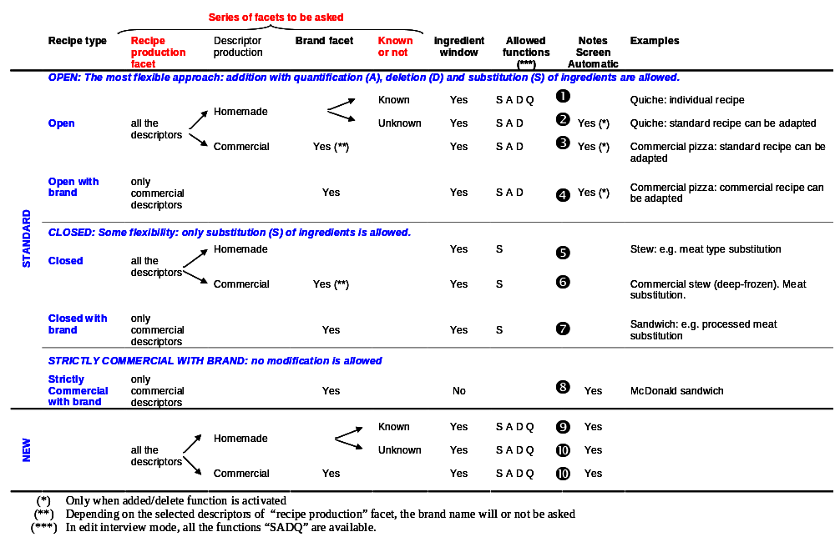

I.5- Special rules and advice/tips to enter the recipes using the RECIPE MANAGER

Here is a list of guidelines to adapt the country-specific recipes so that they are compatible with the GloboDiet methodology.

- Recipes can be entered for any number of persons; in fact it is preferable to enter a recipe for more than one person in order to quantify more accurately ingredients of very small quantities. During the interview, the portion of recipe consumed by the subject is recorded.
- Preferably enter ingredient quantities in g or ml (or use household measures). Do not use photos, nor leave ingredients with unknown quantities, even for commercial recipes. If any recipe ingredient has a missing quantity, the recipe will have a status of unfinished and therefore will not be uploaded to the country-specific recipe database of the GloboDiet application. After the fieldwork, any interviews having recipes with unknown quantities will have to be updated.
- Quantities with decimal numbers can be entered (fractions of units can also be used). For the ingredients of very small thus insignificant quantities (e.g. spices) of less than 1 gram, you may omit them depending on the study objectives.
- For each ingredient, enter in the facet ‘cooking method’ the FATTIEST cooking method used, even if the final cooking method for the whole recipe may differ. For example, if fresh onions were pan fried before they were put to cook in a stew, the cooking method entered should be "pan fried" for the onions. Note that still, the onions could have been quantified as raw. Another example is, if for a savoury aubergine pie, the aubergines were deep fried prior to incorporating them in the pie to bake. In such case, the cooking method for aubergines is "deep fried" rather than baked. The cooking method of an ingredient is not defined when entering its quantity (which can be entered either in cooked or raw state). For example the quantity of the aubergines in the previous example will usually be entered when still raw although its cooking method was described as ‘deep fried’. Therefore, do not confine the information captured by the facet ‘cooking method’ with the question whether the weight of this ingredient is entered as raw or cooked. E.g. ‘Steak’ is entered with its raw weight (200 g), and griddled afterwards (facet 0313).
- The reheating method for the whole recipe will be a separate question asked during the interview by GloboDiet.
- Fat should be entered as a single ingredient per recipe. Exceptions are deep fried foods, for which the amount of fat absorbed during deep-frying should not be listed as an ingredient in the recipe as it will be handled automatically by the RECIPE MANAGER. The reason being, it may be difficult to estimate the quantity of fat absorbed by the deep fried food from the total fat used to immerse the food when deep frying. Thus the RECIPE MANAGER application uses a standard algorithm to calculate this based on the weight of the ingredient. This rule doesn’t apply for fried/shallow-fried/pan-fried foods, for which the quantity of fat used during such frying can be easily estimated.
- The ingredients should be as specific as possible, for example if most of the milk consumed in your country is half-skimmed milk, it is wise to describe it this way but set it as substitutable. Generic ingredients are entered only if these ingredients may vary considerably or if they are often unknown. They should be substitutable. During the interview, a generic item can be replaced by a more specific item, e.g. ‘fat n.s.’ by ‘oil n.s.’ or ‘butter’.
- Any liquid (including water, broth/stock, milk, etc.) used to cook (and rehydrate) dried food items such as pasta, rice, legumes or mushrooms should not be counted twice: the raw-to-cooked coefficient of these items takes water uptake into account, so do not list that water as a separate ingredient. For example, when white beans (dried) are chosen as an ingredient, the uptake of the water during the cooking process will be accounted for based on the item description for the facets “Preservation method” and "Cooking method” (e.g. boiled). So there is no need to list the water or broth used to cook the dried beans.
- On the other hand, for casseroles, stews or soups in which some water evaporates, the FINAL (after evaporation) liquid quantity should be entered as there is no raw-to-cooked coefficient for liquids, knowing that this amount of water can only be crudely estimated (roughly about 20% evaporated during 2hrs of cooking). This means that the amount of liquid that may have evaporated during long cooking processes should be subtracted from the total original used (e.g. the amount of water after cooking in a soup should be added as an ingredient).
- For mixed purees, describe all ingredients as ‘flesh’, not as ‘pureed’ or ‘reconstituted from powder’ (they have facets 15 and 16 asking for type of fat and liquid used) to avoid ‘listing’ liquid and fat twice. In general, avoid the use of facets 15 and 16 which are only qualitative and confuse the ingredient handling.
- For salads, avoid entering the dressing sauce for those salads where the subject normally puts the dressing on by him/herself. The dressing should be added afterwards, e.g. as part of probing, to allow that the standard percentage of sauce or fat can be calculated based on the total quantity of the recipe consumed in case the subject does not know its quantity.
- Do not enter recipes if already found in the food list as complex foods, such as cakes, biscuits, dough, fruit salads, desserts, soups, sauces, some snacks, and battered (breaded) foods.
- When used as ingredients, those complex foods should be used as such and not decomposed into their ingredients. For example, ‘pastry dough’ will be used as ingredient of a ‘quiche’, ‘pancake’ will be used as ingredient of ‘filled pancake’.
- Whenever relevant, use two lines to allow partial substitution, e.g. instead of 200 g cream, enter twice 100 g of cream so that 100 g of cream can be replaced by milk or yogurt.
- It is not possible to enter only a single ingredient in a mixed recipe. A warning will be prompted on the screen.
- For recipes with brands (e.g. Pizza, brand A) saved in the country-specific recipe database, be aware that they may be chosen during the interview even if the brand is not the same (brand B). During the interview, the brand of the product consumed will be captured. It will be up to the coordinators to decide whether a separate recipe for brand B needs to be created in the country-specific recipe database.

Nota bene for existing Recipe lists (for ‘old’ GloboDiet users):
During the ingredient description, descriptors defined as ‘Other’ are no longer proposed (no longer shown on the screen) in the pop-up Facet.
As a result, a red/blue icon will appear next to any pre-entered recipes which contained ingredients described using one or more ‘Other’ descriptors. These specific ingredients will also be identified with a red/blue icon, meaning there is a description problem, and to validate the recipe, the ingredients with a red/blue icon will need to be re-described using the available list of descriptors. The icons of the ingredients and of the attached recipe will become blue (meaning no action needed).

II. GUIDELINES ON THE USE OF THE RECIPE-MANAGER

The RECIPE MANAGER has been developed to facilitate the management of the recipe part of GloboDiet outside the field work. The country coordinator has the task to enter recipes following the GloboDiet methodology tips provided in section I.5 and to update regularly the recipe database by incorporating missing recipes detected during the interviews.
The related recipe files such as the description, quantification of recipes, their standard units, their probing, density coefficients, maxima values, and standard percentages of fat, sauce and sweetener are handled separately based on the recipe list exported from the RECIPE MANAGER.
Before entering recipes, definitions and guidelines concerning mixed and composed recipes should be reviewed carefully and understood (section I). A specific training course on the RECIPE MANAGER application is also available at IARC.
In the following, all steps to enter and edit recipes are described (their functions are summarized in annex 1).
Notes:
- the selection of a menu, function, option or field is made by using the mouse, the keyboard or the hot keys (for menus use ALT + underlined letter, and for functions and options use only the underlined letter).
- A mouse right-click enables to view the menu, then select the function with the mouse/
- the underlined words/letters are those appearing on the screen. Through them, a menu or a function is activated, or a field can be completed.
- a selected function is de-activated through pressing ‘ESC’ or the square in front of the top line of the screen.

To enter the RECIPE MANAGER application, start ‘RecipeManager.exe’ program. On the Recipe Manager screen (main screen), the following menus are displayed in the top line:

- Databases menu,

- Recipe List menu which opens the Recipe List screen,

The red button proposes either to quit a level (e.g. leave the Recipe list menu) or to exit program, depending on its location (top row or menu row).

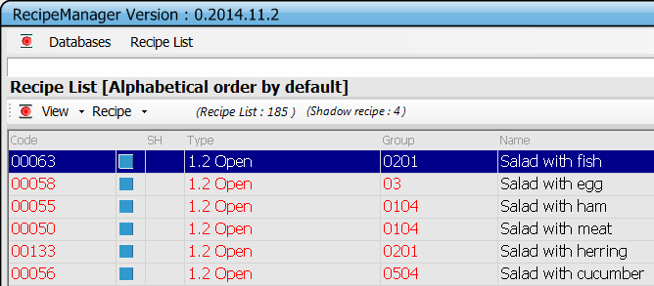

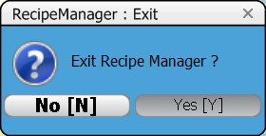

1- Databases menu
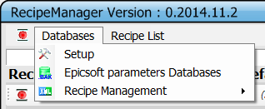
* Setup through which British units can be selected.
If British units are to be used, select Setup from the top line of the RECIPE MANAGER screen and click with the mouse at British units or use the spacebar and confirm. The mark in front of British units indicates that this mode is active.

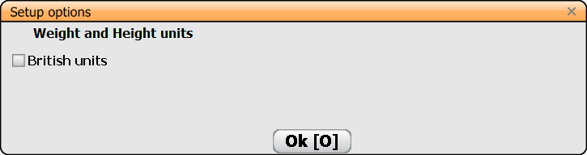

* Epicsoft/GloboDiet parameters Databases

It allows user to select, restore or remove an GloboDiet database. Functions are the same as in the GloboDiet or DataEntry application (see Appendix 4 of the GloboDiet User manual).

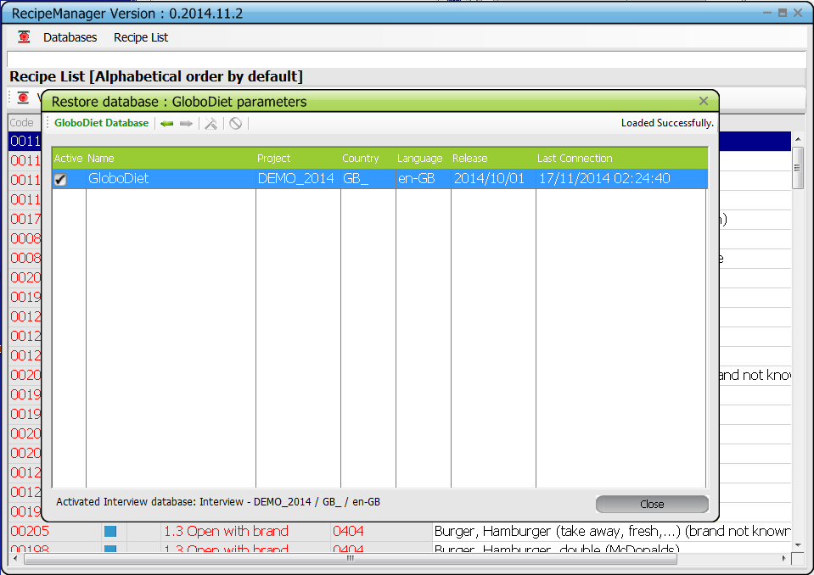

* Recipe Management

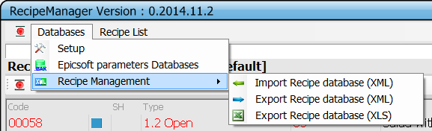

Some menu items are used to import/export recipes with a current recipe GloboDiet database.

a- Import Recipe (XML)

This function allows the user to import an XML file after a confirmation sequence :

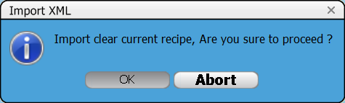

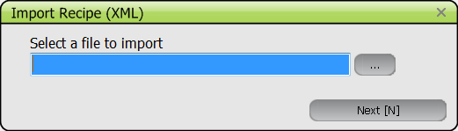

b- Export Recipe (XML)

This function allows the user to generate an XML recipe file to a destination folder :

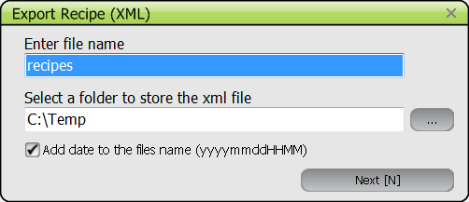
The user can automatically attach the date and time to the file name by ticking the box ‘Add date to the files name’.

c- Export Recipe (XLS)
Same as above (point b) selecting Recipe export (XLS).

2- Recipe List

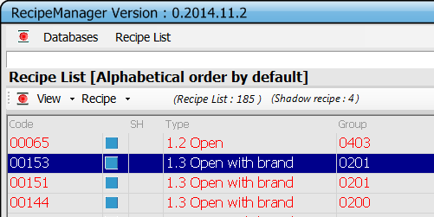

By default, recipes are listed alphabetically.
The recipes may be sorted by clicking on the heading of the columns: by recipe code by clicking on the header ‘Code’, by recipe type by clicking on the header ‘Type’, by recipe classification by clicking on the header ‘Group’, alphabetically by clicking on the header ‘Name’. Shadow recipes may be grouped by clicking on the header ‘SH’.

2.1- View menu

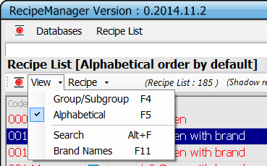

To search an existing recipe, type its name. It will be written in the blank field above the Recipe List header. The by default automatic alphabetical search -Alphabetical (F5)- will occur as in GloboDiet.

As in GloboDiet, the search of the recipe may alternatively be done by searching based on Group/Subgroup (F4) or Search on string (Alt + F).

Brand Name (F11): if selected (ticked), this displays a modified recipe list where the brand names are listed in front of the recipe names, instead of after the name as in the normal recipe list.

2.2- Recipe menu

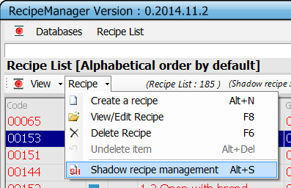

* Create (Alt + N)

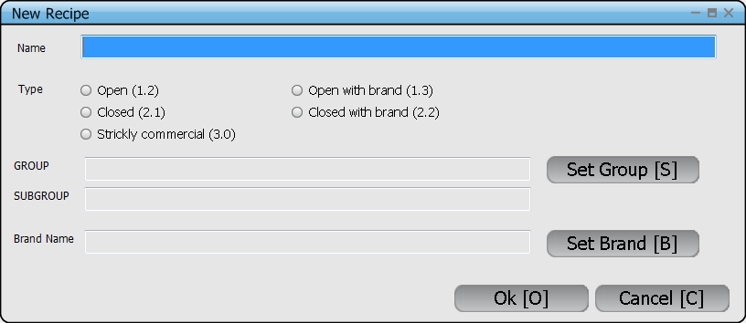

When choosing ‘Create’, new recipes can be entered and immediately edited.

The first step consists in entering the general information of the new recipe
• Name: Enter the name of the recipe

• Type: Choose the type of the recipe.

• Set Group: When pressing Set Group or clicking in the field GROUP, the pop up Group/Subgroup is prompted. Select the GROUP, and if relevant, go to the Recipe Subgroup List through ‘tab’ or clicking the mouse in the list, select the SUBGROUP and press return to close the pop up.

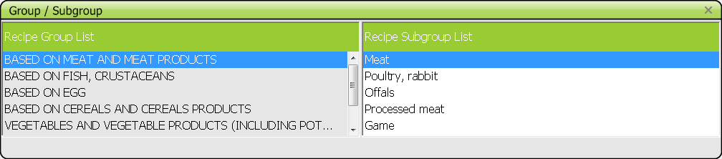

• Set Brand: Enter the Brand Name which is possible only for recipes with brand (including strictly commercial ones). Proposed only when relevant

• Confirm the entries with OK, or Cancel to quit.

The second step consists in describing and quantifying its ingredients:
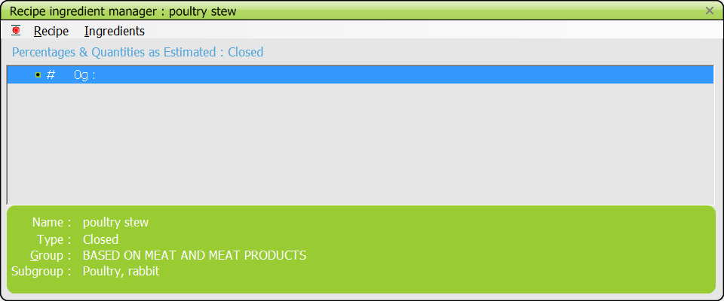

In the top line of the Recipe Ingredient Manager screen, two menus -Recipe and Ingredients- appear.

Select repeatedly the menu Ingredients and Add ingredient (F4), or use F4, to enter each ingredient with its description and quantification.

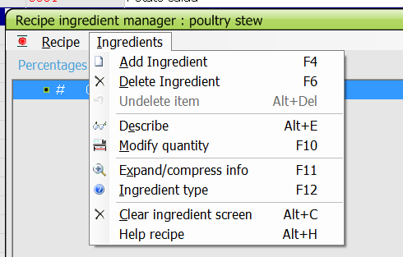

Then indicate if the ingredient is fixed or substitutable.
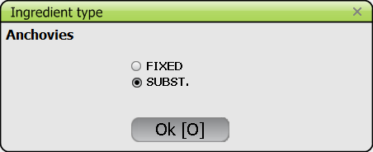
Note that when pressing return with the cursor on an ingredient, the function Describe is automatically activated, enabling to re-describe that ingredient.

Finally, save the recipe through the Recipe menu. Note that the ‘Save’ and ‘Save as’ functions are not active for new recipes.

* Quit without saving (Alt + F4): Enables to go back to the Recipe List screen without saving the recipe information

* Save and exit from the temporary recipe (CTRL +F9): Enables to save the recipe information and to go back to the Recipe List screen. The recipe is flagged as not finalised 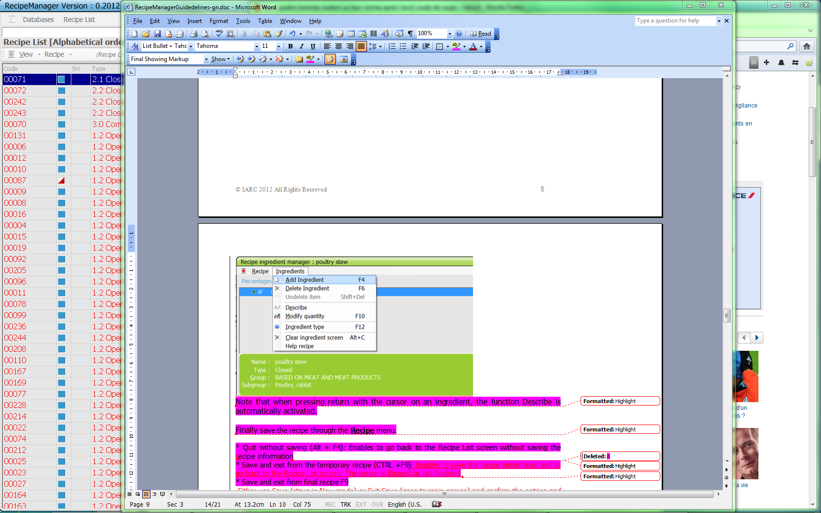.

* Save and exit from final recipe (F9): Enables to save the recipe information and to go back to the Recipe List screen. The recipe is flagged as finalised 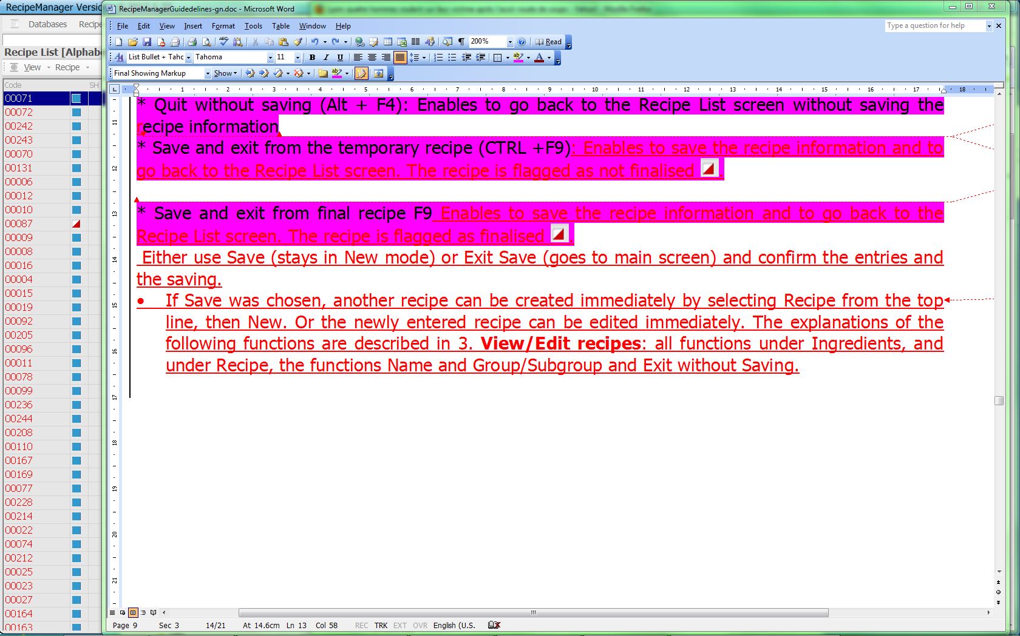.

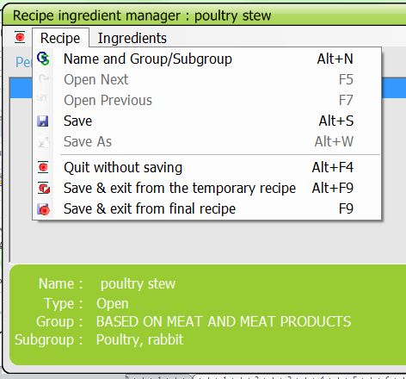

* View/Edit (F8)
After having found the recipe to be edited, you may
- double click on this line of the Recipe List screen.
- select menu Recipe then Edit
- right mouse click and select View/Edit

In the Recipe Ingredient manager screen, Recipe and Ingredients menus appear.
* Recipe menu:
The displayed functions allow for the general handling of the recipe: open, save, and leave the recipes:
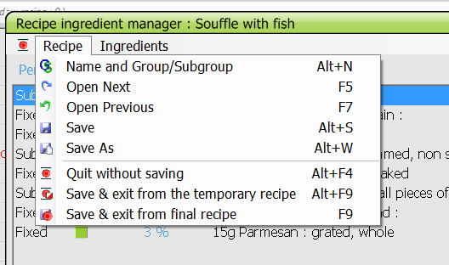

- Name and Group/Subgroup: Enables to update recipe name, type, classification and brandname. Confirm by OK, or Cancel.

- Open Next (F5): If the current recipe has been modified, a question on whether to save it or not is asked. Then the next recipe, in alphabetical order, is opened (not the next higher code).

- Open Previous (F7): If the current recipe has been modified, a question on whether to save it or not is asked. Then the previous recipe in alphabetical order is opened (not the next lower code).

- Save (Alt+S): The recipe is saved after confirming the entries and the saving. The previous entry is overwritten and the code remains the same. You remain in that menu. To be used at any time as when working with Word or Excel.

- Save as (Alt+W): The new recipe should first receive a name, type, classification and brand. This information is pre-filled.
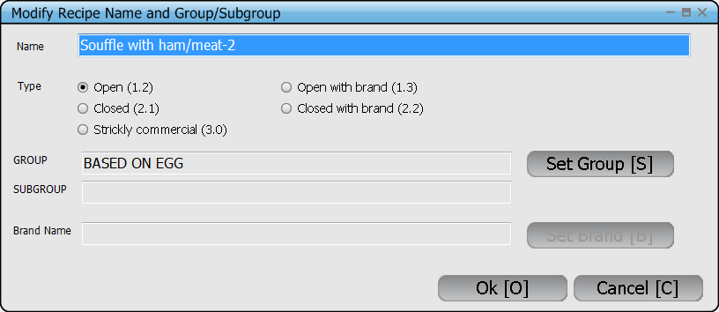
It will automatically receive a new code.
You can then adapt the recipe as you wish.
This function can be used to copy a recipe (if done to create a strictly commercial recipe, all ingredients will be fixed). However, this function should not be used after simply modifying a recipe.

- Quit without Saving (Alt+F4): The recipe is closed without saving, after confirmation. All changes are lost.

- Save & exit from temporary recipe (Alt+F9): The recipe is saved but its temporary status is highlighted by a red/white icon to inform the user a modification is/may be still necessary (it can help user to edit it later).

- Save & exit for final recipe (F9): The recipe is closed and saved after confirmation of the exit, entries and saving.

* Ingredients menu:
The listed functions enable to handle recipe ingredients.
- Add Ingredient (F4): An ingredient is added by choosing it from the prompted food list (or with another search), then confirmed. Enter its description, quantification and type.
- Delete Ingredient (F6): The selected ingredient is deleted after confirmation.
- Undelete Ingredient (Alt +Del): Function allowing listing all the items which have been deleted during the recipe editing. To undelete an item, set the cursor on this item and select ‘OK’. The cursor will be set on the undeleted item in the Recipe Ingredient manager. ‘Cancel’ enables to leave this window without modification.
- Describe (Alt +E): enables to update the description and quantification of an ingredient. An escape before going through all facets deletes changes made in the description.
- Modify Quantity (F10): enables to modify the quantification using either the same quantification method or another one, confirm with OK. Enter in the quantification screen, if the weight entered corresponds to raw or cooked/non applicable, and if it is with or without/non applicable inedible part, when applicable.
- Ingredient type (F12): enables to change the type of the ingredient from fixed to substitutable and vice versa. Note that fixed ingredients of strictly commercial recipes cannot be changed.
Note that by pressing return on an ingredient line, you may 1/re-describe an ingredient, 2/ re-quantify it and 3/ change its type (fixed/substitutable).
- Expand info (F11): For the selected ingredient, detailed information is displayed in a separate window [name, quantification as estimated and as consumed (including rawcook and edible coefficients), and its description]. Another ingredient can be selected by pressing the arrows. To leave this menu, select Ingredient from the top line, then Expand info again, or F11.
- Clear Screen (Alt + C): All ingredients are deleted if confirmed.
- Help recipe (Alt+H): as in GloboDiet, function to display a standard recipe chosen from the recipe list in a separate window (amounts are expressed as percentages as estimated and as consumed).

* Delete (F6)

The selected recipe is first edited. After confirmation that is the correct recipe, the question is asked on whether to delete it or not. If ‘OK’ is selected then the recipe is deleted; if ‘Cancel’ is selected, the recipe is kept.
Note that when deleting a recipe from the recipe list, all attached recipe shadows are automatically deleted.

* Recipe shadow management (Alt + S)

As in the food pathway, a recipe can have synonym names and can be listed in another group or subgroup. In the recipe list, shadows are marked by ‘SH’ after the code.
When selecting Recipe shadow management, you get the following screen

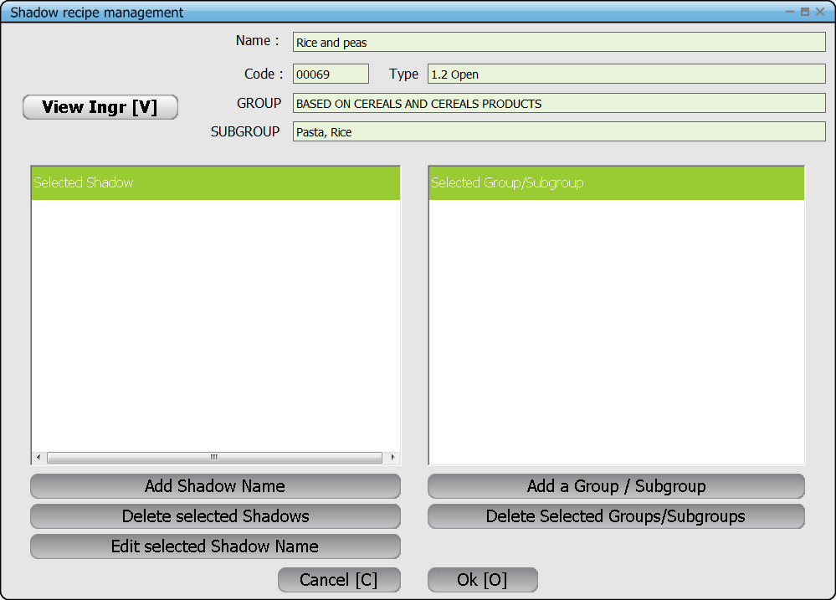

If the user selects the function “Shadow recipe management” after having selected a recipe which already has shadow items, the pop-up will list these shadow names and/or alternative group/subgroups.
- In the block “Selected shadow» are listed all the synonyms attached to this recipe – different from the main name.
- In the block « Selected Group/Subgroup » are listed all the alternative groups/sub-groups –different from the main recipe classification listed at the top of the pop up

- View Ingr: enables to view the ingredients of the recipe and the general information

Creation of Shadow items

If no Shadow item exists for a given recipe then when the user selects the function “Shadow recipe management”, in the pop-up the two blocks « Select Shadow » and « Select Group/Subgroup » will appear empty.
Using buttons “Add », the user can create either synonyms (shadow names) or alternative classification(s) for the recipe.

- Add Shadow name: enables to add synonyms to the recipe
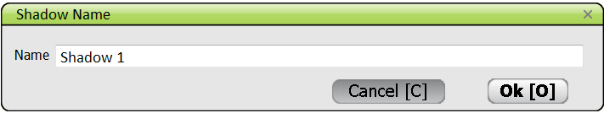

To save the new synonym, the user must choose ‘OK’. To quit without saving, choose ‘Cancel’.
The user can click on the button « Add Shadow Name » as many times as needed to enter all the synonyms. All these names are listed after saving in the left hand block « Selected Shadow ».

- Add a Group/Subgroup: enables to set one or several alternative classification(s) for the recipe.

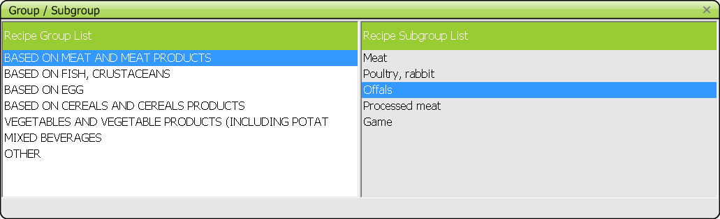

To save the new classification, the user must double-click. To quit without saving, press “escape” or click on X in the top right corner.
All these alternative classifications are listed after saving in the right hand block « Selected Group/subgroup ».

Note that when selecting a shadow from the recipe list, the general information of the original recipe is displayed, not the name, group etc. of the shadow.

Editing Shadow items

Using the button « Edit selected Shadow Name», the user can modify a shadow name.
The user first selects the synonym to be edited/modified by setting the cursor on this item (in the block “Selected Shadow”). Then by clicking on the button “Edit selected Shadow Name”, the following pop-up appears with the existing name to be modified. The user can modify the shadow name and save it by pressing “OK”. By pressing “Cancel” no modification will take place.

After saving, the modified shadow name is listed in the block « select Shadow ».

Deleting Shadow items

To delete one or more shadow items the user has to be on the main recipe or one of its shadow rows then select the function « Shadow recipe management”.

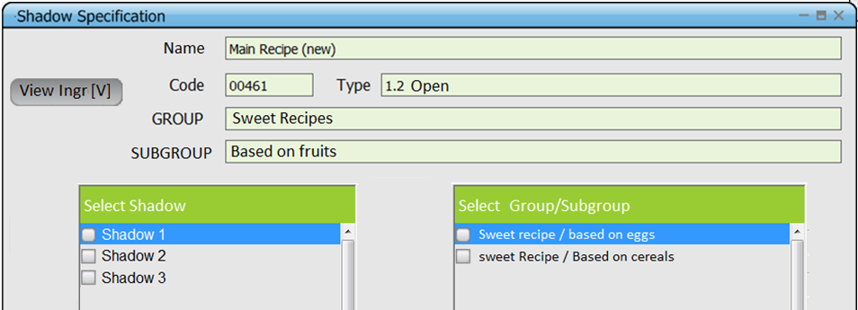

The user first selects the synonyms and/or alternative classifications to be deleted by ticking the boxes in front of the items.
Then the deletion will be done by pressing the buttons
- Deleted selected Shadows
- Deleted selected Groups/Subgroups

The program will list the selected items and ask to confirm before deleting.

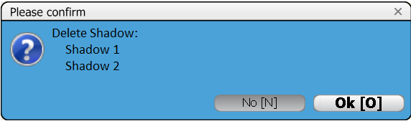

If the user answers « OK » then the selected shadow(s) is/are deleted.
If the user answers “NO », the pop up ‘Shadow Specification’ is prompted back without changes.

Final OK or Cancel (all)

Once the shadow item handling is finished for a recipe, to confirm the changes, the user has to leave the pop-up “Shadow recipe management” by saving with “OK”.
By clicking on the “Cancel” button, the changes made to either shadow names or groups will not be saved in main recipe screen even though you saved them in the pop up: no changes will be taken into account AT ALL and the names will be as before you selected the function!

- Cancel button: If the user chooses « Cancel », nothing at all is modified for that recipe and the screen Recipe list is shown.

- OK button : If the user chooses “OK » then all the shadows items are newly created as defined in the pop-up “Shadow recipe management” and the Recipe list screen is shown with the new shadow items.

ANNEX 1

SUMMARY OF THE RECIPE MANAGER FUNCTIONS AND MENUS

Databases menu
- Setup
- GloboDiet parameters databases (see Appendix 4 of the GloboDiet user manual)
- Recipe Manager
- Import Recipe (XML)
- Recipe Export (XML)
- Recipe Export (XLS)

Recipe List

- View menu
F4 Group/Subgroup : to display only the recipes of a given group/subgroup
F5 Alphabetical : to display the recipe list in alphabetical order
Alt + F Search : to find a string in the list whatever its position in the
recipe name
F11 Brand Names : if ticked, display the brand names in front of the
recipe names

- Recipe menu

Alt+N Create Recipe : to create a new recipe
F8 View/Edit : to view and edit a recipe (see next menus)
F6 Delete recipe : to delete a recipe
Alt+S Recipe shadow management : to create/edit/delete one or several shadow recipe(s) for an existing recipe

Recipe ingredient manager

- RECIPE menu

Alt+N Name and Group/Subgroup : to edit the name, type, classification and brand name of recipes
F5 Open Next : to open the next recipe in alphabetical order
F7 Open Previous : to open the previous recipe in alphabetical order
Alt+S Save : to save the recipe and stay in this menu
Alt+W Save as : to save the recipe with another name and code
Alt+F4 Quit without Saving : The recipe is closed without saving, after confirmation. All changes are lost.
Alt+F9 Save & exit from temporary recipe: The recipe is saved but its temporary status is highlighted by a red/white icon to show user a modification is still necessary (it can help user to edit it later).
F9 Save & exit for final recipe: The recipe is closed and saved after confirmation of the exit, entries and saving.

- INGREDIENTS menu

F4 Add ingredient : to add an ingredient
F6 Delete Ingredient : to delete an ingredient
Alt+Del Undelete ingredient : to undelete a removed ingredient
ALT+E Describe : to change the description and quantification of the selected ingredient
F10 Modify Quantity : to change the ingredient quantity and/or its method of quantification
F11 Expand info : to display detailed information on the selected ingredient [name, quantification as estimated and as consumed (including rawcook and edible coefficients), and its description])
F12 Ingredient type : to change the type of ingredients
ALT+C Clear Screen : to delete all ingredients
ALT+H Help recipe : to show another recipe with its ingredients

Warning: If new recipes are added to the already existent recipe database for a country-version of GloboDiet then all other related recipe files may need to be updated as well (done manually at this time) e.g. RCPQUANT, RCPSTDU, RCPPROBING, RCPFACET, RCPDENSITY, RCPPCTFSS, RCPMAX. Since these are country specific files, the country coordinator or dietician will need to inform IARC’s technical team of their decisions for these recipes files as well. Therefore, one must consider well all the files that may have been affected if changes were made through the RECIPE MANAGER. You can always ask your contact at IARC if not sure.

