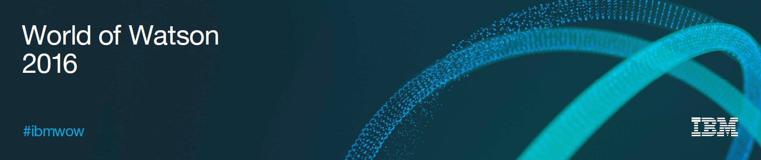

**Hands-on Lab Instructions**

**Session 3282**

**Integrating IBM Watson IoT Platform and IBM Blockchain**

Leucir Marin Junior, Senior Software Architect ([lmarinj@us.ibm.com](mailto:lmarinj@us.ibm.com))

Rahul Gupta, Senior Software Architect ([rahul.gupta@us.ibm.com](mailto:rahul.gupta@us.ibm.com))

**Download Lab Instructions From**

<http://ibm.biz/wowiotlab>

**Table of Contents**

Overview 3

Section 1: Setup IBM Bluemix 5

Signup for Bluemix: New User 5

Log-In Bluemix: New and existing users 5

Create Bluemix organization: New user 6

Create Bluemix space: New user 7

Complete creation of Bluemix organization and space: New user 7

Create IBM Watson IoT Platform Organization 8

Create IBM Watson IoT Blockchain Service 10

Section 2: Configure IBM Watson IoT Platform devices and application access 14

Create ELEVATOR device type 14

Add a device IOT-ELEVATOR-001 of device type ELEVATOR 15

Generate API Keys to access this device from Elevator simulator application 17

Section 3: Register Blockchain users and deploy smart contract 19

Blockchain Peer assignment and roles 19

Register users from different organization with validating peers. 19

Register a user from the government organization 20

Register a user from the customer organization who purchased an Elevator 21

Register a user from Elevator manufacturing company 22

Deploy the Elevator contract 23

Section 4: Activate Blockchain features in IBM Watson IoT Platform 26

Section 5: Configure and connect Elevator simulator to IoT Watson IoT Platform 28

Section 6: Configure Integration routes between IBM Watson IoT Platform and IBM Blockchain 31

Section 7: Access Elevator data in Blockchain: Elevator manufacturing company 35

Section 8: Access Elevator data in Blockchain: Government agency 38

Summary 39

We Value Your Feedback! 40

Acknowledgements and Disclaimers Error! Bookmark not defined.

# Overview

IBM Watson IoT Platform enables IoT devices to send data to private blockchain ledgers for inclusion in shared transactions with tamper-resistant records. Blockchain’s distributed replication allows your business partners to access and supply IoT data without the need for central control and management.

All business partners can verify each transaction, preventing disputes and ensuring each partner is held accountable for their individual roles in the overall transaction.

### Integrate Watson IoT Platform with Blockchain:

The Watson IoT Platform has a built-in capability that lets you add selected IoT data to a private blockchain. The protected data is shared among only the business partners involved with the transaction.

IBM Blockchain provides the private blockchain infrastructure of distributed peers that replicates the device data and validates the transaction through secure contracts. IBM Watson IoT Platform translates existing device data, from one or more device types, into the format needed by the blockchain contract APIs. The blockchain contract doesn’t need to know the specifics of your device data. Watson IoT Platform filters device events and sends only the required data to the contract.

### Hands on Lab overview:

In this hands-on lab, you will create a Blockchain network for an elevator manufacturing company. The company allows its customers and government agencies to participate in this Blockchain network. The elevator manufacturing company installs elevators at their customer location and configure the elevator device data to be sent into IBM Blockchain using the IBM Watson IoT Platform. Once the data reaches Blockchain it cannot be changed.

Elevator manufacturer can use this data for customer service and detecting any malfunctions. The Government agencies can use the data in blockchain for inspection and security compliance. None of the parties have to request data from each other and the data is available in unchangeable format in the Blockchain network.

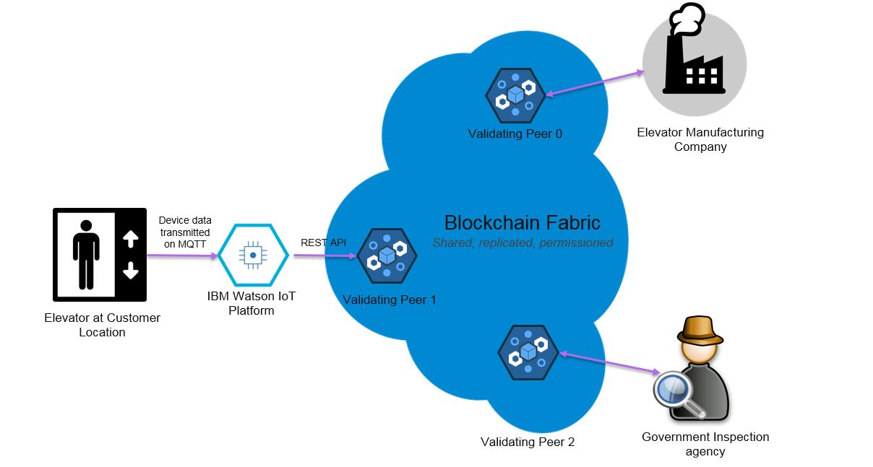

If you require assistance during the lab, please ask an instructor.

# Section 1: Setup IBM Bluemix

## Signup for Bluemix: New User

* This lab requires a IBM Bluemix account. If you don’t have access to IBM Bluemix already, you can register for a 30-day free trial at the following URL:

<https://console.ng.bluemix.net/registration>

* Fill all the details and then click on ***Create Account*** to complete the registration process. Check your email inbox to complete the registration as shown in figure below.

**Note:** Please check the Junk folder if you don’t see email from ***The Bluemix Team*** in your email inbox.

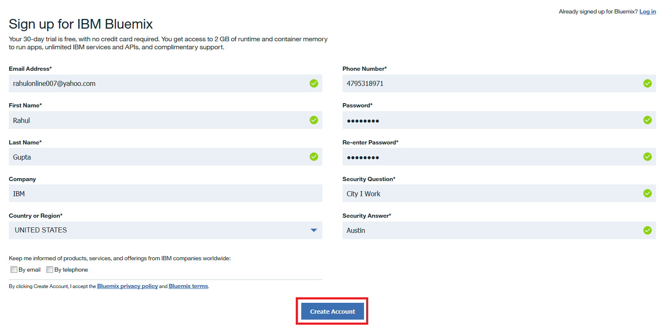

## Log-In Bluemix: New and existing users

* If you already have a IBM Bluemix account, you can directly login using the URL below:

<https://console.ng.bluemix.net/>

* Click on the **Log-In** button to login.

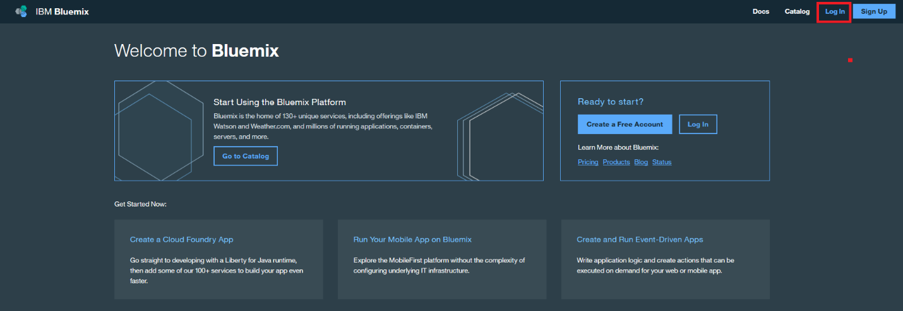

## Create Bluemix organization: New user

* Once you have logged into IBM Bluemix create a Bluemix organization following the steps in the image below. Create an organization with your Bluemix account email id.

***Note:*** *Existing Bluemix users can ignore this step*

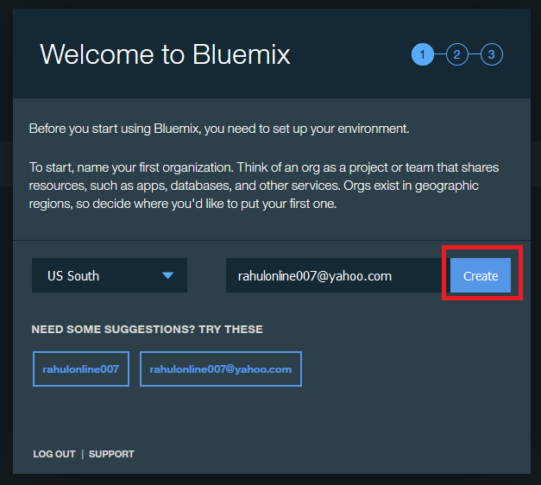

*An organization is the highest concept. When you create a IBM Bluemix account you get your own "organization". You can invite others to your organization, can get invited to join other organizations or create organizations.*

## Create Bluemix space: New user

* Create a space with name **dev**

***Note:*** *Existing Bluemix users can ignore this step*

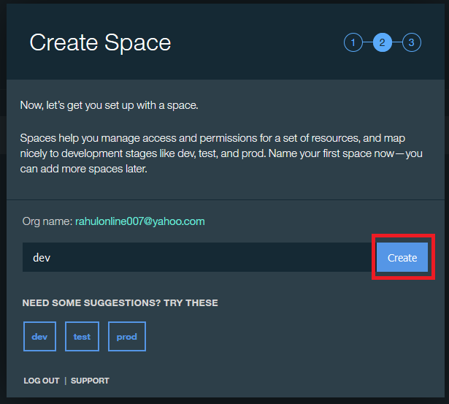

*Spaces are used to group related applications and services together. There can be multiple spaces within an organization. When an application or service is created they are assigned a specific space.*

## Complete creation of Bluemix organization and space: New user

* This step completes the setup of Bluemix organization and space. You can now proceed with creation of IBM Watson IoT Platform and IBM Blockchain services in the next step.

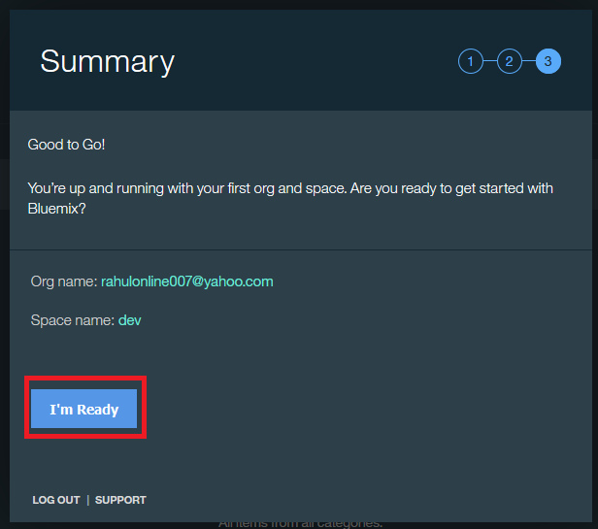

## Create IBM Watson IoT Platform Organization

* Once you have logged in IBM Bluemix, click on the **Catalog** to browse the different services offered in IBM Bluemix platform.

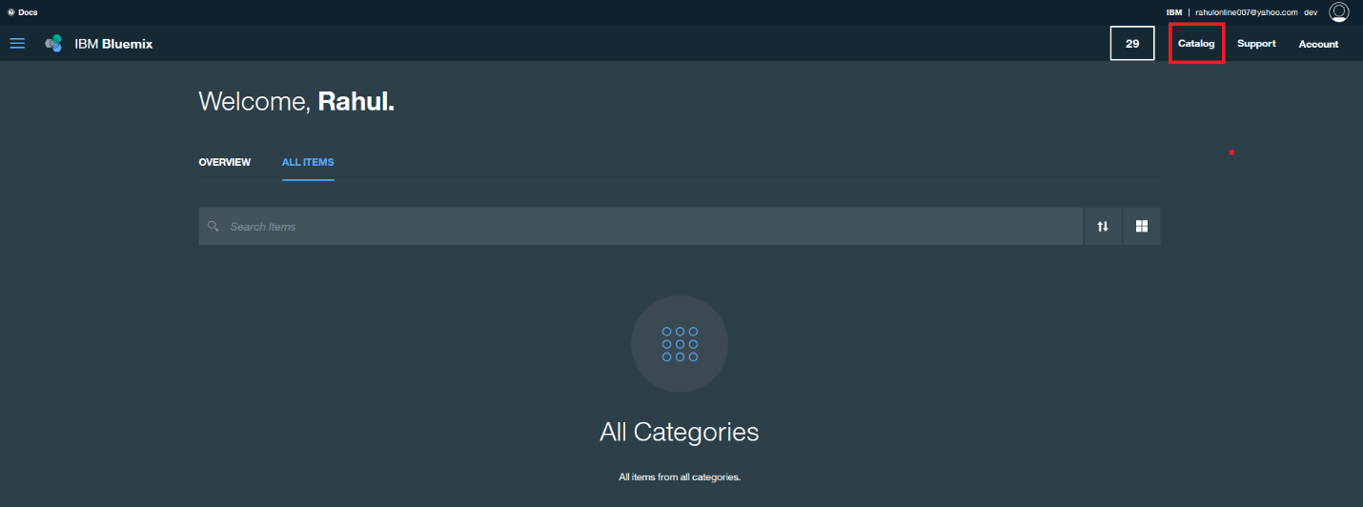

* In the services catalog select **Internet of Things** in the left menu and then click on **Internet of Things Platform** service

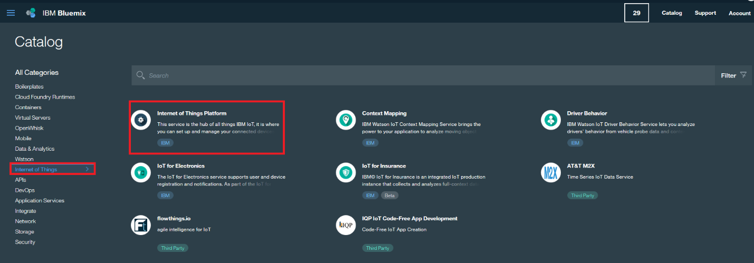

* To create the IBM Watson Internet of Things Platform service, enter following details or something easier which could be remembered:
* **Service Name:** *iot-platform-service*
* **Credentials Name:** *Credentials- iot-platform-service*
* **Pricing Plans –** *Free*
* Click on the **Create** button the create a new instance of IBM Watson IoT Platform service in your IBM Bluemix space.

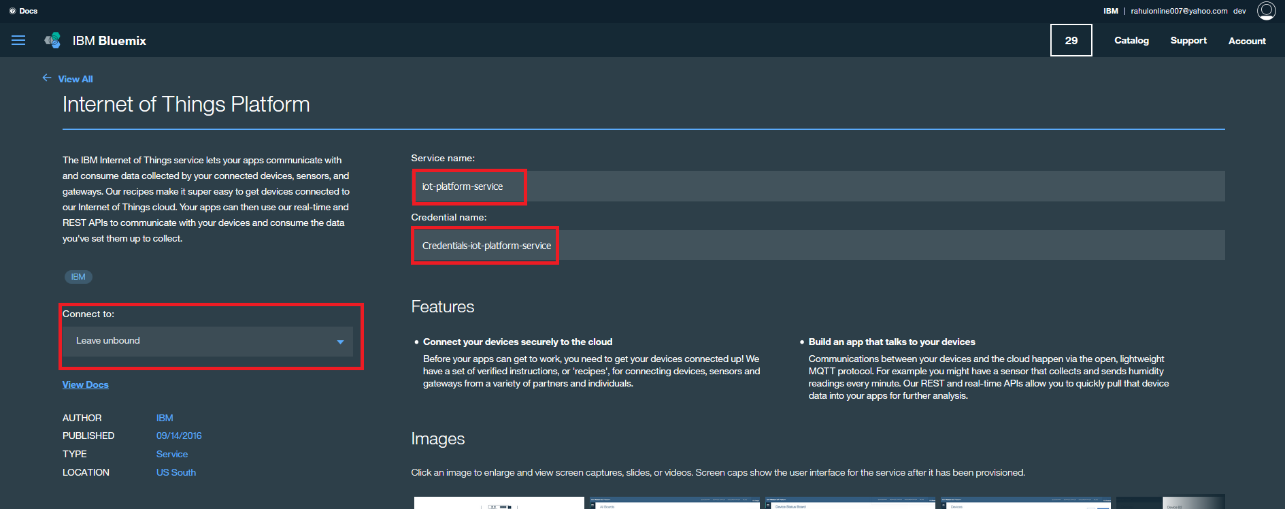

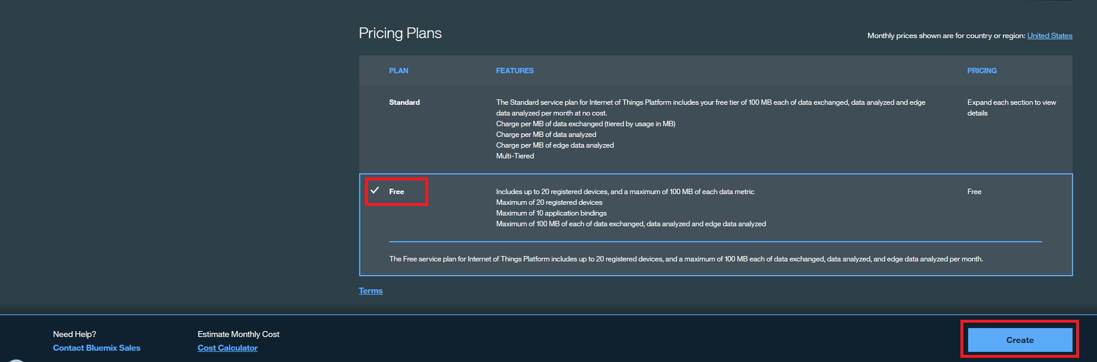

* Once the service is created you can launch the IBM Watson IoT Platform dashboard by clicking the **Launch dashboard** button.

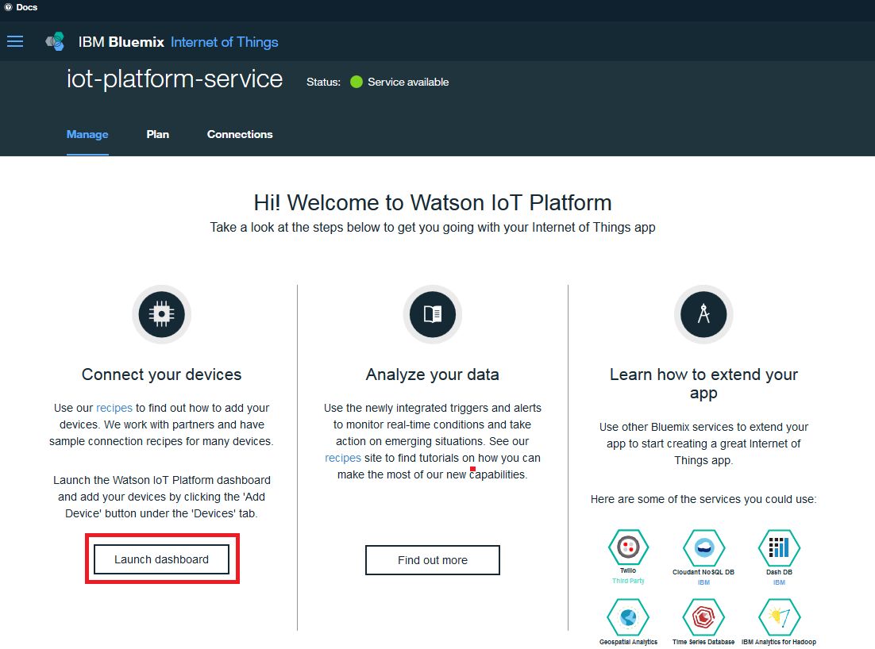

* Watson IoT Dashboard will be opened in a new browser tab. Familiarize yourself with the dashboard and specially the IoT Platform organization ID.

**Note:** The Watson IoT Platform organization ID is different from the IBM Bluemix organization ID

* Copy the Organization ID in a notepad.

**Note:** In the image below the organization ID is highlighted in the rectangular box, every IoT Platform service has a unique organization ID.

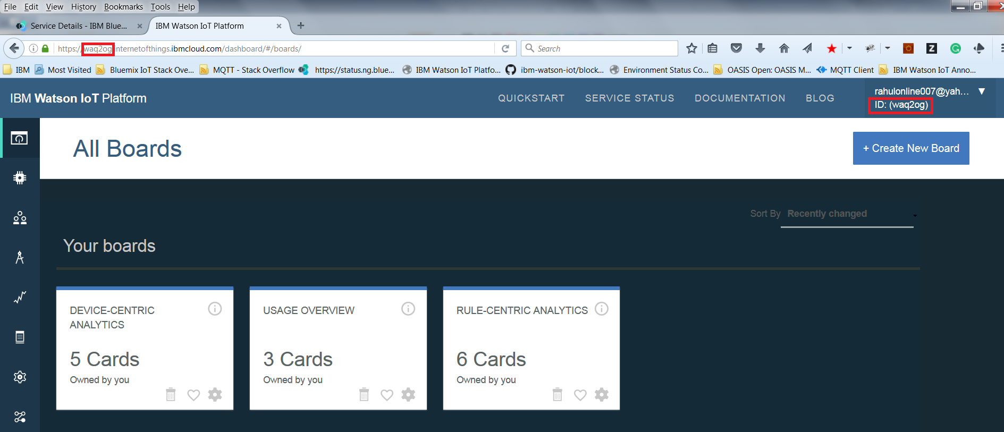

* This completes the creation of IBM Watson IoT Platform service and we can now proceed with creation of IBM Blockchain service.

## Create IBM Watson IoT Blockchain Service

* To create IBM Blockchain service, get back the IBM Bluemix **Catalog**
* Click on the **Application Service** in the catalog menu
* Select **IBM Blockchain** service as shown in the image on next page.

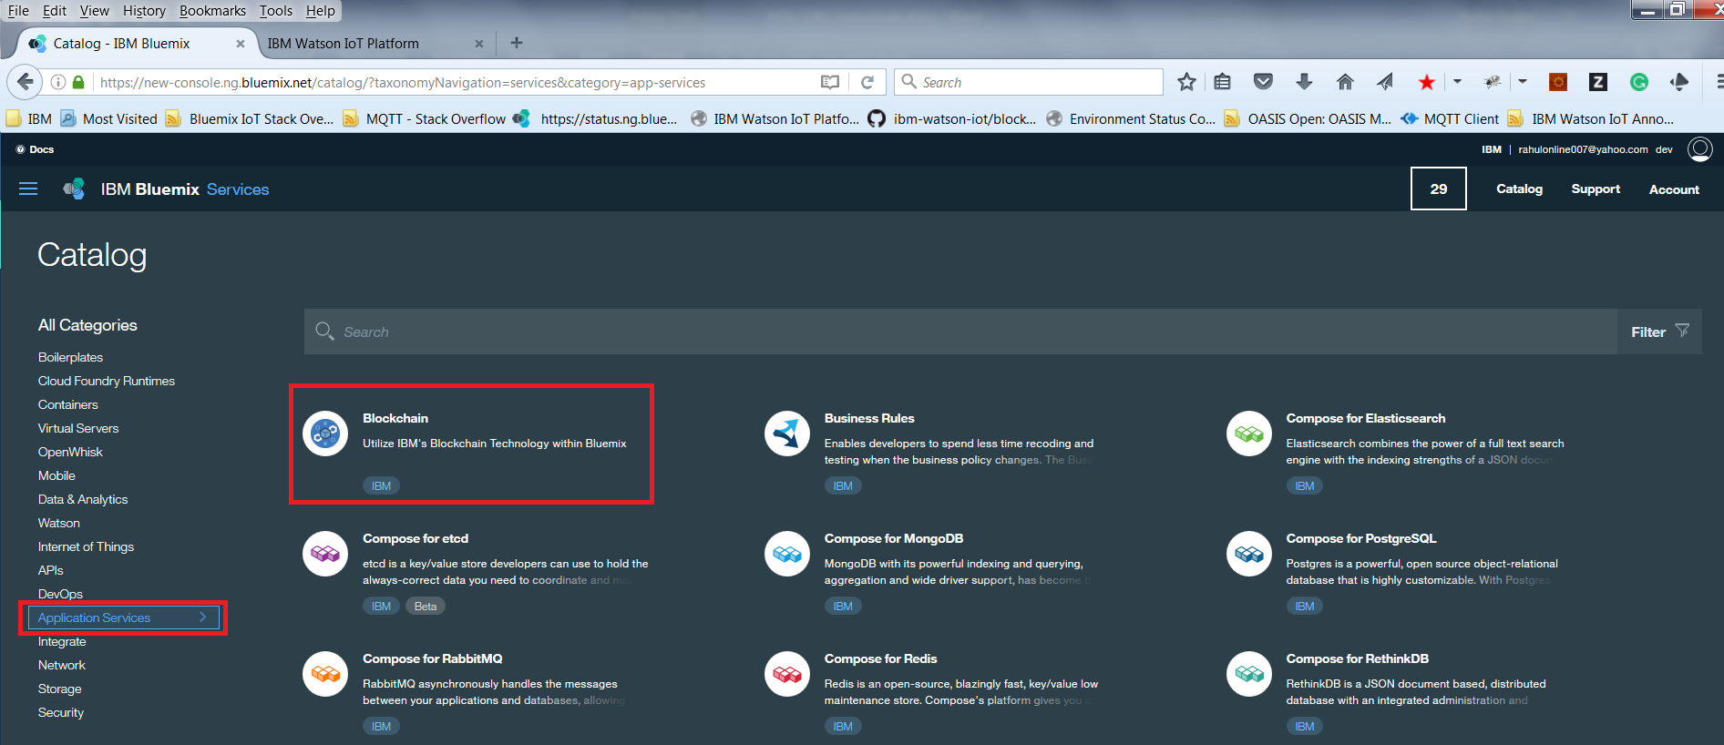

* To create the IBM Blockchain service, enter following details or something easier which could be remembered:
* **Service Name:** *iot-blockchain-service*
* **Credentials Name:** *Credentials- iot-blockchain-service*
* **Pricing Plans –** *Starter Developer Plan (Beta)*

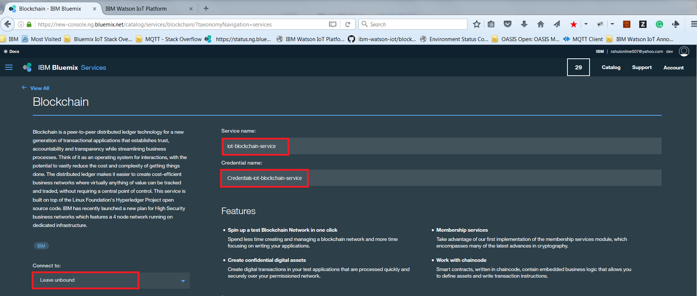

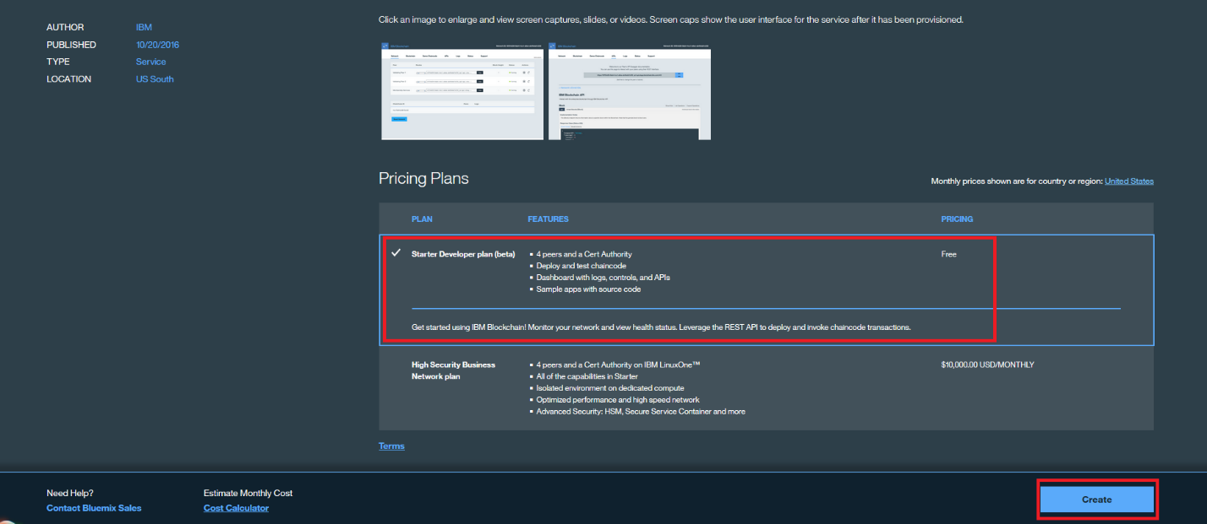

* Once the IBM Blockchain service is created, click on the **Launch** button and that will launch the IBM Blockchain service dashboard in a new browser tab window.

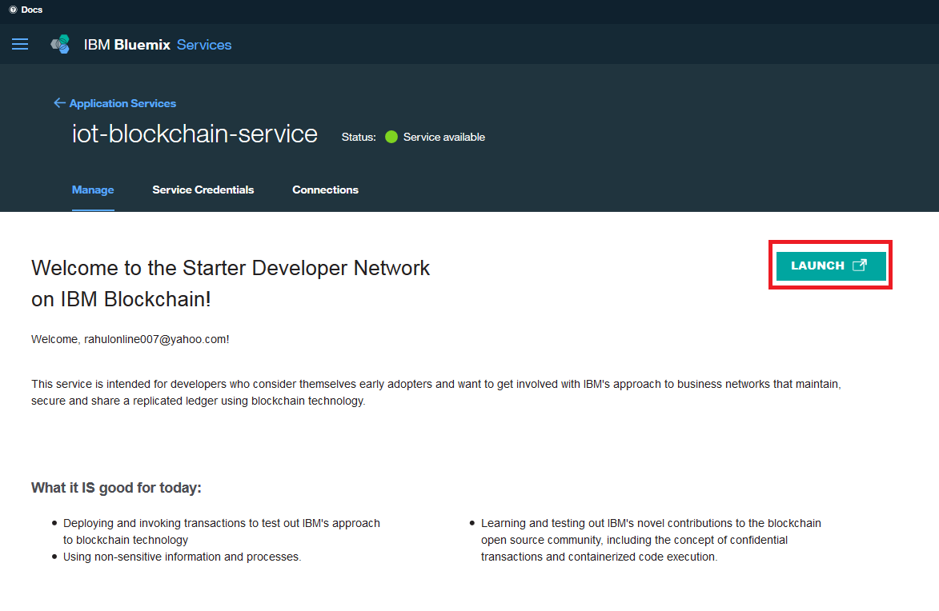

* IBM Blockchain service is now instantiated and ready to be used.
* This service is provisioned with four validating peers and one member ship CA (certificate authority) server.

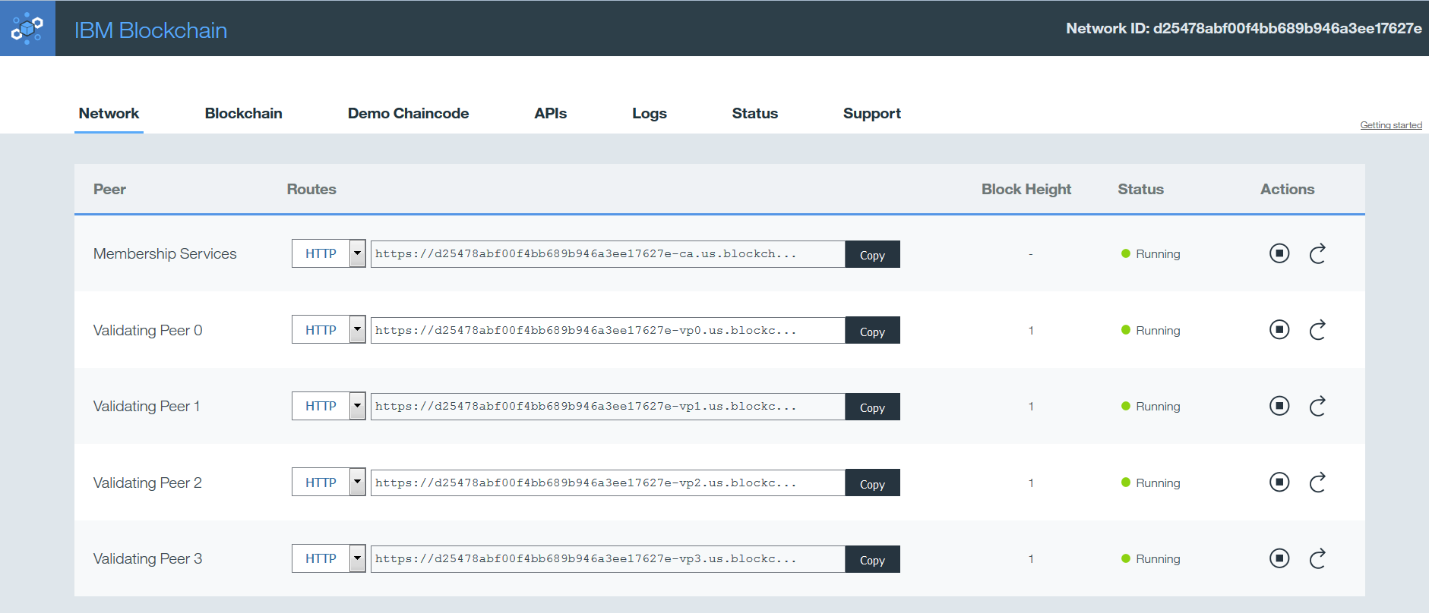

So far we have created the IBM Bluemix account for the new users and later created the IBM Watson IoT Platform and IBM Blockchain service in this Bluemix account.

**Note** – Please don’t close the browser tabs for IBM Watson IoT Platform dashboard and IBM Blockchain dashboard services. They will be used in the later sections.

# Section 2: Configure IBM Watson IoT Platform devices and application access

## Create ELEVATOR device type

* Go to the IBM Watson IoT Platform dashboard tab in the browser window and expand the menu on the left
* Click on **Devices**

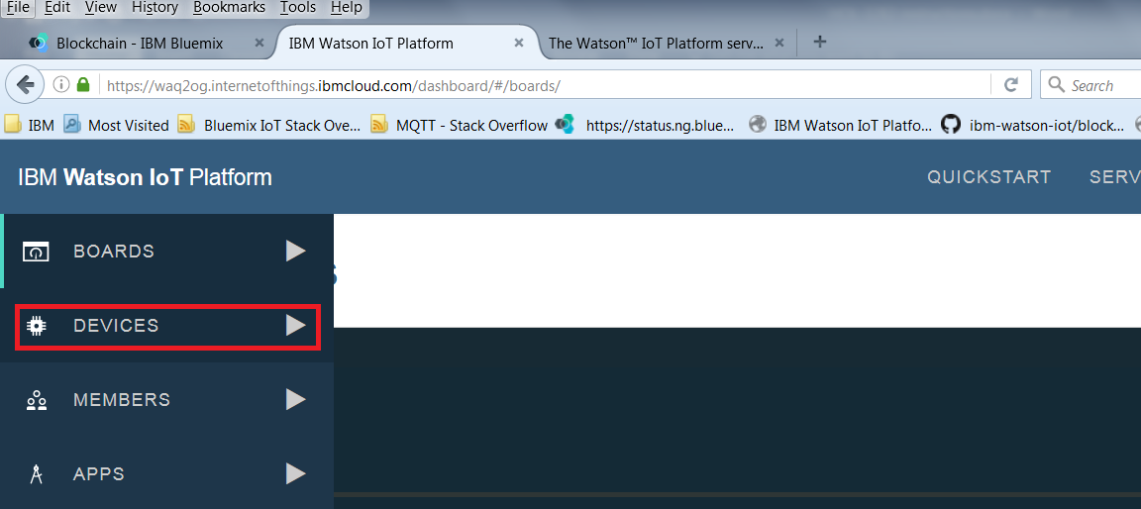

* Click on **Device Types** tab and then click **Create Type** button

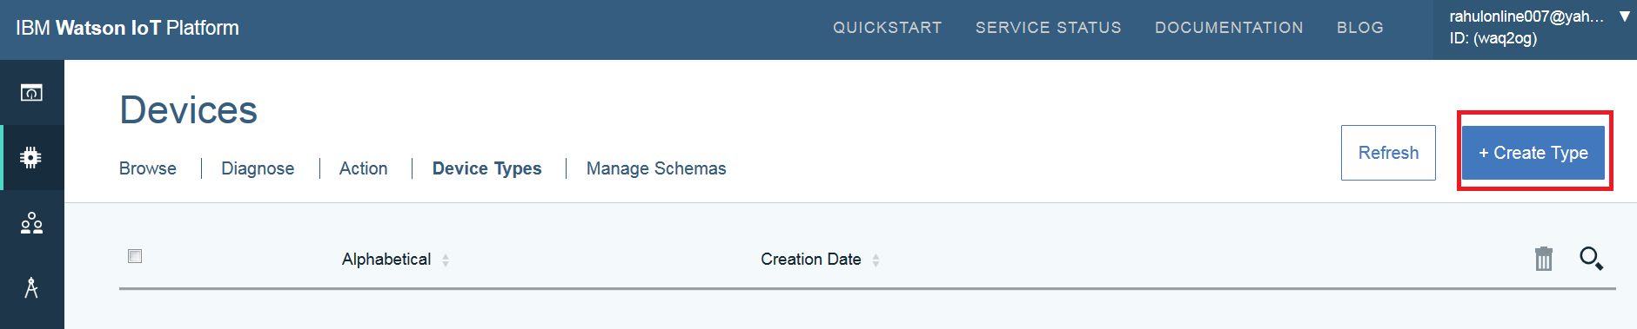

* In the Create Device Type wizard, enter device type **Name** as ***ELEVATOR*** and **Description** as ***ELEVATOR DEVICES***

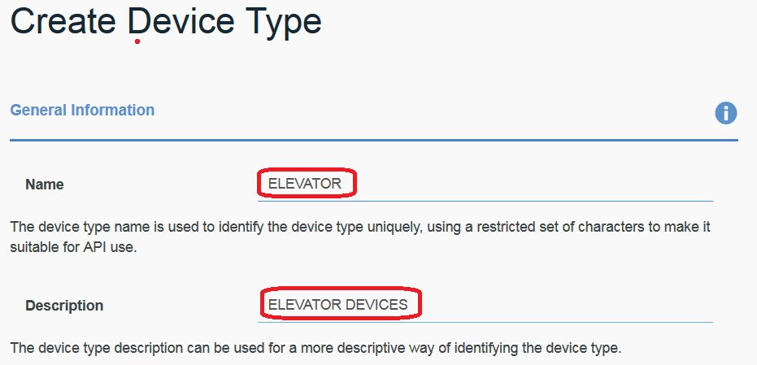

* Click onthe **Next** button
* Click **Next** on templates without selecting anything
* Click **Next** button in Submit Information
* Click **Create** button to create the ELEVATOR device type
* If device type ELEVATOR is successfully created, you will see a device type ELEVATOR in the dashboard as shown in image below

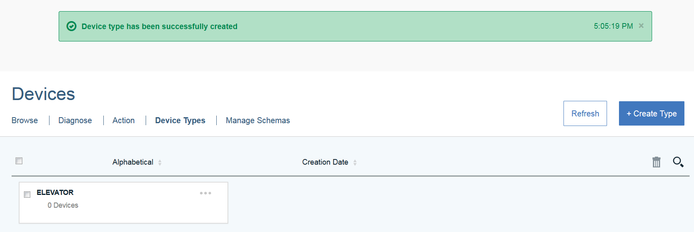

## Add a device IOT-ELEVATOR-001 of device type ELEVATOR

* Go to the IBM Watson IoT Platform dashboard and expand the menu on the left
* Click on **Devices**
* Click on the **Browse** tab and then click on **Add Device** button
* To add a device, select the device type previously created:***ELEVATOR***

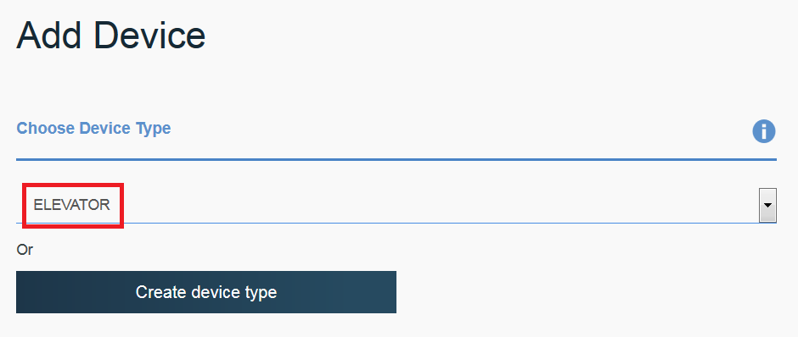

* Click **Next**
* Enter Device ID as: ***IOT-ELEVATOR-001***

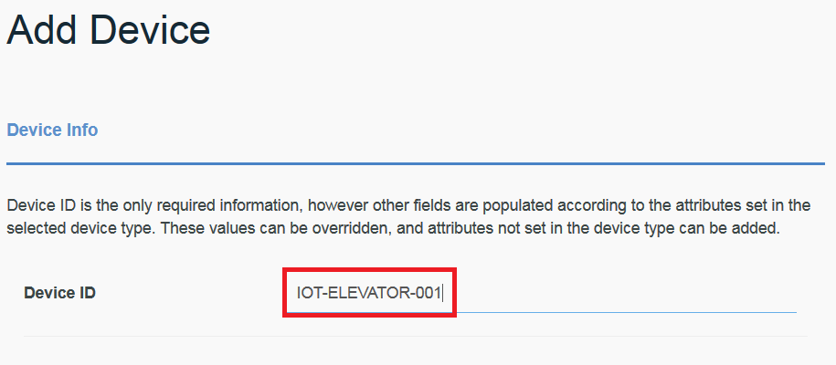

* Click **Next** on the Device Information page
* Click **Next** on the Metadata page
* Click **Next** on the Security page
* Click **Next** on the Summary page
* Copy Organization ID, Device Type, Device ID into a notepad. This information will be required later.

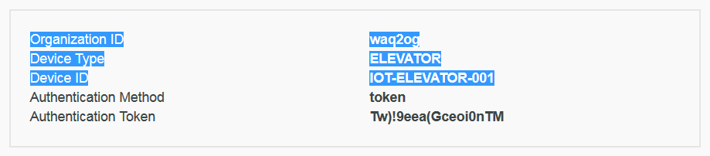

* **IOT-ELEVATOR-001** device of device type **ELEVATOR** is now created. Close the device creation wizard and this device will now be visible in the dashboard.

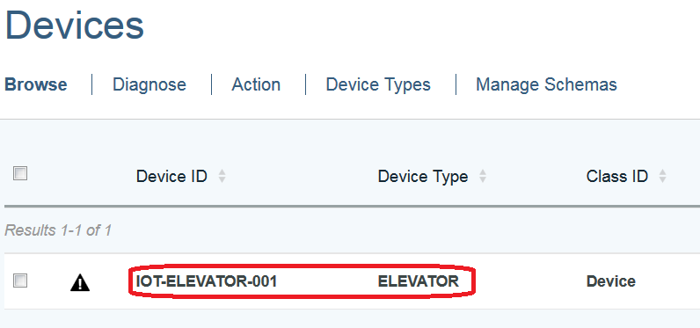

## Generate API Keys to access this device from Elevator simulator application

* Application credentials created in this step will be used by the elevator simulator in later sections
* Go to the IBM IoT Watson Platform dashboard and click on **APPS**

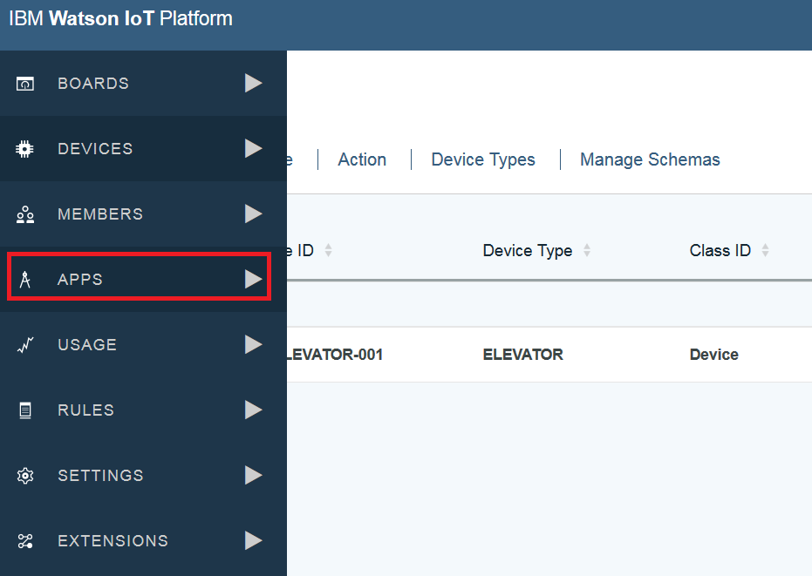

* Click on **Generate API Key**
* Select **Standard Application** and add comments for the keys
* Before clicking **Generate**, *copy* the API Keys and Authentication Token in a notepad. These credentials will be used later in the elevator simulator

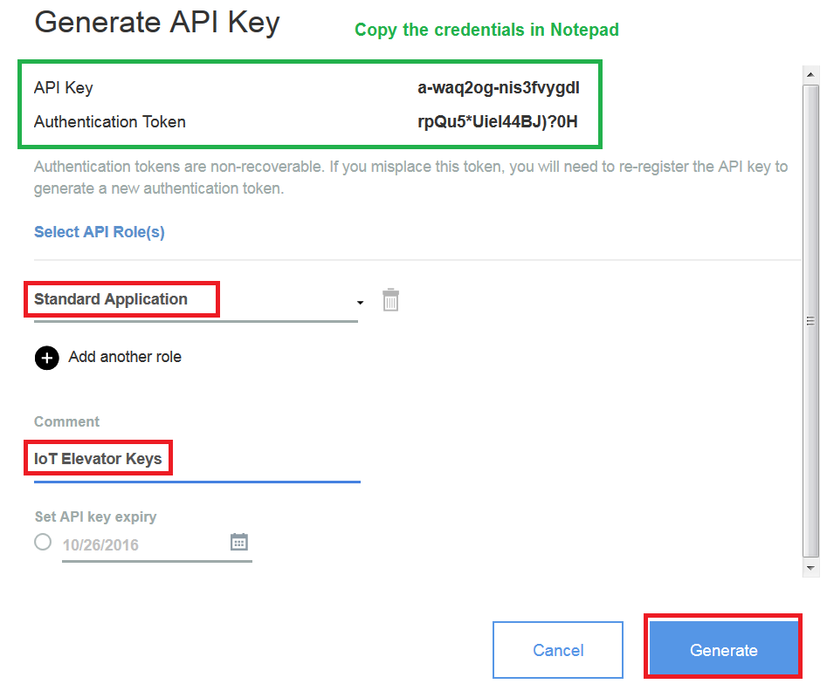

This completes the basic configuration on IBM Watson IoT Platform. We will revisit the Blockchain specific configurations after deploying the smart contract and completing the Blockchain configuration in next section.

# Section 3: Register Blockchain users and deploy smart contract

## Blockchain Peer assignment and roles

* Go back to the IBM Blockchain dashboard
* In the network tab in the dashboard, you will observe five peers in the network tab

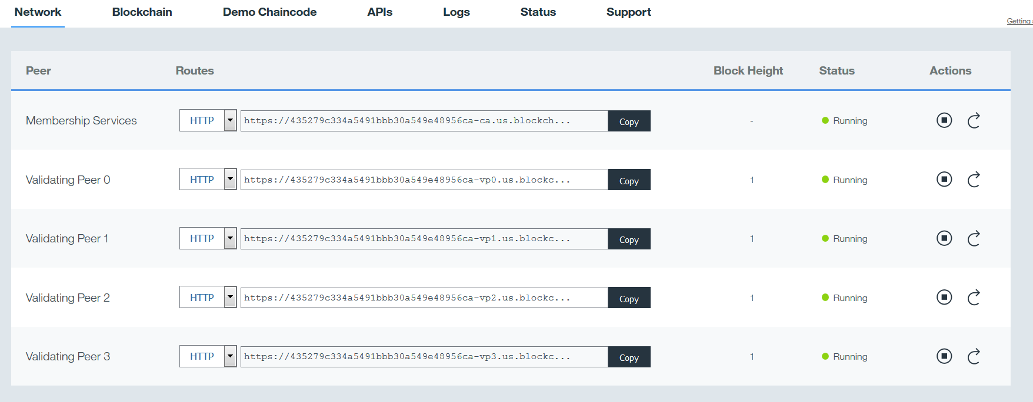

In this lab, we will use three validating peers by three different organizations:

|  |  |
| --- | --- |
| **Validating Peers** | **Business Organizations** |
| Validating Peer 0 | This peer will be used by the elevator manufacturing company to have access to the data transmitted by the elevator to capture any anomalies and compliance |
| Validating Peer 1 | This peer will be used by the customer who has purchased an elevator from the Elevator Company |
| Validating Peer 2 | This peer will be used by the government agency, which must audit the elevators for safety and compliance |

**Note:** The IoT Blockchain Service and IoT Watson IoT Platform service is created on behalf of the elevator manufacturing company

## Register users from different organization with validating peers.

**Note:** IBM Blockchain service provides REST API for user registration, but in this lab, we will use a user interface for user registration.

* In a new browser tab, open URL <https://ibm.biz/wowsimulator>
* Click on **Register Users and Deploy Contract**

### Register a user from the government organization

* Go to the Networks tab in IBM Blockchain Dashboard and copy the URL for Validation Peer 2

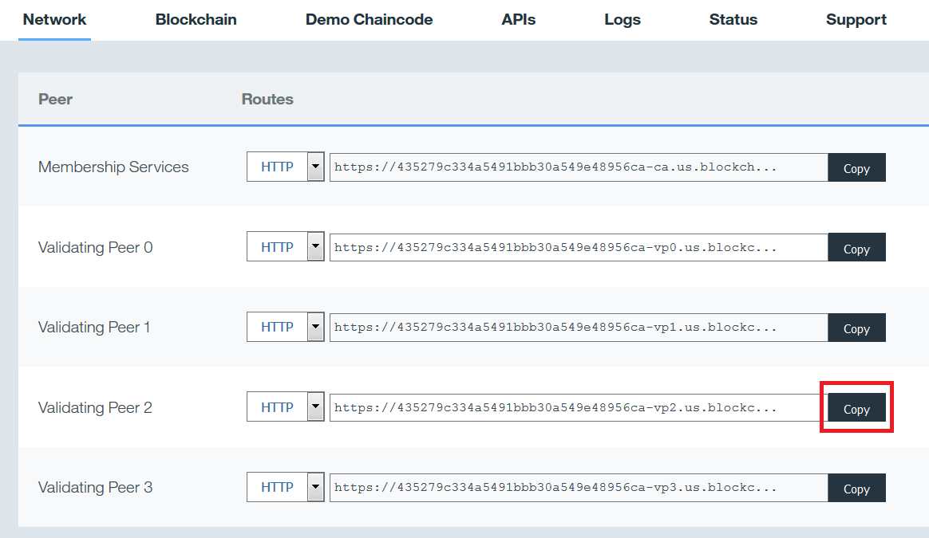

* At the right bottom of Network tab, right click and open **service credentials** in a new tab
* Find the secret of user **“user_type1_2”.** This secret will be needed for user registration with Validating Peer 2 of Blockchain
* Go back to the Register Users and Deploy Contract page in simulator application
* Enter the URL for Validating Peer 2 in **Block Chain Peer URL** text field
* Enter the username ***user_type1_2*** in **Enroll ID** text field
* Enter the secret for user_type1_2 in **Enroll Secret** text field

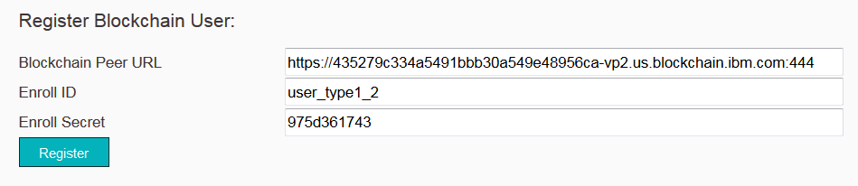

* Once the user is registered you will see the success message, as shown in image on next page

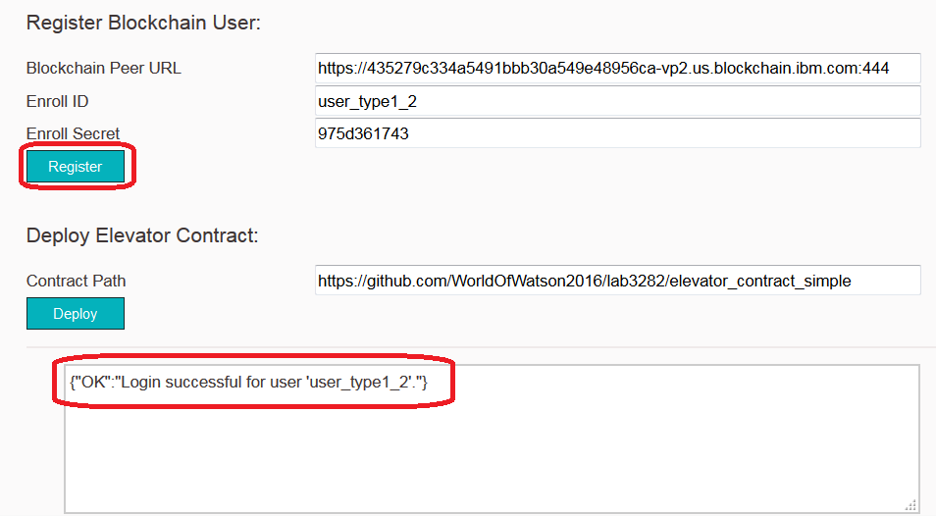

### Register a user from the customer organization who purchased an Elevator

* Go to the Networks tab in IBM Blockchain Dashboard and copy the URL for Validation Peer 1
* At the right bottom of Network tab, right click and open **service credentials** in a new tab
* Find the secret of user **“user_type1_1”.** This secret will be needed for user registration with Validating Peer 1 of Blockchain
* Go back to the Register Users and Deploy Contract page in simulator application
* Enter the URL for Validating Peer 1 in **Block Chain Peer URL** text field
* Enter the username ***user_type1_1*** in **Enroll ID** text field
* Enter the secret for user_type1_1 in **Enroll Secret** text field
* Once the user is registered you will see the success message, as shown in image on next page

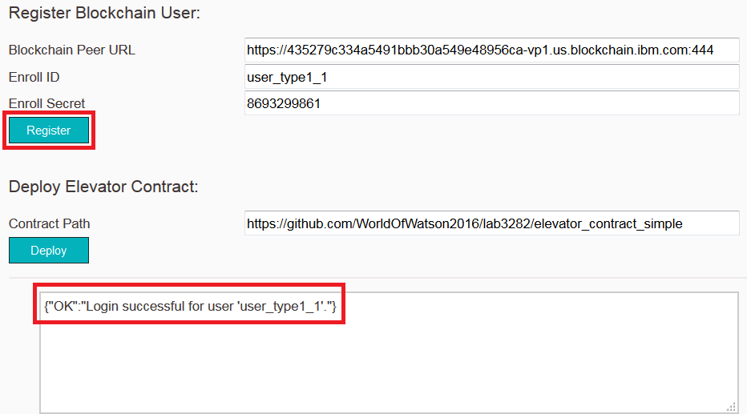

### Register a user from Elevator manufacturing company

* Go to the Networks tab in IBM Blockchain Dashboard and copy the URL for Validation Peer 0
* At the right bottom of Network tab, right click and open **service credentials** in a new tab
* Find the secret of user **“user_type1_0”.** This secret will be needed for user registration with Validating Peer 0 of Blockchain
* Go back to the Register Users and Deploy Contract page in simulator application
* Enter the URL for Validating Peer 0 in **Block Chain Peer URL** text field
* Enter the username ***user_type1_0*** in **Enroll ID** text field
* Enter the secret for user_type1_0 in **Enroll Secret** text field
* Once the user is registered you will see the success message, as shown in image on next page

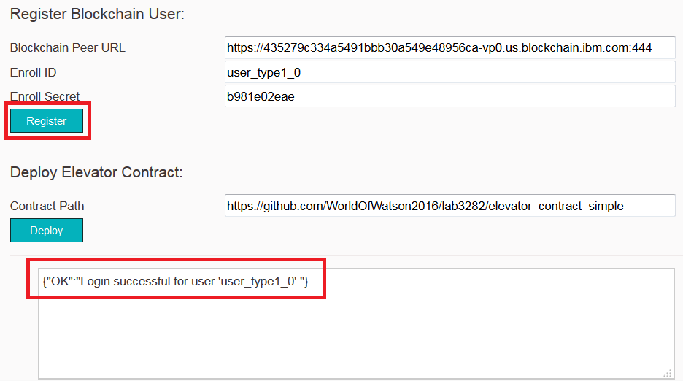

## Deploy the Elevator contract

In this lab as the Blockchain network is owned by the Elevator manufacturing company, we will deploy the smart contract to the Validating Peer 0. The Smart Contract or often called as Chaincode and will be deployed to each validating peer in this network.

Elevator contract is already created and hosted in a public GitHub repository for you to have a look later: <https://github.com/WorldOfWatson2016/lab3282/tree/master/elevator_contract_simple>

* Go to the Networks tab in IBM Blockchain Dashboard and copy the URL for Validation Peer 0
* At the right bottom of Network tab, right click and open **service credentials** in a new tab
* Find the secret of user **“user_type1_0”.** This secret will be needed for user registration with Validating Peer 0 of Blockchain
* Go back to the Register Users and Deploy Contract page in simulator application
* Enter the URL for Validating Peer 0 in **Block Chain Peer URL** text field
* Enter the username ***user_type1_0*** in **Enroll ID** text field
* Enter the secret for user_type1_0 in **Enroll Secret** text field
* Click on the **Deploy** Button

**Note:** The REST API’s to deploy the smart contract/chaincode are asynchronous and the deployment of the contract may take three – four minutes to complete on all the four validating peers in the Blockchain network.

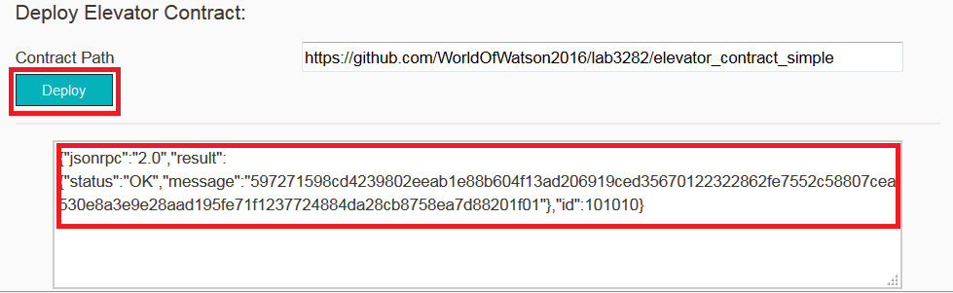

The response message contains the Chaincode ID. Every deployed chaincode gets a unique chaincode id in the Blockchain network. This Chaincode ID will be needed for integration with Watson IoT Platform service, but we can get this from IBM Blockchain dashboard.

* In the Networks tab of Blockchain dashboard, observe the deployed chaincode on all the four validating peers in this Blockchain network.

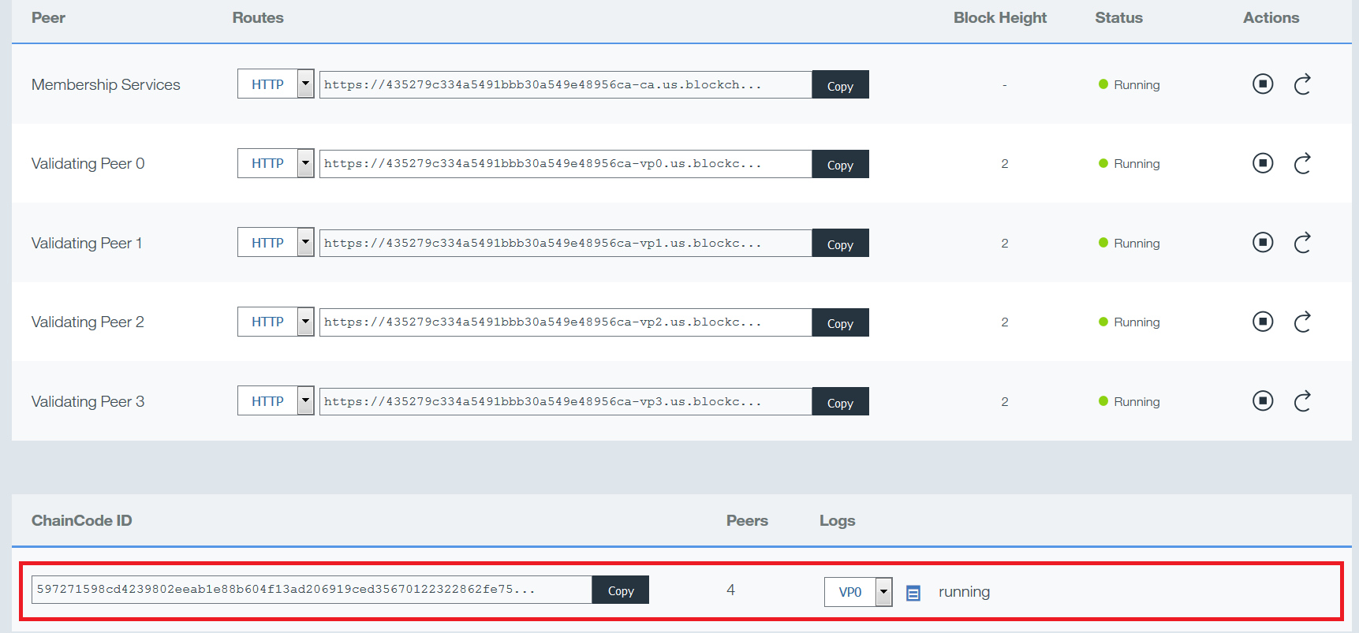

* The ChainCode ID could be copied when needed from the Copy button of the deployed contract
* Go to the Blockchain tab in IBM Blockchain dashboard and you would observe the first Block in the Blockchain network.
* This Block is for the chaincode just deployed in the previous step.

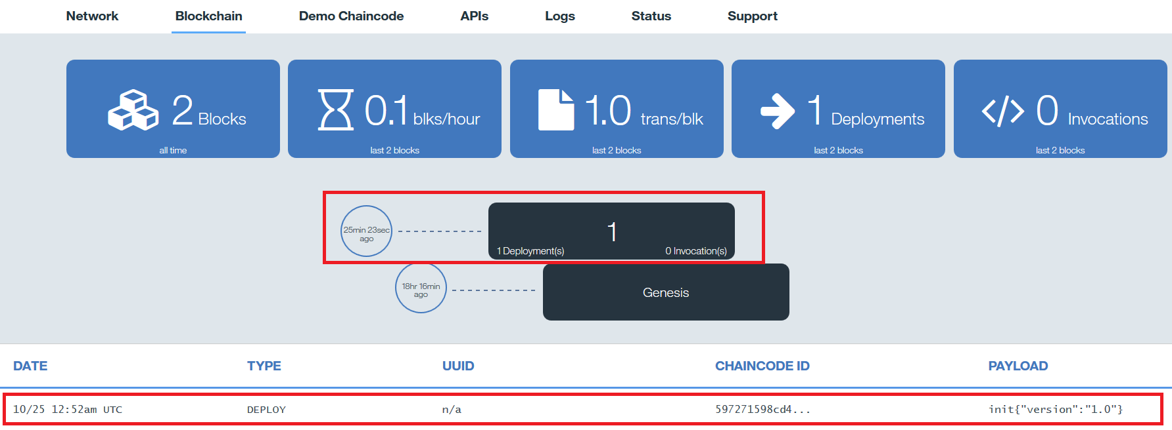

# Section 4: Activate Blockchain features in IBM Watson IoT Platform

**Note:** The IBM Watson IoT Blockchain features used in this lab are still under development and are unsupported.

* To activate the IBM Blockchain integration in IBM Watson IoT Platform, open the simulator (<https://ibm.biz/wowsimulator>) in a new browser tab
* Click on **Activate and Enable Blockchain**
* To activate Blockchain features in IBM Watson IoT Platform, enter the IoT Platform Organization ID and click **Activate Blockchain**.

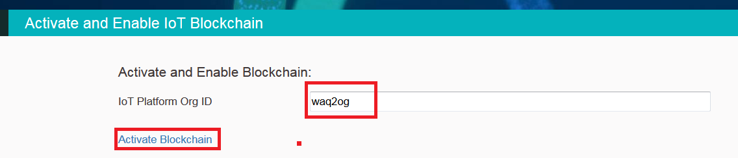

* This will activate Blockchain and you will see following JSON in the browser

{"activated":true,"enabled":false}

* Click back on the browser and you will reach the same page again and can continue with configuration
* Enter your name in the **User Name** text box
* Enter your email in the **User Email** text box
* Click on **Configure Blockchain**

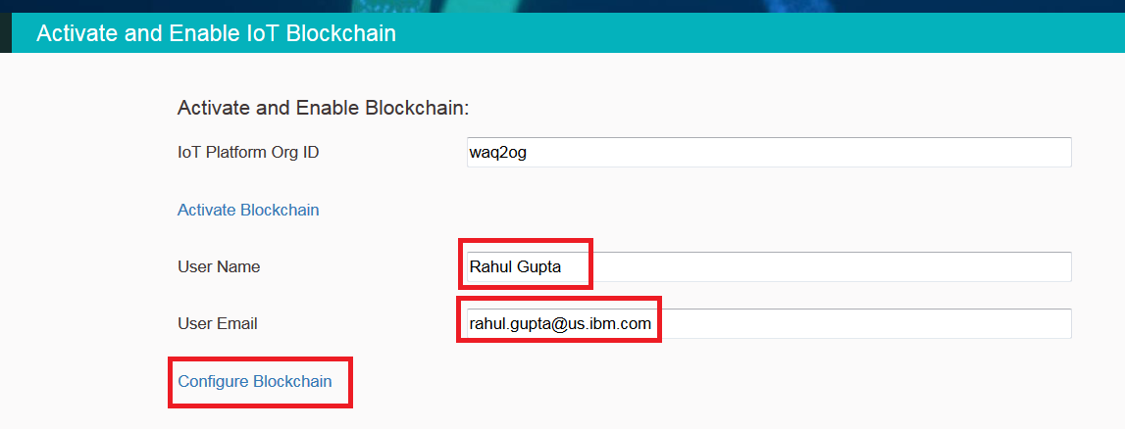

* Now you will be navigated to the IBM Watson IoT Platform to configure Blockchain
* Enable Blockchain by clicking on the toggle button and Confirm all changes

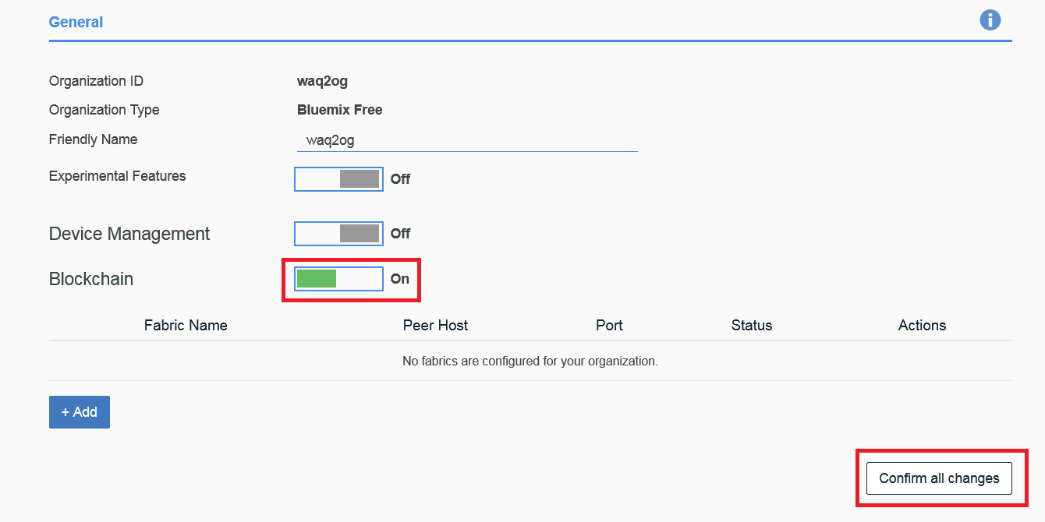

* Click on the Add button to add the Blockchain validating peer details of the Elevator manufacturing company
* In the Add Blockchain Fabric wizard click enter following details
  + **Fabric Name** – *elevator-company-fabric*
  + **Peer Host** – Copy the host name for Validating Peer 1 from the IBM Blockchain dashboard, use just the hostname **remove** **https://** and port **444**
  + **Port Number** – *444*
  + **Peer Name** – *elevator-customer-peer*
  + **User Id -** *user_type1_1* (Use the user ID used earlier for registration with Validating Peer 1**)**
  + **User Secret –** Enter the secret key for user user_type1_1

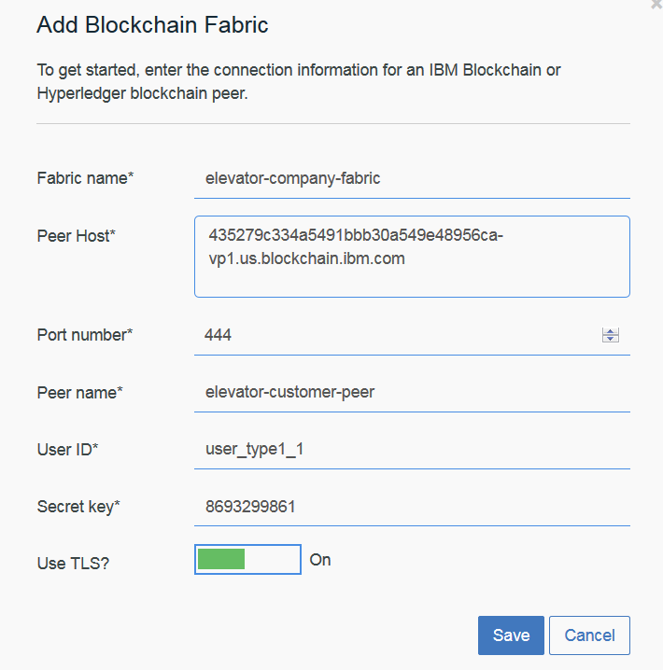

* Click **Save**
* Click again on **Confirm All Changes**

# Section 5: Configure and connect Elevator simulator to IoT Watson IoT Platform

This section will help you configure a virtual elevator simulator. This elevator connects to the IBM Watson IoT Platform and sends data with following JSON elements:

|  |  |
| --- | --- |
| AssetID | This element in the data shows the ID of the elevator |
| Weight | This element in the data shows the weight of passengers in the elevator |
| Speed | This element in the data shows the speed of the elevator wagon |
| Power | This element in the data shows the power consumption by the elevator |
| Temperature | This element in the data shows the temperature of the elevator |
| System | This element in the data shows the CPU and memory consumed by a microcomputer inside the elevator |

* Data from the virtual elevator is sent in following JSON format

{

"d": {

"assetID": "IOT-ELEVATOR-001",

"weight": 96,

"speed": 7,

"power": 78,

"temperature": 34,

"system": {

"cpu": 0.51,

"memory": 459990484

}

}

}

* To access the simulator, open a new tab in the browser window and go to url <https://ibm.biz/wowsimulator>
* Then click on **Elevator Device Simulator**
* Enter the IBM Watson Platform Org ID in the **OrgID** text box
* Enter the application API key in **API Key** text box. (This key was copied in notepad previously)
* Enter the application API Token in the **API Token** text box (This token was copied in notepad previously)
* Click on **Confirm** button
* This will connect the virtual elevator IOT-ELEVATOR-001 to IBM Watson IoT Platform
* Messages from the simulator will be sent at a frequency of every 2 seconds

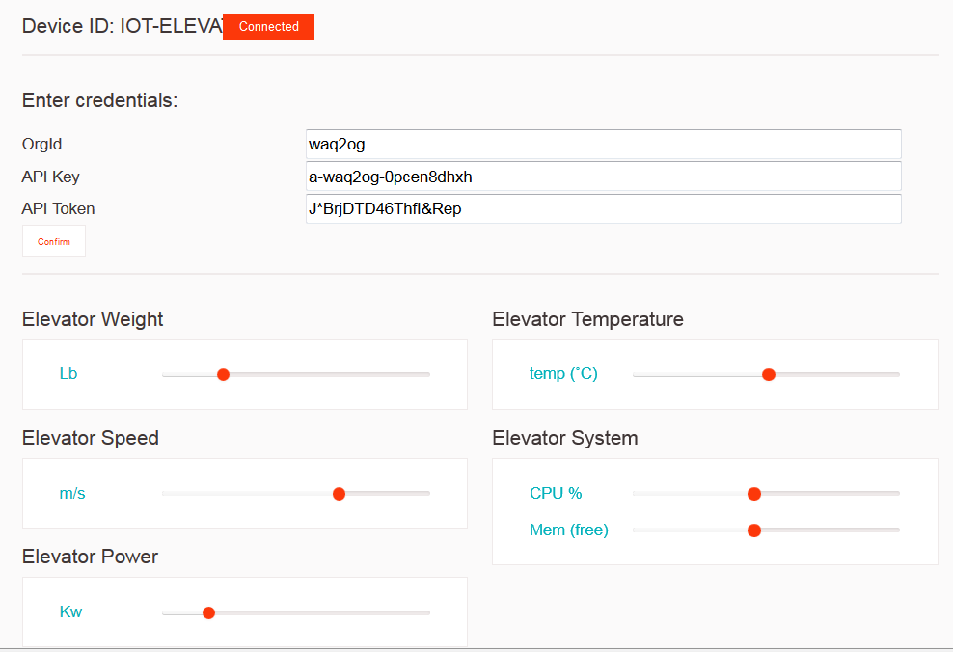

* You can validate if the messages are reaching the IBM Watson IoT Platform by going back to the device IOT-ELEVATOR-001 created previously.

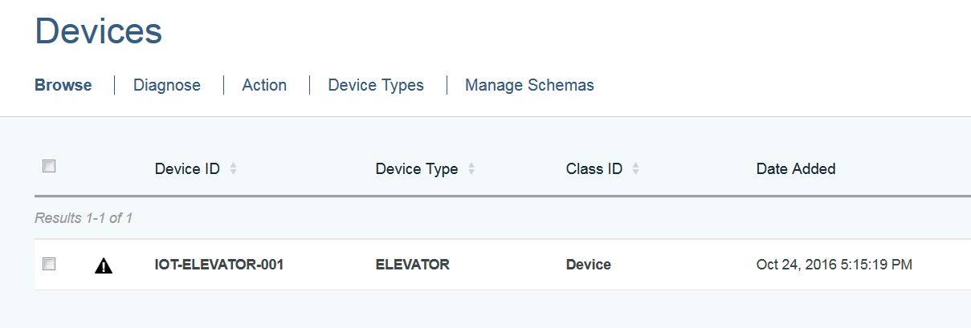

* Double click on device IOT-ELEVATOR-001 and under recent events you could see all the events from the elevator transmitted every two seconds

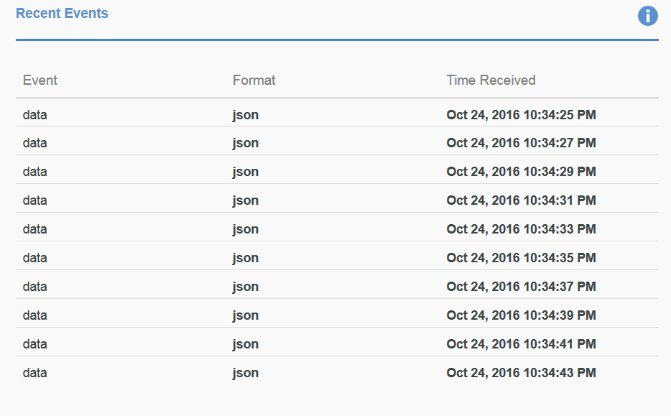

* Data is now getting transmitted from the virtual elevator simulator to IBM Watson IoT Platform service
* In next section, we will configure the integration routes between IBM Watson IoT Platform and the Blockchain fabric

# Section 6: Configure Integration routes between IBM Watson IoT Platform and IBM Blockchain

In this section, we will create routes to transmit data received on IBM Watson IoT Platform to IBM Blockchain service.

* Go to the IBM Watson IoT Platform dashboard and click on Blockchain icon in left menu like below

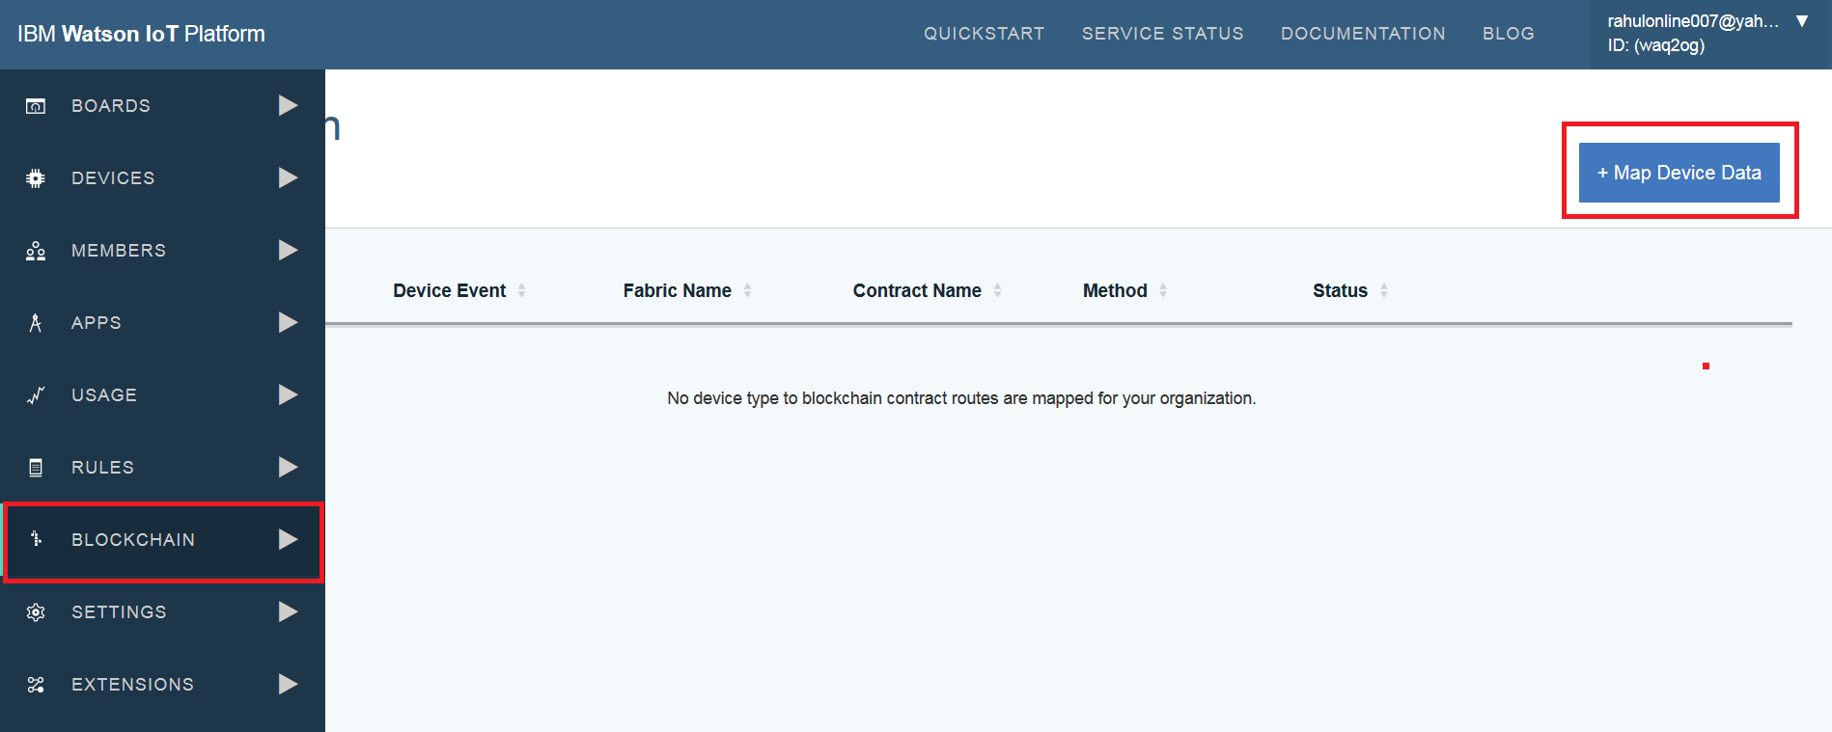

* Click on the **Map Device Data** button
* Add Route wizard will open
* In the Device type and Event form enter
  + **Device type**: *ELEVATOR*
  + **Event:** *data*
* Click Next
* In the Select Fabric form
  + **Fabric Name**: *elevator-company-fabric*
* Click Next
* In the Link Contract form
  + **Contract name:** *elevator-company-contract*
  + **Contract ID:** Copy the chaincode ID from the IBM Blockchain networks tab and paste it here in this form

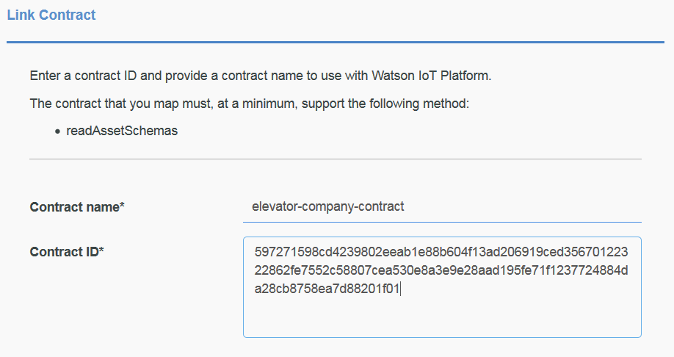

* Click Next
* In the Device data mapping form select the Contract method as **updateAsset**.

**Note:** The schema for the updateAsset method is pulled from the Elevator contract. The incoming data event for the simulator will now be mapped to this schema.

* Enter following details to complete the schema mapping

|  |  |
| --- | --- |
| Schema Property | Map to incoming JSON data |
| assetID | d.assetID |
| weight | d.weight |
| temperature | d.speed |
| speed | d.power |
| power | d.temperature |
| System |  |
| cpu | d.system.cpu |
| memory | d.system.memory |

* Click Next
* Click Finish on summary page to complete the device data mapping to Blockchain

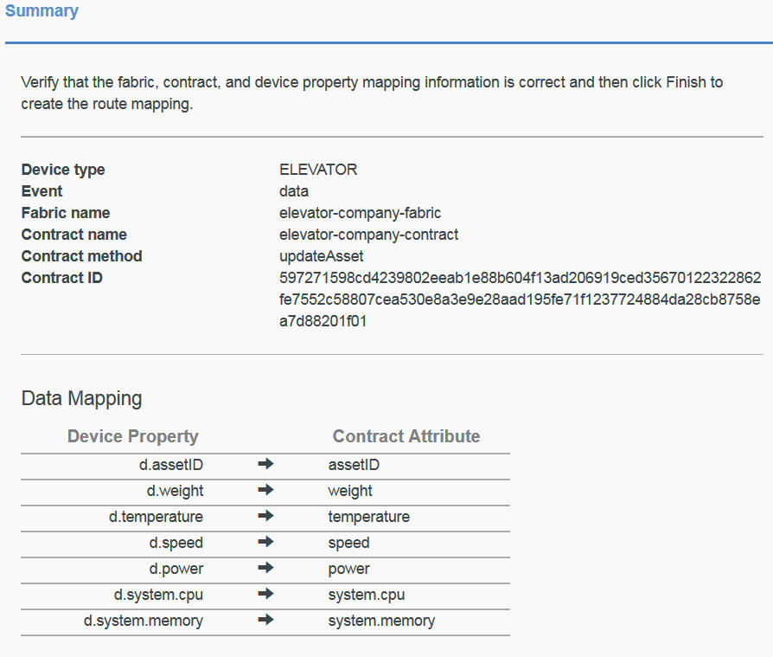

* You must now see a Blockchain route created in IBM Watson IoT Platform

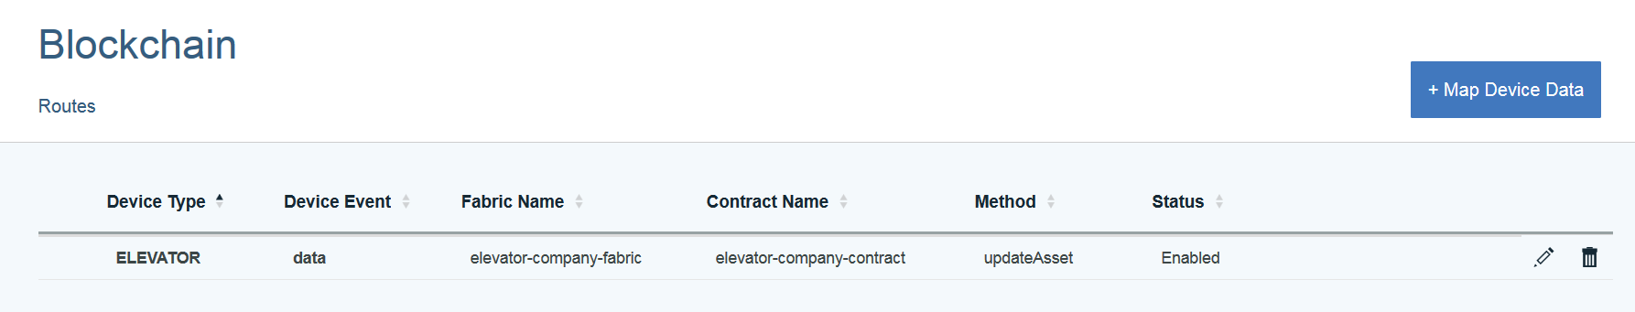

* To validate if the events from Elevator device IOT-ELEVATOR-001 are reaching the IBM Blockchain, go to the IBM Blockchain service dashboard and click on Blockchain tab
* You shall see the new blocks of data getting created
* Click on one of the blocks to see the data coming from the elevator device IOT-ELEVATOR-001

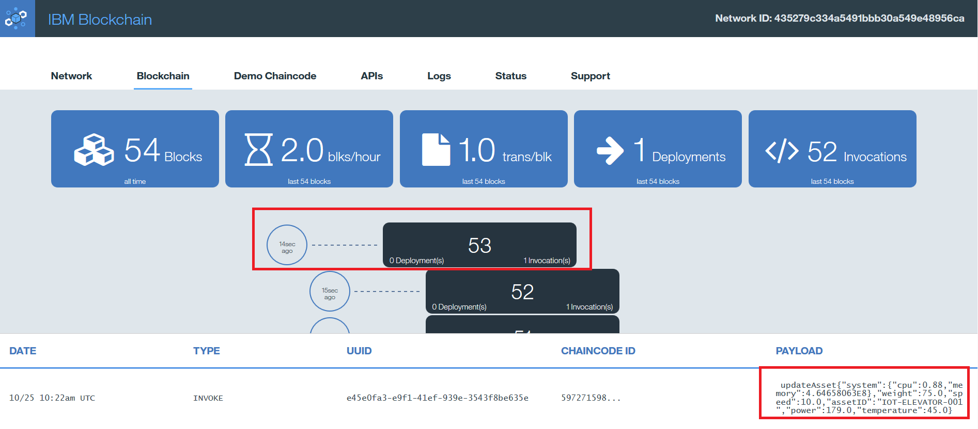

* Now we have the data coming from Elevator IOT-ELEVATOR-001 installed at a customer location into Blockchain. In the next sections, we will configure how the Elevator company and Government agency can access this data from Blockchain network for audits, compliance and customer services.

# Section 7: Access Elevator data in Blockchain: Elevator manufacturing company

The Elevator manufacturing company needs access to the data from Elevator so it can have visibility for any malfunctioning in elevator and could take immediate actions. This will help them provide better services to their customers and clear any audits and compliance issues.

The Blockchain network is owned by the Elevator company and they have a registered a user **user_type1_0** with **validating peer 0**.

The elevator at the customer site is sending data directly to blockchain through validating peer 1 using the IBM Watson IoT Platform integration routes.

In this step, we will provide an ability for the Elevator company to watch the data transmitted by the elevator IOT-ELEVATOR-001 to the Blockchain network.

* In a new browser tab open this URL <https://ibm.biz/wowsimulator>
* Click on **Elevator Company Blockchain Monitor**
* This will open a Blockchain monitoring application in a new tab
* Click on **Configuration** in the top right corner of this application

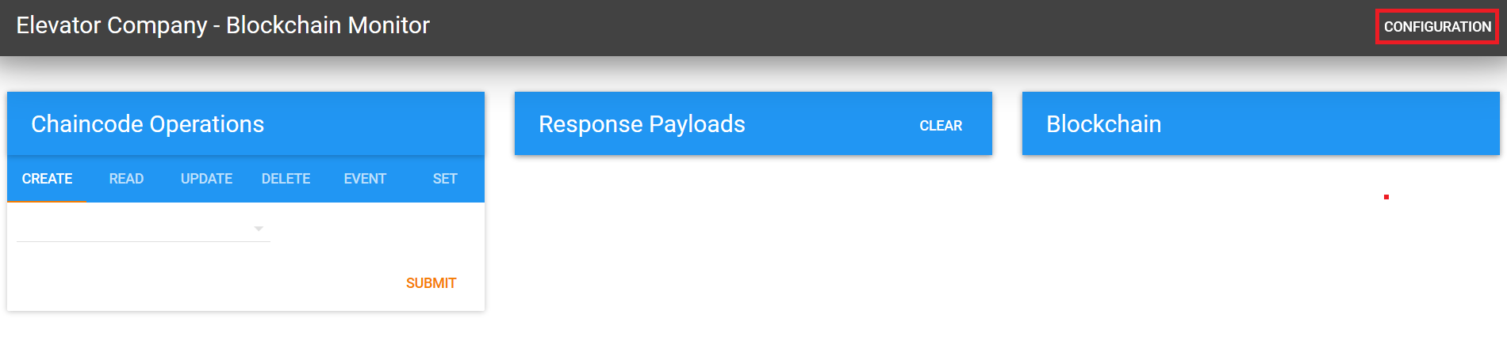

* In the configuration form enter the validating peer host and port for Validating Peer 0 (This information could be captured from the IBM Blockchain dashboard)
* Enter the Chaincode ID for the Elevator Contract (This information could be captured from the IBM Blockchain dashboard)
* In Secure Context enter: **user_type1_0**
* In Number of Block to display: 10
* Then click on SUBMIT as shown in the image on next page

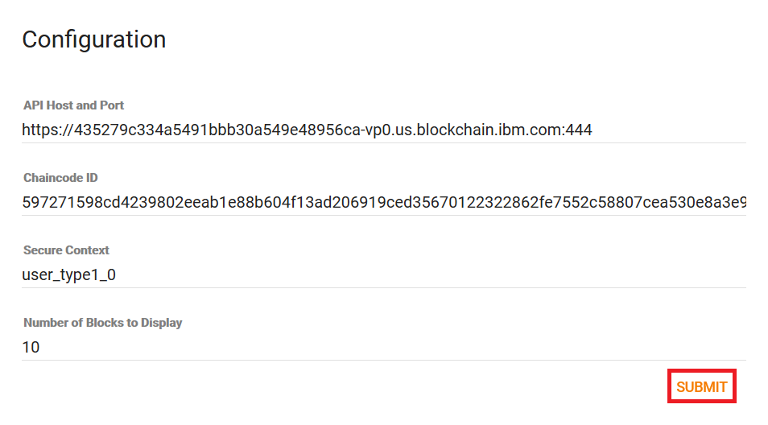

* This configuration will now start reading the last ten blocks of data on the Elevator contract
* Image below shows the latest blocks of data transmitted by the elevator at customer location to the elevator manufacturer

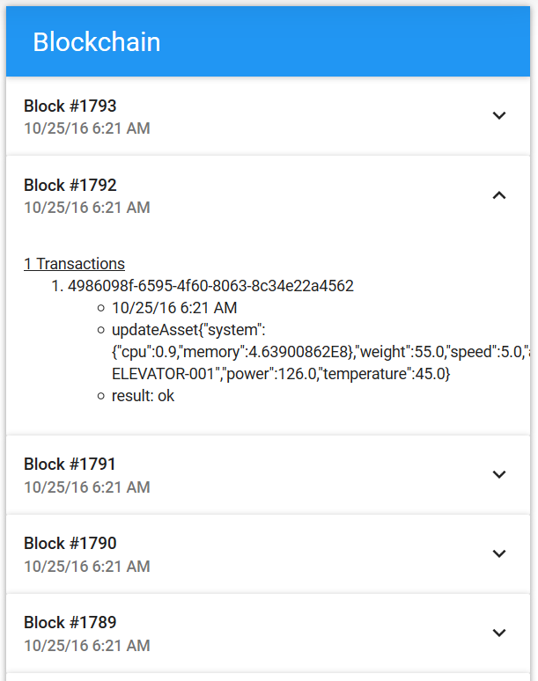

* You can also read the latest state of a specific elevator by providing the **assetID** of the elevator
* Select READ in Chaincode Operations portlet and enter the **assetID** as *IOT-ELEVATOR-001*
* Click **Submit**
* This will provide the latest state of the elevator IOT-ELEVATOR-001 in Blockchain

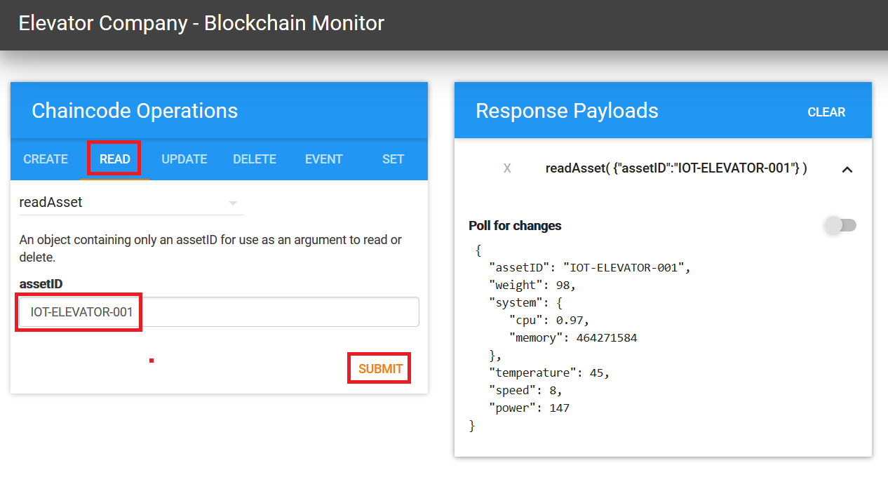

# Section 8: Access Elevator data in Blockchain: Government agency

The Government agency needs access to the data from Elevator so it can have visibility for any malfunctioning in elevator and this information could be used for inspections and security certification. This will help the Government agency for the transparent inspection process and without asking the manufacturer or customer to share this information.

The Government agency is registered in Blockchain network through **Validating Peer 2** with user **user_type1_2**.

The elevator at the customer site is sending data directly to the blockchain through validating peer 1 using the IBM Watson IoT Platform integration routes.

In this step, we will provide an ability for the Government agency to watch the data transmitted by the elevator IOT-ELEVATOR-001 to the Blockchain network.

* In a new browser tab open this URL <https://ibm.biz/wowsimulator>
* Click on **Government Blockchain Monitor**
* This will open a Blockchain monitoring application in a new tab
* Click on **Configuration** in the top right corner of this application
* In the configuration form enter the validating peer host and port for Validating Peer 2 (This information could be captured from the IBM Blockchain dashboard)
* Enter the Chaincode ID for the Elevator Contract (This information could be captured from the IBM Blockchain dashboard)
* In Secure Context enter: **user_type1_2**
* In Number of Block to display: 100
* Then click on SUBMIT as shown in image below

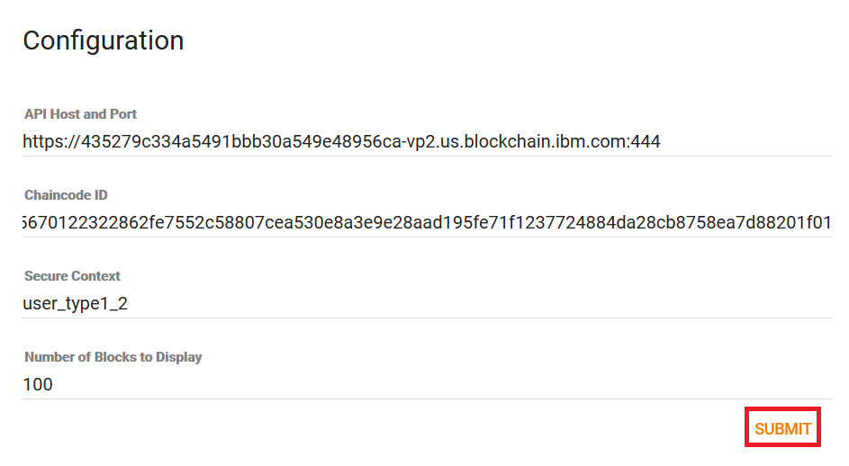

* This configuration will now start reading the last hundred blocks of data from the Elevator contract

# Summary

Blockchain is a technology for a new generation of transactional applications that establishes trust, accountability and transparency while streamlining business processes.

This lab demonstrated how data from IoT devices could be transmitted to the IBM Blockchain network using the IBM Watson IoT Platform and help enable business processes with enabling trust and unchangeable, immutable records transmitted from IoT devices.

# **We Value Your Feedback!**

* Don’t forget to submit your World of Watson session and speaker feedback! Your feedback is very important to us – we use it to continually improve the conference.
* Access the World of Watson Conference Connect tool to quickly submit your surveys from your smartphone, laptop or conference kiosk.

