

dashboard for vista

Configuration of Note Title Documentation Modules



March 18, 2020

Central Regional hosptial

Butner, North Carolina

By

Matthew M. King MD

Joseph Thurber, Programmer

Contents

Introduction 2

Configuring Note Titles Using the Dashboard Rules 2

Using the Rules Engine. 2

Using a Reminder Cohort to Restrict the Note Title to Specific Patients 6

PassThough Reminders – Documentation Based on Findings 8

Complex Logic Using Cohorts, Pass-Through Reminders and Dashboard Logic Together 13

Task Documentation Using Ghost Note Titles 17

Controlling the Entry Colors, Timing and Grace Periods on the Dashboard. 19

Using the Rules Engine to Create a Patient Status Board 21

**Dashboard Configuration – Recurrent Note Documentation Module**

# Introduction

Documentation in Healthcare is important and may be done on a recurring basis. Sometimes the recurring frequency is calculated by the date of the last time the note was written. One example may be an anticoagulation note that is done when the INR lab result is obtained on a patient taking warfarin. Other times it is based on an “anniversary” date. For instance, at our hospital, we have a 30-day and 90-day medical review, based on the date of admission, not when the last note was written.

The purpose of the dashboard note documentation module is to display all the notes a staff member needs to write on the patients for which they are they are responsible. The dashboard is designed to be service specific. For instance, the nurses may look at one set of entries, the medical service doctors at another set and the psychiatrists another.

Staff are responsible for defined sets of patients. For instance, a nurse might have all the patients on Ward A1. A psychiatrist may be the attending for a group of patients spread across several Wards. The dashboard allows you to use patient lists defined in VistA. An entire Ward may be chosen using the “Notes Due” module, while the “Notes Due by Team” module allows patient lists made in CPRS.

There may be “grace periods” associated with the notes due. For instance, the 30-day review may be due at thirty days from the admission date but may have a grace period of plus/minus 5 days.

Dashboard entries for notes due should be timed so they are not always seen on the dashboard. For instance, ours generally appear when the grace period starts, turn yellow at the due date and turn red when the grace period is over.

# Configuring Note Titles Using the Dashboard Rules

The rules engine is used to configure the dashboard. The defined rules are “anniversary” style rules, meaning they are calculated based on an event. This could be an admission date, an order, a day of the week or month, etc. One rule is called “Pass-Though Reminder”. When the Pass-Though Reminder is selected, all the logic for both the cohort and the resolution are handled entirely by the reminders package, except it is applied only to the selected patient list. When the Pass-Though Reminder rule is used, the dashboard entry is calculated based on the dates of the findings in the reminder; not like the anniversary style rules. This is true to the normal behavior of Clinical Reminders.

## Using the Rules Engine.

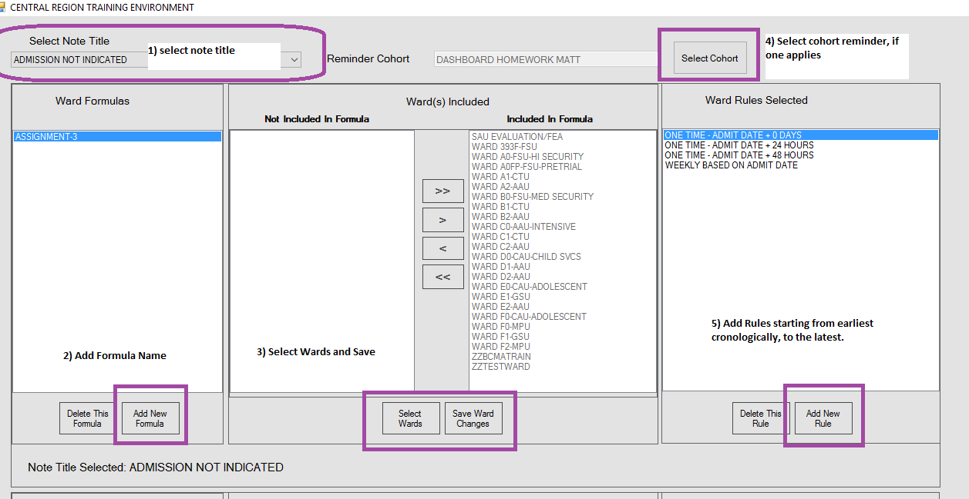

1. Open the Rules Engine Application and select the note title desired.
2. Add a Formula Name
3. Select Wards that are covered by the formula. You can have more than one formula per note, but they must apply to different Wards with no overlap of locations. Outpatient locations can be configured also. For instance, the SAU (First Location in screenshot, above) is an outpatient location. Be sure to save the ward changes.
4. Select a Cohort Reminder if needed, to restrict the rule further. See Reminder Cohort section below, for more details.
5. Add Rules one by one, starting with earliest and progressing to latest. Make sure one and only one rule applies to a specific time period. The computer will process the rules sequentially. For instance, if a note needs to be written at admit, every 15 days for 2 months and then monthly; the rules might look like the screenshot below. Note the 30 day and 60 day are only covered once by the “Monthly Based on Admit Date” rule.

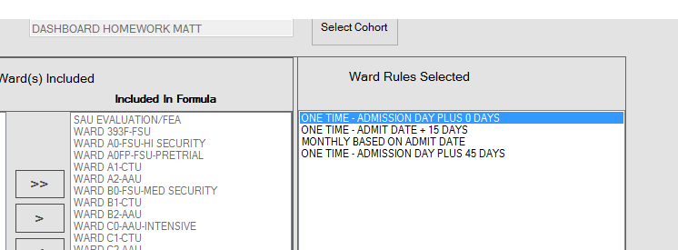

Below is a screenshot of the available rules for making a dashboard entry:

Rules like “ANNUALLY BASED ON ADMISSION DAY” and “MONTHLY BASED ON ADMIT DATE” do not include the date of admission. If you want a note on the admit date, use “ONE TIME ADMISSION DAY + 0 DAYS”

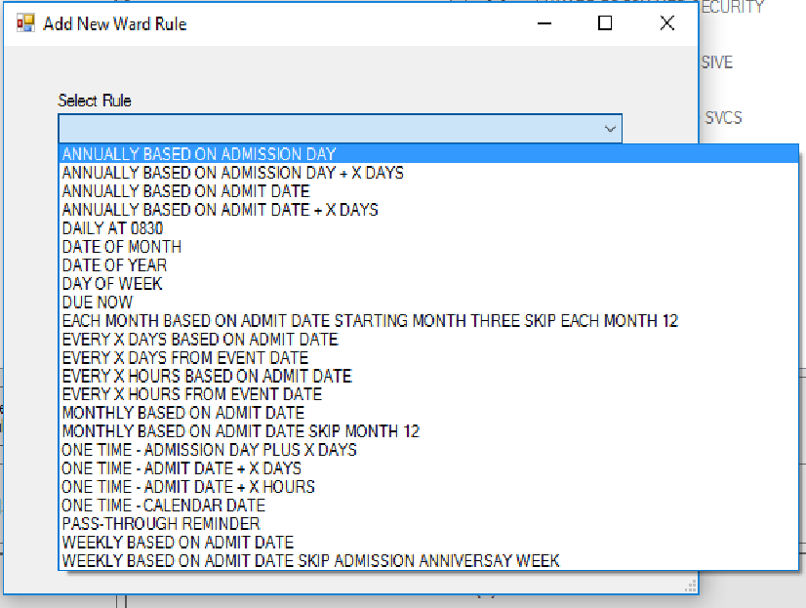

There are two other sections on the dashboard: Unit and Hospital. Unit allows you to make rules for a group of Wards, if defined. Hospital Rules apply to the whole hospital. Only one of the three sections can be used for a given note title.

Finally, test all rules made on the dashboard to ensure accuracy.

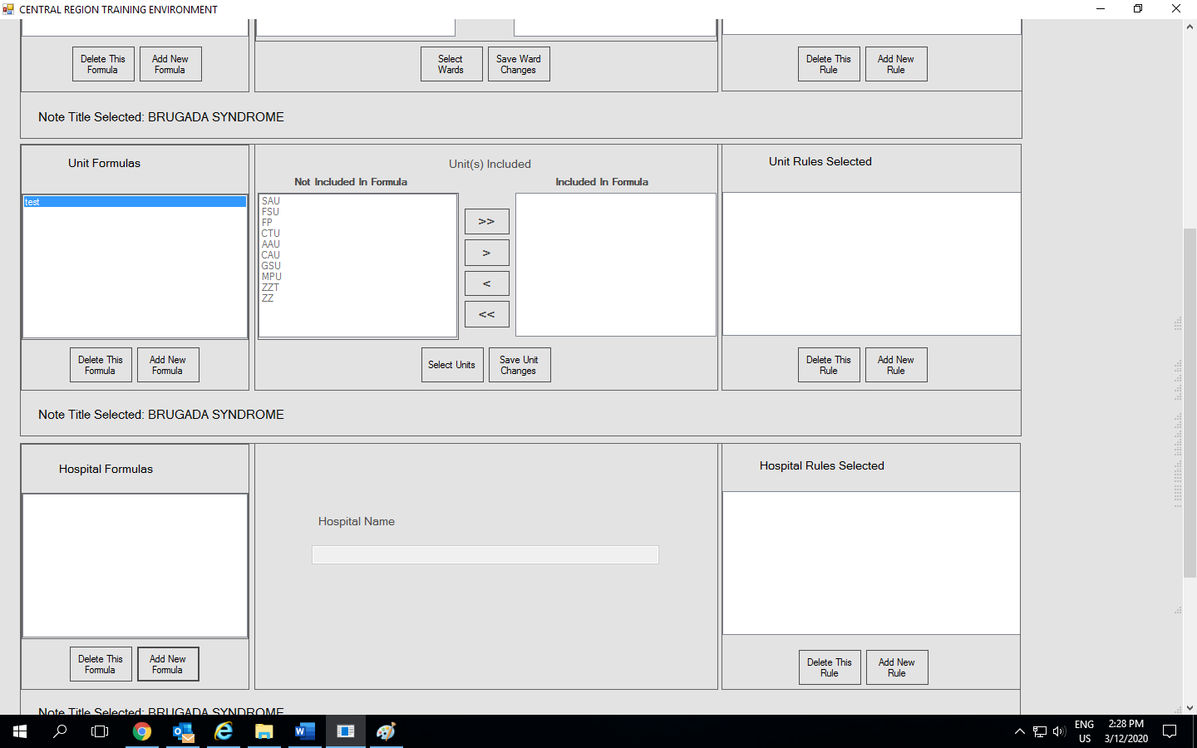

1. Open the Dashboard Application, and select one of the notes modules:

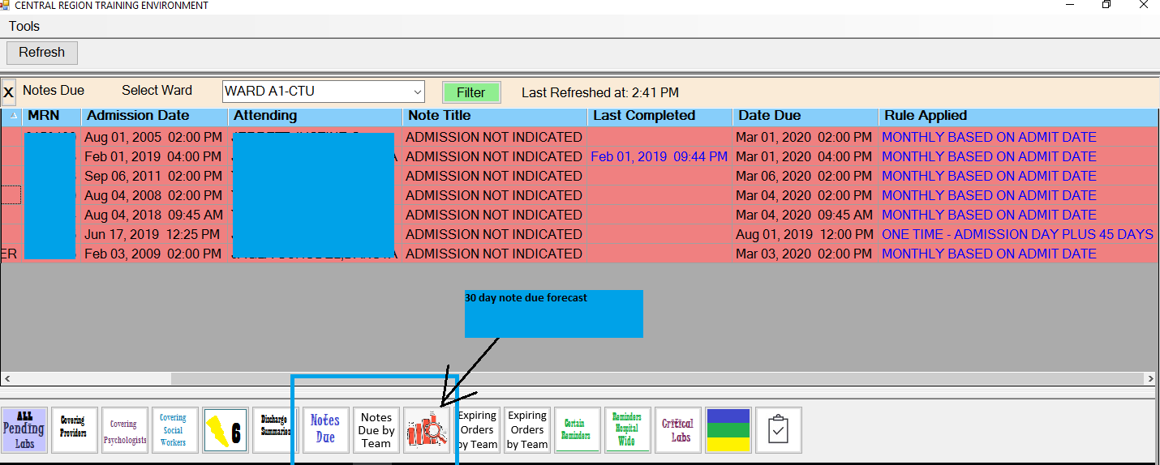

1. Open Filter and select your note title(s), save, and then select your Ward or Patient list (Notes Due by Team). The first column contains the patient names (not shown) The last column is not seen by the end user, but helps the developer troubleshoot errors. Viewing a dashboard with actual real time data may yield white, yellow and red entries. Our dashboard has 16 modules to choose from. This manual covers 3 modules. Clicking the last completed will fetch the last completed note for view. Clicking the Rule Applied will give more information regarding the rule used.
2. You can sort by any column by clicking on the column header, once for A->Z and twice for Z->A.

# Using a Reminder Cohort to Restrict the Note Title to Specific Patients

The dashboard rules you choose for a Note Title Formula will be applied to every patient on the list selected on the dashboard. Sometimes, that is not desired. For instance, maybe the note should only apply to males, or females, or patients over 65 years, or patients on antipsychotics, etc. In that case, you can restrict the cohort using a reminder that contains cohort logic only.

The key is to name the reminder “DASHBOARD” followed by a space and then anything else. Once built, it should be added to the title/formula in the rules engine application:

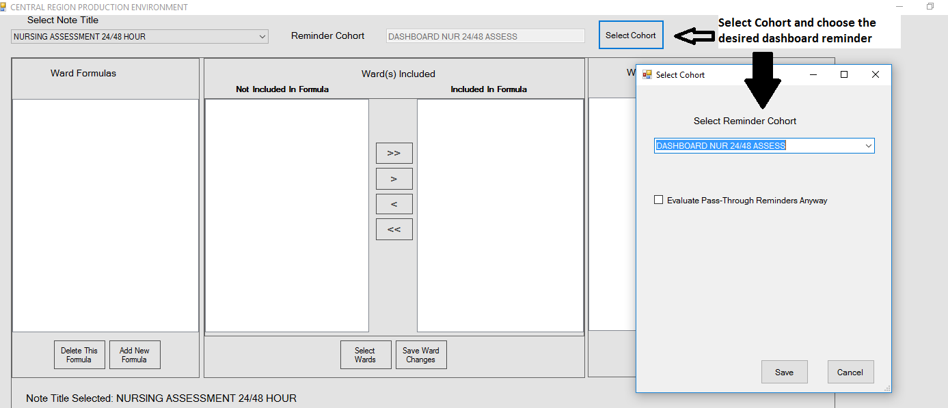

Making Clinical Reminders is beyond the scope of this manual. See the Clinical Reminder Manager Manual on the VA VDL website for definitive information on making Clinical Reminders. Here is the reminder associated with the screenshot above:

**DASHBOARD NUR 24/48 ASSESS**

PRINT NAME: DASHBOARD NUR 24/48 ASSESS

CLASS: LOCAL//

**USAGE: *//**

Baseline Frequency

DO IN ADVANCE TIME FRAME:

SEX SPECIFIC:

Baseline frequency age range set

**Select REMINDER FREQUENCY: 99Y//**

REMINDER FREQUENCY: 99Y//

MINIMUM AGE:

MAXIMUM AGE:

Reminder Definition Findings

Choose from:

CF VA-PROGRESS NOTE Finding # 1

**Select FINDING: `1 VA-PROGRESS NOTE**

FINDING ITEM: VA-PROGRESS NOTE//

REMINDER FREQUENCY:

MINIMUM AGE:

MAXIMUM AGE:

RANK FREQUENCY:

USE IN RESOLUTION LOGIC:

**USE IN PATIENT COHORT LOGIC: AND NOT//**

**BEGINNING DATE/TIME: PXRMLAD//**

ENDING DATE/TIME:

OCCURRENCE COUNT:

CONDITION:

CONDITION CASE SENSITIVE:

USE STATUS/COND IN SEARCH:

**COMPUTED FINDING PARAMETER: NURSING ASSESSMENT MONTHLY/WEEKLY^7**

Replace

Function Findings

Select FUNCTION FINDING:

Patient Cohort and Resolution Logic

CUSTOMIZED PATIENT COHORT LOGIC (OPTIONAL):

CUSTOMIZED RESOLUTION LOGIC (OPTIONAL):

Reminder Dialog

LINKED REMINDER DIALOG:

Web Addresses for Reminder Information

Select URL:

**Warning, there is no Resolution logic.**

**No fatal errors were found.**

**The purpose of this cohort reminder is to remove the 24/48 hour Assessment entry from the dashboard if it is not done (missed), but now the Monthly/Weekly Assessments should be done instead.**

The dashboard entries can be made for front line staff caring for patients, supervisors, managers, quality management, etc. For instance, although the front-line staff may need a missed note suppressed and move on to the next set of required assessments, supervisors might be more interested in seeing which notes were missed.

# PassThough Reminders – Documentation Based on Findings

When you want your dashboard frequencies to be based on the date of the finding, rather than an anniversary, use the pass-through rule in the rules engine.

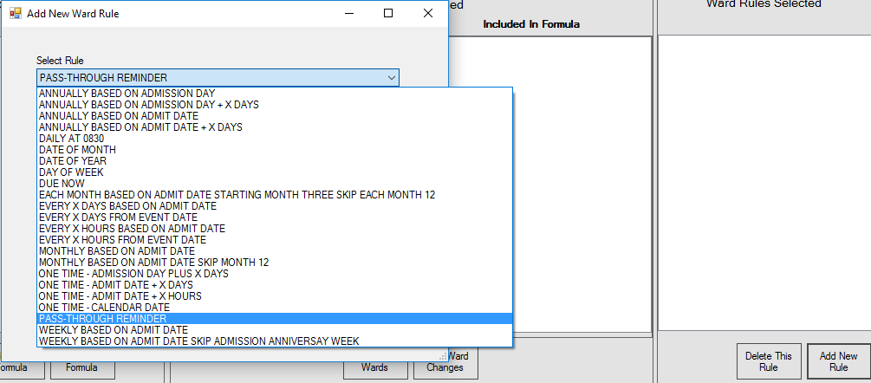

Once the pass-through rule is selected, use the drop-down box to select the pass though reminder needed:

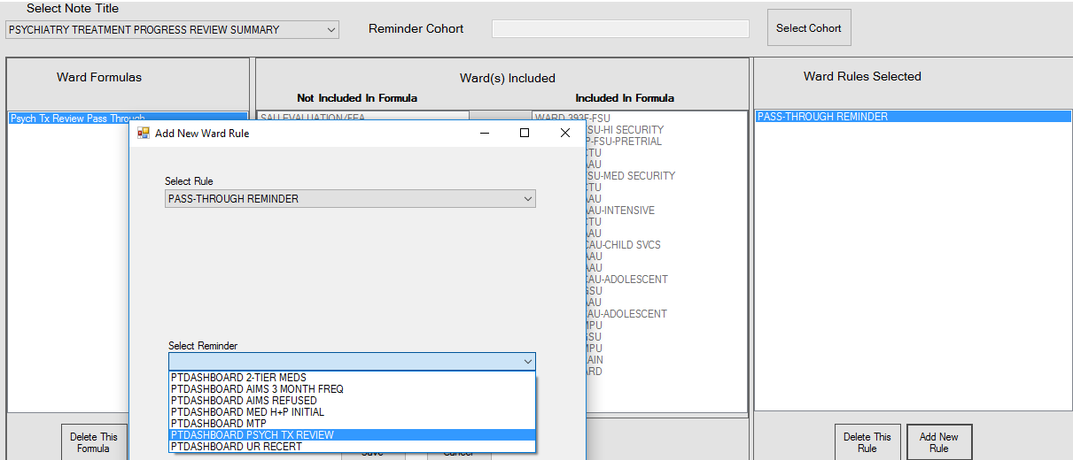

All pass-through reminders need to start with “PTDASHBOARD” in order to show up on the pick list. The dashboard will pass all the logic needed for the cohort and resolution to the reminder and apply the results (zero = false, 1 = true) to the patient list selected by the user. If the cohort is zero, the note/reminder doesn’t apply, and the patient will not be displayed. The computer will stop there and NOT evaluate the resolution logic but go to the next task. If the cohort is one and the resolution is one the note is not due. It may or may not display, depending on the frequency determined by the reminder and the “DO IN ADVANCE TIME FRAME” field. If the “DO IN ADVANCE TIME FRAME” calculation reaches the date due, it will display as white unless today’s date is one third the distance to the due date. In other words, if the “DO IN ADVANCE TIME FRAME” is set to 9D, it will appear 9 days before the note is due and turn yellow 3 days before it is due. It will turn red the day it is due. If the cohort is one and the resolution is zero, it is due now.

Here is the Pass-Though Reminder associated with the screenshots above:

NAME: PTDASHBOARD PSYCH TX REVIEW Replace **(Start with word PTDASHBOARD)**

PRINT NAME: PSYCH TX REVIEW//

CLASS: LOCAL//

USAGE: *//

Baseline Frequency

DO IN ADVANCE TIME FRAME: 7D// **It will show up 7 days before it is due and turn yellow 2.3 days before it is due. It will turn red on due date.**

SEX SPECIFIC:

Baseline frequency age range set

Select REMINDER FREQUENCY: 7D// **Baseline reminder frequency is every 7 days**.

REMINDER FREQUENCY: 7D//

MINIMUM AGE:

MAXIMUM AGE:

AGE MATCH TEXT:

No existing text

Edit? NO//

AGE NO MATCH TEXT:

No existing text

Edit? NO//

Select REMINDER FREQUENCY:

Findings:

CF VA-PROGRESS NOTE Finding # 1

CF VA-PROGRESS NOTE Finding # 2

CF VA-PROGRESS NOTE Finding # 3

CF VA-PROGRESS NOTE Finding # 4

Editing Finding Number: 1

FINDING ITEM: VA-PROGRESS NOTE//

REMINDER FREQUENCY:

MINIMUM AGE:

MAXIMUM AGE:

RANK FREQUENCY:

USE IN RESOLUTION LOGIC: OR//

USE IN PATIENT COHORT LOGIC: //

BEGINNING DATE/TIME: PXRMLAD-1D//

ENDING DATE/TIME: PXRMLAD+59D//

OCCURRENCE COUNT:

CONDITION:

CONDITION CASE SENSITIVE:

USE STATUS/COND IN SEARCH:

COMPUTED FINDING PARAMETER: `9// **We tend to use IEN numbers in case the progress note titles are changed. This note title is “PSYCHIATRIC ATTENDING INITIAL/ANNUAL ASSESSMENT” the very first time the treatment review note is due is 1 week after this note is written. The PSYCHIATRIC ATTENDING INITIAL/ANNUAL ASSESSMENT will be re-written in one year, so it is important to restrict the search period to the first note only. In this case, I choose between 1 day before admission (some notes our done in the “SAU” which is before the technical admission, like an ED) and 59 days.**

FOUND TEXT:

No existing text

Edit? NO//

NOT FOUND TEXT:

No existing text

Edit? NO//

Editing Finding Number: 2

FINDING ITEM: VA-PROGRESS NOTE//

REMINDER FREQUENCY:

MINIMUM AGE:

MAXIMUM AGE:

RANK FREQUENCY:

USE IN RESOLUTION LOGIC: OR//

USE IN PATIENT COHORT LOGIC:

BEGINNING DATE/TIME: PXRMLAD//

ENDING DATE/TIME:

OCCURRENCE COUNT:

CONDITION:

CONDITION CASE SENSITIVE:

USE STATUS/COND IN SEARCH:

COMPUTED FINDING PARAMETER: `1557// **This note is the “PSYCHIATRY TREATMENT PROGRESS REVIEW SUMMARY”. It should be written every week for the first 60 days, then every 14 days for a year and then every 28 days. This is why there are 3 findings for this note. The finding 2 is used in the resolution. The other two below are designed to flip the frequency. The timing in every case is based on the last time the note was written, except for the very first time, when it depends on the “PSYCHIATRIC ATTENDING INITIAL/ANNUAL ASSESSMENT”.**

FOUND TEXT:

No existing text

Edit? NO//

NOT FOUND TEXT:

No existing text

Edit? NO//

Editing Finding Number: 3

FINDING ITEM: VA-PROGRESS NOTE//

REMINDER FREQUENCY: 14D// **This finding is going to reset the frequency if it can find a** **“PSYCHIATRY TREATMENT PROGRESS REVIEW SUMMARY” written between 60 days after admission and 364 days after admission. It isn’t used in the cohort or resolution logic. Its only function is to flip the frequency.**

MINIMUM AGE:

MAXIMUM AGE:

RANK FREQUENCY: 2//

USE IN RESOLUTION LOGIC:

USE IN PATIENT COHORT LOGIC:

BEGINNING DATE/TIME: PXRMLAD+60D//

ENDING DATE/TIME: PXRMLAD+364D//

OCCURRENCE COUNT:

CONDITION:

CONDITION CASE SENSITIVE:

USE STATUS/COND IN SEARCH:

COMPUTED FINDING PARAMETER: `1557// **PSYCHIATRY TREATMENT PROGRESS REVIEW SUMMARY**

Editing Finding Number: 4

FINDING ITEM: VA-PROGRESS NOTE//

REMINDER FREQUENCY: 28D// **This finding is going to reset the frequency if it can find a** **“PSYCHIATRY TREATMENT PROGRESS REVIEW SUMMARY” written 365 days after admission. It isn’t used in the cohort or resolution logic. Its only function is to flip the frequency. Note it has a rank frequency resolution of 1; while finding 3 has a rank frequency of 2. By the time one of these notes is written, the computer will also find plenty of notes in the finding 3 date range. In order to flip the frequency to every 28 days, we need to tell the computer that this finding now should be used.**

MINIMUM AGE:

MAXIMUM AGE:

RANK FREQUENCY: 1//

USE IN RESOLUTION LOGIC:

USE IN PATIENT COHORT LOGIC:

BEGINNING DATE/TIME: PXRMLAD+365D//

ENDING DATE/TIME:

OCCURRENCE COUNT:

CONDITION:

CONDITION CASE SENSITIVE:

USE STATUS/COND IN SEARCH:

COMPUTED FINDING PARAMETER: `1557//

Select FUNCTION FINDING:

Patient Cohort and Resolution Logic

CUSTOMIZED PATIENT COHORT LOGIC (OPTIONAL): (AGE)&(SEX)&(FI(1)!FI(2)) **Note that I used finding 1 and 2 for cohort logic. Finding 1 should be fairly obvious but finding 2 is also needed because we have some patients admitted before we went live with VistA. These patients don’t have a “PSYCHIATRIC ATTENDING INITIAL/ANNUAL ASSESSMENT” within 60 days of their admission date, but they will have plenty of “PSYCHIATRY TREATMENT PROGRESS REVIEW SUMMARIES”.**

CUSTOMIZED RESOLUTION LOGIC (OPTIONAL):

No fatal errors were found.

# Complex Logic Using Cohorts, Pass-Through Reminders and Dashboard Logic Together

Sometimes a note will need a mixture of pass-through reminders and dashboard rules. These can get complex. Generally, they are used when the note needs to be written based on anniversary dates but require more clinical reminder logic than simple cohort restrictions. One example for us is the AIMS note. In our facility, it must be completed on admission for all patients and then every six months for patients that were given antipsychotics within the last 60 days or has a diagnosis of abnormal movements (like Tardive Dyskinesia). Also, sometimes the provider will want to re-set the frequency from every 6 months to every 3 months (or every 2 months, but this example will only cover every three months frequency changes). Also, if the AIMS is refused or unable to be performed, it should remain due and on the dashboard. See the screenshot below:

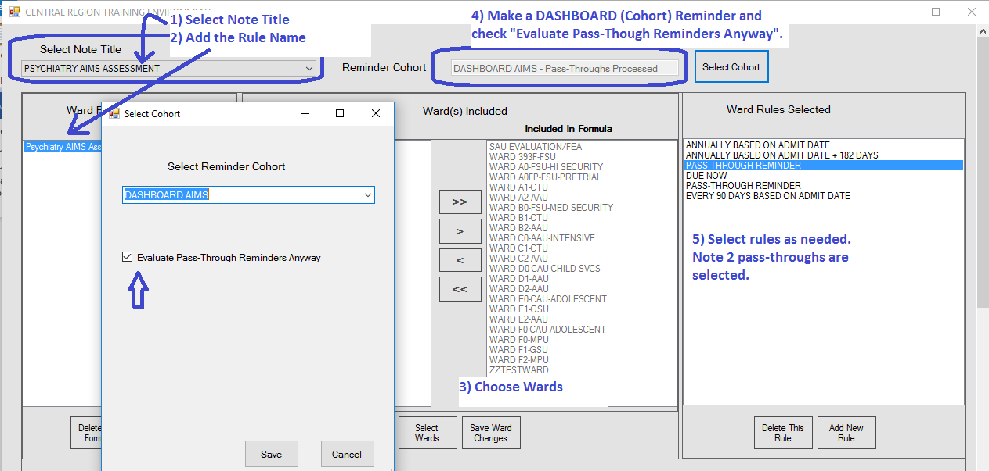

This note title has one DASHBOARD (Cohort) Reminder and 2 PTDASHBOARD (pass-through) Reminders, as well as dashboard rules.

1. Use the DASHBOARD Reminder to exclude from the first cohort any special rules patients:

NAME: DASHBOARD AIMS//

PRINT NAME: AIMS COHORT//

CLASS: LOCAL//

USAGE: *//

Select REMINDER FREQUENCY: 99Y//

REMINDER FREQUENCY: 99Y//

HF AIMS FREQ 2M Finding # 5

HF AIMS FREQ 3M Finding # 4

HF AIMS FREQ 6M Finding # 6

HF AIMS SCREENING TOOL PERFORMED Finding # 3

HF REFUSED AIM EVALUATION Finding # 2

HF UNABLE TO COMPLETE AIM EVALUATION Finding # 1

OI SAFETY ORDERS Finding # 7

RT ANTIPSYCHOTICS CLASSES Finding # 8

RT TARDIVE DYSKINESIA Finding # 10

TX ABNORMAL MOVEMENT ICD9 Finding # 9

Function Findings

1 MRD(3,1)=MRD(1)&MRD(1)>0

2 MRD(3,2)=MRD(2)&MRD(2)>0

3 VALUE(7,1,"DURATION")<45

Patient Cohort and Resolution Logic

CUSTOMIZED PATIENT COHORT LOGIC (OPTIONAL): (AGE)&(SEX)&((FI(7)&FF(3))!FI(8)!FI(

9)!FI(10))&'((FI(1)&FF(1))!(FI(2)&FF(2))!(FI(4)))

This cohort reminder includes any patient on admission, OR with a diagnosis of a movement disorder OR on an antipsychotic within the last 60 days to be part of the cohort UNLESS they refused OR Unable OR the frequency is changed using a health factor AIMS Freq 3M (or AIMS Freq 2M).

If they are in the first cohort, the computer will continue to evaluate the dashboard rules sequentially up to but not including the PTDASHBOARD reminder. The display and colors will behave according to those rules.

If the patient in in one of the cohort exclusions, the computer will skip to the first PTDASHBOARD Reminder and evaluate that next:

1. The next PTDASHBOARD Reminder is the “PTDASHBOARD AIMS REFUSED”. Recall if the patient refused or the physician was unable to evaluate, the note should still be displayed as due. So, the cohort here includes patients that refused the AIMS or it was unable to be completed. If the patient is part of this cohort, it will try to evaluate the resolution logic in the reminder and if that is zero, it will go to the dashboard logic. There is a dashboard rule called “due now” that will return the due date as today. The dashboard rules are evaluated in sequential fashion up to but not including the next PTDASHBOARD Reminder. If the cohort logic evaluates to zero here, the computer will skip to the next PTDASHBOARD Reminder and evaluate it. This continues until there are no more. Here is the PTDASHBOARD AIMS REFUSED Reminder:

NAME: PTDASHBOARD AIMS REFUSED Replace

CLASS: LOCAL//

USAGE: *//

DO IN ADVANCE TIME FRAME:

SEX SPECIFIC:

Select REMINDER FREQUENCY: 99Y//

REMINDER FREQUENCY: 99Y//

MINIMUM AGE:

MAXIMUM AGE:

Reminder Definition Findings

HF AIMS FREQ 3M Finding # 4

HF AIMS SCREENING TOOL PERFORMED Finding # 3

HF REFUSED AIM EVALUATION Finding # 2

HF UNABLE TO COMPLETE AIM EVALUATION Finding # 1

Function Findings

Select FUNCTION FINDING: ?

1 MRD(3,1)=MRD(1)&MRD(1)>0

2 MRD(3,2)=MRD(2)&MRD(2)>0

3 MRD(1,2,4)=MRD(4)&MRD(4)>0

Patient Cohort and Resolution Logic

CUSTOMIZED PATIENT COHORT LOGIC (OPTIONAL): (AGE)&(SEX)&((FI(1)&FF(1))!(FI(2)&FF

(2)))&'FF(3) Replace

CUSTOMIZED RESOLUTION LOGIC (OPTIONAL):

Warning, there is no Resolution logic.

No fatal errors were found.

1. If the cohort logic is zero in both the DASHBOARD AIMS and the PTDASHBOARD AIMS REFUSED, the computer will skip to the next PTDASHBOARD and start evaluation from there. This is the PTDASHBOARD AIMS 3 MONTH FREQ and if the AIMS Freq has been set to 3 months the cohort will evaluate to one and the evaluation process as noted above will apply here. Here, the frequency isn’t changed by the reminder because it must be based on the anniversary (admission) date, not the date of the last note:

F AIMS FREQ 2M Finding # 1

HF AIMS FREQ 3M Finding # 2

HF AIMS FREQ 6M Finding # 3

Select FINDING: `2 AIMS FREQ 3M

Editing Finding Number: 2

FINDING ITEM: AIMS FREQ 3M//

REMINDER FREQUENCY: **No frequency changes here, instead the resolution logic is zero and it starts evaluating the dashboard rule (every 90 days based on admit date).**

MINIMUM AGE:

MAXIMUM AGE:

RANK FREQUENCY:

USE IN RESOLUTION LOGIC:

USE IN PATIENT COHORT LOGIC: AND//

BEGINNING DATE/TIME: PXRMLAD-1D//

Combinations of DASHBOARD Reminders, Dashboard Rules and PTDASHBOARD Reminders are complex and must be tested thoroughly.

# Task Documentation Using Ghost Note Titles

The Note Title Dashboard Module’s mission can be extended beyond note title due displays. For instance, you could display the next time vital signs are due on a patient:

1. **In the TIU package, create a special note title:**

Edit **Document Definitions** Mar 17, 2020@11:45:42 Page: 1 of 2

BASICS

|  |
| --- |
| Name |
|  |
| 1. **CLINICAL DOCUMENTS** |
| 1. +PROGRESS NOTES |
| 1. +ADDENDUM |
| 1. +DISCHARGE SUMMARY |
| 1. **CLINICAL PROCEDURES** |
| 1. **DASHBOARD** |
| 1. NO BM RECORDED IN THREE DAYS |
| 1. **VITALS DUE** |
|  | |

1. **Make a Document Class called Dashboard under Clinical Procedures. These will not be selectable in CPRS but will be on the Dashboard.**
2. **Make a Note title called “Vitals Due” in the Dashboard Document Class**
3. **In Reminders, Make a Cohort that includes an “and not” Vital Sign that lasts until the grace period of the frequency. For instance, if the vitals were every 24 hours and you could do them plus/minus 1 hour, make a pulse finding that only searches back from N-23H:**

NAME: **DASHBOARD VITALS ONCE A DAY** Replace

PRINT NAME: VITALS DAILY//

CLASS: LOCAL//

REVIEW DATE:

USAGE: *//

Select **REMINDER FREQUENCY: 99Y**//

REMINDER FREQUENCY: 99Y//

**VM PULSE** Finding # 1

Select FINDING: `1 PULSE

FINDING ITEM: PULSE//

USE IN RESOLUTION LOGIC:

**USE IN PATIENT COHORT LOGIC: AND NOT**//

**BEGINNING DATE/TIME: N-23H//**

ENDING DATE/TIME:

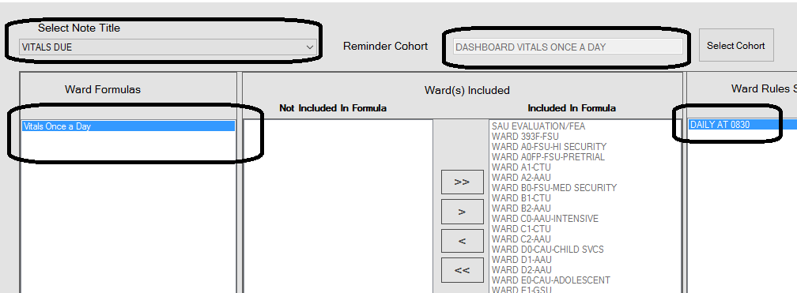

**This example is a proof of concept rather than a practical example because it would be a rare hospital where every patients’ vital signs were due at 0830. We have at least two ways to solve the problem practically, however. The first is using the “smart” order functionality we added. This allows designated orders to execute special code. In this case the frequency of the order would be parsed, and a health factor assigned that allows an arrangement like explained in the Cohort🡪 Pass-though section. The second method would be separate orders and separate “Note Titles”. In both cases, if the computer was unable to resolve the order, it would display, “unable to resolve”. The column heading could be renamed “Task Due” instead of “Note Due” if this idea was used extensively. If the task timing was based on the finding, rather than a time of day a pass-through reminder could be used instead. There is also a module for “Certain Reminders” which doesn’t allow dashboard anniversary rules but could handle finding type ideas. The Certain Reminders Module is covered in a different manual.**

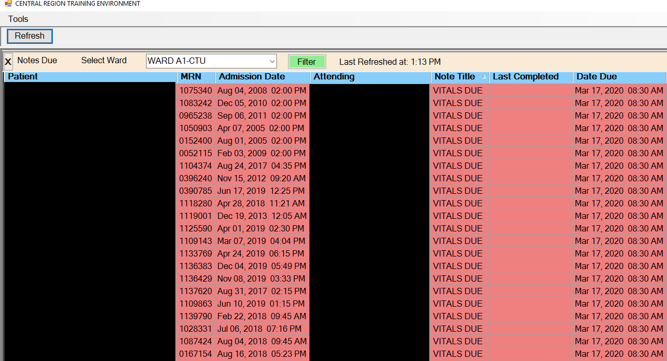

# Controlling the Entry Colors, Timing and Grace Periods on the Dashboard.

You can control when the entry first appears on the dashboard, when the colors change and the acceptable time delta (grace period) for writing a note:

1. Each dashboard rule has its own group of default settings that can be controlled by someone with Fileman access:

CHOOSE 1-35: 34 C9C RULES (23 entries)

Select C9C RULES NAME: ??

Choose from:

**ANNUALLY BASED ON ADMISSION DA**

**ANNUALLY BASED ON ADMISSION DA**

**ANNUALLY BASED ON ADMIT DATE**

**ANNUALLY BASED ON ADMIT DATE +**

**DAILY AT 0830**

**DATE OF MONTH**

**DATE OF YEAR**

**DAY OF WEEK**

**DUE NOW**

**EACH MONTH BASED ON ADMIT DATE**

**EVERY X DAYS BASED ON ADMIT DA**

**EVERY X DAYS FROM EVENT DATE**

**EVERY X HOURS BASED ON ADMIT D**

**EVERY X HOURS FROM EVENT DATE**

**MONTHLY BASED ON ADMIT DATE**

**MONTHLY BASED ON ADMIT DATE SK**

**ONE TIME - ADMISSION DAY PLUS**

**ONE TIME - ADMIT DATE + X DAYS**

**ONE TIME - ADMIT DATE + X HOUR**

**ONE TIME - CALENDAR DATE**

**PASS-THROUGH REMINDER**

**WEEKLY BASED ON ADMIT DATE**

**WEEKLY BASED ON ADMIT DATE SKI**

NUMBER: 6 **NAME: EVERY X DAYS BASED ON ADMIT DATE**

ACTIVE: YES

ABBREVIATION: EVERY X DAYS BASED ON ADMIT DATE

NEARLY DUE LOGIC: S C9CCHECK=$$NEARLY^C9CORIDE(RPOINT,TITLIEN,**BASEDATE,OFFSET,1,0**)

SHOWN LOGIC: S C9CCHECK=$$SHOWN^C9CORIDE(RPOINT,TITLIEN,BASEDATE,OFFSET,**2,0,350,0**)

**OVERDUE LOGIC**: S C9CCHECK=$$OVERDUE^C9CORIDE(RPOINT,TITLIEN,BASEDATE,OFFSET)

**ACCEPTABLE BASEDATE DELTA LOGIC**: S ABD=$$GETABD^C9CORIDE(RPOINT,TITLIEN,**OFFSET,"7.0**")

The numbers in the **$$SHOWN calls are default days before, default hours before, default days after, default hours after**.  I the **$$NEARLY call, they are default days before and default hours before**.  The default for **$$OVERDUE is always due time (but can be overridden).** The **$$GETABD gets the “grace period” and the number is days:hours**. Note 7.5 = 7 days, 5 hours, not 7.5 days. You can edit these defaults using Fileman.

The approach of applying defaults rule by rule was found to have limitations because grace period lengths tend to be different based on length of stay. For instance, “ **X DAYS BASED ON ADMIT DATE”** used at 7 days might have a 1 day grace period, but used at 1 year might need 15 days. Moreover, the same rule might be used for different note title dashboard entries with different grace periods. To overcome these limitations, we added the C9CORIDE routine to override the default logic.

1. Overriding the default logic is a programmer function and based on note title rather than strictly rule logic. The best way for a non-programmer to know if override logic is being used is to press on the “Rule Applied” (Last column on the dashboard, visible only with a key given to CACs).

We have chosen the following behavior for our notes:

1. Appear at onset of grace period with white color. (This stops staff from writing notes too early.)
2. Turn yellow at Due Date
3. Turn Red when grace period expires. We found coral pink was a more acceptable color than red.
4. Timing, color and grace periods on pass-through reminders (PTDASHBOARD) are controlled entirely by the Reminder. It cannot be as precise as the dashboard rules. The “DO IN ADVANCE TIME FRAME” controls the appearance on the dashboard and it will turn yellow when two-thirds of the time between the DO in Advance and the DUE Date have passed. In other words, if the “DO IN ADVANCE TIME FRAME” is 9D the entry will first appear and be white 9 days before it is due and will turn yellow at 3 days. It turns red at the due date.

# Using the Rules Engine to Create a Patient Status Board

The dashboard technology can be used to support other applications. For instance, a Patient Status Board, which can be located at the nursing station and display all the real time tasks needed to be done for all the Ward Patients without logging into a computer. Besides notes, this would include unverified orders, vitals, stat and now orders, etc.