

Dashboard for Vista

Configuration of the Reminders Modules



March 31, 2020

Central Region Hospital

Butner, North Carolina

By

Matthew M. King, MD

Joseph Thurber, Programmer

Table of Contents

Dashboard Configuration – Reminders Modules 1

Introduction 1

Graphing the Results 2

Using the Filter on the Dashboard. 10

Making Reminders for the Dashboard 11

The Due Date column 11

Colors and Appearance on the Dashboard 11

Examples of Dashboard Reminders 11

Example 1: DASHBOARD-C Type Reminders 12

EXAMPLE 2: DASHBOARD-R REMINDER – The “VA-AGE” Finding results in a colorful surprise. 13

Example 3 - High Risk for Flu Complications – Making an entry forever white 16

Conclusion 21

# Dashboard Configuration – Reminders Modules

## Introduction

The purpose of the Reminders Modules on the Dashboard is to show real time data for the daily management of our inpatients. There are two modules:

1. “Certain Reminders” which apply the selected reminders to a single hospital location of your choosing. There is a filter that allows you to control which reminders are displayed.

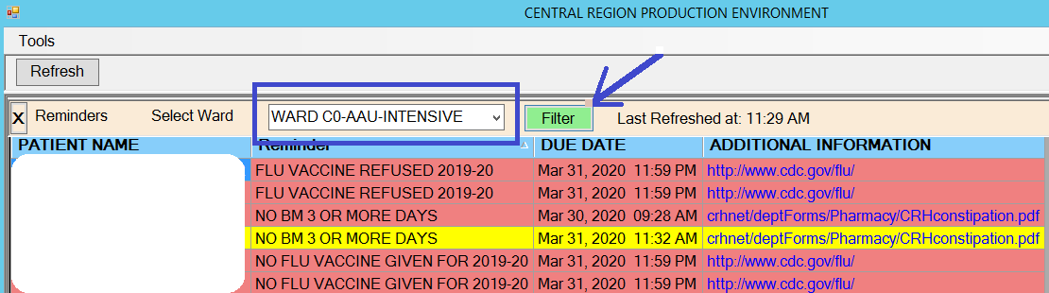

1. “Reminders Hospital Wide” which apply the selected reminders to the whole hospital.

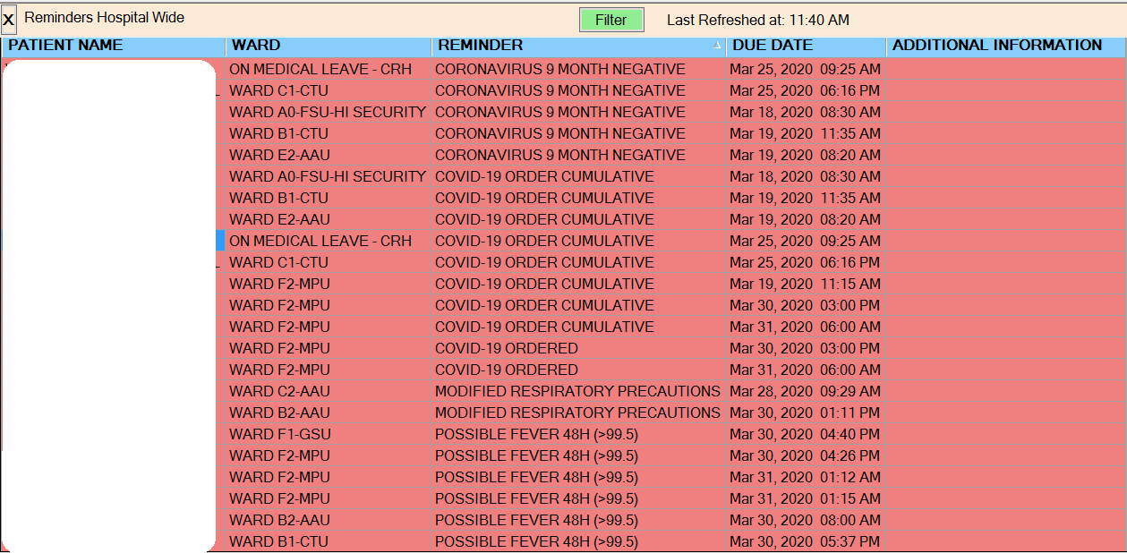

The same columns and reminders are available for both modules, except the location column is missing on the location specific module called “Certain Reminders”. That module is for providers directly managing patients. The hospital wide views are for staff like the Infectious Disease Department, COVID-19 Management Group, Quality Management, etc.

## Graphing the Results

The data generated from the dashboard can be extracted and placed into a spreadsheet where graphs can be created to present the data in a visual format.

## Using the Filter on the Dashboard.

Use the filter to choose what to display on the dashboard by clicking on the green filter button and clicking on the desired reminder to show or not show. Use the middle buttons to move the highlighted reminder to the desired location. Multiple reminders can be viewed at once. Some reminders can be process intensive, so limit your views accordingly. Our hospital has 400 beds and we don’t find the dashboard slowing our system. One of our reminders is “High Risk for Flu Complications” and is used by staff to choose which patients to place on Tamiflu when a ward is placed in isolation because of other positive influenza patients. It includes several hundred diagnoses. Even so, it only takes a few seconds to run on a ward of patient and about 20 seconds to run on the whole hospital. We will eventually set the dashboard to our “quaternary” instance which allows us to mine data without incurring any performance penalty in VistA.

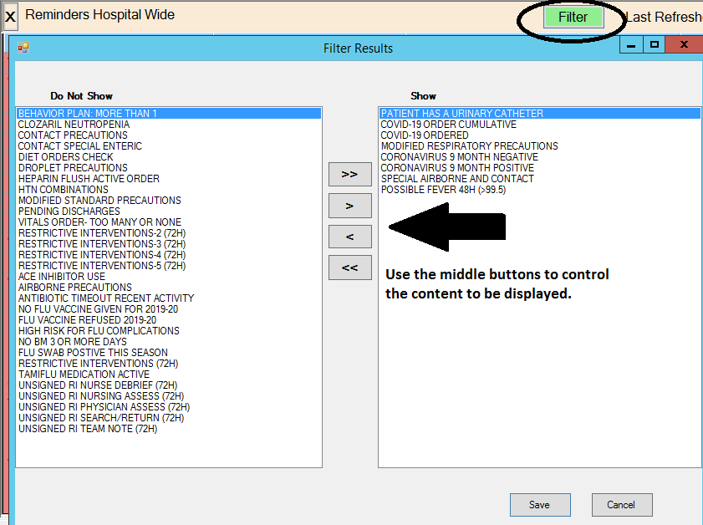

## Making Reminders for the Dashboard

A reminder name must start with either DASHBOARD-C or DASHBOARD-R to be visible in the dashboard filter. A DASHBOARD-C reminder will only run cohort logic. A DASHBOARD-R reminder will run both cohort and resolution logic.

There are only five columns on the dashboard for the Hospital Wide module: Patient Name, Ward, Reminder, Due Date and Additional Information. The Reminder column displays the PRINT NAME of the reminder. This is a field in the reminder. Additional Information is displayed if a web address is entered in the reminder. These can include intranet local locations.

### The Due Date column

The due date column will display today’s date if a DASBOARD-C type reminder is used, because there is no resolution. If a DASHBOARD-R reminder type is used, a due date can be calculated. Many times, we use a DASHBOARD-R on a dashboard entry, but don’t put any resolution logic in the reminder. Then we use the “Custom Due Date” field to mark the due date as the date of the finding. For instance, if Finding 1 is an orderable item, we would “Use Start Date” = Yes in the finding to make the date of the orderable item the date it was ordered. Then in the custom due date field, we would put something like “MAX_DATE(1+0H). Now the computer sets the due date to the date of the first finding and that is what is displayed under the “Due Date” column. These dates are important for graphing data as shown in the previous section.

### Colors and Appearance on the Dashboard

All DASHBOARD-C type reminders will be red and show a “NOW” due date if they evaluate to 1 (true).

The DASHBOARD-R type reminders’ appearance on the dashboard and color will depend on the evaluation of the cohort and resolution logic and the contents of the “DO IN ADVANCE TIMEFRAME” field in the Reminder:

1. The Cohort evaluates to zero means the reminder doesn’t apply. Nothing shows on the dashboard.
2. The Cohort evaluates to one and the resolution logic evaluates to zero. The reminder is Due Now and the date it was due will show on the dashboard. If it can’t calculate a date due, it will show due “NOW”. It will be red.
3. The Cohort evaluates to one and the resolution logic is also one:
   1. It will not show on the dashboard unless the time of evaluation (NOW) is within the date of the “DO IN ADVANCE TIME FRAME”. If that is true then it will show on the dashboard in White until it is within 2/3rds of the Due date. Then it will display in Red. For example, if 9D is put in the “DO IN ADVANCE TIMEFRAME” field, the reminder entry will appear on the dashboard 9 days before the actual due date and remain white until 3 days before. Then it will turn red.

## Examples of Dashboard Reminders

This document is not a tutorial for how to make clinical reminders, but it will show some tricks used to manipulate the Due Dates and colors on the dashboard.

### Example 1: DASHBOARD-C Type Reminders

Some of our dashboard reminders are for “Orders Hygiene”. For instance, we want one and only one vitals sign order per patient. This is a reminder that checks for one Vitals order only:

NAME: DASHBOARD-C VITALS CHECK **Name that allows it to be listed on the filter**

PRINT NAME: VITALS ORDER- TOO MANY OR NONE **Name the appears on the dashboard**

CLASS: LOCAL//

USAGE: *// **I always use * for dashboard types**

Baseline Frequency

DO IN ADVANCE TIME FRAME:

SEX SPECIFIC:

Baseline frequency age range set

Select REMINDER FREQUENCY: 99Y//

REMINDER FREQUENCY: 99Y//

Choose from:

OI VITALS Finding # 1 **Only one finding**

Select FINDING: `1 VITALS

Editing Finding Number: 1

FINDING ITEM: VITALS//

USE IN RESOLUTION LOGIC:

USE IN PATIENT COHORT LOGIC: AND//

BEGINNING DATE/TIME: PXRMLAD-1D//

ENDING DATE/TIME:

OCCURRENCE COUNT: 2//

USE START DATE: YES//

CONDITION:

CONDITION CASE SENSITIVE:

USE STATUS/COND IN SEARCH:

Statuses already defined for this finding item:

ACTIVE

PENDING

**Function Findings**

1. COUNT(1)>1//
2. COUNT(1)<1

USE IN RESOLUTION LOGIC:

USE IN PATIENT COHORT LOGIC: //

Patient Cohort and Resolution Logic

CUSTOMIZED PATIENT COHORT LOGIC (OPTIONAL): (AGE)&(SEX)&(FI(1)&FF(1))!FF(2)

CUSTOMIZED RESOLUTION LOGIC (OPTIONAL):

Web Addresses for Reminder Information

Select URL:

Warning, there is no Resolution logic.

Warning cohort logic is true even when there are no true findings!

No fatal errors were found.

**The reminder entry will appear if it finds zero or more than one vitals order**

### EXAMPLE 2: DASHBOARD-R REMINDER – The “VA-AGE” Finding results in a colorful surprise.

In our State Hospital, we use a lot of antipsychotic medications. Some of them are very constipating. We have added BM to the Vitals Package and can track how often our patients have a BM. We have bowel protocols and guidance available at point of care. The Dashboard reminder tracks patients that haven’t had a BM within the last three days. It turns yellow after 2 days of no BM.

NAME: DASHBOARD-R NO BM 3 OR MORE DAYS **Name for Dashboard Filter**

PRINT NAME: NO BM 3 OR MORE DAYS

CLASS: LOCAL//

USAGE: *//

Baseline Frequency

DO IN ADVANCE TIME FRAME: 147H// **Causes the entry to appear yellow at 49 hours (25 hours before three full days).**

Baseline frequency age range set

Select REMINDER FREQUENCY: 72H// **If it can resolve the reminder, it calculates the next due date for 72 hours from the date of resolution**

REMINDER FREQUENCY: 72H//

**CF VA-AGE Finding # 3**

**VM BLOOD PRESSURE Finding # 2**

**VM Bowel Movement Finding # 1**

**Select FINDING: `3 VA-AGE**

***Finding 3 is shameless trick!*** *We wanted the Reminder to appear yellow on the dashboard at 48 hours of no BM, but not appear at all before that time. We needed to make the DO IN ADVANCE TIMEFRAME 2/3rds longer (149 hours) to change the color to yellow at 48 hours. What this finding does is remove the entry from the cohort until 48 hours before it is due. That way it doesn’t appear at all until 48 hours of no BM and then the resolution logic applied and also turns the entry yellow.*

Editing Finding Number: 3

FINDING ITEM: VA-AGE//

REMINDER FREQUENCY:

MINIMUM AGE:

MAXIMUM AGE:

RANK FREQUENCY:

USE IN RESOLUTION LOGIC:

**USE IN PATIENT COHORT LOGIC: AND**//

**BEGINNING DATE/TIME: FIEVAL(1,"DATE")+48H** **Remember that the Time and Date of the Finding “VA-AGE” is “NOW”, the moment of calculation. So it will not be in the search zone until Finding 1 is 48 hours old. Until that happens, this reminder doesn’t apply at all and is not displayed!**

ENDING DATE/TIME:

OCCURRENCE COUNT:

CONDITION:

CONDITION CASE SENSITIVE:

USE STATUS/COND IN SEARCH:

**Editing Finding Number: 2**

*Ok, this is another trick ☺. If a patient comes into the hospital and doesn’t have a prompt BM, how can we start the clock? One way is to start the timer from the first BP measurement. With a range of PXRMLAD-1D to NOW and occurrence of minus one, it will only select the earliest BP for this admission.*

FINDING ITEM: **BLOOD PRESSURE**//

REMINDER FREQUENCY:

MINIMUM AGE:

MAXIMUM AGE:

RANK FREQUENCY:

**USE IN RESOLUTION LOGIC: OR//**

**USE IN PATIENT COHORT LOGIC: AND//**

**BEGINNING DATE/TIME: PXRMLAD-1D//**

ENDING DATE/TIME:

**OCCURRENCE COUNT: -1//**

CONDITION:

CONDITION CASE SENSITIVE:

USE STATUS/COND IN SEARCH:

**Select FINDING: `1 Bowel Movement**

Editing Finding Number: 1

FINDING ITEM: **Bowel Movement**//

REMINDER FREQUENCY:

MINIMUM AGE:

MAXIMUM AGE:

RANK FREQUENCY:

**USE IN RESOLUTION LOGIC: OR**//

USE IN PATIENT COHORT LOGIC:

**BEGINNING DATE/TIME: PXRMLAD-1D**//

ENDING DATE/TIME:

OCCURRENCE COUNT:

**CONDITION: I V>0**// **We record zeros**

CONDITION CASE SENSITIVE:

**USE STATUS/COND IN SEARCH: YES// This makes sure a zero isn’t counted**

Select FUNCTION FINDING: (None)

Patient Cohort and Resolution Logic

CUSTOMIZED PATIENT COHORT LOGIC (OPTIONAL):

CUSTOMIZED RESOLUTION LOGIC (OPTIONAL):

LINKED REMINDER DIALOG:

Web Addresses for Reminder Information

**Select URL: crhnet/deptForms/Pharmacy/CRHconstipation.pdf The link to the BM management guidelines**

URL: crhnet/deptForms/Pharmacy/CRHconstipation.pdf

**WEB SITE TITLE: Constipation Treatment Guidelines I wish this displayed instead of the actual link, but it doesn’t yet.**

No fatal errors were found.

How it looks on the dashboard:

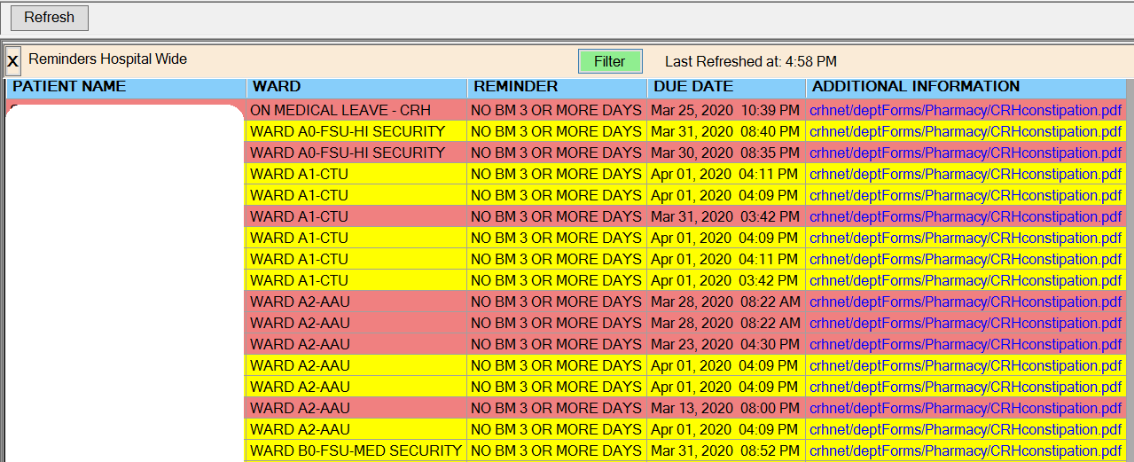

### Example 3 - High Risk for Flu Complications – Making an entry forever white

The CDC has criteria for identifying patients at high risk for flu complications. These patients should be given antiviral prophylaxis under certain conditions. These conditions can occur in our healthcare setting. The criteria can be found on the CDC Website.

We wanted a tool to find all the patients by unit so they can be given Tamiflu if the conditions are met for to start prophylaxis therapy:

**NAME: DASHBOARD-R HIGH RISK FLU**

**PRINT NAME: HIGH RISK FOR FLU COMPLICATIONS**

CLASS: LOCAL//

USAGE: *//

Baseline Frequency

**DO IN ADVANCE TIME FRAME: 4D// This is another color trick. This time to keep the entry white.**

Baseline frequency age range set

**REMINDER FREQUENCY: 1D// Color trick**

MINIMUM AGE:

MAXIMUM AGE:

Choose from:

CF VA-AGE Finding # 1 **Patient older than 64**

CF VA-AGE Finding # 2 **Patients younger than 6**

CF VA-AGE Finding # 7 **Part of the color trick**

CF VA-BMI Finding # 3 **Patient with BMI > 39.9**

CF VA-RACE 2003 Finding # 4 **Native American**

LT ABSOLUTE NE# -CLOZARIL Finding # 6 **Absolute Neutrophil Count < 1.5 (most recent)**

TX CRH HIGH RISK FOR FLU Finding # 5 **Bazillion Diagnoses (copied from VA)**

Select FINDING: `5 CRH HIGH RISK FOR FLU

Editing Finding Number: 5

FINDING ITEM: CRH HIGH RISK FOR FLU//

USE IN RESOLUTION LOGIC:

**USE IN PATIENT COHORT LOGIC: OR//**

BEGINNING DATE/TIME:

ENDING DATE/TIME:

Editing Finding Number: 1

FINDING ITEM: VA-AGE//

**USE IN PATIENT COHORT LOGIC: OR//**

BEGINNING DATE/TIME:

ENDING DATE/TIME:

OCCURRENCE COUNT:

**CONDITION: I V>64//**

CONDITION CASE SENSITIVE:

USE STATUS/COND IN SEARCH:

COMPUTED FINDING PARAMETER:

Editing Finding Number: 2

FINDING ITEM: VA-AGE//

USE IN RESOLUTION LOGIC:

**USE IN PATIENT COHORT LOGIC: OR//**

BEGINNING DATE/TIME:

ENDING DATE/TIME:

OCCURRENCE COUNT:

**CONDITION: I V<6//**

CONDITION CASE SENSITIVE:

USE STATUS/COND IN SEARCH:

**FINDING ITEM 7: VA-AGE// Not in Cohort like other VA-AGE findings and no Condition set.**

USE IN RESOLUTION LOGIC:

USE IN PATIENT COHORT LOGIC:

BEGINNING DATE/TIME:

ENDING DATE/TIME:

**FINDING ITEM: VA-BMI//**

USE IN RESOLUTION LOGIC:

**USE IN PATIENT COHORT LOGIC: OR//**

BEGINNING DATE/TIME:

ENDING DATE/TIME:

OCCURRENCE COUNT:

**CONDITION: I V>39.9//**

CONDITION CASE SENSITIVE:

USE STATUS/COND IN SEARCH:

**FINDING ITEM: VA-RACE 2003//**

USE IN RESOLUTION LOGIC:

**USE IN PATIENT COHORT LOGIC: OR//**

BEGINNING DATE/TIME:

ENDING DATE/TIME:

**CONDITION: I V["AMERICAN INDIAN"**

CONDITION CASE SENSITIVE:

USE STATUS/COND IN SEARCH:

COMPUTED FINDING PARAMETER:

FINDING: `6 ABSOLUTE NE# -CLOZARIL

**FINDING ITEM: ABSOLUTE NE# -CLOZARIL//**

REMINDER FREQUENCY:

MINIMUM AGE:

MAXIMUM AGE:

RANK FREQUENCY:

USE IN RESOLUTION LOGIC:

USE IN PATIENT COHORT LOGIC:

BEGINNING DATE/TIME: PXRMLAD-1D//

ENDING DATE/TIME:

OCCURRENCE COUNT:

**CONDITION: I V<1.5//**

CONDITION CASE SENSITIVE:

USE STATUS/COND IN SEARCH:

Patient Cohort and Resolution Logic

CUSTOMIZED PATIENT COHORT LOGIC (OPTIONAL): (AGE)&(SEX)&(FI(1)!FI(2)!FI(3)!FI(4)

!FI(5)!FI(6)) **Just a bunch of “OR” Statements**

Web Addresses for Reminder Information

**Select URL: www.cdc.gov/flu/highrisk/index.htm//**

URL: www.cdc.gov/flu/highrisk/index.htm

WEB SITE TITLE: CDC Flu High Risk Criteria

Warning, there is no Resolution logic.

No fatal errors were found.

Custom Date Due

CUSTOM DATE DUE: MAX_DATE(7+3D)// **This forever sets the Due Date to 3 days from “NOW”, which is in the white zone:**

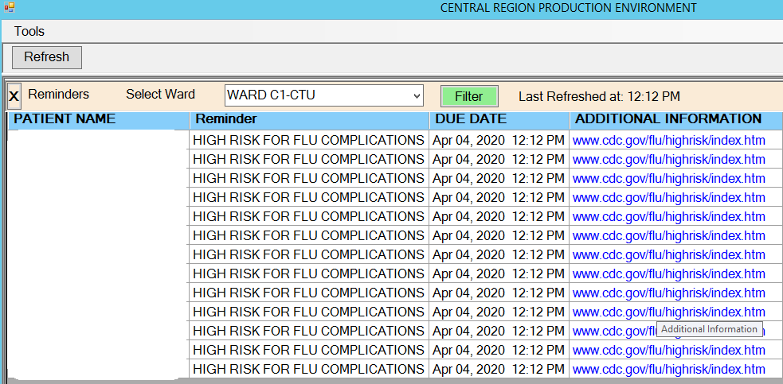

## Conclusion

An experienced CAC can quickly make dashboard reminders in minutes to hours that can be used by patient care staff, management and crucial departments. Access to the VistA server side is not required for the end-user to view them. In an emergency, these dashboard reminders can be made to provide a rapid response to changing clinical needs