

DASHBOARD FOR VISTA

Coronavirus Tools Tutorial



March 19, 2020

Central regional hospital

Butner, North Carolina

# Coronavirus Tools for the Dashboard

The following is a brief document on making dashboard tools for tracking and managing hospital patients during the Coronavirus Pandemic. This is not an exhaustive treatise on Coronavirus Management or an endorsement of any method. Rather these are representative examples on how easy and quick it is to build the tools you need. This is important because as information and treatment becomes available, you can make the appropriate tool in minutes to hours.

# Dashboard Introduction

# The dashboard is an open source tool built by Central Regional Hospital designed to be used by hospitals using VistA as an electronic health record. It will be released under the Apache 2 open source license. It has modules that can selected by the enduser. One of those modules is called “Hospital Wide” reminders. We will be using this module to build our tools.

# Building an Elevated Temperature Screen

All reminders made for this module are named starting with “DASHBOARD-C” (only the cohort logic is run) or “DASHBOARD-R” (both cohort and resolution logic are run). The elevated temperature screen is a –R type only to allow the date and time of the elevated temperature to be reflected on the dashboard,

NAME: **DASHBOARD-R T>99.5 48H**

PRINT NAME: **POSSIBLE FEVER 48H (>99.5)** **This is what appears on the dashboard**

CLASS: LOCAL//

SPONSOR:

REVIEW DATE:

**USAGE: *//**

Baseline frequency age range set

Select REMINDER FREQUENCY: 99Y//

**REMINDER FREQUENCY: 99Y**//

MINIMUM AGE:

MAXIMUM AGE:

VM TEMPERATURE Finding # 1

Select FINDING: `1 TEMPERATURE

FINDING ITEM: TEMPERATURE//

USE IN RESOLUTION LOGIC:

**USE IN PATIENT COHORT LOGIC: AND**//

**BEGINNING DATE/TIME: N-48H**//

ENDING DATE/TIME:

OCCURRENCE COUNT:

**CONDITION: I V>99.5**//

CONDITION CASE SENSITIVE:

**USE STATUS/COND IN SEARCH: YES**//

Select FINDING:

Function Findings

Select FUNCTION FINDING:

Patient Cohort and Resolution Logic

CUSTOMIZED PATIENT COHORT LOGIC (OPTIONAL):

Warning, there is no Resolution logic. **Even though this is a –R, put no resolution logic. It just allows the date of the finding to appear in the “Date Due” column on the dashboard.**

No fatal errors were found.

**Custom Date Due**

CUSTOM DATE DUE: **MAX_DATE(1+0H)//**

**This screen takes less than 5 minutes to make. Here is the screenshot:**

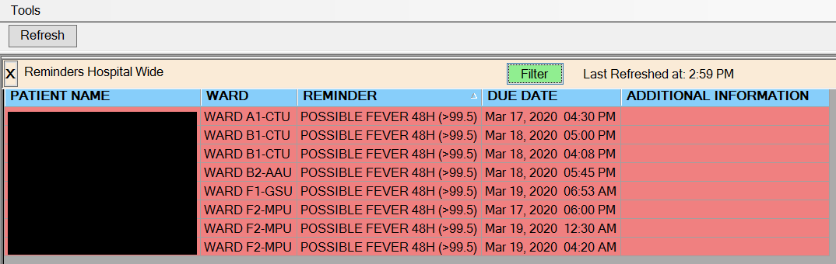

# Tracking the Isolated Patients

Central Regional Hospital has 6 different isolation order types. A special one for Coronavirus is called “Special Airborne and Contact Precautions”

**NAME: DASHBOARD-R SPECIAL AIRBORNE AND CONTACT PRECAUTIONS**

**PRINT NAME: SPECIAL AIRBORNE AND CONTACT**

CLASS: LOCAL//

**USAGE: *//**

Baseline Frequency

DO IN ADVANCE TIME FRAME:

SEX SPECIFIC:

**REMINDER FREQUENCY: 99Y//**

**OI SPECIAL AIRBORNE AND CONTACT PRECAUTIONS** Finding # 1

USE IN RESOLUTION LOGIC:

**USE IN PATIENT COHORT LOGIC: AND//**

**BEGINNING DATE/TIME: PXRMLAD-1**//

ENDING DATE/TIME:

OCCURRENCE COUNT:

**USE START DATE: YES**// **For the dashboard due date column**

USE STATUS/COND IN SEARCH:

Patient Cohort and Resolution Logic

CUSTOMIZED PATIENT COHORT LOGIC (OPTIONAL):

**Warning, there is no Resolution logic**.

No fatal errors were found.

Custom Date Due

**CUSTOM DATE DUE: MAX_DATE(1+0H)**

The time needed to make this dashboard tool is minutes. Here is the screenshot:

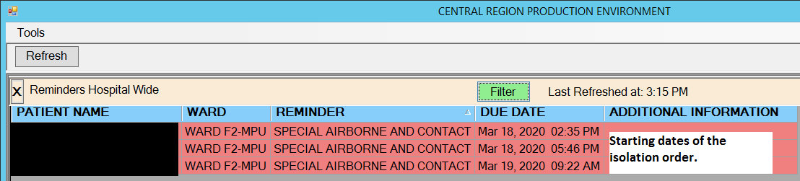

# Coronavirus Result Positive

Central Regional has tools to track positive, negative and indeterminate coronavirus results. Some coronavirus tests ordered may go to the commercial labs while others are sent to the State lab. We are not interfaced directly with the State, but the test in ordered in VistA and then manually entered by our laboratory personnel.

**NAME: DASHBOARD-R POSTIVE CORONAVIRUS**

**PRINT NAME: CORONAVIRUS 9 MONTH POSITIVE (Name that appears on Dashboard)**

**CLASS: LOCAL//**

**SPONSOR:**

**REVIEW DATE:**

**USAGE: *//**

**Baseline Frequency**

**DO IN ADVANCE TIME FRAME:**

**Select REMINDER FREQUENCY: 99Y//**

**REMINDER FREQUENCY: 99Y//**

**LT COVID-19, NCSLPH Finding # 2**

**LT SARS-COV-2, NAA (139900) Finding # 1**

**Finding Number: 1**

**FINDING ITEM: SARS-COV-2, NAA (139900)//**

**USE IN RESOLUTION LOGIC:**

**USE IN PATIENT COHORT LOGIC: //**

**BEGINNING DATE/TIME: T-9M//**

**ENDING DATE/TIME:**

**OCCURRENCE COUNT:**

**CONDITION: I V="DETECTED"//**

**CONDITION CASE SENSITIVE:**

**USE STATUS/COND IN SEARCH:**

**Finding Number: 2**

**FINDING ITEM: COVID-19, NCSLPH//**

**USE IN RESOLUTION LOGIC:**

**USE IN PATIENT COHORT LOGIC:**

**BEGINNING DATE/TIME: T-9M//**

**ENDING DATE/TIME:**

**OCCURRENCE COUNT:**

**CONDITION: I V="DETECTED"//**

**CONDITION CASE SENSITIVE:**

**USE STATUS/COND IN SEARCH:**

**Patient Cohort and Resolution Logic**

**CUSTOMIZED PATIENT COHORT LOGIC (OPTIONAL): (AGE)&(SEX)&(FI(1)!FI(2))**

**Warning, there is no Resolution logic.**

**No fatal errors were found.**

**Custom Date Due**

**CUSTOM DATE DUE: MAX_DATE(1+0H,2+0H)// Allows display of the date of test.**

We have no positives yet. The screenshot below is from a testing VistA instance:

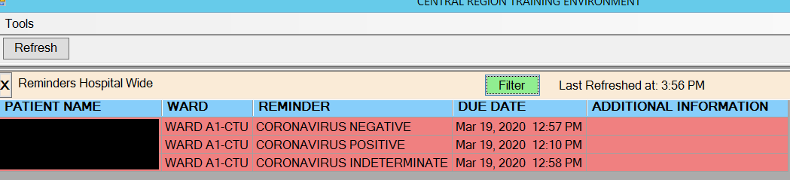

# Conclusion

The dashboard can be used to track and manage Coronavirus patients. The tools can be developed in a matter of minutes to hours by an experienced Clinical Applications Coordinator. The ability to respond quickly to changing requirements is an important characteristic and is an advantage of using VistA.