Sean Webster

Operating Systems
Homework 2
Due 10/13/2016
Objective: The objective of this assignment was to learn thread intercommunication by created 'buyer' and 'provider' threads that exchange a number between each other.

Background: Multithreading is one of the most important concepts in operating systems. By allowing programs to be broken into multiple threads, different functions can be processed nearly simultaneously, allowing for better utilization of current architectures.

Functions Used: Functions used were: pthread_create() which creates linux threads, pthread_join(), which waits for a thread to finish, then terminates it, sem_init() which initiates a semaphore, pthread_mutex_init() which initiates a mutex, sem_destroy() which destroys a semaphore, pthread_mutex_destroy() which destroys a mutex, pthread_mutex_lock() which locks a mutex, em_post() which increases a semaphore, pthread_mutex_unlock() which unlocks a mutex, sem_wait() which decrements a semaphore, and the functions in the Queue class included in the C++ library.

Results:
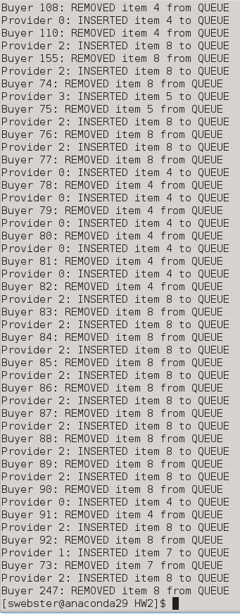
Figure 1: Part 1 Output
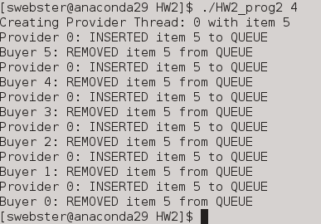Figure 2: Part 2 Output

Conclusions and Observations: Thread intercommunication seems like a very useful tool. By allowing different parts of the program to work simultaneously, streamlining programs would be easy. However, in my code, I found that at the end of the program, sometimes a provider puts in another item, but is terminated because there are no buyers left to buy the item. I also found the wording in the instruction sheet very confusing, and spent a bit of time trying to understand what it was asking. Thread functions are easy to understand after looking up their documentation, as well.

The change from part 1 to 2 to make the program more efficient was to remove semaphores. Semaphores are only needed when multiple threads are accessing multiple locations, which wasn't the case with part 2.

Readme:

Sean Webster

Homework 1 readme

Source Code Files:
HW2_prog1.cpp
HW2_prog2.cpp

Executables:
HW2_prog1
HW2_prog2

Instructions for running:
Run programs with intended number of buyer threads in arg section

Inputs:
./HW2_prog1 258
./HW2_prog2 4

Part 1:
- /*****************************************************
- * Sean Webster
- * Operating Systems
- * Homework 2
- * Due 10/13
- *
- *
- * ***************************************************
- * HW2_prog1.cpp
- * Creates N buyer threads and 4 provider threads, where
- * buyer threads 'take' the number out of a queue that
- * is filled by provider threads
- *
- * Code from the examples given in class was used as a
- * template for this assignment
- * ***************************************************/

- #include<stdio.h>
- #include<stdlib.h>
- #include<unistd.h>
- #include<pthread.h>
- #include<semaphore.h>
- #include<signal.h>
- #include<time.h>
- #include<queue>
- #include <stdlib.h>

- int BUYER_NUM;
- #define PROVIDER_NUM 4

- int index_counter = 0;

- // global variable, all threads can acess

- void *thread_Insert(void *arg); // function for sending
- void *thread_Remove(void *arg); // function for receiving

- sem_t bin_sem; // semaphore
- pthread_mutex_t mutx; // mutex

- std::queue<int> theQueue; // Queue
- //int theItem = 0;

- int counter = 0;

- int main(int argc, char **argv)
- {
- //for(int m = 0; m < argc; m++)
- // {
- /* initialize random seed: */
- srand (time(NULL));

- BUYER_NUM = strtol(argv[1], NULL, 10) + 2;
- const int BUY_NUM = BUYER_NUM;
- pthread_t pID[PROVIDER_NUM];
- pthread_t bID[BUY_NUM];
- void *thread_result;
- int state1, state2;
- state1 = pthread_mutex_init(&mutx, NULL);
- state2 = sem_init(&bin_sem, 0 ,0);
- //mutex initialization
- //semaphore initialization, first value = 0

- if(state1||state2!=0)
- puts("Error mutex & semaphore initialization!!!");

- // Create provider threads
- for(long int j = 0; j < PROVIDER_NUM; j++)
- {
- pthread_create(&pID[j], NULL, thread_Insert, (void*)j);

- }
- sleep(1);

- // Create buyer threads
- for(long int i = 0; i < BUYER_NUM; i++)
- {
- pthread_create(&bID[i], NULL, thread_Remove, (void*)i);
- }

- // Waiting buyer threads to terminate
- for(int k = 0; k < BUYER_NUM; k++)
- {
- //printf("Buyers executed: %d\n", k + 1);
- pthread_join(bID[k], &thread_result);
- }
- // Waiting buyer threads to terminate
- for(int l = 0; l < PROVIDER_NUM; l++)
- {
- //printf("PROVIDER executed: %d\n", l + 1);
- pthread_join(pID[l], &thread_result);
- }

- sem_destroy(&bin_sem); // destroy semaphore
- pthread_mutex_destroy(&mutx); // destroy mutex
- //printf("Final Index: %d\n", index_counter);

- // }
- return 0;
- }

- // Provider inserts item into queue
- void *thread_Insert(void *arg)
- {
- int theGoods = rand() % 10 + 1;
- printf("Creating Provider Thread: %d with item %d\n", (int*)arg, theGoods);

- //for(i = 0;i < PROVIDER_NUM; i++)
- for(;counter < BUYER_NUM -1;)
- {
- pthread_mutex_lock(&mutx);

- if(theQueue.empty() && !index_counter)
- //if(!theItem)
- {
- sleep(.5);
- index_counter++;
- //printf("index added - index: %d - counter: %d\n", index_counter, counter);
- theQueue.push(theGoods);
- //theItem = theGoods;
- printf("Provider %d: INSERTED item %d to QUEUE\n", (int*)arg, theGoods);
- sem_post(&bin_sem); // semaphore to increase
- }
- else
- {
- sleep(.5);
- }
- pthread_mutex_unlock(&mutx);
- }
- }

- // Thread decreases items
- void *thread_Remove(void *arg)
- {
- bool isDone = 0;

- //printf("Creating Buyer Thread: %d\n", (int*)arg);

- for(;isDone < 1;)
- {
- if(theQueue.empty())
- sleep(.5);
- else
- {
- sem_wait(&bin_sem); //decrease index_counter
- pthread_mutex_lock(&mutx);
- sleep(.5);
- counter++;
- printf("Buyer %d: REMOVED item %d from QUEUE\n", (int*)arg, theQueue.front());
- //printf("threads executed: %d \n", counter);
- theQueue.pop();
- //theItem = 0;
- //printf("index subbed - index: %d - counter: %d\n", index_counter, counter);
- index_counter--;

- pthread_mutex_unlock(&mutx);
- isDone = 1;
- }
- }
- }

Part 2:
- /*****************************************************
- * Sean Webster
- * Operating Systems
- * Homework 2
- * Due 10/13
- *
- *
- * ***************************************************
- * HW2_prog2.cpp
- * Creates N buyer threads and 4 provider threads, where
- * buyer threads 'take' the number out of a queue that
- * is filled by provider threads
- *
- * Code from the examples given in class was used as a
- * template for this assignmen
- * ***************************************************/

- #include<stdio.h>
- #include<stdlib.h>
- #include<unistd.h>
- #include<pthread.h>
- #include<semaphore.h>
- #include<signal.h>
- #include<time.h>
- #include<queue>
- #include <stdlib.h>

- int BUYER_NUM;
- #define PROVIDER_NUM 1

- int index_counter = 0;

- // global variable, all threads can acess

- void *thread_Insert(void *arg); // function for sending
- void *thread_Remove(void *arg); // function for receiving

- sem_t bin_sem; // semaphore
- pthread_mutex_t mutx; // mutex

- std::queue<int> theQueue; // Queue
- //int theItem = 0;

- int counter = 0;

- int main(int argc, char **argv)
- {
- //for(int m = 0; m < argc; m++)
- // {
- /* initialize random seed: */
- srand (time(NULL));

- BUYER_NUM = strtol(argv[1], NULL, 10) + 2;
- const int BUY_NUM = BUYER_NUM;
- pthread_t pID[PROVIDER_NUM];
- pthread_t bID[BUY_NUM];
- void *thread_result;
- int state1, state2;
- state1 = pthread_mutex_init(&mutx, NULL);
- //state2 = sem_init(&bin_sem, 0 ,0);
- //mutex initialization
- //semaphore initialization, first value = 0

- if(state1=0)
- puts("Error mutex & semaphore initialization!!!");

- // Create provider threads
- for(long int j = 0; j < PROVIDER_NUM; j++)
- {
- pthread_create(&pID[j], NULL, thread_Insert, (void*)j);

- }
- sleep(1);

- // Create buyer threads
- for(long int i = 0; i < BUYER_NUM; i++)
- {
- pthread_create(&bID[i], NULL, thread_Remove, (void*)i);
- }

- // Waiting buyer threads to terminate
- for(int k = 0; k < BUYER_NUM; k++)
- {
- //printf("Buyers executed: %d\n", k + 1);
- pthread_join(bID[k], &thread_result);
- }
- // Waiting buyer threads to terminate
- for(int l = 0; l < PROVIDER_NUM; l++)
- {
- //printf("PROVIDER executed: %d\n", l + 1);
- pthread_join(pID[l], &thread_result);
- }

- //sem_destroy(&bin_sem); // destroy semaphore
- pthread_mutex_destroy(&mutx); // destroy mutex
- //printf("Final Index: %d\n", index_counter);

- // }
- return 0;
- }

- // Provider inserts item into queue
- void *thread_Insert(void *arg)
- {
- int theGoods = rand() % 10 + 1;
- printf("Creating Provider Thread: %d with item %d\n", (int*)arg, theGoods);

- //for(i = 0;i < PROVIDER_NUM; i++)
- for(;counter < BUYER_NUM -1;)
- {
- pthread_mutex_lock(&mutx);

- if(theQueue.empty() && !index_counter)
- //if(!theItem)
- {
- sleep(.5);
- index_counter++;
- //printf("index added - index: %d - counter: %d\n", index_counter, counter);
- theQueue.push(theGoods);
- //theItem = theGoods;
- printf("Provider %d: INSERTED item %d to QUEUE\n", (int*)arg, theGoods);
- //sem_post(&bin_sem); // semaphore to increase
- }
- else
- {
- sleep(.5);
- }
- pthread_mutex_unlock(&mutx);
- }
- }

- // Thread decreases items
- void *thread_Remove(void *arg)
- {
- bool isDone = 0;

- //printf("Creating Buyer Thread: %d\n", (int*)arg);

- for(;isDone < 1;)
- {
- if(theQueue.empty())
- sleep(.5);
- else
- {
- //sem_wait(&bin_sem); //decrease index_counter
- pthread_mutex_lock(&mutx);
- sleep(.5);
- counter++;
- printf("Buyer %d: REMOVED item %d from QUEUE\n", (int*)arg, theQueue.front());
- //printf("threads executed: %d \n", counter);
- theQueue.pop();
- //theItem = 0;
- //printf("index subbed - index: %d - counter: %d\n", index_counter, counter);
- index_counter--;

- pthread_mutex_unlock(&mutx);
- isDone = 1;
- }
- }
- }

