

INSTALLATION MANUAL

### **Table of Contents**

### **Applicable Version**………………..…....……………………………….……………………….1

### **Installation**....………………………….……….……………………………………………………1

### **Configuring Ingenico**………………..……………………………………………………………3

### **Applicable versions**

|  |  |
| --- | --- |
| **Applications** | **Versions** |
| PHP | 7.1.x to 7.4.x |
| Prestashop | 1.7.x |

### **Installation & Upgrade**

Please follow the given steps to install and run the Ingenico Payment Gateway module

1. Login to site admin in prestashop site

2. After successful login, we will find a menu bar at the left side of the corner. Go to Modules menu select ‘Module Manager ’ option.

3. Click the ‘Upload A Module’ button.

4. Browse the provided zip folder and click on the ‘Install Now’ button.

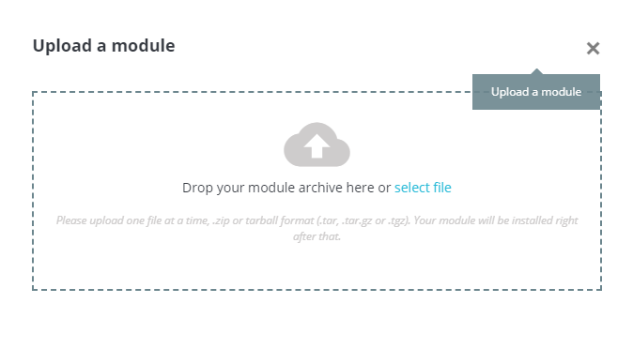

5. After successful install click on ‘Configure’ button to configure the Payment Gateway.

**Update Module**

1. Go to the Modules/Module Manager’ in the left admin Menu, scroll down to payment section and select the Ingenico Module and and press ‘Uninstall’ button

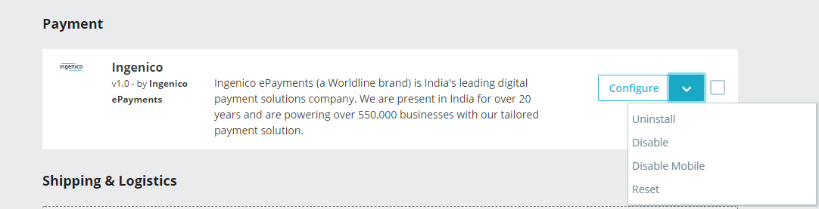

1. After Uninstalling, Upload a new module and Install the module.

### **Configuring Ingenico**

1. Go-to Module/Module Manager and in the left admin menu and press the ‘Configure’ button of Ingenico Paymemt Gatewway.
2. Scroll down. You will get following fields:
3. Configure it as below:

|  |  |
| --- | --- |
| **Column Name** | **Description** |
| Enabled | Click on the checkbox in order to Enable Ingenico |
| Merchant Code | Enter Merchant Code |
| Salt | Enter Salt. |
| Payment Type | For Test mode Select ‘Test’ and for Live mode select ‘Live’ |
| Merchant Scheme Code | Enter Scheme Code |

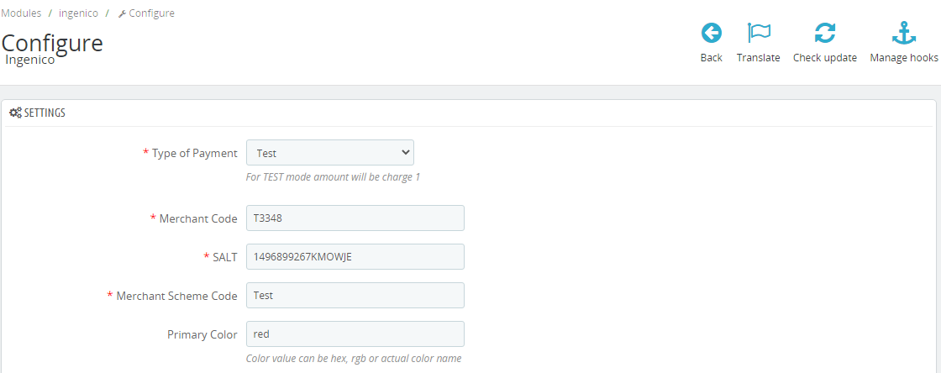

1. Now click on “Save” on the bottom-right corner.
2. Ingenico Payment Gateway is now configured & ready to use.

**Advanced Configuration**

There are also some advanced configuration options you may consider as shown below:

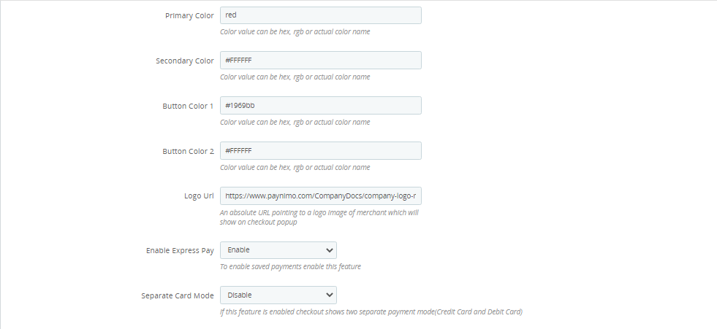

### **Features List**

### **Dual verification of response:**

We are validating responses with a hash value and call again Payment Gateway for dual verification from the payment gateway before updating to the order status.

### **Reconciliation**

Merchants can update the pending status of the order automatically if the payments are successful. This page can be found under Left Admin menu > Orders > Reconciliation

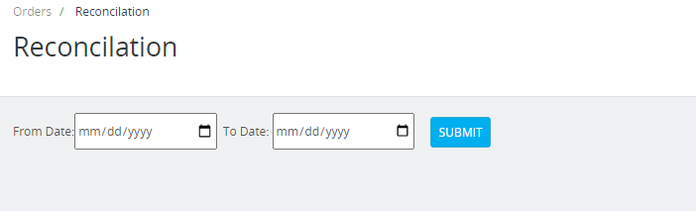

### **Logs request and response**

Daily new file creates for the logs request and response from the server for future reference.

### **S2S Verification**

If we do not receive any response from the payment gateway then after 30 mins, we will get a response from the server and based on the response it will update order status.

To configure S2S URL, contact prod team.

S2S url format : hostname/module/ingenico/s2sverification

S2S url example : [http://example.com/module/ingenico/s2sverification](http://example.com/wp-json/ingenico/s2sverification)

### **MCG**

It supports the multi currency like USD, GBP, SGD and a lot more.

### **Ingenico Offline Verification**

Merchants can verify the status of their payment by using the Payment Verification page. The payment verification page can be found under Left Admin menu > Orders > Ingenico Offline Verification

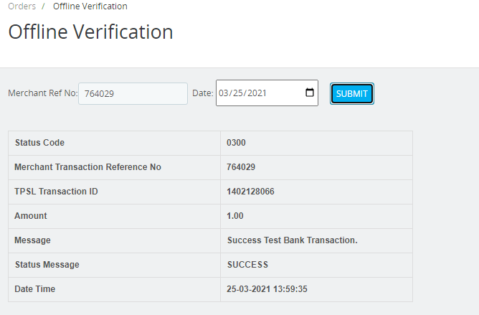

### **Refund**

Merchants should be able to process the refund online for the order whose payment has been done via Ingenico.

To refund an order select the particular order you want to refund and click on Partial Refund > Refund via Ingenico.

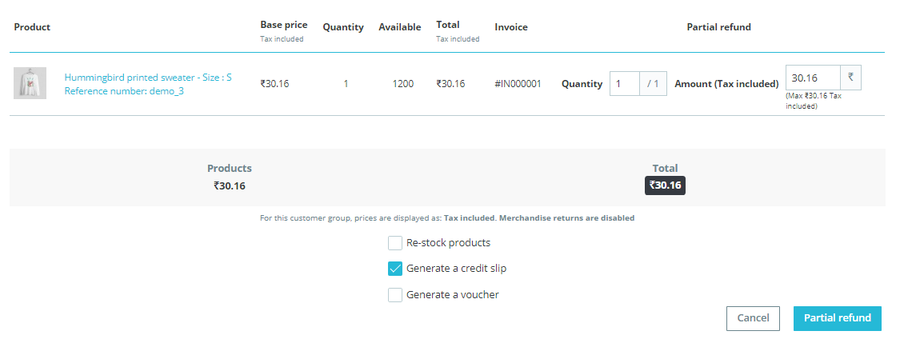

### **Embed Payment Gateway**

After enabling this setting, payment gateway displays like embedded on the page instead of pop-up so user experience would be good.

## **Documentation link**

[**https://www.tecprocesssolution.com/proto/p2m/client/salt-based-documentation.htm#online**](https://www.tecprocesssolution.com/proto/p2m/client/salt-based-documentation.htm#online)