

**INSTALLATION MANUAL FOR DRUPAL**

### **Applicable Version**

### **Installation**

### **Configuring worldline**

### **Applicable versions**

|  |  |
| --- | --- |
| **Applications** | **Versions** |
| PHP | 7.x to 7.4.x |
| Drupal | 8x |
| Ubercart | 8x |

### **Installation**

Please follow the given steps to install and run the worldline Payment Gateway module

1. Login to site admin in drupal site

* + 1. After successful login, we will find a menu bar at the top of the menu. Go to Extend menu and click on **intall new module** button.
    2. Click the ‘Upload file’ select uc_worldline.zip file button and then click on inatall.

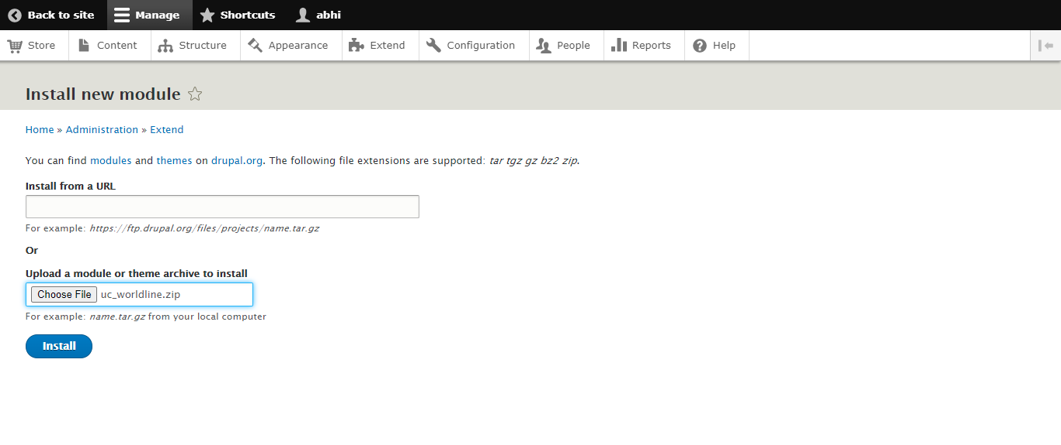

After Intallation goto extend menu and find worldline option in ubercart payment

Method and select worldline and click intall

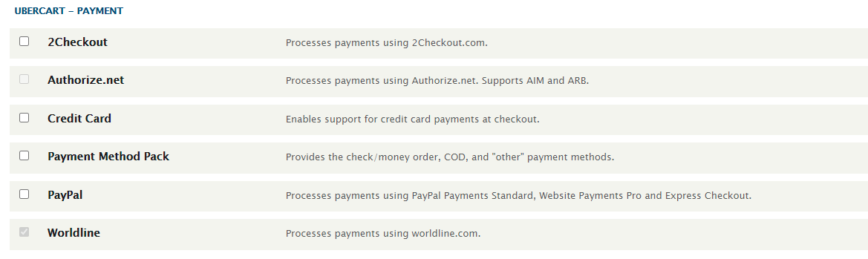

after the intallation now go to shop menu and click on payment methods of ubercart

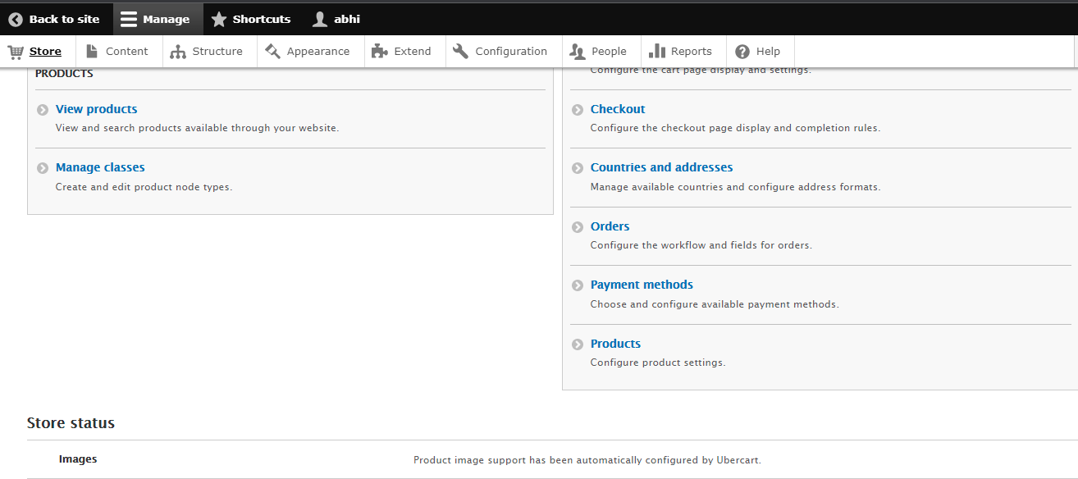

In the payment methods click on the add payment method and click on pay

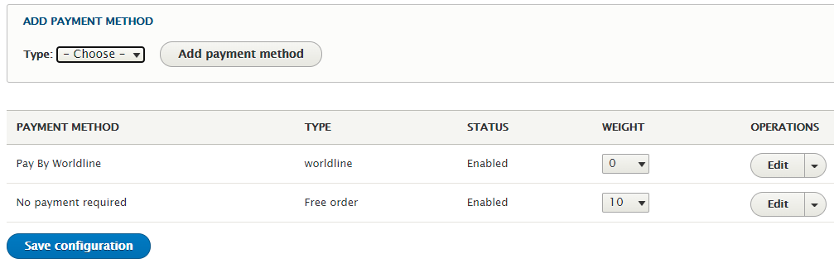

### **Configuring worldline**

1. Go-to edit page.
2. Scroll down. You will get following fields:
3. Configure it as below:

|  |  |
| --- | --- |
| **Column Name** | **Description** |
| Merchant Code | Enter Merchant Code |
| Salt | Enter Salt. |
| Payment Type | For Test mode Select ‘Test’ and for Live mode select ‘Live’ |
| Merchant Scheme Code | Enter Scheme Code |

click on edit button to add merchant credentials in settings page.

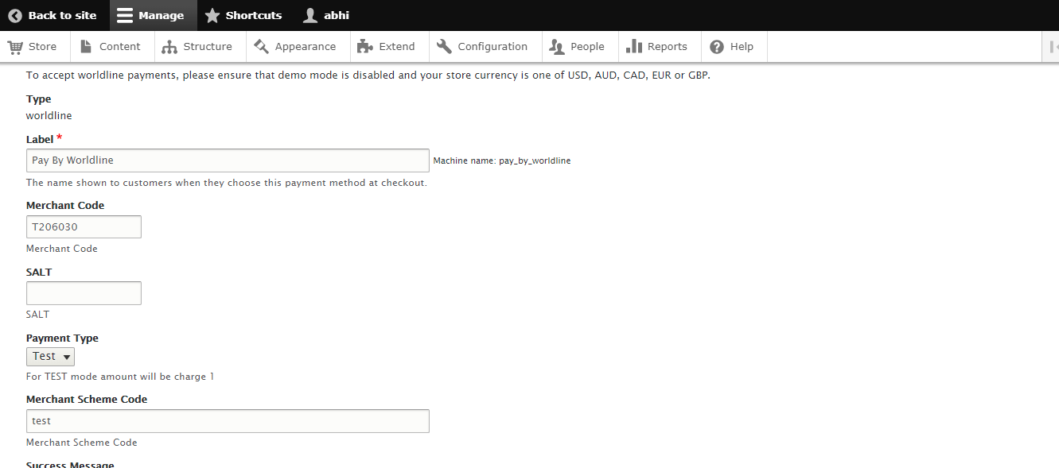

## **Features List**

### **Dual verification of response:**

We are validating responses with a hash value and call again Payment Gateway for dual verification from the payment gateway before updating to the order status.

### **Reconciliation**

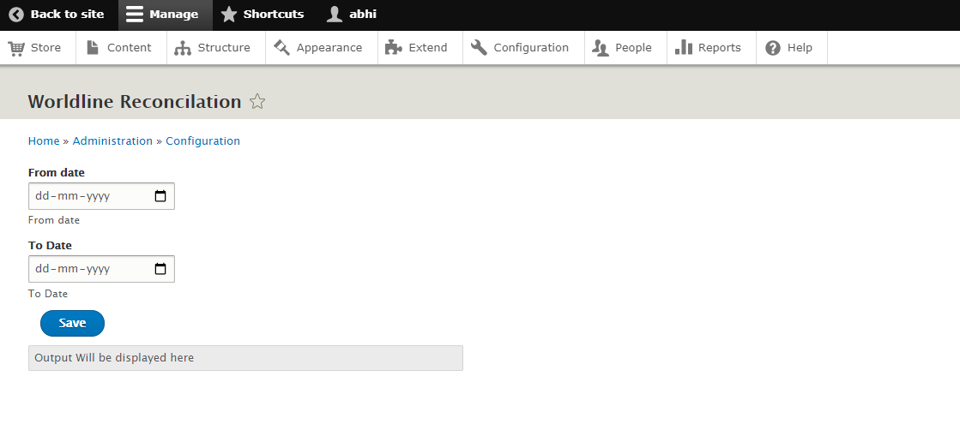 Merchants can update the pending status of the order automatically if the payments are successful. This page can be found under configuration > Reconciliation

### **Logs request and response**

Daily new file creates for the logs request and response from the server for future reference.

### **S2S Verification**

If we do not receive any response from the payment gateway then after 30 mins, we will get a response from the server and based on the response it will update order status.

To configure S2S URL, contact prod team.

S2S url format : hostname/uc_worldline/s2s_request/

S2S url example : [http://example.com/](http://example.com/wp-json/ingenico/s2sverification)uc_worldline/s2s_request/

### **MCG**

It supports the multi currency like USD, GBP, SGD and a lot more.

### **Worldline Offline Verification**

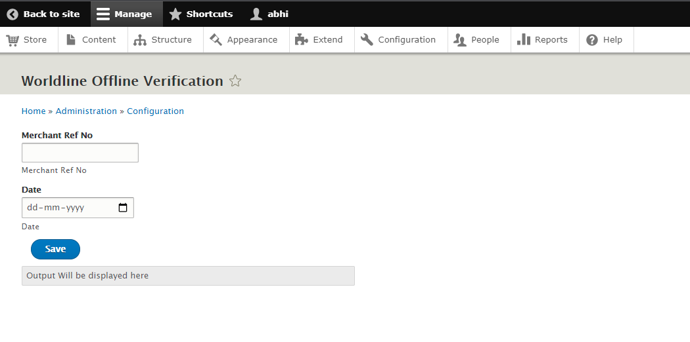 Merchants can verify the status of their payment by using the Payment Verification page. The payment verification page can be found under configuration > Worldline Offline Verification.

**Worldline Documentation**

https://www.paynimo.com/paynimocheckout/client/salt-based-documentation.htm#online