

**INSTALLATION MANUAL**

### **Table of Contents**

### **Applicable Version**………………..…....……………………………….……………………….1

### **Installation**....………………………….……….……………………………………………………1

### **Configuring worldline**………………..……………………………………………………………3

### **Applicable versions**

| **Applications** | **Versions** |
| --- | --- |
| PHP | 7.1.x to 8.1.x |
| Prestashop | 8.1.x |

### **Installation & Upgrade**

Please follow the given steps to install and run the worldline Payment Gateway module

1. Login to site admin in prestashop site

2. After successful login, we will find a menu bar at the left side of the corner. Go to the Modules menu select ‘Module Manager ’ option.

3. Click the ‘Upload A Module’ button.

4. Browse the provided zip folder and click on the ‘Install Now’ button.

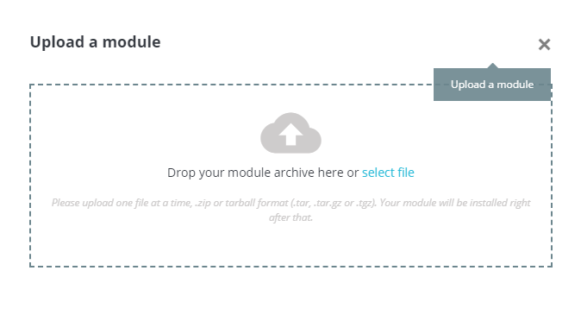

5. After successful install click on ‘Configure’ button to configure the Payment Gateway.

**Update Module**

1. Go to the Modules/Module Manager’ in the left admin Menu, scroll down to payment section and select the worldline Module and and press ‘Uninstall’ button

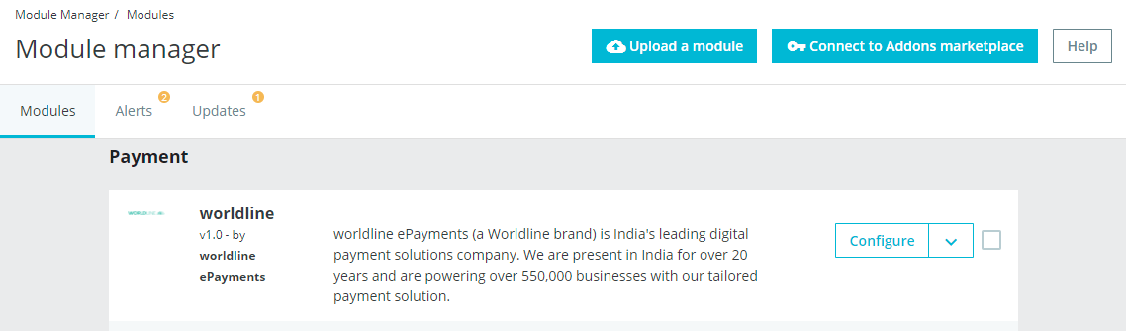

1. After Uninstalling, Upload a new module and Install the module.

### **Configuring worldline**

1. Go-to Module/Module Manager and in the left admin menu and press the ‘Configure’ button of worldline Payment Gateway.
2. Scroll down. You will get following fields:
3. Configure it as below:

| **Column Name** | **Description** |
| --- | --- |
| Enabled | Click on the checkbox in order to Enable worldline |
| Merchant Code | Enter Merchant Code |
| Salt | Enter Salt. |
| Payment Type | For Test mode Select ‘Test’ and for Live mode select ‘Live’ |
| Merchant Scheme Code | Enter Scheme Code |

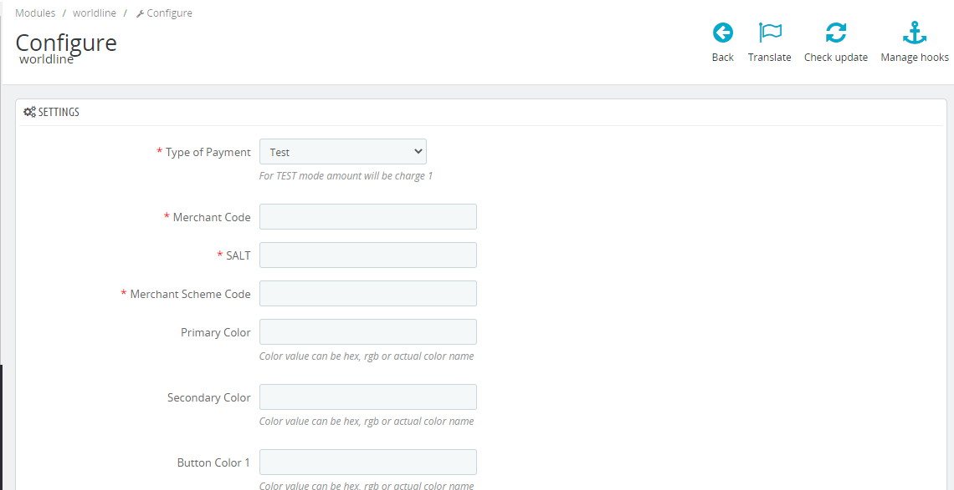

1. Now click on “Save” on the bottom-right corner.
2. Worldline Payment Gateway is now configured & ready to use.

**Advanced Configuration**

There are also some advanced configuration options you may consider as shown below:

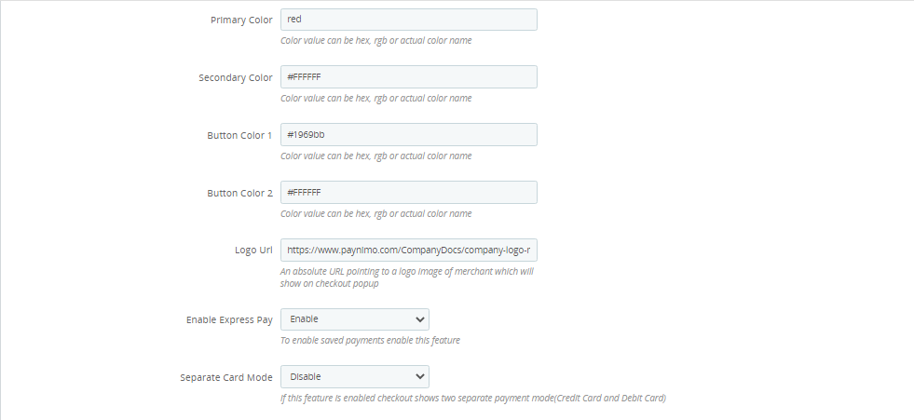

### **Features List**

### **Dual verification of response:**

We are validating responses with a hash value and call again Payment Gateway for dual verification from the payment gateway before updating to the order status.

### **Reconciliation**

Merchants can update the pending status of the order automatically if the payments are successful. This page can be found under Left Admin menu > Orders > Reconciliation

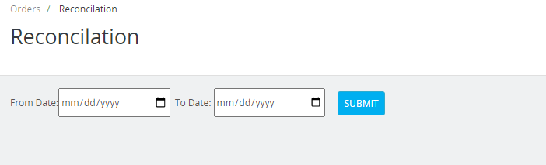

### **Logs request and response**

Daily new file creates for the logs request and response from the server for future reference.

### **S2S Verification**

If we do not receive any response from the payment gateway then after 30 mins, we will get a response from the server and based on the response it will update order status.

To configure the S2S URL, contact the prod team.

S2S url example :[http://example.com/](http://example.com/module/worldline/s2sverification)[index.php?fc=module&module=worldline&controller=s2sverification](http://13.200.116.12/index.php?fc=module&module=worldline&controller=s2sverification&msg=0300%7Csuccess%7CNA%7C435745%7C470%7C273165643%7C46.20%7C%7Bitc:%7D%7Bcustname:ashvini)

### **worldline Offline Verification**

Merchants can verify the status of their payment by using the Payment Verification page. The payment verification page can be found under Left Admin menu > Orders > worldline Offline Verification

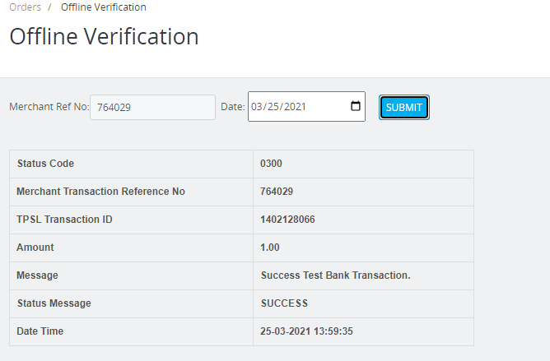

### **Refund**

Merchants should be able to process the refund online for the order whose payment has been done via worldline.

To refund an order select the particular order you want to refund and click on Partial Refund > Refund via worldline.

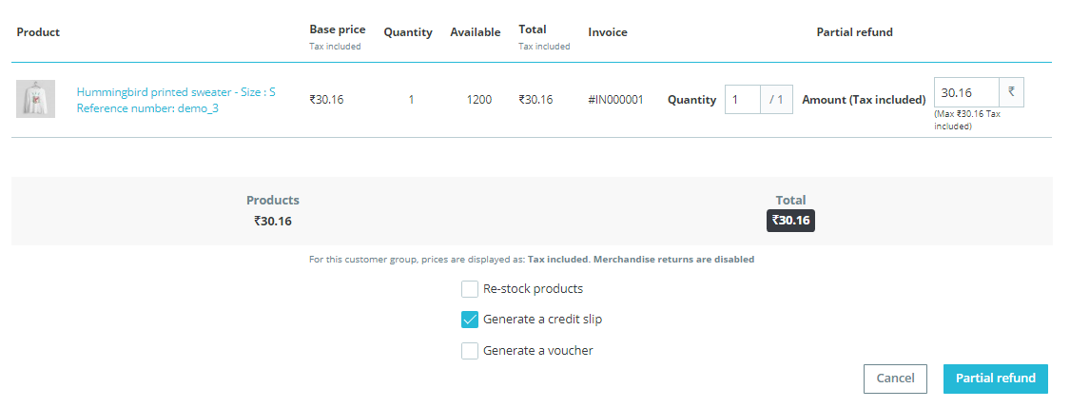

### **Embed Payment Gateway**

After enabling this setting, payment gateway displays are embedded on the page instead of pop-up so user experience would be good.