**Worldpay Integration**

Version 19.1.0





1. SUMMARY 3

1.1 TEST CASES 3

1.2 TEST DATA 3

1.3 Automation test suit for functional testing 3

APPENDIX A: APM/Card mapping keys 9

APPENDIX B: IDEAL Bank List 11

APPENDIX C: Error Codes and Error Messages for Transaction Notification 11

APPENDIX D: Order Notification and SFCC Order status mapping 12

APPENDIX E: Error Codes and Error Messages 13

# SUMMARY

This document provides Test cases for each Worldpay service integrated within SFCC platform with MobileFirst Reference Application version to ensure main functionality is operating correctly.It includes Automation Test Suite for Functional Testing, Integration Testing and Unit Testing to verify the implementation.



## 1.1 TEST CASES

This Cartridge has gone through QA and UAT including live proving across all the payment methods. Please refer to the test cases attached here.





## 1.2 TEST DATA

Refer to Appendix A for values of test card numbers.

## 1.3 Automation test suit for functional testing

**Pre Requiste**

1. Redirect credit card payment should be in page format so remove any config did for iframe or light box in payment method.
2. We chat redirect and direct payment can be test one at a time. So while testing redirect mode make the line change around 22(describe => describe.skip) in wechatDirectPaymentMethod.js and vice versa on the file wechatRedirectPaymentMethod.js while testing the we chat direct mode.
3. Order confirmation page customer zipcode, customer country and customer phone number comparison can be done with the data configured in test/functional/mocks/customers.js. So we recommend to create one new customer for automation testing which having the address zip code ‘14304’ and country code ‘US’ and phone number ‘3333333333’. Save Visa card ‘4917610000000000’ for that customer.
4. Do Site export, the required xml files are: customer-list, catalogs, pricebooks, promotions

In Business Manager, Administration => Site Development => Site Import and Export

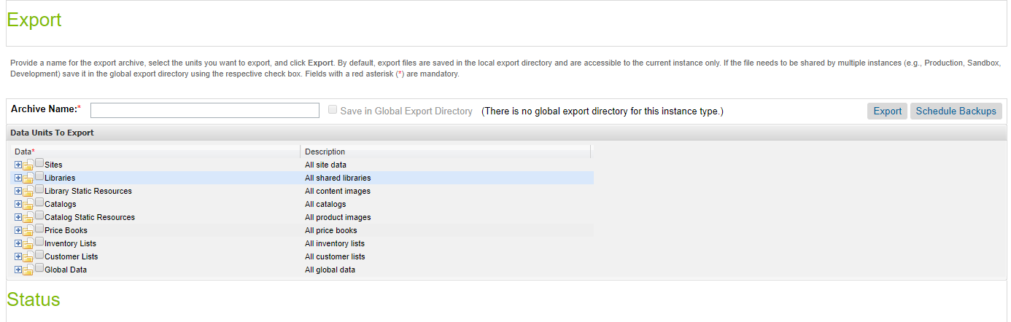

Select which one you want to take export of like Price Books, select all price books, give

Archive Name and click on export after the success status you can download that file/folder by clicking on download button.

1. Update the folder path and file name to be sync with the path given in the file

functional/mocks/testDataMgr/main.js.

1. For example

Customer xml path is mentioned in the file like this

files: [demoDataDir + '/customer-lists/customer.xml']

The same path should exist in the site export directory, if you site export direct contains the file path like this C:\projects\WPSFCC\work\code\sfcc_worldpay\customer-lists\{siteid}.xml means you need to rename the file name and make the structure C:\projects\WPSFCC\work\code\sfcc_worldpay\customer-lists\customer.xml like this.

So check the xml folder structure corresponding the path mentioned in the file.

Site export folder structure should like this

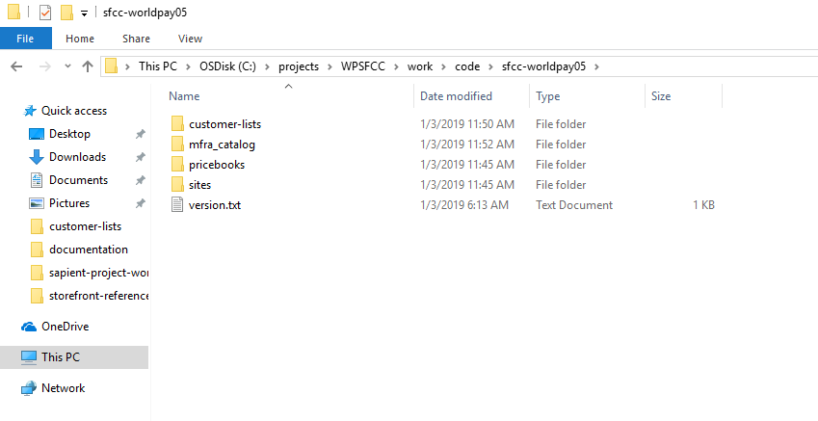

b. There are some issues in parsing customer-list, so in the customer lists customer xml file update the xml string ‘customer-list’ to ‘customers’. Or you can export all the customer directly from business manager and replace that xml in the ‘customer-lists’ folder.

1. In worldpay_main.js, functional/mocks/testDataMgr/worldpay_main, provide the required credentials which are existing in the site

a) loginUserEmail – existing user email(recommend user email in 3rd point)

b) loginPassword - existing user password

c) newUserPassword – new user registration password

d) storefrontPath – absolute folder path to the site export

e) resourcePath – absolute folder path to storefront reference architecture resource folder

f) 3 Variant Product ID like variantProduct1, variantProduct2, variantProduct3(example product ids which are having good inventory)

g) All credit card details scenario you want to check like creditCardAmex, creditCardDiscover, creditCardVisa, creditCardError, creditCardRefused, creditCard3D containing card name, card type, number, expiry date, cvv number.

Note:- Login user email should be available in the customer list xml file also.

1. If dw.json is not there in root folder, create one containing following :

{

"hostname": "worldpay03-tech-prtnr-eu04-dw.demandware.net",

"username": "USERNAME_OF_STOREFRONT",

"password": "PASSOWRD_OF_STOREFRONT",

"code-version": "CODE_VERSION"

}

**Steps to configure and run the automation testing**

1. Run command npm install in root folder
2. Download selenium-standalone globally and start selenium server using command:-

npm install selenium-standalone@latest -g

selenium-standalone install

selenium-standalone start

1. To run functional testing, run command “selenium-standalone start” in one terminal and the command to run test “npm run test:functional” in another terminal. Functional automation testing will be started running each file individually in the folder ‘test/functional/checkout’

The test scenarios are,

* For Guest User :-

Direct Credit Card Payment Method – directcreditcardPaymentMethod.js

Redirect Credit Card Payment Method – redirectcreditcardPaymentMethod.js

Wechat Direct Payment Method – wechatDirectPaymentMethod.js

Wechat Redirect Payment Method – wechatRedirectPaymentMethod.js

Paypal Payment Method – paypalPaymentMethod.js

Refused Credit Card Payment Method – refusedCreditCardPaymentMethod.js

* For Registered User :-

Login and using Saved cards (User account should have saved cards for this)

Register Customer and Direct Credit Card Payment Method

Sepa Payment Method – sepaPaymentMethod.js

Alipay Payment Method – alipayPaymentMethod.js

3D Payment Method – 3dPaymentMethod.js

Mister cash Payment Method –mistercashPaymentMethod.js

Error Credit Card Payment Method – errorCreditCardPaymentMethod.js

To run single scenario/single file only change the specs line(around 88) in the file ‘test/functional/webdriver/wdio.conf.js’. For ex. To test only the savecard functionality change the line

specs: [

specs

],

To

specs: [

'test/functional/checkout/registeredUser/loginSavedCard.js'

],

Note:- You should be able to see count of testcases passing, failing and skipped ones. And also required order number in the console.

**Integration Testing**

1. Open terminal and run command “npm run test:integration” to run the test/integration files one by one and you will be able to see the required response using different payment options and for failed scenario, only error message is printed.

Note:- The response we get is of “CheckoutServices-PlaceOrder”.

1. The test scenarios are as follows:-

* 3DCreditCardPaymentMethod
* alipayPaymentMethod
* errorCreditCardPaymentMethod
* loginDirectCreditCardPaymentMethod
* loginSavedCardPaymentMethod
* mistercashPaymentMethod
* paypalPaymentMethod
* redirectCreditCardPaymentMethod
* sepaPaymentMethod
* wechatPaymentMethod

For integration testing :-

<https://medium.com/adobetech/how-to-combine-rest-api-calls-with-javascript-promises-in-node-js-or-openwhisk-d96cbc10f299>

**Unit Testing**

Open terminal and run command “npm run test” to run the test/unit files

# APPENDIX A: APM/Card mapping keys

Supported Cards Mapping table:

|  |  |  |
| --- | --- | --- |
| **Card Name** | **Key Value** | **Test card number** |
| Airplus | AIRPLUS-SSL | 122000000000003 |
| American Express | AMEX-SSL | 34343434343434 |
| Dankort | [DANKORT-SSL](http://dtd.worldpay.com/v1/paymentService_v1.dtd.html#ElementDef161) | 5019717010103742 |
| Diners | DINERS-SSL | 36700102000000 |
| Discover card | DISCOVER-SSL | 6011000400000000 |
| JCB | JCB-SSL | 3528000700000000 |
| Laser | LASER-SSL | 630495060000000000 630490017740292441 |
| Maestro | MAESTRO-SSL | 6759649826438453, 6799990100000000019 |
| MasterCard | ECMC-SSL | 5555555555554444, 5454545454545454 |
| Visa | VISA-SSL | 4444333322221111,  4911830000000 |

Supported Payment Method Mapping table:

|  |  |
| --- | --- |
| **Payment Method Name** | **Key Value** |
| Konbini | KONBINI-SSL |
| Poli | POLI-SSL |
| Poli NZ | POLINZ-SSL |
| Przelewy24 | PRZELEWY-SSL |
| SEPA-DD | ELV-SSL |
| Alipay | ALIPAY-SSL |
| Boleto | BOLETO-SSL |
| CashU | CASHU-SSL |
| Credit Card – Direct | CREDIT_CARD |
| Credit Card – Redirect | Worldpay |
| China Union Pay | CHINAUNIONPAY-SSL |
| ENETS | ENETS-SSL |
| Giropay | GIROPAY-SSL |
| IDEAL | IDEAL-SSL |
| Mistercash | MISTERCASH-SSL |
| Paypal | PAYPAL-EXPRESS |
| Sofort | SOFORT-SSL |
| Qiwi | QIWI-SSL |
| Yandex | YANDEXMONEY-SSL |

# APPENDIX B: IDEAL Bank List

|  |  |
| --- | --- |
| **Bank Name** | **Bank Code** |
| ABN | ABN_AMRO |
| ASN | ASN |
| ING | ING |
| Knab | KNAB |
| Rabobank | RABOBANK |
| SNS | SNS |
| SNS Regio | SNS_REGIO |
| Triodos | TRIODOS |
| Van Lanschot | VAN_LANSCHOT |

# APPENDIX C: Error Codes and Error Messages for Transaction Notification

|  |  |
| --- | --- |
| **Master Error Code** | **Error Message** |
| 111 | XML Parse error has occurred |
| 112 | XML Corrupted, Could not find Order No. |
| 113 | XML in Custom Object Corrupted |
| 114 | Error occurred while deleting Custom Object |
| 115 | Error occurred while reading status history from Order Object |
| 116 | Error occurred while Updating Order Object |
| 117 | Error occurred while reading Custom Object |
| 118 | No Transaction History Available |
| 119 | Last status Not available as No Transaction History is Available |
| 120 | Wrong Order Number |

# APPENDIX D: Order Notification and SFCC Order status mapping

|  |  |
| --- | --- |
| **Order Notifications Received From Worldpay** | **Changes in Order object in Business Manager** |
| **AUTHORISED** | Order Status: NEW                  Payment Status: no change                  Export Status: READY FOR EXPORT                  Confirmation Status : CONFIRMED |
| **CANCELLED** | Order Status: FAILED/CANCELLED  Payment Status: NOT PAID                  Export Status: NOT EXPORTED  Confirmation Status : NOT CONFIRMED |
| **CAPTURED** | Order Status: COMPLETED                  Payment Status: PAID                  Export Status:  no change                  Confirmation Status :  no change |
| **SENT_FOR _REFUND** | Order Status:  no change                  Payment Status:  no change                  Export Status: no change                  Confirmation Status :  no change |
| **REFUSED** | Order Status: FAILED  Payment Status: NOT PAID                   Export Status: NOT EXPORTED  Confirmation Status : NOT CONFIRMED |
| **SETTLED** | Order Status: no change                  Payment Status: no change                  Export Status:  no change                  Confirmation Status :  no change |
| **INFORMATION_REQUESTED** | Order Status:  no change                  Payment Status:  no change                  Export Status: no change                  Confirmation Status : no change |
| **CHARGED_BACK** | Order Status:  no change                  Payment Status:  no change                  Export Status: no change                  Confirmation Status : no change |
| **EXPIRED** | Order Status:   FAILED                  Payment Status:   NOT PAID                  Export Status:   NOT EXPORTED           Confirmation Status :  NOT CONFIRMED |

# APPENDIX E: Error Codes and Error Messages

|  |  |
| --- | --- |
| **Master Error Code** | **Error Message** |
| worldpay.error.code1 | Internal error has occurred , please choose a different Payment Method or try again later. |
| worldpay.error.code2 | Parse error has occurred, please choose a different Payment Method or try again later. |
| worldpay.error.code3 | Invalid amount error, please choose a different Payment Method or try again later. |
| worldpay.error.code4 | Security error , please choose a different Payment Method or try again later. |
| worldpay.error.code5 | Invalid request, please choose a different Payment Method or try again later. |
| worldpay.error.code6 | Please choose a different Payment Method or try again later. |
| worldpay.error.code7 | Payment details in the order element are incorrect, please choose a different Payment Method or try again later. |
| worldpay.error.code8 | Submission error , please choose a different Payment Method or try again later. |
| worldpay.error.generalerror | Please choose a different Payment Method or try again later. |
| worldpay.error.cancelerror | Your transaction has been cancelled. |