**DigiTracker User’s Guide**

**(Rev. 2)**

**Quick Instructions (Memory Jogger):**

First, Capture Worm Data:

1. DigiTracker
2. DigiRecognizer

then, Process Worm Data (Matlab):

1. wormproc;
2. metrics6(mm-per-pixel, #seconds, 1, ‘directoryA’, ‘directoryB’, ‘directory…’);

finally, Display Worm Data (Matlab):

1. histograms4(‘directoryA’, ‘directoryB’, ‘directory…’);
2. stats(‘directoryA’, ‘directoryB’, ‘directory…’);

Table of Contents

Capture Worm Data 3

DigiTracker: 3

DigiRecognizer 5

Process Worm Data 8

Wormproc: 8

Calculating Metrics 10

Display Worm Data 12

Histograms: 12

Statistics: 12

Appendix 14

Accept/Reject Toggle 14

Explanation of Behavior Measures (Metrics) 15

Christopher J. Cronin

cjc@caltech.edu

Sternberg Laboratory

California Institute of Technology

Biology M/C 156-29

1200 E California Blvd

Pasadena CA 91125

Rev. 2

April 22, 2016

# Capture Worm Data

## DigiTracker:

DigiTracker is a PC-based program used to capture digital video of crawling nematodes for later quantification and analysis. While recording images from a microscope-mounted Firewire camera, the program watches for movement within the camera’s field of view. When movement of the crawling worm is noticed near the edge of the camera’s view field, the program automatically moves the motorized microscope stage to reposition the nematode near the middle of the view field, thus ‘tracking’ the worm as it moves on the Petri dish.

1. Power up the motion tracking rig:

* PC set up to run DigiTracker
* Microscope light source
* Motorized microscope stage

1. Start DigiTracker:

Double click the DigiTracker icon.

**First-time Set-up:**

The first time DigiTracker is started, a ‘Stage Style’ window will appear asking for the style of motorized stage to be used. Select the proper style and click ‘Okay.’

A second window appears reminding the user to calibrate the microscope stage to the microscope’s optics. Note the instructions (hold <Ctrl> while clicking on a feature in the DigiTracker display…). Perform the calibration when the DigiTracker display appears, after the user has adjusted the lighting and camera settings, and has selected the desired magnification.

The DigiTracker window (titled “Automated Worm Tracker”) will appear that looks like the one shown in Figure 1. If necessary, adjust the microscope’s light path and use DigiTracker’s “Camera and Stage Controls” window (use the “Settings Dialog” button to access) to get a reasonable image in the on-screen display. If changing magnification, be sure to set the “magnification” slider appropriately.

An ideal image should exhibit high contrast with a dark worm on a uniform pale background.

1. Place a Petri dish with one worm onto the motorized microscope stage. Using the stage controller’s joystick and/or the on-screen Up/Down/Left/Right buttons, move the microscope stage to bring the worm into view in the display. Click the “Enable Tracking” button while the worm is within the black outline in the DigiTracker display. As the worm crawls out of the outline, the computer should move the microscope stage to re-center the worm in the camera’s field of view. Be sure to focus the microscope so the image in the DigiTracker window is sharp.

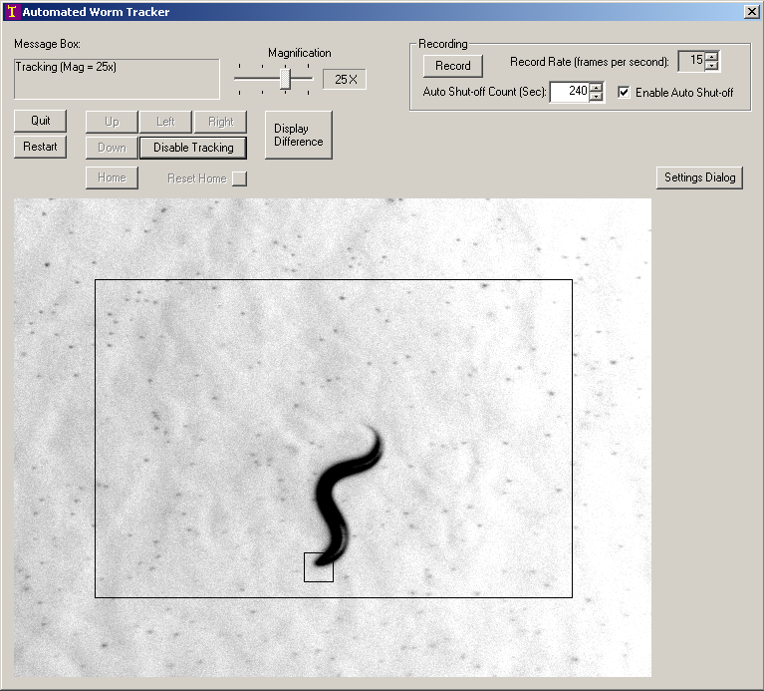

Figure DigiTracker User Interface

1. When ready to record, set the desired recording speed (frames per second). (NB: 6 frames per second is the traditional record rate at Caltech.) Set the Auto Shut-off Count to the desired recording length and click the “Record” button. In the “Save As” window set the desired path, specify the desired filename, and click “Save.” DigiTracker will record worm video data as instructed, displaying the elapsed time and recording rate in the window. When the recording is finished, the PC will beep and the “Record” button will reappear.
2. When finished recording a worm, click the “Disable Tracking” button in the DigiTracker window to stop the tracking action before removing the Petri dish from the stage. Repeat the recording process with all of the experiment’s worms.

Helpful hint:

The “Reset Home” button will teach DigiTracker that the current view is its “home” position. Use the “Home” button to quickly return the microscope stage to this same position.

When finished recording for the day, shut down the:

* Microscope light source
* Motorized microscope stage

(These aren’t necessary for the next step.)

## DigiRecognizer

DigiRecognizer is a program that extracts worm posture and position data from the *.dat (“video”) files recorded by DigiTracker. The output from this program is a set of sequentially numbered folders named wormN suffixed with the name of the *.dat files. Each will contain a data file called “points” and a set of numbered reference images.

1. Start DigiRecognizer:

Double click the DigiRecognizer icon to start the program. The DigiRecognizer window (titled “MWRecognizer”) will appear (Figure 2).

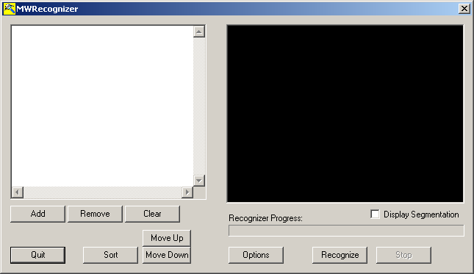

Figure - DigiRecognizer User Interface

1. Select files for ‘Recognition’:

Click the “Add” button and select the *.dat files desired for processing. (As with other Windows programs, one can choose multiple files at the same time by holding the Ctrl or Shift keys while selecting from list.) After clicking “Open” the *.dat files appear as a list in the DigiTracker window. Use the “Sort” and/or “Move Up/Down” buttons to reorder the files as desired, for example to list the worms in the order recorded or grouped by condition.

1. Adjust settings (if necessary):

The “Options” window (access by clicking the “Options” button) allows the user to adjust program settings (Figure 3). Typically these will remain unchanged, but are available for use if necessary. Note that:

* The Points-file name should remain “points” (for wormproc to operate properly and the spine size should typically remain set to 13 points (that is, 13 vertices spread along the worm’s spine).
* “Save every ___th image” specifies how often during processing DigiRecognizer should save a reference image. Saving every 100th image has proven to be a reasonable balance between utility and disk space for recordings made at 6 frames per second.
* Enabling the Enhanced Segmentation checkbox tells DigiRecognizer to “smooth” the background in the worm video while processing. This is very helpful for capturing useable worm data from poor quality recordings (for example recordings with low contrast, deep worm tracks visible,…) but can *SIGNIFICANTLY* slow the processing speed. Use when necessary (or when not in any hurry).

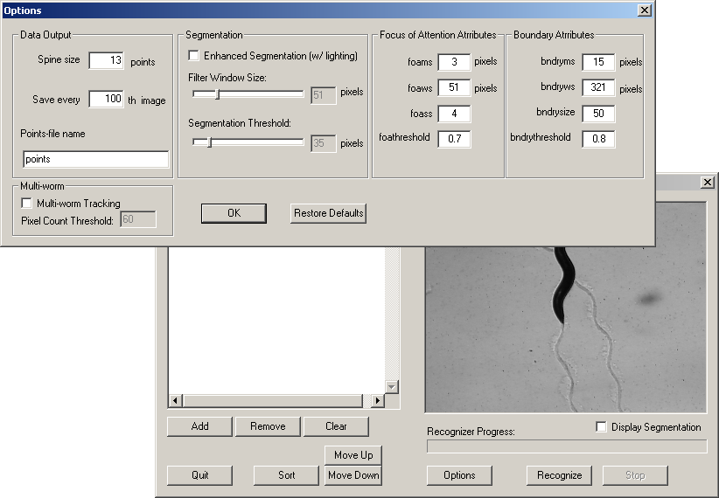

Figure - DigiRecognizer Options Window

1. Start Recognizing:

Click the “Recognize” button and select the destination folder for the processed data folders. Click “OK” to start processing the selected *.dat files. As DigiRecognizer progresses the user interface display window will show the video stream being processed with the worm’s spine overlaid. Enabling “Display Segmentation” will also highlight the edge of the worm as determined by DigiRecognizer (handy to verify that DigiRecognizer is recognizing what it should and to troubleshoot if not). When processing of each worm is complete, click “Quit.”

# Process Worm Data

Open Matlab (double click on the Matlab icon). The prompt (>>) in the Command Window and “Ready” in the lower left corner of the window frame indicate that Matlab is ready to accept input from you.

## Wormproc:

Wormproc is a master script that automates using the worm data screening functions. The objectives here are twofold:

1. Check that all worms are oriented correctly
2. Screen data to verify that bogus data is ignored.

Start “Wormproc:

Type *wormproc <Enter>* to begin processing worm data.

Matlab will prompt:

Enter Directory name>

Type (or copy & paste) the name of the ‘worm__’ directory (WITH THE PATH) containing files called ‘points’ and ‘file.1’, ‘file.101’, ‘file.201’, ‘file301’…

Example:

*D:\Chris\HeatShockJ_exp24\NonAblated_N2\worm7_N2_2 <Enter>*

Matlab will display two windows, one with several buttons and a ‘movie screen’ with a grid and the other (labeled ‘Worm Images’) initially blank. These two windows act as an “editing room” for you to double-check Matlab’s calculations… (Figure 4)

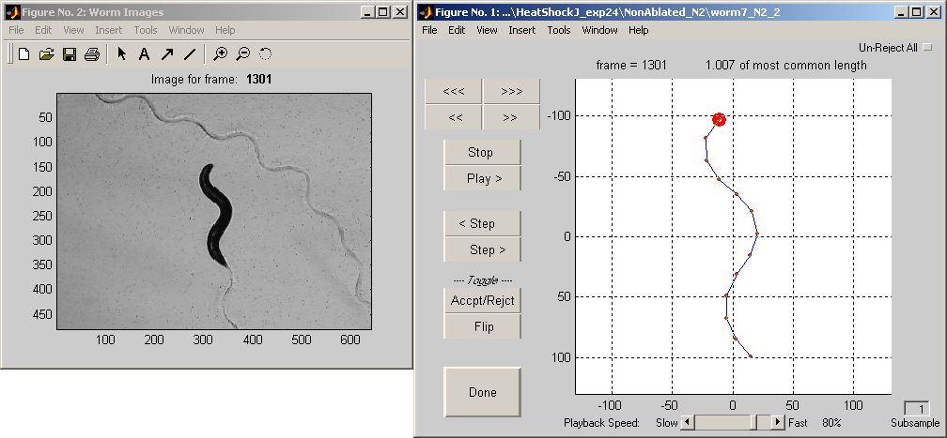

Figure - Wormproc User Interface

Review worm data:

In the editing window:

The top rows of buttons work similar to those on a VCR: Play>, Stop, Fast Forward (“fast” >>, and “really fast” >>>), Rewind (again, “fast” << and “really fast” <<<).

The two buttons labeled Step> and <Step move forward or backward one frame at a time.

Use the mouse to click the “Play>” button in the window. A ‘skeleton’ worm with a large red dot for its head will move on the screen and a series of reference still images appear in the ‘Worm Images’ window. Use the on-screen buttons to control the movie playback. (Don’t forget about the “Playback Speed” slider at the bottom of the screen to speed up or slow down the playback to suit your taste and your computer’s processor speed!)

*Accept/Reject:*

During playback of the movie, Matlab will occasionally place a large red ‘X’ over the center of a worm… This indicates a frame with missing data or a frame containing data that Matlab suspects to be invalid, for example if the worm’s ‘spine’ becomes shorter or longer than Matlab thinks is likely. This is where the ‘editor’ comes in: there may be times when Matlab misses a series of frames that should have been rejected or conversely, rejects a series of frames that present obviously valid data…

The button labeled <Accpt/Rejct> acts as a toggle to REVERSE the acceptance/rejection of the current frame AND ALL SUBSEQUENT FRAMES all the way from the Current frame to the end of the ‘movie’ -- all of the “Okay” frames (from the current frame onward) become “No Good” and vice versa. So, in cases where you need to invalidate a series of frames that Matlab missed, simply forward to the first frame that needs to be rejected, click on the <Accpt/Rejct> button, forward to the first frame that now needs to be re-accepted, and click on the <Accpt/Rejct> button once more!

(For further discussion on how the toggle feature works, please refer to the Appendix.)

*Flip:*

Likewise, there will be times (particularly when a worm doubles back on itself) when Matlab becomes confused as to which end of the skeleton is the worm’s head end. In this case corrections are made with the button labeled <Flip>

<Flip> works the same way as the <Accpt/Rejct> button but this time by reversing (head-to-tail and tail-to-head) the orientation of worms in all subsequent frames. (The toggle feature can save HUNDREDS of keystrokes on particularly uncooperative worms!)

During playback use the still images presented in the ‘Worm Images’ window as a guide to the orientation of the skeleton in the editor window. Be sure to note the frame numbers listed in the figure titles in the editor and Worm Images windows.

When the ‘movie’ is completely edited (after verifying that all of the skeletons are properly oriented and the data is properly accepted or rejected), use the mouse to press the “Done” button. Matlab will automatically finish processing the worm data and will save the results as a file called *data.mat* in the worm__ directory specified at the beginning.

Repeat with any other worm__ folders, including those in other folders (for example for other drug conditions or other mutants).

Helpful hint:

The “Un-Reject All” button in the upper right corner of the window removes all “reject” editing (except for missing worms) and resets the movie to the beginning. This button will typically only be used for extraordinarily uncooperative worms.

## Calculating Metrics

The Matlab function “*metrics*” uses the pre-processed worm data from “*wormproc*” to calculate measures of worm movement. The resulting metrics can be graphed or tabulated as needed.

From the Matlab command prompt type:

*metrics6(mmpp, scnds, fpt, ‘directory1’, ‘directory2’,…)*

where

* mmpp is millimeters per pixel (must be calculated for each camera and magnification setting).
* scnds is the length (in seconds) of the ‘recognized’ recording (For example, 240 for a 4 minute recording: 4 minutes * 60 seconds/minute = 240 seconds).
* fpt (frames per timeblock) is the number of frames (worm positions) to group together for the velocity calculation. That is, Metrics calculates velocity by looking at how far a worm moves every N'th frame, where N = fpt.

**🡪 fpt should typically be kept as 1 (calculating velocity for every frame). 🡨**

For example:

*metrics6(0.0041, 240, 1, ‘‘D:\Chris\HeatShockJ_exp24\NonAblated_N2’); <Enter>*

or for multiple directories:

*metrics6(0.0041, 240, 1, …<Enter>*

*‘D:\Chris\HeatShockJ_exp24\NonAblated_N2’, …<Enter>*

*‘D:\Chris\HeatShockJ_exp24\Ablated_N2’, …<Enter>*

*‘D:\Chris\HeatShockJ_exp24\MockAblated_N2’); <Enter>*

(Note, the ellipses at the end of the lines above tell Matlab that you will enter more information. Also, the semicolon at the end of the last line tells Matlab not to print out intermediate gibberish to the screen.)

Matlab will prompt:

Display progress status? (y)yes (n)no?

Enter ‘y’ to see how long each sub-process takes, or ‘n’ for blissful ignorance.

Next Matlab will prompt:

Display coverage statistic charts? (y)yes (n)no?

Here, enter ‘y’ to have Matlab display charts showing how much of each worm’s data is being used for calculating different metrics. (Or ‘n’ for more blissful ignorance.)

Matlab should then display something like:

Processing C:\Jane-AVD\Arsenite-cat4-03-11-02\N2-0-NaAsO2\worm1

and should continue through with each worm in the specified folders. (This is a good time to enjoy a cup of coffee since each worm will take ~20 to 60 seconds.)

When *metrics* is done Matlab will again display the command prompt (>>).

# Display Worm Data

## Histograms:

To see the standard histograms of the processed data for sets of worms, from the Matlab command prompt type:

*histograms4(‘drive:\path…\folder1’, ‘drive:\path…\folder2’); <Enter>*

For example:

*histograms4(…*

*‘D:\Chris\HeatShockJ_exp24\NonAblated_N2’, …<Enter>*

*‘D:\Chris\HeatShockJ_exp24\Ablated_N2’, …<Enter>*

*‘D:\Chris\HeatShockJ_exp24\MockAblated_N2’); <Enter>*

Histograms will prompt for title and legend information. Update and click “OK”. The program will display a set of histogram charts displaying the distributions of each measure of behavior.

Note:

* You can graph the data for up to ten sets of worms on the same set of charts by specifying up to ten folders. (NB: More than ten folders will cause the line colors to repeat.)
* For a set of worms to be treated as a single line on the histogram charts, the ‘worm__’ folders should be grouped into the same parent-folder. For example, worm__ folders for all wild-type worms exposed to 1.25mM of NaAsO2 from several days’ recordings could be grouped together into a folder like

*‘D:\Chris\Summary_exps23_26\NonAblated_N2’.<Enter>*

* Each folder listed separately when starting the function ‘histograms’ will create a separate line on the resulting charts.

If necessary, the titles and legends identifying the charts the charts can be edited. Do this by clicking the ‘edit plot’ arrow first, then double clicking the text to be edited. You can also add additional labels, etc., to the histograms, print them and save them to disk or CD. To allow the chart to print in color (or grayscale), be sure to click

‘Color (don’t convert)’

on the ‘Lines and Text’ tab of the ‘Page Setup’ window.

(File | Page Setup… | Lines and Text)

## Statistics:

To display the statistics for a set of worm populations, from the Matlab command prompt type:

*stats(‘drive:\path…\folder1’, ‘drive:\path…\folder2’); <Enter>*

For example:

*stats(…*

*‘D:\Chris\HeatShockJ_exp24\NonAblated_N2’, …<Enter>*

*‘D:\Chris\HeatShockJ_exp24\Ablated_N2’, …<Enter>*

*‘D:\Chris\HeatShockJ_exp24\MockAblated_N2’); <Enter>*

Stats will prompt for formatting information. For each, select or update and click “OK”.

Note:

* The Alpha value requested is a number between 0 and 1 that determines the confidence levels for null hypothesis testing. From Matlab’s help files: “…you can specify the value alpha = 0.05 to insure that when there is no real difference [between two populations], you will incorrectly find a significant difference no more than 5% of the time.”
* Selecting to display individual worm details presents mean data for each of the individuals that comprise the populations for each condition in addition to the population data that is always presented.

# Appendix

## Accept/Reject Toggle

Additional help on understanding how the Accept/Reject toggle (and Flip toggle, too) works:

Note: A convenient analogy to how the Accept/Reject toggle button works is to imagine a hanging ribbon with a green front and a red back… Imagine that most of the ribbon is green-side up, but that the ribbon is twisted in places to reveal sections with the red-side visible. In this analogy we can think of the green sections as “accepted” data and the red sections as “rejected” data. Further, we can think of the top-end of the ribbon as the first frame of our “worm movie” and the bottom-end of the ribbon as the last frame in our “movie”. To “reject” a section of data we would twist the ribbon at the start of the new “rejected” section and un-twist the ribbon at the end of the new “rejected” section.

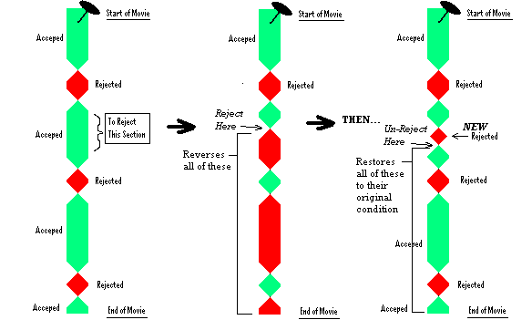

## Explanation of Behavior Measures (Metrics)

