General Engineering Department
______________________________________________________

GestureLink
Final Design Report

Version 2.0

Project Team Members:
Evelina Piwnik (Design Lead)
Kayla Zhang (Project Manager)
Worren Zhu (Circuitry and Coding Lead)
Group: SLDP 27
Section: B1
Date: April 24, 2026

Abstract
Communication between Deaf or hard of hearing individuals and hearing individuals had often been difficult during everyday interactions because sign language had not been widely understood. A wearable sign language translation glove had been developed to reduce this barrier by detecting hand and finger movements and producing spoken audio in real time. The prototype had used four flex sensors and one force sensor connected to an Arduino Uno microcontroller. Sensor values had been read as analog inputs and had been classified into American Sign Language number gestures from one through ten. After classification, a loudspeaker had played the corresponding audio output. The circuitry had been mounted in an adjustable forearm compartment secured with a Velcro strap to improve comfort and stability. Testing had shown that the system had detected numbers one through ten and had produced the expected audio output after each recognized gesture. Gestures for four and five had been detected most quickly and precisely under the final sensor placement and threshold settings. Future work had included expanding recognition from numbers to the ASL alphabet and common words, adding an inertial measurement unit to capture hand orientation, and reducing circuit size for improved wearability.

1. Introduction

1.1 Purpose of Project
GestureLink had been presented as a prototype assistive-technology company that had focused on making communication more accessible and efficient. The project team had consisted of Evelina Piwnik, Kayla Zhang, and Worren Zhu. Evelina Piwnik had served as the Design Lead and had overseen the overall form factor, wearability decisions, and the physical layout of the glove and forearm-mounted compartment. Kayla Zhang had served as the Project Manager as well as the Logistics and Research Lead, and coordination of tasks, documentation, competitive research, and procurement had been supported through this role. Worren Zhu had served as the Circuitry and Coding Lead and had been responsible for circuit integration, sensor wiring, and software implementation for gesture classification and audio output.
The company mission had been stated as follows: communication had been made accessible and efficient for everyone. The problem that had been addressed had been the lack of a portable, private, and real-time method for Deaf or hard of hearing individuals to communicate with hearing individuals who had not understood sign language during everyday interactions.

1.2 Background Information
Hearing loss and Deafness had affected a large population and had created frequent barriers in time-sensitive daily settings. In the United States, approximately 15% of adults, or 37.5 million people, had reported some trouble hearing, and a measurable portion of this population had relied on sign language and other communication supports (National Institute on Deafness and Other Communication Disorders). Globally, over 5% of the world population, or 430 million people, had been estimated to experience disabling hearing loss requiring rehabilitation, and growth had been projected over the coming decades (World Health Organization). Although not every Deaf or hard of hearing person had used American Sign Language, ASL had remained a critical language for many community members. Estimates of primary ASL users had varied, and a widely cited range for primary users had been reported as 100,000 to 500,000 (Mitchell et al.).
Communication barriers had been amplified because most hearing individuals had not been fluent in sign language. In many public interactions, translation had relied on one of three existing solution categories. First, human interpreters had provided high accuracy, but access had often been limited by availability, scheduling delays, and cost. Second, camera-based sign recognition systems had introduced privacy concerns in public spaces and had required substantial computational resources for real-time video processing. Third, mobile applications had been portable, but consistent performance had often been reduced by camera positioning requirements, lighting variability, and background clutter. As a result, an unmet need had remained for a solution that had provided translation support without requiring a third party, a camera, or extended setup time.
A wearable glove-based prototype had been designed as an alternative because finger bending and contact could be measured directly through sensors rather than inferred from images. Flex sensors had exhibited changes in resistance when bending had occurred, and force-sensing resistors had decreased in resistance when force had been applied (Spectra Symbol; Interlink Electronics). These sensor behaviors had enabled hand movement to be represented as analog signals. When these signals had been read by a microcontroller, a gesture could be classified and mapped to an output. This approach had reduced privacy risks associated with cameras and had reduced dependence on controlled environmental conditions.
The proposed product had been defined as a sign language translation glove integrated with a loudspeaker capable of real-time interpretation. The prototype scope had been intentionally focused on number gestures from one through ten because this limited vocabulary had enabled higher accuracy under a threshold-based classification method. The key functions of the product had included reading sensor values, classifying a gesture in real time, and producing spoken output that could be understood by hearing individuals. The intended users had included Deaf or hard of hearing individuals in daily settings such as schools, clinics, and customer-facing work environments, where quick and direct communication had been needed.

2. Requirements

2.1 Physical Components
The solution had been built as a wearable glove with sensor inputs, a microcontroller for classification, and an audio output device. Four flex sensors had been used to detect finger bending patterns, and one force sensor had been used to detect contact-based input. An Arduino Uno Rev3 microcontroller had been used as the central controller because analog inputs had been supported and rapid iteration had been enabled through USB programming (Arduino UNO R3). A breadboard and jumper wires had been used during prototyping to allow rapid reconfiguration of voltage-divider circuits and pin routing. A 10 kΩ resistor had been used in voltage-divider configurations to convert sensor resistance changes into measurable analog voltages. A loudspeaker had been integrated to play audio output after gesture classification.
The physical layout had included a glove worn on the hand and a forearm-mounted compartment that had housed the Arduino, breadboard, and wiring. The compartment position had been adjustable along the forearm and had been tightened using a Velcro strap so that different users could achieve comfort and stability. This configuration had reduced the mass on the hand and had reduced sensor-wire strain during repeated gestures.
CAD drawings of the forearm-mounted compartment and its integration with the glove had been required to document the final form factor. In the final presentation, the required views had included an isometric view, a top view, and a bottom view.
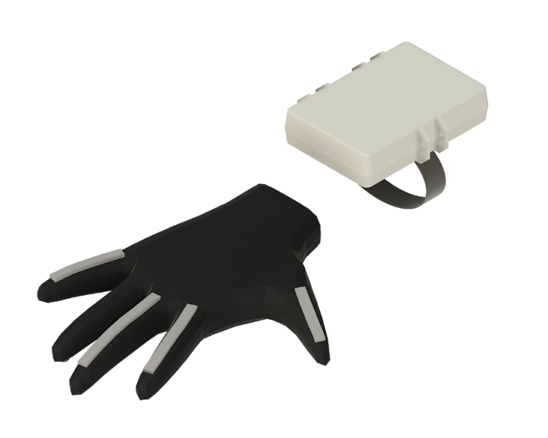
Figure 1. CAD Drawing: Isometric view of the forearm-mounted electronics compartment and glove integration
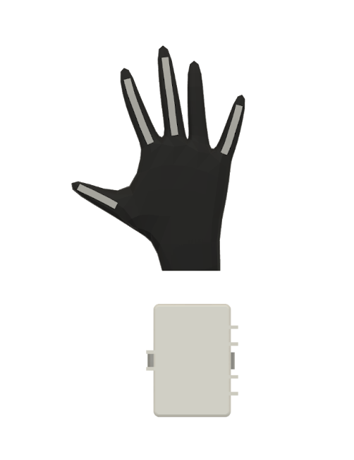
Figure 2. CAD Drawing: Top view of the forearm-mounted electronics compartment
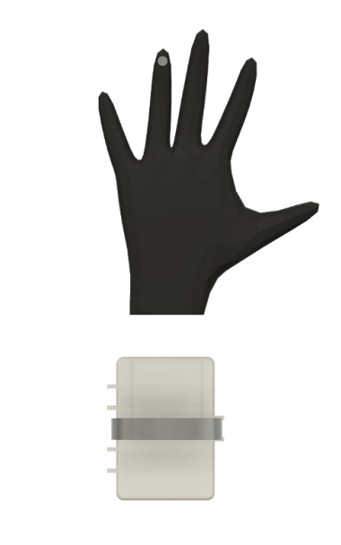
Figure 3. CAD Drawing: Bottom view of the forearm-mounted electronics compartment
A final cost estimate had been calculated from purchased components used in the prototype. The total prototype material cost had been $65.36. The projected target price for a basic educational or pilot deployment had been estimated at approximately $75 to account for assembly and overhead. Table 1 had summarized the final cost estimate for the prototype components.
Table 1. Cost Estimate for the GestureLink Prototype.
Item | Quantity | Cost/Unit ($) | Total Cost ($)
Gloves | 1 | 6.99 | 6.99
Flex sensor | 4 | 6.00 | 24.00
Force sensor | 1 | 3.25 | 3.25
Arduino R3 | 1 | 27.60 | 27.60
Breadboard | 1 | 1.27 | 1.27
Speaker | 1 | 2.25 | 2.25
Total |  |  | 65.36

2.2 Software Components
The software had been developed using the Arduino Integrated Development Environment, and the Arduino Uno had been programmed through USB connection (Arduino, "Arduino IDE v1"). No external libraries had been required for basic analog sensor reading and digital output control because default Arduino functions had supported these tasks. The program had been required to repeatedly read sensor values, classify gestures, and trigger audio output in a loop so that real-time interaction had been supported.
A final circuit diagram had been required to show how each sensor channel had been connected to the microcontroller and how the loudspeaker had been driven. Each resistive sensor channel had been implemented as a voltage divider, where a fixed resistor and a variable-resistance sensor had been placed in series between 5 V and ground, and the midpoint voltage had been read by an analog input. 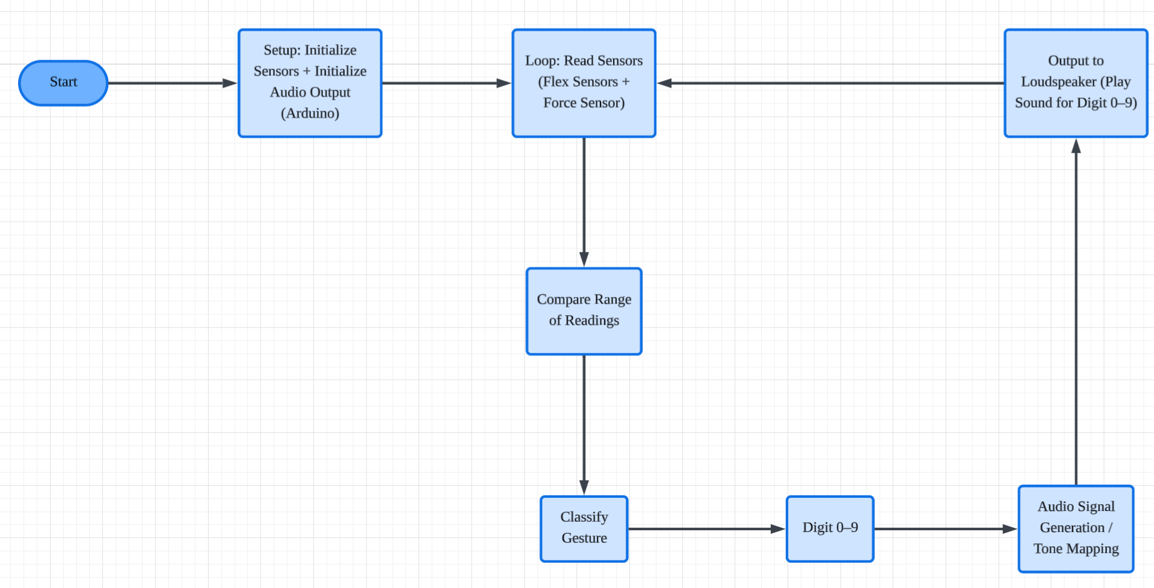
Figure 4. Code Flowchart: Program logic for sensor reading, gesture classification, and audio output (inserted from final presentation).
The interaction between components had been represented as a simple pipeline: sensors had generated analog voltages, the Arduino had read these values and classified the current gesture, and the loudspeaker had produced the mapped audio output. This pipeline had been selected to minimize latency and reduce computation requirements relative to camera-based recognition systems.

3. Procedure

3.1 Physical Construction
The physical prototype had been assembled by attaching sensors to a glove and routing wires to a forearm-mounted compartment that had contained the microcontroller and breadboard. Flex sensors had been aligned along the fingers so that bending had produced repeatable resistance changes. The force sensor had been positioned at a contact point where additional input had been needed to distinguish similar finger-bend patterns. After placement had been selected, sensors had been secured to the glove using fastening methods that had reduced sliding during repeated gestures.
The Arduino Uno and breadboard had been placed inside the forearm compartment, and jumper wires had been used to connect each sensor voltage-divider midpoint to an Arduino analog input. A common ground had been shared across all channels. The loudspeaker had been wired to the Arduino output so that audio output could be triggered when classification had occurred. After wiring had been completed, the forearm compartment had been tightened using a Velcro strap and adjusted to a position that had reduced hand loading while maintaining comfort.
During assembly, sensor placement had been iteratively adjusted to increase classification separability between gestures. This adjustment process had included repeated trials of number gestures and observation of how sensor readings had shifted when glove fit or sensor alignment had varied.

3.2 Software Setup
The Arduino IDE had been installed and used to create, compile, and upload code to the Arduino Uno (Arduino, "Using the Arduino Software (IDE)"). Analog input pins had been used to read voltage-divider outputs from the flex sensors and force sensor. In the setup stage, output pins for the loudspeaker interface had been configured and serial monitoring had been initialized for calibration. In the main loop, sensor values had been read continuously and compared against gesture thresholds that had represented numbers one through ten.
Gesture classification had been implemented through a set of conditional checks that had matched sensor patterns to known number gestures. After a gesture had been classified, an audio output command had been triggered so that the corresponding number had been played through the loudspeaker. The classification approach had been maintained as a lightweight method to support real-time output on an embedded microcontroller without wireless connectivity or external computation.

3.3 Software Troubleshooting
During development, inconsistent gesture recognition had been observed when sensor readings had drifted due to glove fit, sensor placement shifts, or differences in finger bending angles across trials. To address this issue, sensor attachment had been reinforced and wires had been routed to reduce tugging forces. Threshold values used for classification had also been retuned after multiple trials had been performed for each gesture.
False positives had also been observed when two number gestures had produced similar bend patterns under a loose glove fit. This issue had been mitigated by requiring a more specific combination of flex sensor and force sensor ranges before a gesture had been accepted. In addition, brief stabilization delays had been tested so that classification had been triggered only after a consistent reading had been measured across multiple loop cycles.
Audio output troubleshooting had included verification of wiring polarity, confirmation of shared ground, and testing of the loudspeaker output using a simple tone signal prior to full gesture mapping. After baseline speaker output had been confirmed, gesture-to-audio mapping had been reintroduced and verified for each number gesture.

4. Milestone and Final Product Requirements

4.1 Benchmark A Requirements
Benchmark A requirements had been focused on establishing a clear problem statement, defining the intended users, and producing initial documentation for the proposed engineering solution. A company mission statement and a problem statement had been developed to distinguish between the long-term purpose of the company and the specific communication barrier that had been addressed by the prototype. Research on existing solutions had been completed, and limitations of human interpreters, camera-based recognition, and mobile applications had been summarized.
Documentation for Benchmark A had included a preliminary circuit diagram, a preliminary code flowchart, and initial CAD drawings of the wearable enclosure concept. A project schedule had also been maintained in a Gantt chart format to track responsibilities and deadlines. The schedule had been intended to be included in the final report as Figure 6, with tasks grouped by design, circuitry, coding, testing, and documentation.

4.2 Benchmark B Requirements
Benchmark B requirements had been focused on integrating the physical and software subsystems into a functional prototype that had been testable as a wearable device. Sensor placement and wiring had been completed on the glove, and the forearm-mounted compartment had been assembled to support comfortable use. Software classification logic had been implemented and refined through testing so that multiple gestures had been recognized reliably.
Benchmark B documentation had included updated CAD drawings, an updated circuit diagram reflecting final pin routing, and a refined code flowchart representing the implemented logic. A cost estimate table had also been finalized to support market viability discussion and to document prototype feasibility.

4.3 Commissioning Requirements
Commissioning requirements had been focused on demonstrating end-to-end system functionality and confirming that project objectives had been met. The prototype had been required to detect hand and finger movements accurately, translate the recognized sign into spoken output in real time, and remain portable and easy to use. Commissioning evaluation had been performed by completing repeated trials of the supported number gestures and confirming that correct audio output had been produced.

4.4 Human Resources and Training
Completion of the prototype had required coordinated work across design, circuitry, software, and documentation. Course teaching assistants and laboratory resources had been utilized for feedback on wiring practices, sensor integration, and prototyping safety. Basic prototyping skills such as breadboard wiring, sensor calibration using serial monitoring, and iterative testing had been applied. If additional maker-space equipment training had been required for printing or fabrication, this training had been completed prior to fabrication steps so that safe operation procedures had been followed.

5. Results

5.1 Benchmark A Results
Benchmark A deliverables had been completed and had provided a foundation for integration work. A clear company mission statement and problem statement had been established, and the scope had been defined as real-time translation of ASL number gestures. Existing solutions had been compared and the prototype direction had been justified through privacy, portability, and computation considerations.
Initial documentation had been produced, including early CAD drawings, a circuit diagram draft, and a code flowchart draft. These materials had guided subsequent construction and software implementation.

5.2 Benchmark B Results
Benchmark B evaluation had confirmed that subsystem integration had been achieved. The glove had been assembled with sensors attached securely enough for repeated gesture trials. The forearm-mounted compartment had supported stable wiring and had reduced strain on the hand during use.
Software classification logic had been implemented and had produced correct audio output for multiple test gestures. Recognition reliability had improved after sensor placement and threshold ranges had been refined. Benchmark B results had indicated that the prototype had been ready for commissioning-level demonstration.

5.3 Commissioning Results
Commissioning tests had shown that the prototype had detected hand and finger movements for number gestures one through ten and had translated them into spoken output in real time. The loudspeaker had produced the expected number output after each recognized gesture, which had indicated that sensor reading, classification, and audio output had operated as a complete system.
Recognition performance had varied by gesture. The number gestures for four and five had been detected most quickly and precisely under final settings. Other gestures had been detected successfully, but detection speed and precision had been more sensitive to glove fit and consistent finger bending angles.

5.4 Difficulties Experienced
Several technical and logistical difficulties had been encountered during development. Sensor readings had shifted when glove tension had changed, which had reduced classification stability in early tests. This issue had been addressed by reinforcing sensor attachment and by repositioning sensors to reduce slipping. Wire routing had also been modified to reduce tugging forces near sensor joints.
Gesture overlap had been another difficulty because some number gestures had produced similar finger-bend patterns. To reduce overlap, classification ranges had been narrowed and the force sensor had been used as an additional distinguishing feature. Repeated calibration trials had been performed until acceptable separation had been observed for the supported gesture set.
Audio output had also required troubleshooting during integration. Speaker output had initially been verified using simple test signals, and mapping errors had been corrected after the correct output pathway had been confirmed. After these corrections, audio output had been produced consistently during commissioning trials.

6. Conclusions

6.1 Results of Project
The GestureLink prototype had demonstrated that a wearable glove with resistive sensors and a microcontroller could support real-time translation of a limited set of sign language gestures into spoken output. The final design had included four flex sensors and one force sensor, an Arduino Uno microcontroller, and a loudspeaker output system. A forearm-mounted compartment had improved comfort and had allowed the circuitry to be worn securely.
The project objectives had been met at the prototype scope level. Hand and finger movement had been detected, number gestures had been classified, and spoken output had been produced in real time. However, limitations had remained. The vocabulary had been limited to numbers one through ten, and threshold-based classification had been sensitive to glove fit and user variation. In addition, the breadboard-based circuit layout had increased bulk and had reduced long-term wearability relative to a compact integrated design.

6.2 Future Improvements
If additional time and funding had been available, the recognition scope would have been expanded from numbers to the ASL alphabet and simple words. To improve recognition robustness, an MPU6050 inertial measurement unit could have been integrated so that hand orientation and motion dynamics could have been measured in addition to finger bending. This additional sensor modality would have increased separability between gestures that had shared similar finger-bend patterns.
Hardware miniaturization would also have been prioritized. The breadboard would have been replaced with a printed circuit board so that wiring complexity and size could have been reduced. A higher power loudspeaker would have been integrated to improve clarity in noisy environments. Calibration procedures could have been added so that threshold ranges could have been adapted to different users and glove sizes, which would have improved accuracy and usability at scale.

7. Works Cited
Arduino. "Arduino IDE v1." Arduino, https://www.arduino.cc/en/Guide/Environment. Accessed 27 Apr. 2026.
Arduino. "UNO R3." Arduino Documentation, https://docs.arduino.cc/hardware/uno-rev3. Accessed 27 Apr. 2026.
Arduino. "Using the Arduino Software (IDE)." Arduino Docs, https://docs.arduino.cc/learn/starting-guide/the-arduino-software-ide/. Accessed 27 Apr. 2026.
Interlink Electronics. "FSR 402 Data Sheet." SparkFun CDN (Interlink Electronics), https://cdn.sparkfun.com/assets/8/a/1/2/0/2010-10-26-DataSheet-FSR402-Layout2.pdf. Accessed 27 Apr. 2026.
Mitchell, Ross E., et al. "How Many People Use ASL in the United States?" Gallaudet Research Support and International Affairs, 2006, https://www.gallaudet.edu/documents/Research-Support-and-International-Affairs/ASL_Users.pdf. Accessed 27 Apr. 2026.
National Institute on Deafness and Other Communication Disorders. "Quick Statistics About Hearing." NIH, 20 Sept. 2024, https://www.nidcd.nih.gov/health/statistics/quick-statistics-hearing. Accessed 27 Apr. 2026.
UCLA Newsroom. "Wearable-Tech Glove Translates Sign Language into Speech in Real Time." UCLA, 29 June 2020, https://newsroom.ucla.edu/releases/glove-translates-sign-language-to-speech. Accessed 27 Apr. 2026.
World Health Organization. "Deafness and Hearing Loss." WHO Fact Sheet, 3 Mar. 2026, https://www.who.int/news-room/fact-sheets/detail/deafness-and-hearing-loss. Accessed 27 Apr. 2026.
MindTecStore. "BrightSign - Sign Language Translator Glove." MindTecStore, https://www.mindtecstore.com/brightsign-sign-language-translator-gloves-for-people-with-hearing-and-language-impairments. Accessed 27 Apr. 2026.
Spectra Symbol. "Flex Sensor Data Sheet." Spectra Symbol, https://spectra-symbol-landing.s3.us-west-1.amazonaws.com/data-sheets/Flex-Sensor-Datasheet-v2019a.pdf. Accessed 27 Apr. 2026.

Figure Captions (Placeholders for Inserted Illustrations)
Figure 1. CAD Drawing: Isometric view of the forearm-mounted electronics compartment and glove integration (inserted from final presentation).
Figure 2. CAD Drawing: Top view of the forearm-mounted electronics compartment (inserted from final presentation).
Figure 3. CAD Drawing: Bottom view of the forearm-mounted electronics compartment (inserted from final presentation).
Figure 4. Code Flowchart: Program logic for sensor reading, gesture classification, and audio output (inserted from final presentation).
Figure 5. Circuit Diagram: Electrical connections between sensors, resistors, Arduino Uno, and loudspeaker (inserted from final presentation).
Figure 6. Project Schedule: Gantt chart showing task assignments and milestone deadlines (to be inserted by the team).

