**1NN + DTW**

Window length = length(sample) / 10; Sakoe-Chiba band

Used Keogh’s lower bound

(w1,w2,w3) = (vertical,diag,horizantal)

(L2)

|  |  |  |  |  |  |  |  |  |
| --- | --- | --- | --- | --- | --- | --- | --- | --- |
| Weight/Instances | ECG200 | Coffee | Beef | Beef(L1) | Gun_Point | OliveOil | Lightning7 |  |
| (1,1,1) | 1.0 | 1.0 | 0.5666 | 0.6666 | 1.0 | 1.0 | 0.808219 |  |
| (1,1,2) | 0.989 | 1.0 | 0.5666 |  | 1.0 | 1.0 | 0.8356 |  |
| (1,2,1) | 1.0 | 0.96428 | 0.5666 | 0.6666 | 1.0 | 1.0 | 0.83561 |  |
| (2,1,1) | 0.979 | 1.0 | 0.533 |  | 1.0 | 1.0 | 0.8630 |  |
|  |  |  |  |  |  |  |  |  |

ECG200: weights

(1,1,1) = 0.85

(1,2,1) = 0.81

(1,1,2 ) = 0.85

(2,1,1) = 0.86

(3,1,1) =

(2,1,2) =

(2,0.5,1) =

(1,2,2) =

ECG200: weights(normalized)

(1,1,1) = 0.930

(1,2,1) = 0.95999

(1,1,2 ) = 0.911

(2,1,1) = 0.9200

(1,3,1) = 0.979999

(1,4,1) = 0.989999

(2,4,1) = 0.969999

(1,5,1) = 0.989999

(2,5,1) = 0.989999

ECG200: weights(normalized+Euclidean)

(1,1,1) = 1.0

(1,2,1) = 1.0

(1,1,2 ) = 0.989999

(2,1,1) = 0.9799999

Coffee

(1,1,1) = 0.857

(1,2,1) = 0.821

(1,1,2)= 0.857

(2,1,1) = 0.821

(1,1,1.5) =

(1,1,1.4) =

Coffee(normalized)

(1,1,1) = 0.964

(1,2,1) = 0.964

(1,1,2)= 0.964

(2,1,1) = 0.964

Beef

(1,1,1) = 0.50

(1,1,2) = 0.50

(1,2,1) = 0.5333

(2,1,1) = 0.50

Beef (normalized)

(1,1,1) = 0.6666

(1,1,2) =

(1,2,1) = 0.6666

(2,1,1) =

Beef (L2,normalized)

(1,1,1) = 0.5666

(1,1,2) = 0.566666

(1,2,1) = 0.56666

(2,1,1) = 0.533333333

Lightning7

(1,1,1) = 0.78

(1,1,2) =

(1,2,1) = 0.767

(2,1,1) =

(2,2,1) =

Lightning7(normalized)

(1,1,1) = 0.849315

(1,1,2) = 0.8356

(1,2,1) = 0.835616438

(2,1,1) = 0.849315

(3,1,1) = 0.83561

(2,2,1) = 0.849315

Lightning7(L2,normalized)

(1,1,1) = 0.808219

(1,1,2) =

(1,2,1) =

(2,1,1) =

(3,1,1) =

(2,2,1) =

Gun point(normalized)

(1,1,1) = 0.95999

(1,2,1) = 0.979999

(1,1,2) = 0.9666667

(2,1,1) = 0.9533337

(1,3,1) = 0.986999999

(1,3,2) = 0.986999999

(1,4,1) = 0.9869999

Gun point(normalized+Euclidean)

(1,1,1) = 1.0

(1,2,1) = 1.0

(1,1,2) = 1.0

(2,1,1) = 1.0

Olive oil (normailzed)

(1,1,1) = 1.0

(1,1,2) = 1.0

(1,2,1) = 1.0

(2,1,1) = 1.0

**1.2**

|  |  |  |  |  |  |  |  |  |
| --- | --- | --- | --- | --- | --- | --- | --- | --- |
| Weight/Instances | ECG200 | Coffee | Beef | Gun_Point | OliveOil | Lightning7 |  |  |
| (1,1,1) – pattern1 | 1.0 | 1.0 | 0.5666 | 1.0 | 1.0 | 0.808219 |  |  |
| (1,1,1)– pattern2 | 0.89000 | 1.0 | 0.500 | 1.0 | 1.0 | 0.8904 |  |  |
| (1,1,1)– pattern3 | 0.920000 | 0.964285 | 0.5333 | 1.0 | 1.0 | 0.917808 |  |  |
|  |  |  |  |  |  |  |  |  |
|  |  |  |  |  |  |  |  |  |

**2. Shape Averaging**

**All data use test+train**

**Lightning7:**

**ECG200**

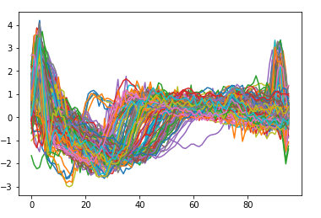

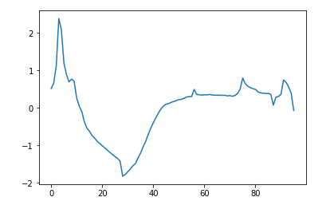

**Coffee**

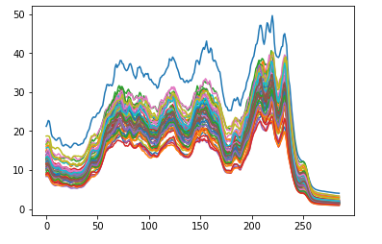

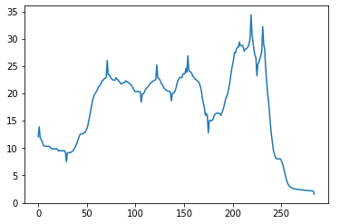

**Beef**

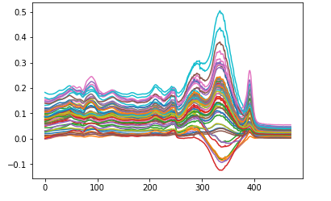

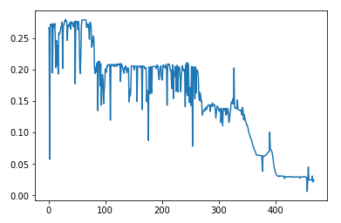

**OliveOil:**

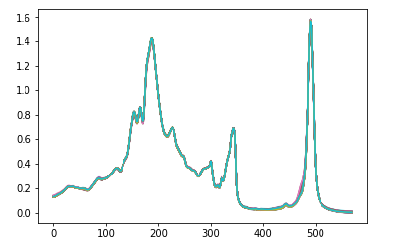

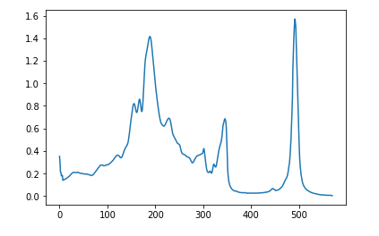

**Gun_Point:**