# Software Engineer: Candidate Assignment

## Introduction

There are **2 parts** of this assignment. Candidate will be given 1 excel file <PreciousMetalSpot.xlsx>, inside there are 4 tabs each for 1-year historical precious metal spot price: “Gold Spot”, “Silver Spot”, “Platinum Spot” and “Palladium Spot”. This file is used as input for both parts of the assignment.

## Part I

Candidate create **python script** that generate distribution of daily return chart, 1 distribution chart per 1 precious metal.

Daily return formula is below.

**Daily return(T+1) = [ ( ClosePrice(T+1) – ClosePrice(T) ) / ClosePrice(T) ] * 100**

**Note:**

ClosePrice(T)  is the close price of precious metal spot on the day (T), e.g. 1 Jan 2019

ClosePrice(T+1)  is the close price of precious metal spot on the day (T+1), e.g. 2 Jan 2019

***Example***

|  |  |  |
| --- | --- | --- |
| Date | Close | %Daily Return |
| 10/3/2019 | 1653.505 | -2.01452 |
| 10/2/2019 | 1687.5 | 2.14891 |
| 10/1/2019 | 1652 | XXX |
| … | … | … |
| … | … | … |

**Output:**

The result of this python script looks similar to the below charts. Candidate can design the look of their chart as they wish. Note that x-axis is percentage daily return and y-axis is density which is comparable to number of days.

Hint: Use python library to create a distribution chart, define number of bins appropriately.

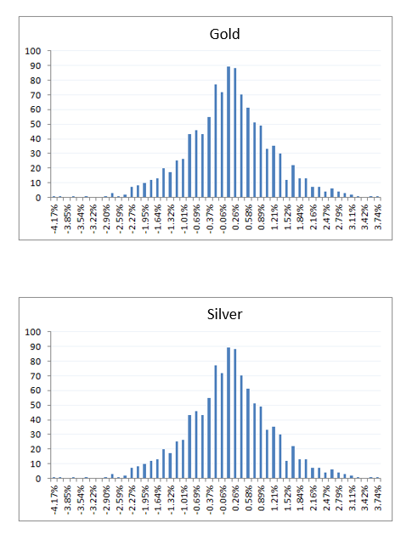

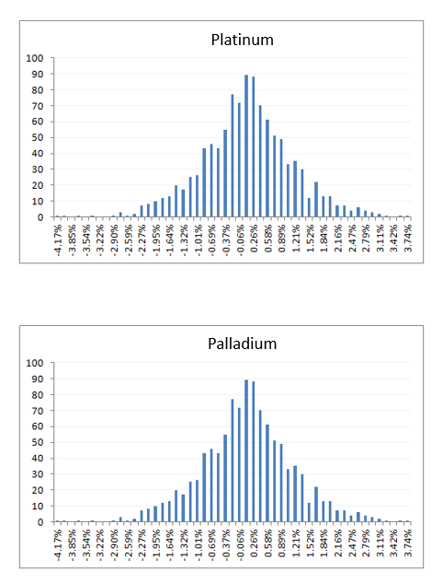

## Part II

Candidate create the application in **any programing language** they are comfortable with. This application prints out the maximum profit within a week where

* A trader can only buy and sell at daily close price
* A trader can only make 2 transactions per week (buy once and sell once)
* No short sell allowed (need to **buy first** then sell, **cannot** sell first and buy back to make profit)
* A week start from Monday to Friday

Note that this application only needs to find a week maximum profit **for gold spot** on these following 4 months in a year 2019: March, June, Sep and December.

Do skip **first and last** week of that month **only if** it doesn’t make full week (not complete dates from Mon-Fri)

***Example***

|  |  |  |
| --- | --- | --- |
| Day | Date | Close |
| Fri | 6/7/2019 | 1329 |
| Thu | 6/6/2019 | 1344 |
| Wed | 6/5/2019 | 1335 |
| Tue | 6/4/2019 | 1337 |
| Mon | 6/3/2019 | 1348 |

**Output:**

Maximum profit week 6/3/2019 to 6/7/2019 is 9, buy at 1335 on 6/5/2019, sell at 1344 on 6/6/2019

## Expectations

* Source code (e.g. application, services) needs to be committed to a **Git repository**. Send us your compressed project including everything in .git folder or send us a link to your project hosted on Github or Bitbucket.
* Your application should be **unit tested**.
* Use any libraries/frameworks/toolchains you see fit. Be prepared to justify your choices.
* Candidate is expected to give a **demonstration** on how you complete this assignment (e.g. code walk through)
* Feel free to ask us any questions that you would normally ask your stakeholders.