Instructions:

You are required to produce a library in C++ that will provide part of the functionality of the SANS10160-3_2011 wind code. The details of the wind code can be found from the attached pdf document.

The library should be able to calculate the wind pressure from the provided input. The input will require:

* Return period (Years)
* Terrain Category
* Wind speed (m/s)
* Altitude (m)
* Topography factor

Below is a screenshot from Prokon’s Wind Analysis program

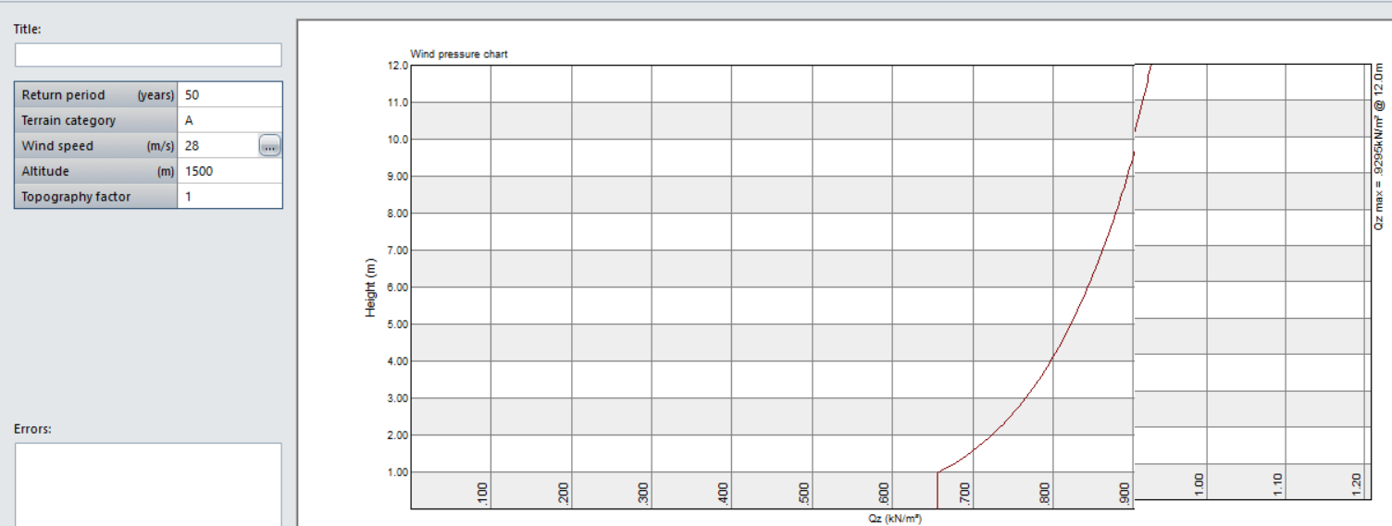

You will be given until the 4th of June, 13h00, to complete the project. Should you not be able to complete the project, please provide us with the unfinished code. Also indicate the amount of time spend on the project.