1、

x=linspace(-1,1);

y=asin(x);

z=acos(x);

t=atan(x);

plot(x,y,'y',x,z,'m',x,t,'c');

gtext('arcsin(x)');

gtext('arccos(x)');

gtext('arctan(x)');

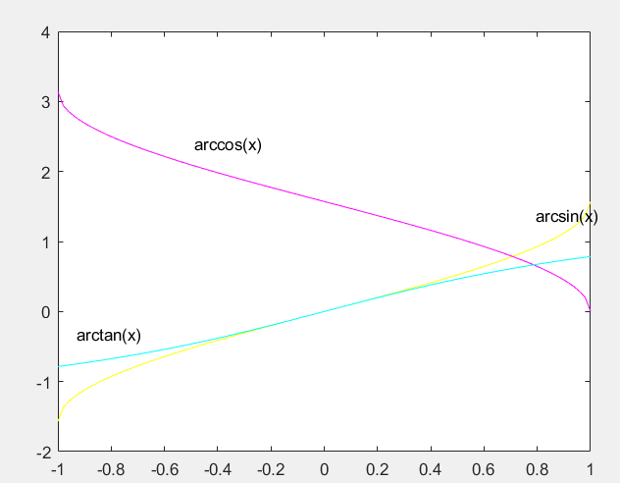

2、

x=linspace(0,pi);

>> y=sec(x);

>> z=csc(x);

>> plot(x,y)

>> gtext('sec(x)')

>> plot(x,z)

>> gtext('csc(x)')

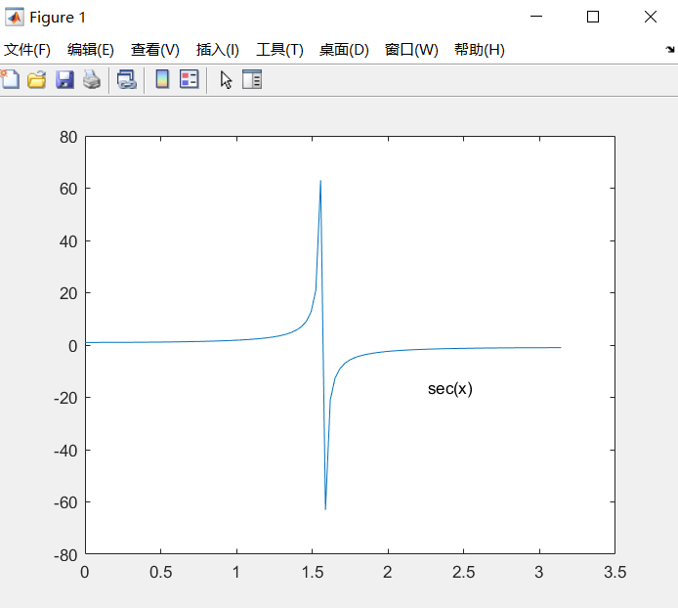

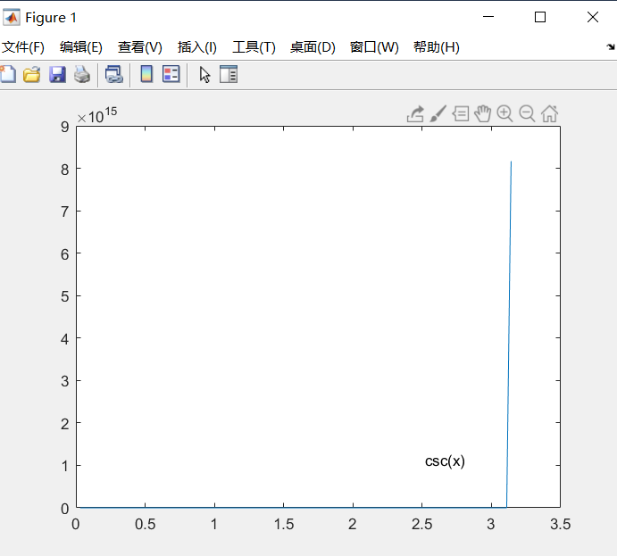

3、

x=linspace(-2,2);

y1=sqrt(x);

y2=x.^2;

y3=x.^(1/3);

y4=x.^3;

y5=x.^4;

y6=x;

plot(x,y1,'r')

hold on

plot(x,y2,'m')

hold on

plot(x,y3,'y')

hold on

plot(x,y4,'c')

hold on

plot(x,y5,'k')

hold on

plot(x,y6,'b')

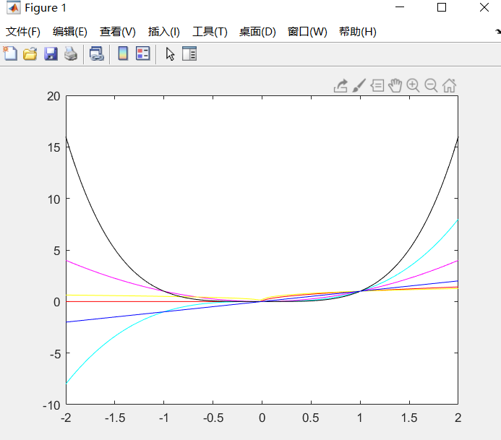

4、

x=linspace(-10,10);

y=(1-x).^(2/3)+(1+x).^(2/3);

plot(x,y);

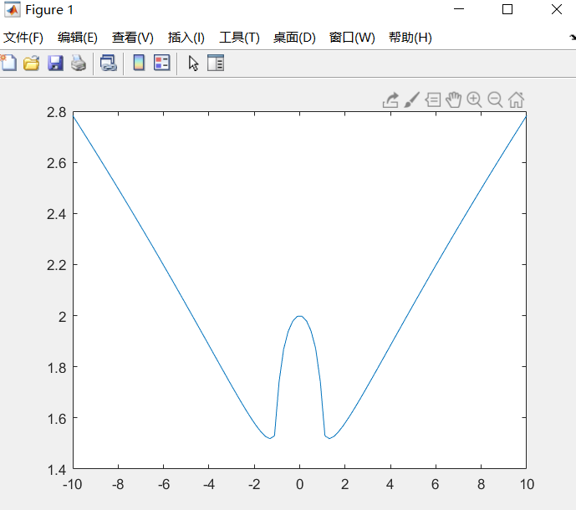

偶函数

5、

x=linspace(-10,10);

y=1+log(x+2);

plot(x,y);

hold on;

plot(y,x);

hold on;

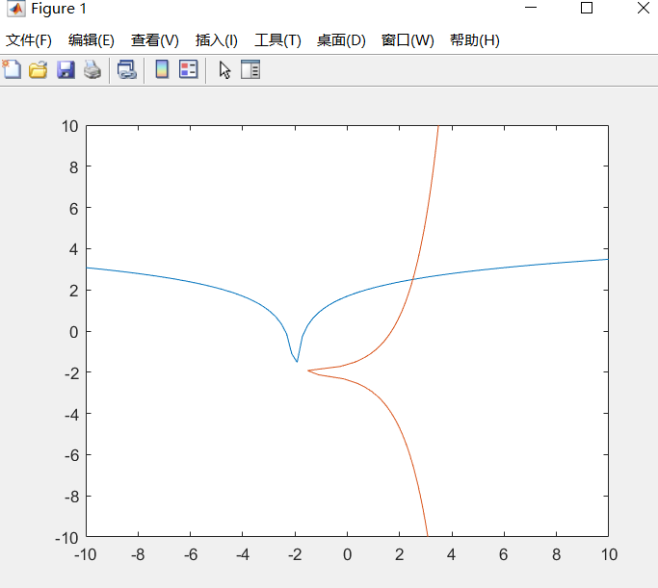

6、

x=-10:0.01:10;

y=(x.^2+1).^(1/3);

plot(x,y);

hold on;

plot(y,x);

hold on;

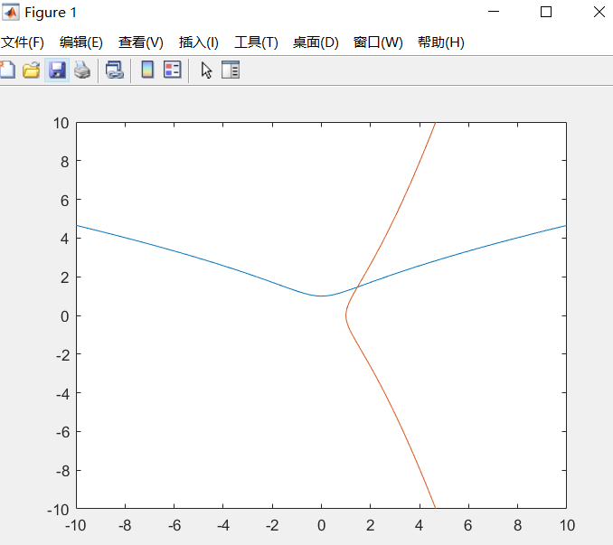

7、

t=-1:0.01:1;

x=t.^2;

y=t.^3;

plot3(x,y,t);

grid on;

hold on;

t=-2\*pi:0.01:2\*pi;

a=1;b=1;c=1;

x=a\*cos(t);

y=b\*sin(t);

z=c\*t;

plot3(x,y,z);

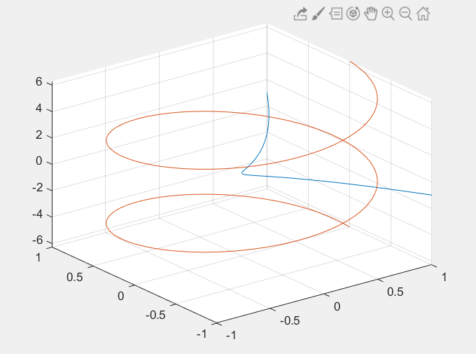

8、

theta=0:0.01:2\*pi;

a=1;

p=a.\*sin(theta);

polar(theta,p);

hold on;

p=exp(p);

polar(theta,p);

