1、

x=rand(1,100)\*100;

for i=1:100;

for j=100:-1:i+1;

if x(j-1)<x(j);

t=x(j);

x(j)=x(j-1);

x(j-1)=t;

end;

end;

end;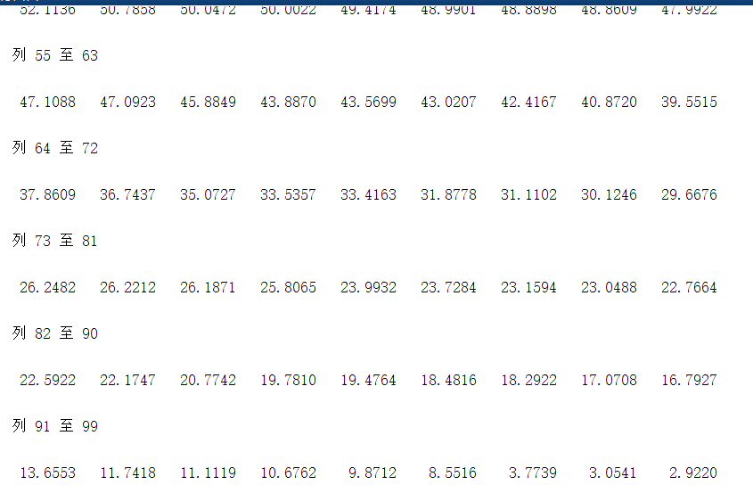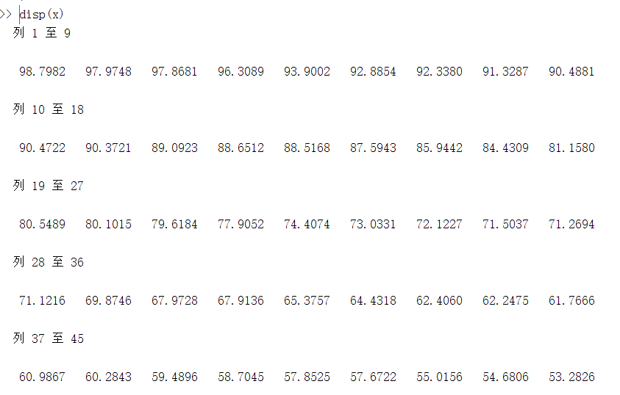

2、

x=rand(8,5);

max=0;

for i=1:8;

for j=1:5;

if x(i,j)>max

max=x(i,j);

end;

end;

end;

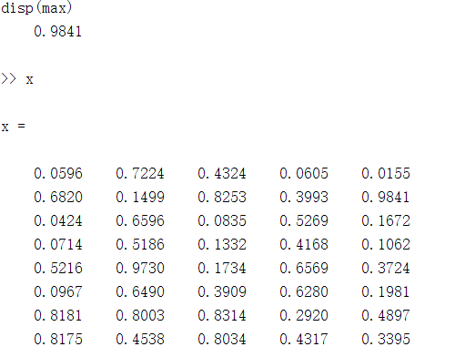

3、

result=0;

for i=1:50;

temp=1;

for j=1:i;

temp=temp\*j;

end;

result=result+temp;

end;

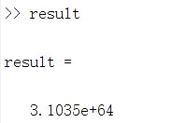

4、orign=100;

distance=0;

for i=1:10;

distance=distance+orign;

orign=orign\*2/3;

distance=distance+orign;

end;

disp(distance);

disp(orign);

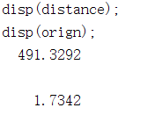

5、

function f=fun(t)

f=t(1)^2+sin(t(1)\*t(2))+2\*exp(t(2))

end

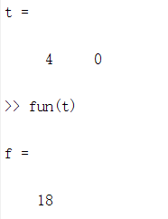

6、

e=1;

i=1;

deta=10^-10;

while (abs(e-exp(1))>deta)

e=e+vpa(1/factorial(i));

i=i+1;

end

e

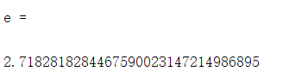

7、

deta=10^-8;

x=2:1:10000000;

y=((x+1)./x).^(x)-(x./(x-1)).^(x-1);

for i=1:1:9999999

if abs(y(i))<deta

break

end

end

temp=(1+1/i)^i;

vpa(temp)

