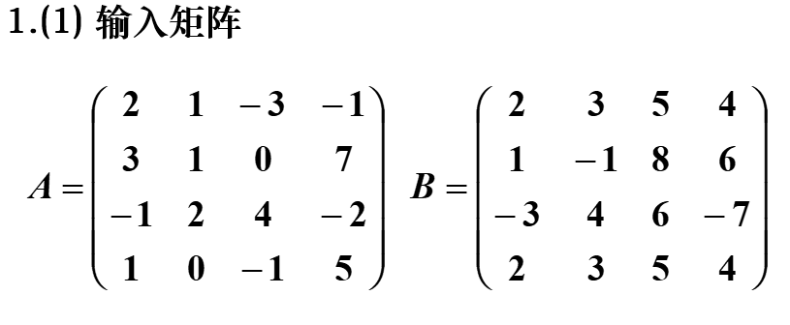

>> A=[2 1 -3 -1;3 1 0 7;-1 2 4 -2;1 0 -1 5]

A =

2 1 -3 -1

3 1 0 7

-1 2 4 -2

1 0 -1 5

>> B=[2 3 5 4;1 -1 8 6;-3 4 6 -7;2 3 5 4]

B =

2 3 5 4

1 -1 8 6

-3 4 6 -7

2 3 5 4



>> C=A-B

C =

0 -2 -8 -5

2 2 -8 1

2 -2 -2 5

-1 -3 -6 1

>> D=A+B

D =

4 4 2 3

4 0 8 13

-4 6 10 -9

3 3 4 9

>> E=A*B

E =

12 -10 -5 31

21 29 58 46

-16 5 25 -28

15 14 24 31

>> b=B'

b =

2 1 -3 2

3 -1 4 3

5 8 6 5

4 6 -7 4

>> dA=det(A)

dA =

-85

>> I_A=sym(inv(sym(A)))

I_A =

[ -4/85, 10/17, -23/85, -16/17]

[ 33/85, -6/17, 41/85, 13/17]

[ -19/85, 5/17, -3/85, -8/17]

[ -3/85, -1/17, 4/85, 5/17]



>> C=[A B]

C =

2 1 -3 -1 2 3 5 4

3 1 0 7 1 -1 8 6

-1 2 4 -2 -3 4 6 -7

1 0 -1 5 2 3 5 4



>> D=C([1 2 4],[3 5 7])

D =

-3 2 5

0 1 8

-1 2 5



>> E=C(:,[3 5])

E =

-3 2

0 1

4 -3

-1 2



>> eyeA=eye(size(A))

eyeA =

1 0 0 0

0 1 0 0

0 0 1 0

0 0 0 1

>> oneA=ones(size(A))

oneA =

1 1 1 1

1 1 1 1

1 1 1 1

1 1 1 1

>> zeroA=zeros(size(A))

zeroA =

0 0 0 0

0 0 0 0

0 0 0 0

0 0 0 0



>> dot=A([2],[3])

dot =

0

>> dot=A(2,3)

dot =

0

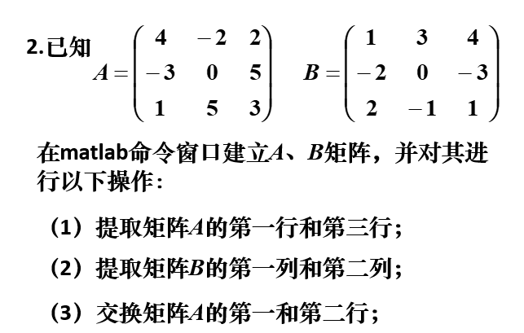

>> clear

>> A=[4 -2 2;-3 0 5;1 5 3]

A =

4 -2 2

-3 0 5

1 5 3

>> B=[1 3 4;-2 0 -3;2 -1 1]

B =

1 3 4

-2 0 -3

2 -1 1

(1)

>> x1=A([1 3], : )

x1 =

4 -2 2

1 5 3

(2)

>> y1=B( : ,[1 2])

y1 =

1 3

-2 0

2 -1

(3)

>> A([1 2],:)=A([2 1],:)

A =

-3 0 5

4 -2 2

1 5 3

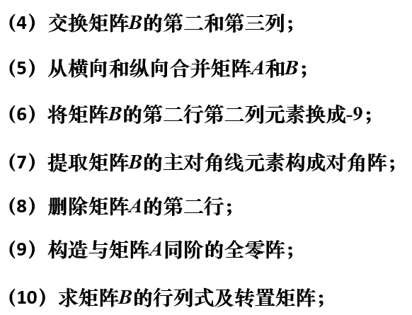

(4)

>> B( : , [2 3])=B( : ,[3 2])

B =

1 4 3

-2 -3 0

2 1 -1

(5)

>> transverse=[A B]

transverse =

-3 0 5 1 4 3

4 -2 2 -2 -3 0

1 5 3 2 1 -1

>> vertical=[A;B]

vertical =

-3 0 5

4 -2 2

1 5 3

1 4 3

-2 -3 0

2 1 -1

(6)

>> B(2,2)=-9

B =

1 4 3

-2 -9 0

2 1 -1

(7)

>> diag(diag(A))

ans =

-3 0

0 5

(8)

>> A(2,:)=[]

A =

-3 0 5

1 5 3

(9)

>> zeroA=zeros(size(A))

zeroA =

0 0 0

0 0 0

(10)

>> det(B)

ans =

49

>> B'

ans =

1 -2 2

4 -9 1

3 0 -1

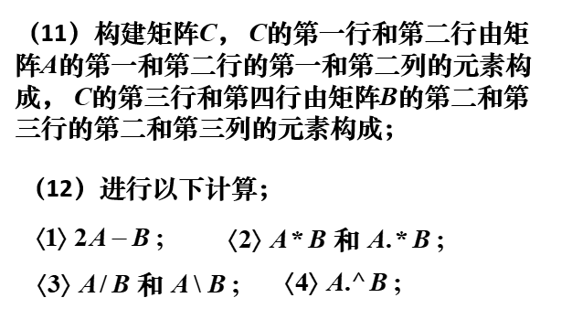

(11)

>> C=[A([1 2],[1 2]);B([2 3],[2 3])]

C =

-3 0

1 5

-9 0

1 -1

(12)

<1>

>> clear

>> A=[4 -2 2;-3 0 5;1 5 3];

>> B=[1 3 4;-2 0 -3;2 -1 1];

>> 2*A-B

ans =

7 -7 0

-4 0 13

0 11 5

<2>

>> A*B

ans =

12 10 24

7 -14 -7

-3 0 -8

>> A.*B

ans =

4 -6 8

6 0 -15

2 -5 3

<3>

>> sym(A)/sym(B)

ans =

[ 0, 0, 2]

[ -19/7, -8, -57/7]

[ 17/7, 3, 16/7]

>> sym(A)\sym(B)

ans =

[ 77/158, 65/158, 1]

[ 29/79, -34/79, 0]

[ -17/158, 39/158, 0]

<4>

>> A.^B

ans =

4.0000 -8.0000 16.0000

0.1111 1.0000 0.0080

1.0000 0.2000 3.0000

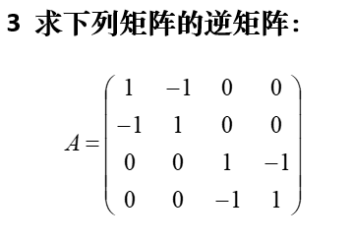

>> clear

>> a=[1 -1;-1 1];

>> A1=[a;zeros(size(a))];

>> A2=[zeros(size(a));a];

>> A=[A1 A2];

>> det(A)

ans =

0

矩阵为非奇异矩阵，不存在逆矩阵，下求伪逆

>> sym(pinv(A))

ans =

[ 1/4, -1/4, 0, 0]

[ -1/4, 1/4, 0, 0]

[ 0, 0, 1/4, -1/4]

[ 0, 0, -1/4, 1/4]

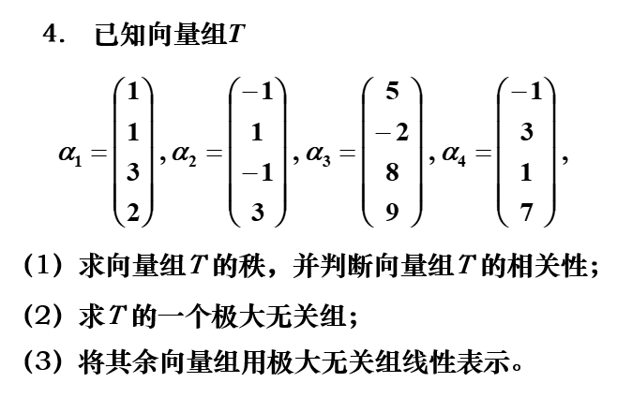

(1)

>> clear

>> A=[1 1 3 2;-1 1 -1 3;5 -2 8 9;-1 3 1 7];

>> A=A'

>> r=rank(A)

r =

3

向量组秩为3，线性相关

(2)

>> [R,jb]=rref(A)

R =

1.0000 0 0 1.0909

0 1.0000 0 1.7879

0 0 1.0000 -0.0606

0 0 0 0

jb =

1 2 3

极大无关组 $α1$、 $α2$、 $α3$

(3)

$$α4=1.0909α1+1.7879α2-0.0606α3$$

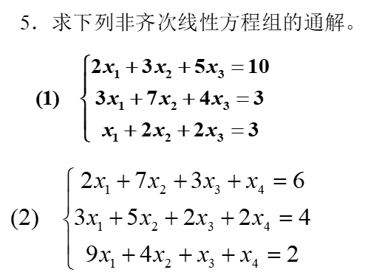

(1)

>> clear

>> A=[2 3 5;3 7 4;1 2 2];

>> b=[10;3;3];

>> C=[A b];

>> [rank(A),rank(C)]

ans =

3 3

方程组有唯一解

>> X=inv(A)*b

X =

3.0000

-2.0000

2.0000

方程组的解为：

x1=3

x2=-2

x3=2

(2)

>> clear

>> A=[2 7 3 1;3 5 2 2;9 4 1 1];

>> b=[6;4;2];

>> C=[A b];

>> [rank(A),rank(C)]

ans =

3 3

方程组有无数多个解

>> rref(C)

ans =

1.0000 0 -0.0909 0 -0.1818

0 1.0000 0.4545 0 0.9091

0 0 0 1.0000 0

>> sym(ans)

ans =

[ 1, 0, -1/11, 0, -2/11]

[ 0, 1, 5/11, 0, 10/11]

[ 0, 0, 0, 1, 0]

方程组的解为

$$x=k\left(\begin{matrix}-1/11 \\ 5/11 \\ 0\end{matrix}\right)+\left(\begin{matrix}-2/11 \\ 10/11 \\ 0\end{matrix}\right)$$

其中k为任意常数

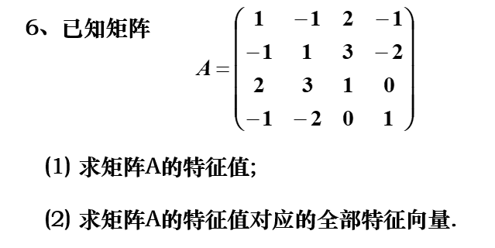

(1)

>> clear

>> A=[1 -1 2 -1;-1 1 3 -2;2 3 1 0;-1 -2 0 1];

>> [V,D]=eig(A)

V =

0.4412 -0.2042 -0.8328 0.2647

0.6012 0.1266 0.4853 0.6221

-0.5683 0.4886 -0.2227 0.6234

0.3477 0.8388 -0.1462 -0.3927

D =

-3.7266 0 0 0

0 0.9416 0 0

0 0 1.9420 0

0 0 0 4.8430

特征值为 $λ_{1}=-3.7266$， $λ_{2}=0.9416$， $λ_{3}=1.9420$， $λ_{4}=4.8430$

(2)

$k⋅\left(\begin{matrix}0.4412 \\ 0.6012 \\ -0.5683 \\ 0.3477\end{matrix}\right)$ k不为0

$λ_{1}$ 对应的特征向量为

$λ_{2}$ 对应的特征向量为

$k⋅\left(\begin{matrix}-0.2042 \\ 0.1266 \\ -0.4886 \\ 0.8388\end{matrix}\right)$ k不为0

$λ_{3}$ 对应的特征向量为

$k⋅\left(\begin{matrix}-0.8327 \\ 0.4853 \\ -0.2227 \\ -0.1462\end{matrix}\right)$ k不为0

$k⋅\left(\begin{matrix}0.2647 \\ 0.6221 \\ 0.6234 \\ -0.3927\end{matrix}\right)$ k不为0

$λ_{4}$ 对应的特征向量为

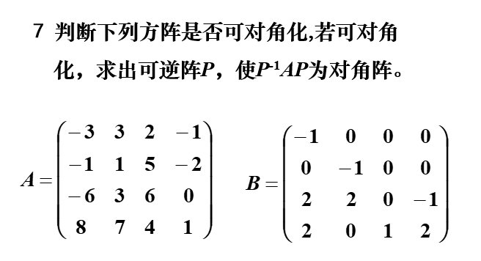

编写m文件trigle

function [flag,V] = trigle(A)

[m,n]=size(A);

if m~=n

flag=0;

return;

else

[V,D]=eig(A);

if rank(V)==n

flag=1;

return;

else

flag=0;

end

end

命令行输入

>> A=[-3 3 2 -1;-1 1 5 -2;-6 3 6 0;8 7 4 1];

>> [flag,V]=trigle(A)

flag =

1

V =

列 1 至 3

-0.5042 + 0.0000i 0.0462 + 0.2234i 0.0462 - 0.2234i

0.5841 + 0.0000i -0.0110 + 0.3621i -0.0110 - 0.3621i

-0.4912 + 0.0000i 0.0034 + 0.0582i 0.0034 - 0.0582i

0.4041 + 0.0000i 0.9018 + 0.0000i 0.9018 + 0.0000i

列 4

0.0887 + 0.0000i

0.1855 + 0.0000i

0.5332 + 0.0000i

0.8206 + 0.0000i

A可对角化，所求矩阵P为V

>> B=[-1 0 0 0;0 -1 0 0;2 2 0 -1;2 0 1 2];

>> trigle(B)

ans =

0

B不可对角化

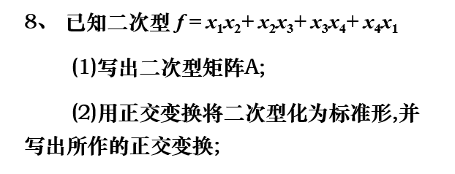

$$A=\left(\begin{matrix}0 & 0.5 & 0 & 0.5 \\ 0.5 & 0 & 0.5 & 0 \\ 0 & 0.5 & 0 & 0.5 \\ 0.5 & 0 & 0.5 & 0\end{matrix}\right)$$

(1)

(2)

>> clear

>> A=[0 0.5 0 0.5;0.5 0 0.5 0;0 0.5 0 0.5;0.5 0 0.5 0];

>> [P,T]=schur(A)

P =

0.5000 0.5000 0.5000 0.5000

-0.5000 0.5000 -0.5000 0.5000

0.5000 -0.5000 -0.5000 0.5000

-0.5000 -0.5000 0.5000 0.5000

T =

-1.0000 0 0 0

0 -0.0000 0 0

0 0 0.0000 0

0 0 0 1.0000

所做的正交变换为 $X=PY$

二次型的标准型为

$$f=x'Ax=y'P'APy=y'Ty=-y_{1}^{2}+y_{4}^{2}$$

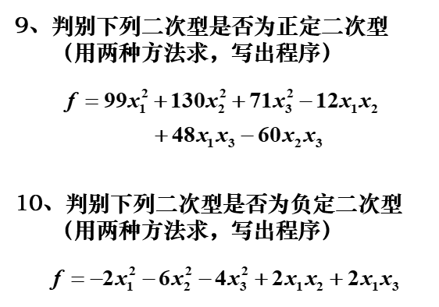

是正定二次型。

$$A=\left(\begin{matrix}99 & -6 & 24 \\ -6 & 130 & -30 \\ 24 & -30 & 71\end{matrix}\right)$$

编写m文件PDeigenvalue，用特征值是否全大于0判断是否正定

function [judge] = PDeigenvalue(A)

eigen=eig(A);

dim=size(eigen);

n=dim(1)*dim(2);

judge=1;

for i=1:1:n

if(eigen(i)<0)

judge=0;

end

end

编写m文件PD_LPM,用顺序主子式是否全大于0判断是否正定

function [judge] = PD_LPM(A)

n=size(A);

judge=1;

for i=1:n

w(i)=det(A(1:i,1:i));

if(w(i)<=0)

judge=0;

break;

end;

end

命令行输入

>> clear

>> A=[99 -6 24;-6 130 -30;24 -30 71];

>> PDeigenvalue(A)

ans =

1

>> PD_LPM(A)

ans =

1



不是负定二次型

$$A=\left(\begin{matrix}-2 & 1 & 1 \\ 1 & 6 & 0 \\ 1 & 0 & 4\end{matrix}\right)$$

编写m文件NDeigenvalue，用特征值是否全小于0判断负定

function [judge] = NDeigenvalue(A)

eigen=eig(A);

dim=size(eigen);

n=dim(1)*dim(2);

judge=1;

for i=1:1:n

if(eigen(i)>=0)

judge=0;

end

end

编写m文件ND_LPM,用顺序主子式是否偶数阶顺序主子式都大于零，而奇数阶顺序主子式都小于零判断是否负定

function [judge] = ND_LPM(A)

n=size(A);

judge=1;

for i=1:n

w(i)=det(A(1:i,1:i));

if(mod(i,2)==0)

if(w(i)<=0)

judge=0;

break;

end;

else

if(w(i)>=0)

judge=0;

break;

end;

end;

end

命令行输入

>> clear

>> A=[-2 1 1;1 6 0;1 0 4];

>> NDeigenvalue(A)

ans =

0

>> ND_LPM(A)

ans =

0