**Project MvcMusicStore notes**

To setup project edit config to be able to create a local database.

<add name="DefaultConnection" connectionString="Data Source=(localdb)\ProjectsV13;Initial Catalog=aspnet-MvcMusicStore-20131025034205;Integrated Security=True" providerName="System.Data.SqlClient" />

<add name="MusicStoreEntities" connectionString="Data Source=(localdb)\ProjectsV13;Initial Catalog=MusicStore;Integrated Security=True" providerName="System.Data.SqlClient" />

**Performance Counters:**

1. Performance counters are created programmatically on application start (requires starting VS as an administrator)

2. To track the counters:

a. Open Performance Monitor (default Windows application)

b. Click “Performance Monitor” menu

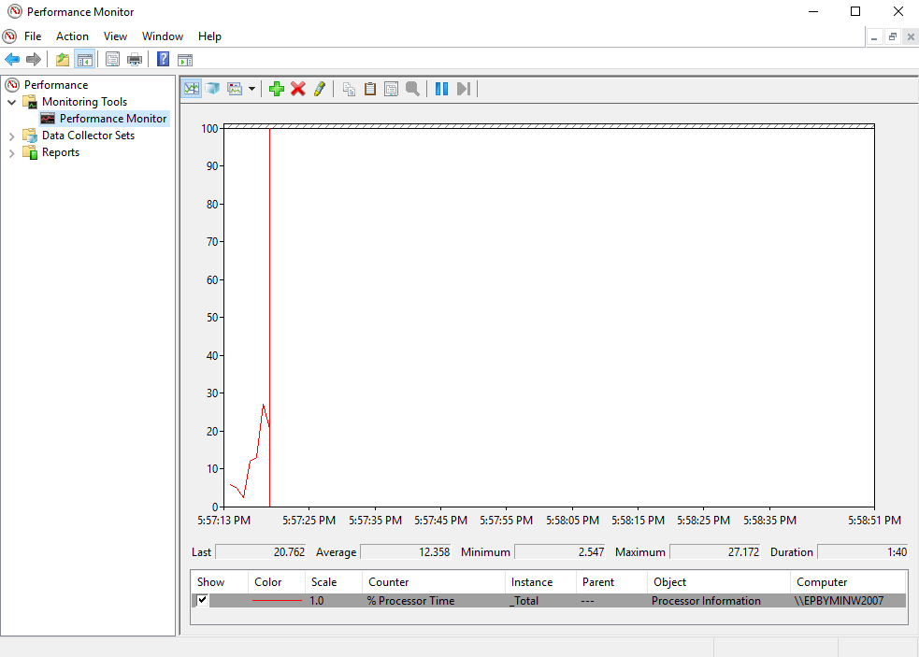

c. Click “+” on the menu on top and select “CustomCounter” from Available counters window

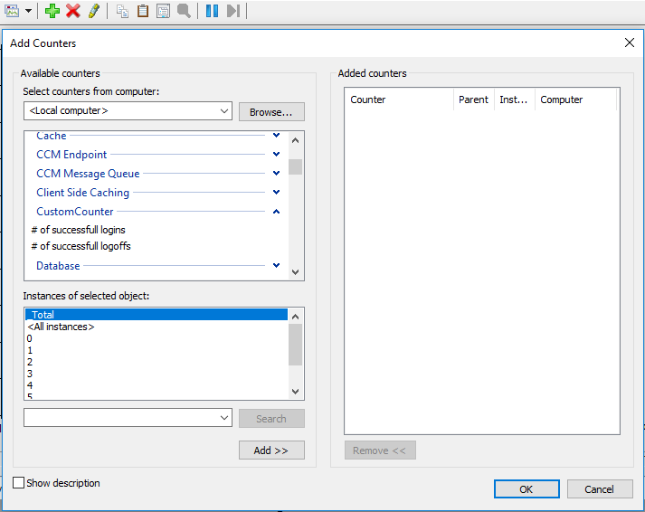

d. Add all the counters in this category

e. For better looking change the color of the counters

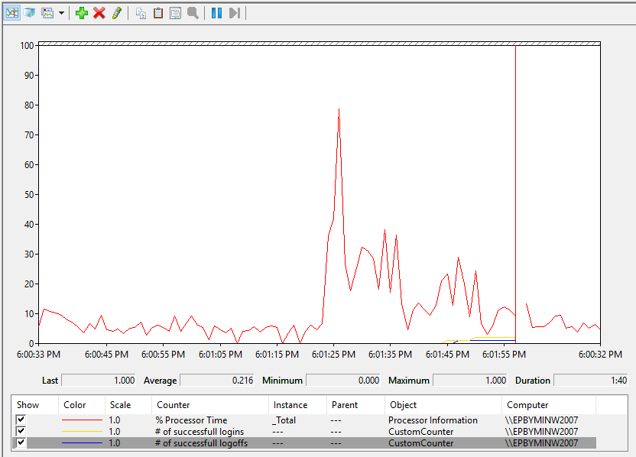

**Logging:**

Logs are stored in **(projectlocation)**\MvcMusicStore\mvcstorelogs.xml

To enable/disable logging edit in MvcMusicStore web config file the following line:



**Logs analyze:**

Must have LogParser 2.2 installed and referenced in the project (MvcMusicStore.Console) manually.

To start the log analyzing specify the log file path in MvcMusicStore.Console config file

