Red hood’s adventure

Game type: 2D platformer

Introduction

Our team doesn’t really have any experience using unity, however we have decided to take on the challenge and make a platformer. We will base our gameplay on [hollow knight](https://www.hollowknight.com/?msclkid=97dcabdac54a11ecbf7109fffd02332d) and our story will be loosely based on red riding hood.

Rationale

We will try implementing gravity and movement mechanics as well as basic enemy movements and attacks to our game. All this packed into a platformer game. Given the limited time, the mechanics might not be fully fledged.

Competitor analysis

Since our game will mostly be based on [hollow knight](https://www.hollowknight.com/?msclkid=97dcabdac54a11ecbf7109fffd02332d), it would only be logical that this is our main competitor. Hollow knight has got beautiful visuals and vibrant colours that contrast well with the dark background. We have tried replicating this in our game using the assets we found. Another example of a competitor would be [ori and blind forest](https://store.steampowered.com/app/261570/Ori_and_the_Blind_Forest/?msclkid=ca232137c54a11eca40a0dbb3e8af019) but we got less of a focus on storytelling, instead we chose to focus on gameplay.

Story

Everyone knows the story of the red riding hood. We decided to add a twist to it as on her way to her grandma’s house, she decides to not take her mother’s advice and she goes through the dark forest. However, she has a way to get rid of the dangers that may lurk in the dark forest…

Gameplay

Make your way through the map as you jump from platform to platform, using your attack to clear the area of enemies. Your objective is to make it to grandma safely. 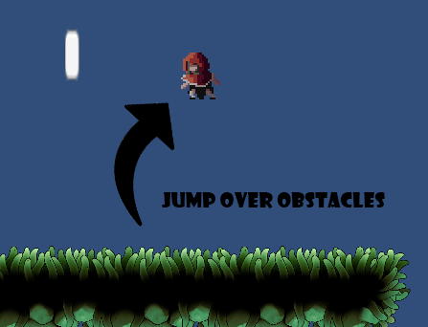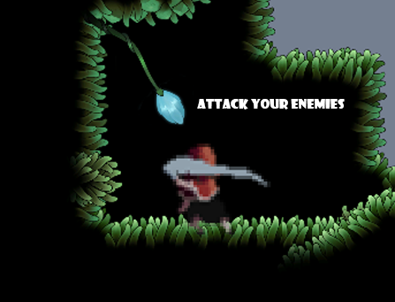

USP

What makes our game unique is the way you can relive the famous story from your childhood and interact with the environment of the world in which the story takes place while playing a relaxing game.

Game Elements

Main character



Enemies



Location

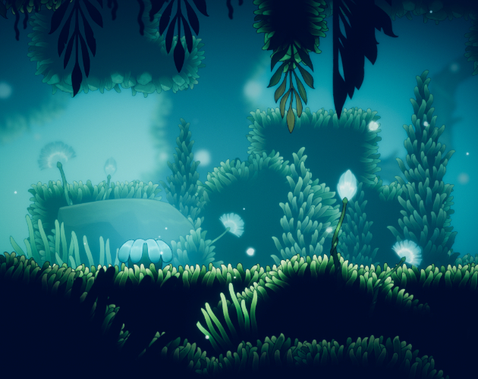

Level design

