Batterijen:
- N. Seidle, „Battery Technologies,” SparkFun Electronics, 2016. [Online]. Available: https://learn.sparkfun.com/tutorials/battery-technologies/lithium-polymer.
- „Lithium polymer battery,” Wikimedia Foundation, Inc., 13 5 2017. [Online]. Available: https://en.wikipedia.org/wiki/Lithium_polymer_battery.
- S. W. Moore en P. J. Schneider, „A Review of Cell Equalization Methods for Lithium Ion and Lithium Polymer Battery Systems,” SAE Technical paper 2001-01-0959, 2001.
https://nl.wikipedia.org/wiki/Lithium-ion-polymeer-accu

http://www.manoonpong.com/Other/main_page=page_2.pdf They also have a low self-discharge rate, which is about 5% per month
En geven 4 keer meer stroom dan NiCd en NImH batterijen
https://www.jauch.com/downloadfile/5c5050fa5b6510e9a8ad76299baae4e53/white_paper_introduction_to_lipo_battery_technology_11-2018_en.pdf ==> geven iets meer stroom dan Litium-ion batterijen

https://nl.wikipedia.org/wiki/Oplaadbare_batterij tabel met vergelijking van verschillende soorten batterijen Energiedichtheid vs vermogensdichtheid

https://nl.wikipedia.org/wiki/Energiedichtheid Energiedichtheid
https://nl.wikipedia.org/wiki/Vermogensdichtheid Vermogensdichtheid
https://www.conrad.nl/info/inspiration/batterijen-en-opladers/het-memory-effect-bij-batterijen ==> Lipo heeft geen geheugeneffect
https://www.replacedirect.be/nl/batterij-technieken/lithium-polymeer-batterijen.html Het geheugeneffect

Security (MavLink)
- K. Domin, „Security Analysis of the Drone Communication Protocol: Fuzzing the MAVLink Protocol,” 2016.
- Alhawi, O.M., Mustafa, M.A., & Cordeiro, L.C. (2019). Finding Security Vulnerabilities in Unmanned Aerial Vehicles Using Software Verification. ArXiv, abs/1906.11488.
- Defense Techniques Against Cyber Attacks on Unmanned Aerial Vehicles, https://csce.ucmss.com/cr/books/2018/LFS/CSREA2018/ESC4302.pdf
- „Marshalling / communication library for drones.,” Github Corporation, 16 5 2017. [Online]. Available: https://github.com/mavlink/mavlink. [Geopend 18 5 2017].
- “MavLink”, Wikipedia [Online]. Available: https://en.wikipedia.org/wiki/MAVLink
- https://www.dji.com/be/aeroscope ==> DJI biedt dit aan om drone te onderscheppen.
- https://scholarworks.sjsu.edu/cgi/viewcontent.cgi?article=8423&context=etd_theses Goed voor verdere uitbreiding, best niet behandelen. Te diepgaand voor een bachelorproef.
- https://mavlink.io/en/services/heartbeat.html
- https://ardupilot.org/planner/

!!!! QGroundControl User Guide in de methodologie kan je dit gebruiken om te communiceren met mavlink

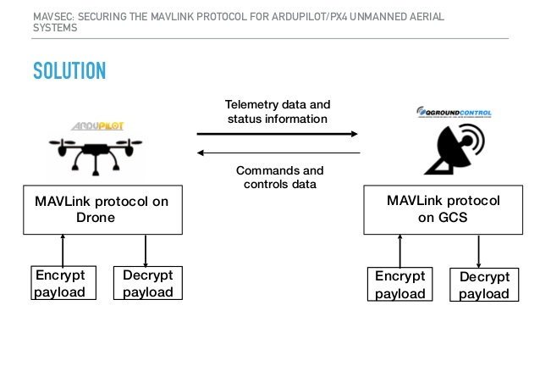
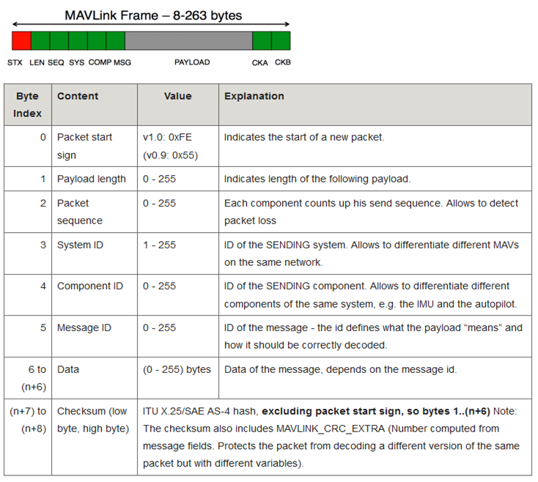Detectie van objecten en doorsturen van data
- Moeyersons, Jerico, Maenhaut, P.-J., De Turck, F., & Volckaert, B. (2018). Aiding first incident responders using a decision support system based on live drone feeds. In Jian Chen, Y. Yamada, M. Ryoke, & X. Tang (Eds.), Knowledge and Systems Sciences (pp. 87–100). Presented at the KSS2018, Knowledge and Systems Sciences, Singapore: Springer Singapore.
- Bishop, C.M.: Pattern Recognition and Machine Learning. Springer (2006). https://doi.org/10.1117/1.2819119
- Tijtgat, N., Volckaert, B., & De Turck, F. (2017). Real-time hazard symbol detection and localization using UAV imagery. 2017 IEEE 86TH VEHICULAR TECHNOLOGY CONFERENCE (VTC-FALL) (pp. 1–6). Presented at the 86th IEEE Vehicular Technology Conference (VTC-Fall) .
- Moeyersons, J., Verhoeve, B., Maenhaut, P.-J., Volckaert, B., & De Turck, F. (2019). Pluggable drone imaging analysis framework for mob detection during open-air events. Proceedings of the 8th International Conference on Pattern Recognition Applications and Methods (pp. 64–72). Presented at the ICPRAM2019, the 8th International Conference on Pattern Recognition Applications and Methods.
- “OpenCV: Introduction.” [Online]. Available: https://docs.opencv.org/4.1.1/d1/dfb/intro.html

Swarm
- Mac Thi, T., Copot, C., Duc, T. T., & De Keyser, R. (2016). AR.Drone UAV control parameters tuning based on particle swarm optimization algorithm. PROCEEDING OF 2016 IEEE INTERNATIONAL CONFERENCE ON AUTOMATION, QUALITY AND TESTING, ROBOTICS (AQTR) (pp. 475–480). Presented at the IEEE International Conference on Automation, Quality and Testing, Robotics (AQTR).
- A.L. Alfeo, M.G.C.A. Cimino, N. De Francesco, A. Lazzeri, M. Lega, G. Vaglini, "Swarm coordination of mini-UAVs for target search using imperfect sensors", Intelligent Decision Technologies, IOS Press, Vol. 12, Issue 2, Pages 149-162, 2018 The final publication is available at IOS Press through http://dx.doi.org/10.3233/IDT-170317

Detection in verschillende omstandigheden (nacht, mistig, schaduw)

- González, A., Fang, Z., Socarras, Y., Serrat, J., Vázquez, D., Xu, J., & López, A. (2016). Pedestrian Detection at Day/Night Time with Visible and FIR Cameras: A Comparison. Sensors, 16(6), 820. doi:10.3390/s16060820
- A. Broggi, "Robust real-time lane and road detection in critical shadow conditions," Proceedings of International Symposium on Computer Vision - ISCV, Coral Gables, FL, USA, 1995, pp. 353-358.

