Power Supply

Variable supply

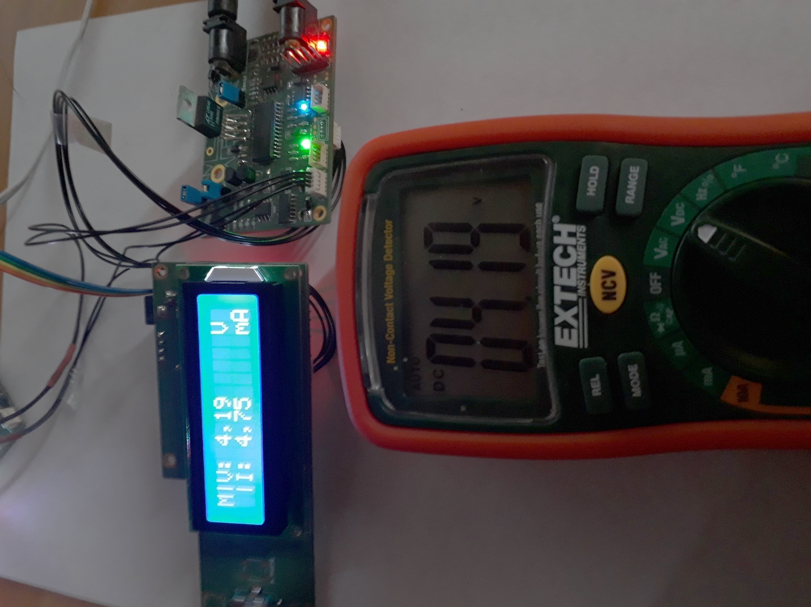

## Description

The design is split into two circuits: supply and controller. The supply circuit contains a microcontroller which controls the voltage and current of a linear voltage regulator. Said supply board receives instructions from the controller circuit, which on its turn is steered by a rotary push button or a serial interface connected to an external computer application.

Specs:

* Input voltage: 12V
* Output voltage: 0.7V to 10V (0.1V accuracy)
* Output current: 0A to 1.5A (10mA accuracy)
* Current and temperature limiting

## State

PCBs are created and tested. The specs were met with a better accuracy than anticipated.  
Next steps:

* Creating (plexiglass) case
* Add GUI to external computer application
* PID and calibration finetuning
* Increase Vout to 30V, Iout to 3A

## details

The controller board sends the desired Vout and Imax to the supply board via I²C, meanwhile it receives the measured Vout and Iout. The rotary push button enables the user to change these values, which are displayed on the LCD of the controller board. Apart from the rotary button, the controller board can receive input from a UART serial port.

The output signal of 12-bit DAC (MCP4922, SPI controlled) is amplified (TLC272) and applied to the SET pin of the linear regulator (LT3081). The current is limited by a comparator controlling a switch which grounds the SET pin if needed. The inputs of this comparator are taken from the DAC and the measured input current (MAX4080). Temperature and current monitored by the regulator, current measured by current sensor and an attenuated output voltage are fed back to the microcontroller (dsPIC33EP) which samples these signals with a 10-bit ADC (DMA enabled).

The supply can be put in a calibration state where set points from 0V to 10V are applied to the circuit. The microcontroller stores the actual needed DAC values for each desired output. In a next phase these calibration values can be interpolated and applied to the DAC.

## MISC

#### Periode

2018 - Heden

#### GitHub

<https://github.com/WouterThys/PowerSupply>