Bluetooth sleutelhanger: prototype

**Korte beschrijving:**

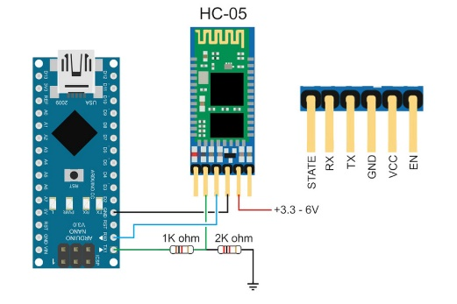Een sleutel hanger die met bluetooth in verbinding staat met een zeer eenvoudige app op de Android gsm. Wanneer de verbinding verbroken wordt en dus de sleutelhanger ‘kwijt’ is, dan zal deze een geluid maken en zal er eveneens een melding worden weergegeven op de gsm. Een doel is dit zo compact en gebruiksvriendelijk mogelijk te maken.

**Onderdelen**

* Arduino pro micro OF Aruino Nano
* BT-module
* App (Android)
* Jumping wires
* Breadboard
* Buzzer

**Uitvoering:**

Software:

Arduino-code: 2u

Android-code: 5u

Hardware:

Assemblage: 5u

Testen: Variabel (1u-5u)

**Links en referenties:**

<https://nl.aliexpress.com/item/32496218488.html?src=google&src=google&albch=shopping&acnt=494-037-6276&isdl=y&slnk=&plac=&mtctp=&albbt=Google_7_shopping&aff_platform=google&aff_short_key=UneMJZVf&&albagn=888888&albcp=1706100219&albag=73428776544&trgt=539263010115&crea=nl32496218488&netw=u&device=c&gclid=CjwKCAiA8K7uBRBBEiwACOm4d6tMyHT98f0C07l8P77NK0040B_3o27HdXHx4SFLDdNPFsKEokyAUBoCWusQAvD_BwE&gclsrc=aw.ds> (BT serial adapter, HC-05)

<https://chipolo.net/en/pages/chipolo-collection?gclid=CjwKCAiA8K7uBRBBEiwACOm4d6ATifef-coI086Yu51OyTuDMhj4ErbLwj0uBIm4DSo_KrvbCgI8DhoCdtYQAvD_BwE> (Existing device)

<https://www.banggood.com/Geekcreit-ATmega328P-Arduino-Compatible-Nano-V3-Module-Improved-Version-No-Cable-Development-Board-p-959231.html?rmmds=search&cur_warehouse=CN> (Arduino Nano, long delivery time, low price)

<https://store.arduino.cc/arduino-nano> (Arduino Nano, short delivery time, high price)

<https://www.aliexpress.com/item/32341751484.html?spm=a2g0o.productlist.0.0.dedb1723rleS21&s=p&algo_pvid=5bdfe2ca-88e6-4859-88aa-a86a2cd4f83c&algo_expid=5bdfe2ca-88e6-4859-88aa-a86a2cd4f83c-0&btsid=fd936032-a5c5-48c7-acd1-60d4145b38b5&ws_ab_test=searchweb0_0,searchweb201602_6,searchweb201603_52> (Arduino Mini, long delivery time, low price)

<https://store.arduino.cc/arduino-micro> (Arduino micro, short delivery time, high price)

<https://nl.banggood.com/10pcs-Pro-Micro-5V-16M-Mini-Leonardo-Microcontroller-Development-Board-For-Arduino-p-1089562.html?gmcCountry=BE&currency=EUR&createTmp=1&utm_source=googleshopping&utm_medium=cpc_bgs&utm_content=xibei&utm_campaign=xibei-ssc-beg-nl-all-0910-13anv&gclid=CjwKCAiAuK3vBRBOEiwA1IMhutSvHkEH0dfWghM7-U8sJ6kS7XCWPzc8hk8pqMF4PLpgX82Rj1ySHBoC5NcQAvD_BwE&cur_warehouse=UK> ( 10 x Arduino pro micro, long delivery time, low price)

<https://www.banggood.com/3-24V-Piezo-Electronic-Tone-Buzzer-Alarm-95DB-Continuous-Sound-p-919348.html?rmmds=search&cur_warehouse=CN> (Buzzer 1, long delivery time, low price, 95dB)

<https://www.banggood.com/5-PCS-Super-Loud-5V-Active-Alarm-Buzzer-Beeper-Tracker-95_5mm-for-Racing-Drone-p-1117207.html?rmmds=search&cur_warehouse=CN> (Buzzer 2, long delivery time, low price, “Super Loud”)