Hotel Management System
Database Project – Phase 1
Course Code | CSC 380
Course Name | Database Systems
Project Title | Hotel Management System
Student Name(s) | Mohammad Alkhenizan  Naif Almutairi
Student ID(s) | 443102405  …
Submission Date | 18 / 4 / 2026

1. Project Subject
The subject chosen for this project is a Hotel Management System This system is designed to manage the daily operations of a hotel from rooms to reservations to employee

We desined the database to help this hotel function good and manage guests/rooms/etc..

2. Project Description

The Hotel Management System is a database application that manages the core operations of a hotel

Each Hotel has a name, address, city, and phone number, and contains many Rooms . Each room stores its number, floor, type (Single, Double, Suite), price per night, capacity, and status

Guests are the customers who stay at the hotel. Each guest has a name, email, phone, and nationality, with email and phone required to be unique. A guest can make multiple Reservations, but each reservation belongs to one guest (one-to-many)

A Reservation records a booking with its dates and status (confirmed, checked-in, checked-out, or cancelled). Since a reservation can include multiple rooms, and a room can appear in many reservations over time a Reservation_Room junction entity resolves this many-to-many relationship and stores the price at the time of booking

Every reservation generates exactly one Invoice (one-to-one), which records the total amount, payment method, payment status, and issue date

Each hotel also employs many Employees (one-to-many), where each employee has a name, role (e.g., receptionist, housekeeper, manager), salary

2.1 Constraints
- Every primary key is auto-generated, unique, and NOT NULL.
- Guest email and phone number must be unique across the system.
- Reservation status is restricted to a predefined set of values.
- Room number must be unique within the same hotel.
- Each invoice must reference exactly one reservation.

2.2 Relationship Summary
Relationship | Type | Description
Hotel – Room | 1 : M | A hotel contains many rooms; each room belongs to one hotel.
Hotel – Employee | 1 : M | A hotel employs many employees; each employee works at one hotel.
Guest – Reservation | 1 : M | A guest makes many reservations; each reservation has one guest.
Reservation – Invoice | 1 : 1 | Each reservation generates exactly one invoice.
Reservation – Room | M : N | A reservation can include many rooms; a room can appear in many reservations (resolved via Reservation_Room).

3. Entity-Relationship (ER) Diagram
The following Entity-Relationship (ER) diagram illustrates the complete structure of the Hotel Management System database, including all entities, attributes,keys, and the relationships among them
It was made by Drawio

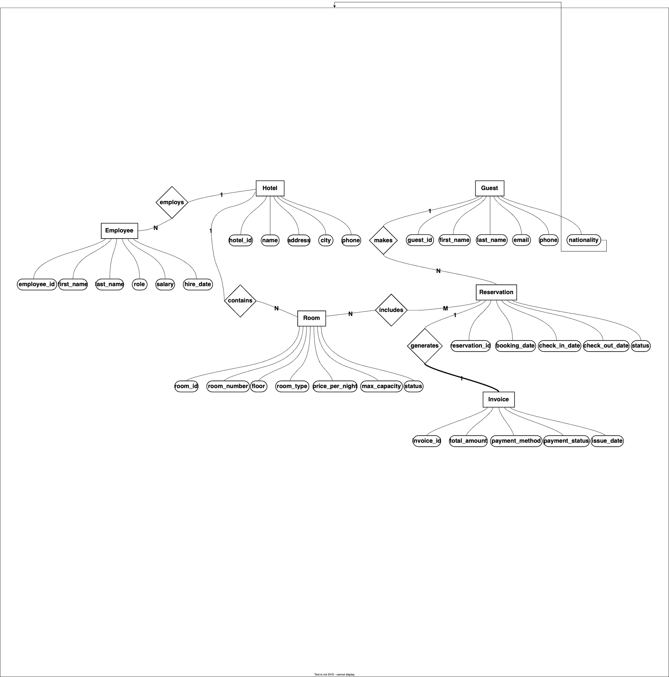

4. Relational Schema
The ER diagram is mapped into the following relational schema. Primary keys are underlined (indicated by PK), foreign keys are marked with FK, and unique constraints are marked with UK. Each foreign key references the primary key of its parent table.

4.1 Schema Notation
Hotel ( hotel_id, name, address, city, phone )
PK
FK

Room ( room_id, room_number, floor, room_type,
PK
price_per_night, max_capacity, status,
hotel_id)
FK
PK
Guest ( guest_id, first_name, last_name,
email, phone, nationality )
FK

Reservation ( reservation_id, booking_date,
PK
check_in_date, check_out_date, status,
guest_id )
FK
FK

Reservation_Room ( reservation_id, room_id, price_at_booking)
PK
FK

Invoice ( invoice_id, reservation_id, total_amount, payment_method, payment_status,
PK
issue_date)

Employee ( employee_id, first_name, last_name,
PK
role, salary, hire_date,
hotel_id)

4.2 Constraints Summary
- Primary Keys: All PKs are NOT NULL, UNIQUE
- Foreign Keys: Each FK references the PK of its parent table
- Unique Constraints: email and phone in Guest and reservation_id in Invoice
- NOT NULL: All PKs, FKs, and essential attributes (names, dates, amounts) are declared NOT NULL

5. SQL Schema
The SQL schema will be generated using MySQL Workbench's Forward Engineering feature. After constructing the EER diagram in MySQL Workbench, the CREATE TABLE statements (along with all primary key, foreign key, unique, and not null constraints) will be exported and included in this section of the final report.
[ To be inserted after running Forward Engineering in MySQL Workbench. ]

6. Technical Environment
The following table describes the technical environment planned for the development of this project.
Component | Tool / Specification
Database Management System (DBMS) | MySQL 8.x
Database Design Tool | MySQL Workbench (for EER diagram & Forward Engineering)
ER Diagram Tool | Draw.io (diagrams.net)
Operating System | Windows 10 / 11
Documentation Tool | Microsoft Word
Query Language | SQL (Structured Query Language)

