### Experience

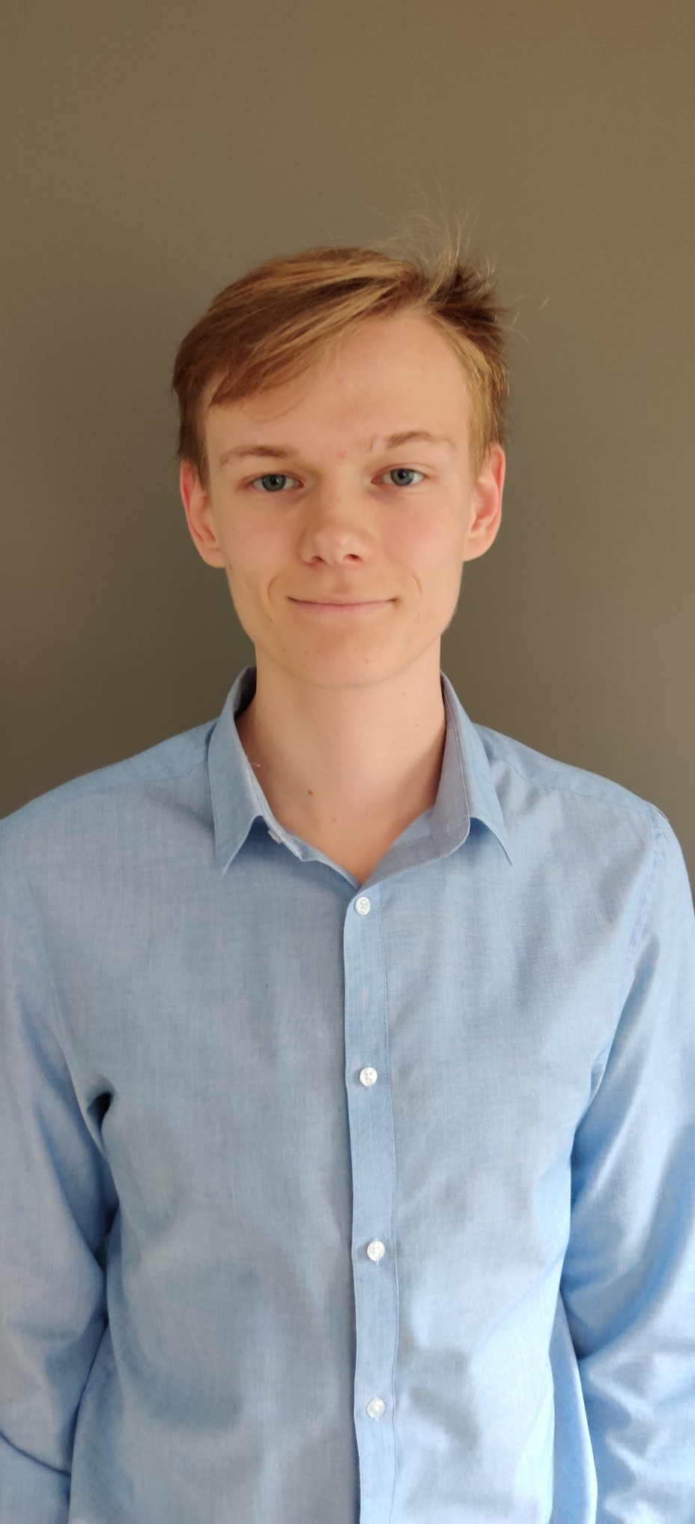

Wout Vinckevleugel

Student Applied Informatics

# Objective

My dream is to become a Software Engineer to help the software of today to the next level.

## Skills & Abilities

Soft skills: Team player, listener, analytical, logical thinker

Developing skills: Java, .NET, SQL, Angular,…

Tools: IntelliJ IDEA, Visual Studio, VS Code, …

## Vitals

Plantijnlei 17  
2900 Schoten, Belgium

**E** [wout.vinck@gmail.com](mailto:wout.vinck@gmail.com)

 <https://www.linkedin.com/in/wout-vinckevleugel/>

#### Melexis, Tessenderlo

##### Februari-mei 2022

Internship as software developer in Typescript

#### Lunch Garden, burcht

##### July 2021

Student job as cashier

#### A-Concept interim, Antwerp

##### January 2020

Student job as steward, Making sure everyone follows the rules during the Covid-19 pandemic

#### Water-Link, Antwerp

##### August 2019

Student job as ICT Helpdesk employee

#### FTC, Deurne

##### February – March 2019

Hardware internship, making pc builds for schools

### Education

#### AP College/University Antwerp, Bachelor’s degree Applied Informatics

Finished September 2022

#### Atheneum Schoten, High school diploma

Last two years of high school IT Management

### Languages

#### Dutch

Native language

#### English

Fluent speaking and writing (IELTS still to be done)

#### French

Basic speaking and writing