# QuickGraph

**Link:** <https://archive.codeplex.com/?p=quickgraph>

**Beschreibung:**

* C# Library für gerichtete/ ungerichtete Graph-Datenstrukturen
* mit verschiedenen Algorithmen

**Beispiele:**

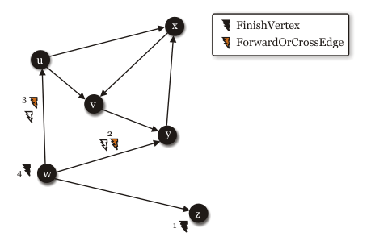

# Microsoft Automatic Graph Layout

**Link:** <https://www.microsoft.com/en-us/research/project/microsoft-automatic-graph-layout/>

**Beschreibung:**

* Zoom und Verschieben des erstellten Graphen möglich
* Navigation durch Graph möglich
* Tooltips konfigurierbar (z.B. Use Case Beschreibung)
* Highlighting von Teilen des Graphen möglich
* Suchen im Graph möglich
* Nur für Windows Forms! Portierung nach WPF nötig!

**Beispiele:**

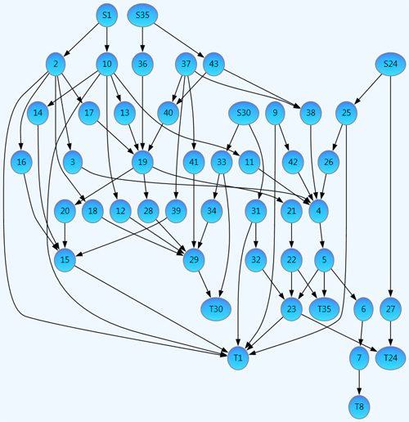

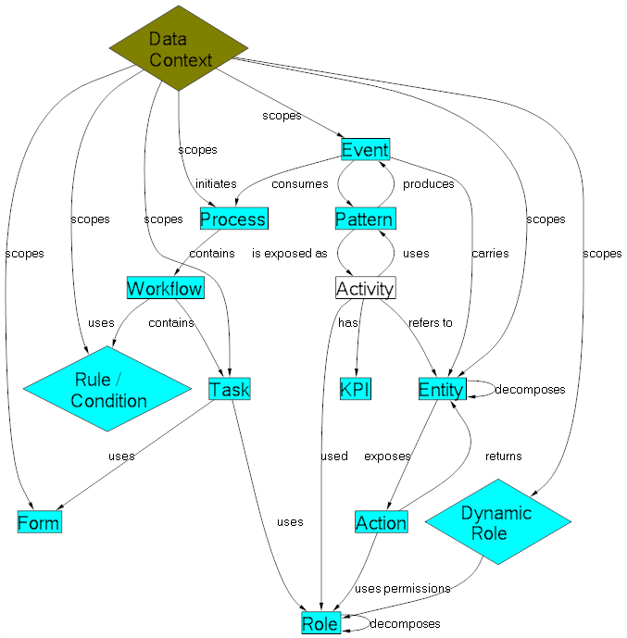

Graphviz - Graph Visualization Software

**Link:** <http://www.graphviz.org/about/>

**Beschreibung:**

* Zoom und Verschieben des erstellten Graphen möglich
* Navigation durch Graph möglich
* Tooltips konfigurierbar (z.B. Use Case Beschreibung)
* Highlighting von Teilen des Graphen möglich
* Suchen im Graph möglich

**Beispiele:**

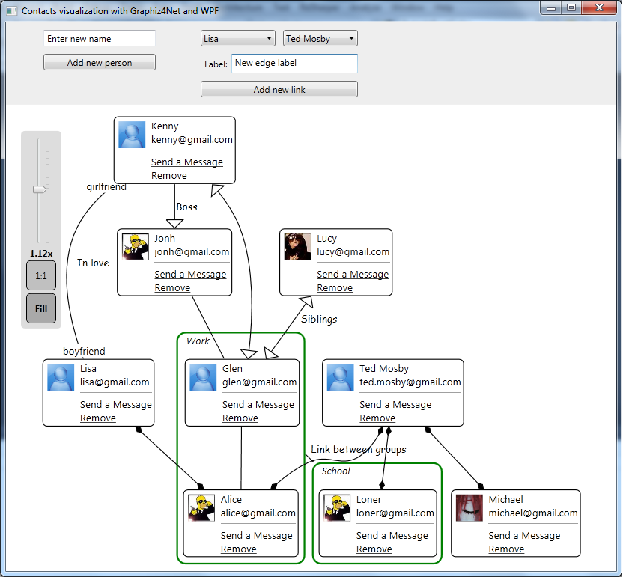

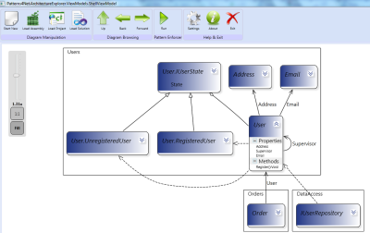

Graph#

**Link:** <https://archive.codeplex.com/?p=graphsharp>

**Beschreibung:**

* Basierend auf quickgraph
* Navigation durch Graph möglich
* Tooltips konfigurierbar (z.B. Use Case Beschreibung)
* Highlighting von Teilen des Graphen möglich
* Suchen im Graph möglich

**Beispiele:**

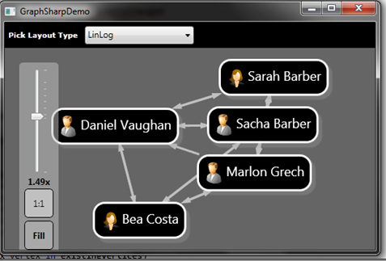

GraphX

**Link:** <http://www.panthernet.org/>

**Beschreibung:**

* Basierend auf Graph#
* Navigation durch Graph möglich
* Tooltips konfigurierbar (z.B. Use Case Beschreibung)
* Highlighting von Teilen des Graphen möglich
* Suchen im Graph möglich

**Beispiele:**



# Option 1: Microsoft Automatic Graph Layout

Free

<http://research.microsoft.com/en-us/projects/msagl/>

**GitHub**

<https://github.com/Microsoft/automatic-graph-layout.git>

**Winforms >> WPF**

It's WinForms, but it can be imported into WPF with a few lines of code.

**Visualizing Nodes and Edges with Microsoft Automatic Graph Layout**

<http://www.codeguru.com/csharp/.net/net_wpf/article.php/c16963/Visualizing-Nodes-and-Edges-with-Microsoft-Automatic-Graph-Layout.htm>

**Beispiele**

<http://research.microsoft.com/en-us/projects/msagl/#Layouts>

**FAQ**

<http://research.microsoft.com/en-us/projects/msagl/faq.aspx>

# Option 2: QuickGraph - A 100% C# graph library with Graphviz Support

Free

<http://quickgraph.codeplex.com/>

This library is 100% C#. Don't be misled by the line "Graphviz Support", this means that it uses C# code to import the output from Graphviz. No C++ code in sight.

<http://www.codeproject.com/Articles/5603/QuickGraph-A-C-graph-library-with-Graphviz-Sup>

Has a NuGet package.

Under development from 2003 to 2011 (8 years!!).

# Option 3: GraphSharp

Free

<http://graphsharp.codeplex.com/>

* Depends on QuickGraph (which is 100% C#).
* Supports async/await (nice!).

**Demo**

<https://sachabarbs.wordpress.com/2010/08/31/pretty-cool-graphs-in-wpf/>

**Notes**

This one worked really well, was up and running in a couple of hours. It also supports DataTemplates, so each node can have any look and feel that you want.

# Option 4: Graphviz4net

Free

<http://graphviz4net.codeplex.com/>

# Option 5: Using WPF to Visualize a Graph with Circular Dependencies

Free

<http://www.codeproject.com/Articles/43776/Using-WPF-to-Visualize-a-Graph-with-Circular-Depen>

# Option 6: GraphViz

Free

<http://www.graphviz.org/Download..php>

This is not C#, and uses non-managed code. There are C# wrappers for it, however.

Opensourced by AT&T, see "AT&T Researchers — Inventing the Science Behind the Service", and "research home > portfolio > software tools": <http://www.research.att.com/software_tools?fbid=NEk8_gxLLEc>

**Source**

<http://www.graphviz.org/Download_source.php>

They also open sourced Rserve!

# Option 7: Shields.GraphViz

Free

Wrapper for GraphViz.

<https://github.com/timothy-shields/graphviz>

# Option 8: NetworkView: A WPF custom control for visualizing and editing networks, graphs and flow-charts

Free

<http://www.codeproject.com/Articles/182683/NetworkView-A-WPF-custom-control-for-visualizing-a>

This library allows the user to create connections between nodes, which is probably a bit of an overkill.

**Example**

<https://channel9.msdn.com/coding4fun/blog/Noodling-Network-Nodes-Diagraming-with-the-NetworkView-custom-WPF-control>

It's all MVVM.

# Option 9: Gephi - The Open Graph Viz Platform

Free

See <http://gephi.github.io/>

Not a WPF graphing library, but provides great Examples of how really nice graphs can look. The tutorial is excellent.

# Option 10: WPF Diagram Designer

Free

Not so much graphing tool, but it does show you how to move, resize and rotate objects of any type on a canvas.

<http://www.codeproject.com/Articles/22952/WPF-Diagram-Designer-Part-1>

# Option 11: Dot2WPF

Free

A WPF control for viewing DOT graphs.

<http://www.codeproject.com/Articles/18870/Dot-WPF-a-WPF-control-for-viewing-Dot-graphs>