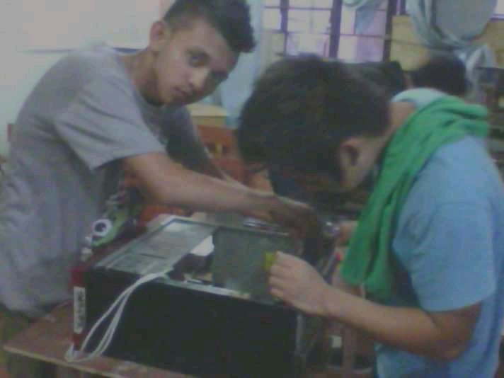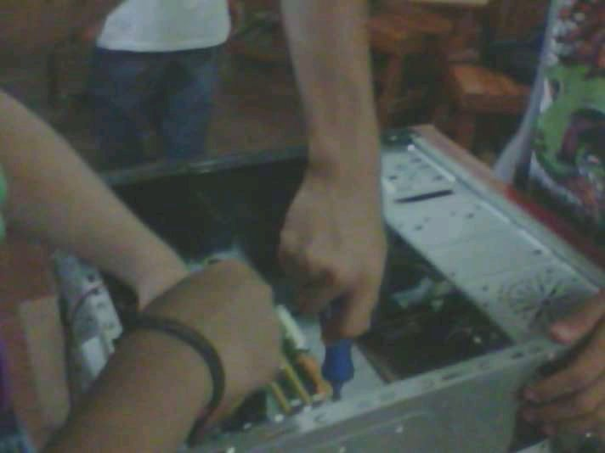

This is my first hands on that is assemble and dis-assemble it is hard because my hand is shaking and he has a time when I will finish and no components should be destroyed because we will pay.

After that we took a break and in order to be able to rest and when we came back, sir seemed angry because there was a lot of damage to the components and we all paid for something to learn from what we did.