**UNIVERSIDAD PONTIFICIA BOLIVARIANA**

**ESTRUCTURAS DE DATOS**

**ARTICULO TABLA HASH**

**18/05/2021**

**PRESENTADO POR**

* Whayner Eduardo Porras Rodriguez *000428333*

**EXPLICACIÓN**

*El código completo se encuentra al final del documento*

**Clase Employe**

Los objetos de tipo Employe serán los que se almacenarán en la tabla Hash [2]. Poseen un constructor sencillo y el metodo para representarlos como String.

package edu;

public class Employe{

public String name;

public String lastName;

public int id;

public int age;

//constructor

public Employe(String name, String lastName, int id, int age){

this.name = name;

this.lastName = lastName;

this.id = id;

this.age = age;

}

//convert to string

public String toString(){

return "Employe{" +

"name:" + this.name +

", lastName:" + this.lastName +

", id:" + String.valueOf(this.id) +

", age:" + String.valueOf(age) +

"}";

}

}

**Clase Hash**

**Metodo generateObjectKey( String name, int id )**

Se encarga de generar una clave unica para el objeto basado en sus propiedades, su nombre y su id.

//generate object key from NAME and ID

private int generateObjectKey(String name, int id){

int objKey = 0;

//get name numeric value

for (int i = 0; i < name.length(); i++){

objKey += (int) name.charAt(i);

}

//add the id

objKey += id;

return objKey;

}

**Metodo getHashKey( int key )**

Toma la llave de objeto y la convierte en la llave de hash, que representa la posición que tendrá el objeto dentro de la tabla.

//generate object key from NAME and ID

private int generateObjectKey(String name, int id){

int objKey = 0;

//get name numeric value

for (int i = 0; i < name.length(); i++){

objKey += (int) name.charAt(i);

}

//add the id

objKey += id;

return objKey;

}

**Metodo insert( Object obj )**

El metodo insert recibe el nuevo objeto que se va a añadir, genera su llave de objeto y su llave de posición. Comprueba que la posición esté libre y lo agrega en el array.

//insert object

public int insert(Object obj){

//generate key

int key = generateObjectKey( ((Employe) obj).name, ((Employe) obj).id );

int position = getHashKey(key);

//check empty space

if (this.arrayStorage[position] == null){

this.size++;

this.arrayStorage[position] = obj;

return position;

}

De lo contrario, significa que hubo una colisión. En este ecenerario se aplica el metodo de la **Dependiente de la Clave** [1] el cual consiste en usar una variable extra, la cual ciclicamente se irá sumando a la posición original de forma cuadrática, hasta encontrar una posición que este disponible para agregarle.

else{

int collisions = 1;

//aplicacion metodo: Dependiente de la clave

int d = (int) key / this.length;

//convertir a numero impar

if (d % 2 == 0) d += 1;

//iterate till find an empty space

for(int i = 1; i <= this.length; i++){

//get new position

position = getHashKey(key + d*i);

//check position

if (this.arrayStorage[position] == null){

System.out.println(ANSI_YELLOW + "Collision x" + String.valueOf(collisions) + ANSI_RESET);

//counter

if (collisions > 0) this.insertedByCollision += 1;

this.size++;

this.arrayStorage[position] = obj;

return position;

}

else collisions += 1;

}

System.out.println(ANSI_YELLOW + "Collision x" + String.valueOf(collisions) + ANSI_RESET);

return -1;

}

}

**Metodo getObject( String name, int id )**

Este metodo nos permite recuperar datos de la tabla hash por medio de la construcción de la clave con los datos que ya sepamos. En este caso para recuperar un objeto Employe necesitaremos el nombre y su id. Se calcula la llave y nuevamente se aplica el metodo de la **Dependiente de la clave** [1]para comprobar que la posición posee el objeto que estamos buscando. Una vez encontrado se devuelve.

//recover object from NAME and ID

public Object getObject(String name, int id){

int key = generateObjectKey( name, id );

int position = getHashKey(key);

Object retObj = null;

Employe iObj = null;

int collisions = 1;

//aplicacion metodo: Dependiente de la clave

int d = (int) key / this.length;

//convertir a numero impar

if (d % 2 == 0) d += 1;

//iterate till find the correct object

for(int i = 0; i <= this.length; i++){

//get new position

position = getHashKey(key + d*i);

if (this.arrayStorage[position] != null){

iObj = (Employe) this.arrayStorage[position];

//check it's the correct one

if ((iObj.name == name) && (iObj.id == id)){

retObj = (Object) iObj;

break;

}

else{

collisions += 1;

continue;

}

}

else{

System.out.println("Couldn't find that object.");

break;

}

}

System.out.println(ANSI_YELLOW + "Collision x" + String.valueOf(collisions) + ANSI_RESET);

return retObj;

}

**DEMOSTRACIÓN**

**Insersión automatizada**

Se generar 1000 registros aleatorios que serán añadidos a la tabla hash. Además se creó un metodo para generar nombres aleatorios de personas para tener una representación más precisa.

//create hash table

Hash myHash = new Hash( (int) Math.pow(2, 10) ); //N Elements -> potencia de dos (1024)

//vars

Employe myEmploye;

int posInserted;

//insert one thousand values automatically

for(int i = 0; i < 1000; i++){

//new employee

myEmploye = new Employe(generateName(), generateName(), randomIntRange(1000, 9999), randomIntRange(18, 50));

posInserted = myHash.insert(myEmploye);

//check

if (posInserted >= 0){

System.out.println(ANSI_GREEN + "Inserted in " + String.valueOf(posInserted) + " " + ANSI_RESET + myEmploye.toString());

}

else{

System.out.println(ANSI_RED + "Not inserted " + String.valueOf(myHash.getSize()) + "/" + String.valueOf(myHash.getLength()) + " " + ANSI_RESET + myEmploye.toString());

}

}

**Generador de nombres**

//generate a name

private static String generateName(){

String name = "";

int[] vocals = {97, 101, 105, 111, 117};

//lengt in range

int length = randomIntRange(3, 8);

//generate first (UPPERCASE)

name += (char) randomIntRange(65, 90);

//generate rest (LOWERCASE)

for (int i = 0; i < length-1; i++){

//vocal

if (i % 2 == 0)

name += (char) vocals[randomIntRange(0, 4)];

//consonant

else

name += (char) randomIntRange(97, 122);

}

return name;

}

**Insersión manual**

Insertamos un caso de prueba para utilizarlo más adelante en la recuperación.

//manual insertion

System.out.println( "\nMANUAL INSERTION" );

myEmploye = new Employe("Woynert", "Red", 8888, 20);

posInserted = myHash.insert(myEmploye);

//show flag

if (posInserted >= 0){

System.out.println(ANSI_GREEN + "Inserted in " + String.valueOf(posInserted) + " " +

ANSI_RESET + myEmploye.toString());

}

**Recuperación manual**

Para recuperar un registro empleamos el metodo getObjet y suplimos los datos necesarios.

//manual recovery

System.out.println( "\nMANUAL RECOVERY" );

Employe myEmployeBack = (Employe) myHash.getObject("Woynert", 8888);

//show flag

if (myEmployeBack != null){

System.out.println(ANSI_GREEN + "Recovered: " + myEmployeBack.toString() + ANSI_RESET);

}

**Output**

En el terminal tenemos varias alertas que nos informan del estado de las inserciones, además del ratio de elementos que tuvieron colisiones a la hora de insertarse. Que es alrededor de un 50%

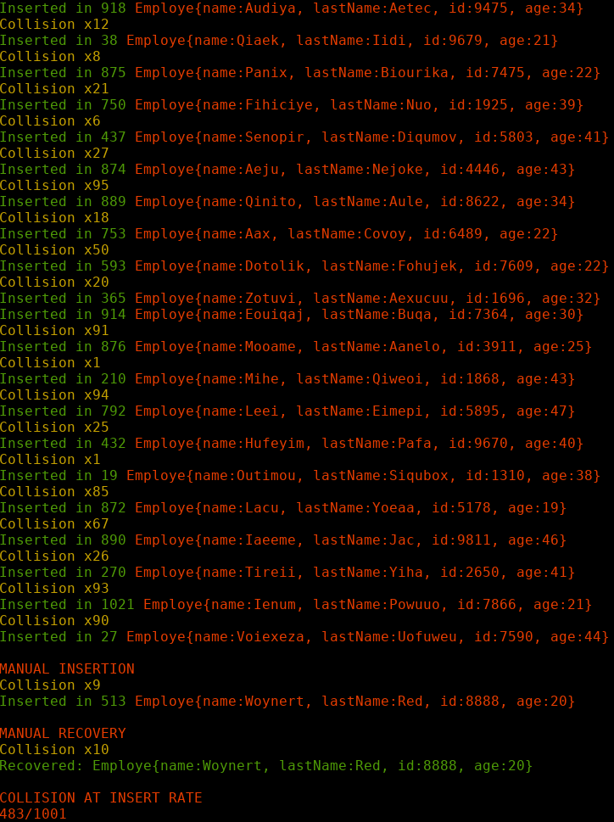

**CÓDIGO**

main.java

import edu.*;

import java.util.Random;

import java.lang.Math;

public class main{

//terminal colors

public static final String ANSI_RESET = "\u001B[0m";

public static final String ANSI_RED = "\u001B[31m";

public static final String ANSI_GREEN = "\u001B[32m";

public static void main(String[] args) {

//create hash table

Hash myHash = new Hash( (int) Math.pow(2, 10) ); //N Elements -> potencia de dos (1024)

//vars

Employe myEmploye;

int posInserted;

//insert one thousand values automatically

for(int i = 0; i < 1000; i++){

//new employee

myEmploye = new Employe(generateName(), generateName(), randomIntRange(1000, 9999), randomIntRange(18, 50));

posInserted = myHash.insert(myEmploye);

//check

if (posInserted >= 0){

System.out.println(ANSI_GREEN + "Inserted in " + String.valueOf(posInserted) + " " + ANSI_RESET + myEmploye.toString());

}

else{

System.out.println(ANSI_RED + "Not inserted " + String.valueOf(myHash.getSize()) + "/" + String.valueOf(myHash.getLength()) + " " + ANSI_RESET + myEmploye.toString());

}

}

//manual insertion

System.out.println( "\nMANUAL INSERTION" );

myEmploye = new Employe("Woynert", "Red", 8888, 20);

posInserted = myHash.insert(myEmploye);

//show flag

if (posInserted >= 0){

System.out.println(ANSI_GREEN + "Inserted in " + String.valueOf(posInserted) + " " + ANSI_RESET + myEmploye.toString());

}

//manual recovery

System.out.println( "\nMANUAL RECOVERY" );

Employe myEmployeBack = (Employe) myHash.getObject("Woynert", 8888);

//show flag

if (myEmployeBack != null){

System.out.println(ANSI_GREEN + "Recovered: " + myEmployeBack.toString() + ANSI_RESET);

}

//Stadistics

System.out.println( "\nCOLLISION AT INSERT RATE" );

System.out.println( String.valueOf( myHash.getInsertedByCollision() ) + "/" + String.valueOf( myHash.getSize() ));

}

//generate a name

private static String generateName(){

String name = "";

int[] vocals = {97, 101, 105, 111, 117};

//lengt in range

int length = randomIntRange(3, 8);

//generate first (UPPERCASE)

name += (char) randomIntRange(65, 90);

//generate rest (LOWERCASE)

for (int i = 0; i < length-1; i++){

//vocal

if (i % 2 == 0)

name += (char) vocals[randomIntRange(0, 4)];

//consonant

else

name += (char) randomIntRange(97, 122);

}

return name;

}

//get random number in range

private static int randomIntRange(int min, int max){

Random random = new Random();

return (min + random.nextInt(max - min +1));

}

}

Employe.java

package edu;

public class Employe{

public String name;

public String lastName;

public int id;

public int age;

//constructor

public Employe(String name, String lastName, int id, int age){

this.name = name;

this.lastName = lastName;

this.id = id;

this.age = age;

}

//convert to string

public String toString(){

return "Employe{" +

"name:" + this.name +

", lastName:" + this.lastName +

", id:" + String.valueOf(this.id) +

", age:" + String.valueOf(age) +

"}";

}

}

Hash.java

package edu;

import java.util.Iterator;

import static java.lang.System.*;

//import java.lang.Math;

public class Hash{

private int length;

private int size;

private Object[] arrayStorage;

//terminal colors

public static final String ANSI_RESET = "\u001B[0m";

public static final String ANSI_RED = "\u001B[31m";

public static final String ANSI_GREEN = "\u001B[32m";

public static final String ANSI_YELLOW = "\u001B[33m";

//stadistics

public int insertedByCollision = 0;

//constructor

public Hash(int length) {

this.length = length;

clear();

}

//clear

public void clear(){

arrayStorage = new Object[ this.length ];

}

//check emptyness

public boolean isEmpty(){

return (length < 1);

}

//insert object

public int insert(Object obj){

//generate key

int key = generateObjectKey( ((Employe) obj).name, ((Employe) obj).id );

int position = getHashKey(key);

//check empty space

if (this.arrayStorage[position] == null){

this.size++;

this.arrayStorage[position] = obj;

return position;

}

else{

int collisions = 1;

//aplicacion metodo: Dependiente de la clave

int d = (int) key / this.length;

//convertir a numero impar

if (d % 2 == 0) d += 1;

//iterate till find an empty space

for(int i = 1; i <= this.length; i++){

//get new position

position = getHashKey(key + d*i);

//check position

if (this.arrayStorage[position] == null){

System.out.println(ANSI_YELLOW + "Collision x" + String.valueOf(collisions) + ANSI_RESET);

//counter

if (collisions > 0) this.insertedByCollision += 1;

this.size++;

this.arrayStorage[position] = obj;

return position;

}

else collisions += 1;

}

System.out.println(ANSI_YELLOW + "Collision x" + String.valueOf(collisions) + ANSI_RESET);

return -1;

}

}

//generate object key from NAME and ID

private int generateObjectKey(String name, int id){

int objKey = 0;

//get name numeric value

for (int i = 0; i < name.length(); i++){

objKey += (int) name.charAt(i);

}

//add the id

objKey += id;

return objKey;

}

//calculate hash key

private int getHashKey(int key){

return (key % this.length);

}

//recover object from NAME and ID

public Object getObject(String name, int id){

int key = generateObjectKey( name, id );

int position = getHashKey(key);

Object retObj = null;

Employe iObj = null;

int collisions = 1;

//aplicacion metodo: Dependiente de la clave

int d = (int) key / this.length;

//convertir a numero impar

if (d % 2 == 0) d += 1;

//iterate till find the correct object

for(int i = 0; i <= this.length; i++){

//get new position

position = getHashKey(key + d*i);

if (this.arrayStorage[position] != null){

iObj = (Employe) this.arrayStorage[position];

//check it's the correct one

if ((iObj.name == name) && (iObj.id == id)){

retObj = (Object) iObj;

break;

}

else{

collisions += 1;

continue;

}

}

else{

System.out.println("Couldn't find that object.");

break;

}

}

System.out.println(ANSI_YELLOW + "Collision x" + String.valueOf(collisions) + ANSI_RESET);

return retObj;

}

//getters

public int getSize(){

return this.size;

}

public int getLength(){

return this.length;

}

public int getInsertedByCollision(){

return this.insertedByCollision;

}

//print queue by recurssion

public void rec(Hash node) {

return;

}

}

**REFERENCIAS**

[1] A. Muñoz, "CO Algorítmia - Tema 6. Hashing. Colisiones", *Youtube.com*, 2013. [Online]. Available: https://www.youtube.com/watch?v=e4DqU1sqHWQ. [Accessed: 17- May- 2021].

[2] M. Serrano, "Estructura de datos Tema 6: Tablas de dispersión (hashing)", *Universidad de Valladolid*. [Accessed 16 May 2021].