**Upward trends**

**_________________________________________________________________________**

**climb      modest      overall      rocketed      steadily upwards**

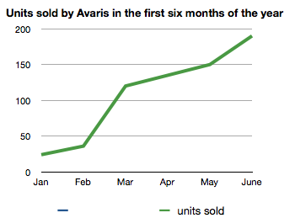

It is of note that the **overall** trend for the first six months of the year was **steadily upwards**.  
After a **modest** increase of 10 units sold in February, this figure **rocketed** to approximately 125 in March, and then continued to **climb** until it reached nearly 200 by the end of June.

**Downward trends**

**_________________________________________________________________________**

**downward      dropped      slightly      slipping      spectacular**

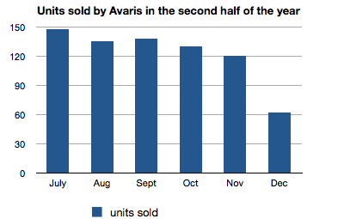After starting the period at almost 150 units, sales **dropped** to around 130 in August. They then rose **slightly** to 135 in September before **slipping** back to 130 in October, a**downward** trend that continued in November. The period ended with a **spectacular** fall to 60 units sold.

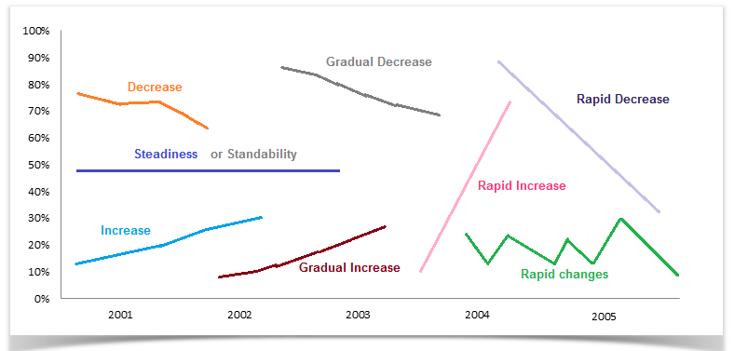

**Vocabulary to represent changes in graphs:**

|  |  |  |
| --- | --- | --- |
| **Type of Change** | **Adverb form** | **Adjective form** |
| **Rapid change** | dramatically / rapidly / sharply / quickly / hurriedly / speedily / swiftly | dramatic / rapid / sharp / quick / hurried / speedy / swift |
| **Moderate change** | moderately / gradually / progressively / sequentially | moderate / gradual / progressive /  sequential |
| **Slight change** | slightly / slowly / mildly / tediously | slight / slow / mild / tedious |

***Example:***

1. The economic inflation of the country increased sharply by 20% in 2008.
2. There was a sharp drop in the industrial production in the year 2009.
3. The demand for new houses dramatically increased in 2002.