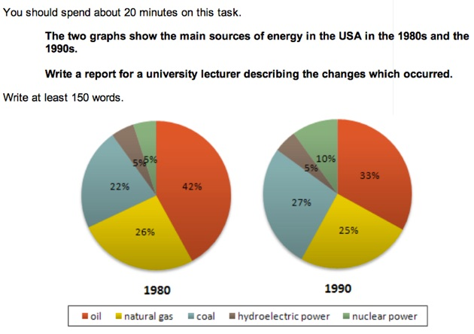

Cc

The two graphs show that oil was the major energy source in the USA in both 1980 and 1990 and that coal, natural gas and hydroelectric power remained in much the same proportions. On the other hand, there was a dramatic rise in nuclear power, which doubled its percentage over the ten years.  
  
Oil supplied the largest percentage of energy, although the percentage decreased from 42% in 1980 to 33% in 1990. Coal in 1990 was the second largest source of energy, increasing its proportion to 27% from 22% in the previous decade. Natural gas, the second largest source in 1980 at 26%, decreased its share very slightly to provide 25% of America’s energy ten years later. There was no change in the percentage supplied by hydroelectric power which remained at 5% of the total energy used. Nuclear power the greatest change: in 1990 it was 10%, twice that of the 1980s.

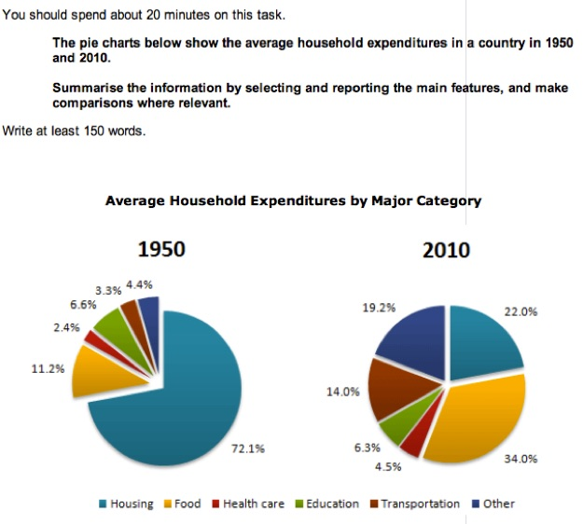

The two pie charts give information about *what households spent their money on / household expenditure on goods and services* in 1950 and 2010. It is immediately obvious that *there are some quite significant differences / some things are significantly different* between the two charts.  
  
In 2010 *the largest proportion of expenditure was / most money was spent* on food whereas in 1950 it was on housing, with food for just 11.2%. There is a great difference in terms of *the amount of money people’s spent on housing / housing expenditure* between the two years. In 1950 72.1% of *the total household budget / the total of what households spent* went towards housing, compared to only 22% in 2010.  
  
*There has been a notable increase in / People have notably increased* the amount of money spent on transportation between the two dates. In addition, the charts show *a significant rise in the proportion of money spent on health care / that people spent more on health care* in 2010 compared to 1950.  
  
There are some similarities, however. For example, in both 1950 and 2010 *people spent a similar proportion on education. / the proportion of education expenditure was roughly the same.*

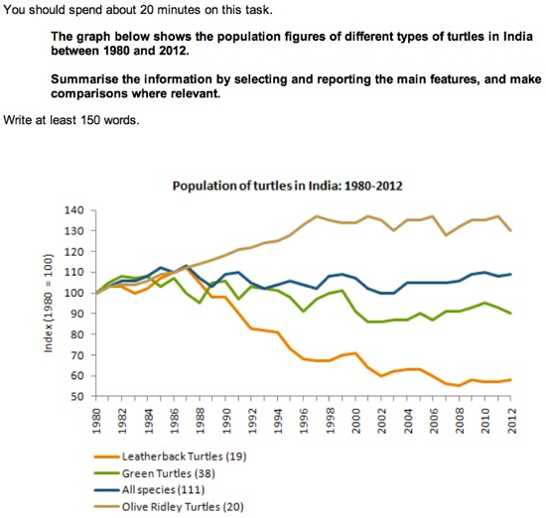

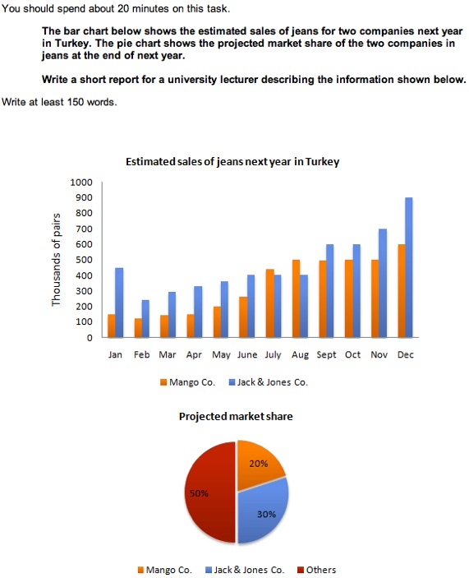

**Task #1 - Sample response #1**

The bar chart shows the estimated sales of jeans in thousands of pairs for two companies in Turkey next year.  
  
It is anticipated that purchases of jeans at Mango Co. will rise from 150,000 pairs in January to approximately 500,000 pairs in August, and will remain there until November. For December, sales are expected to be in the region of 600,000 pairs.  
  
Meanwhile, it is estimated that the sales of jeans for Jack & Jones Co. will begin the year at around 450,000 pairs in January, falling to about 250,000, before increasing to around 400,000 in June. For the next two months until August, sales are forecast to remain steady at this level, after which they are expected to rise steadily to hit a peak of approximately 900,000 pairs in December.  
  
The pie chart shows that, at the end of next year, the anticipated market share for Mango Co. and Jack & Jones Co. is 20% and 30% respectively.  
  
As can be seen from the chart, the overall sales trends for both companies are forecast to be upwards.

**Task #1 - Sample response #2**

The bar chart shows the predicted sales of jeans in thousands of pairs for two companies in Turkey; Mango Co. and Jack & Jones Co. for next year.  
  
The most striking feature is that sales will increase for both companies, It is anticipated that sales of Jack & Jones Co. will start at 450,000 pairs in January decreasing by 200,000 pairs following month with a gradual recover over the subsequent four months reaching 400,000 pairs in June. Those of Jack & Jones Co. are predicted to be stable until August picking up to 600,000 pairs in September and October.   
  
Sales of Jack & Jones will reach a pick of 900,000 in December, For those of Mango Co. is forecasted a gradual increase with the largest sale of 600,000 pairs in December. In the beginning of the next year those of Mango Co. will stand at 150,000 pairs falling back to 100,000 pairs in February, rising steadily to 250,000 in June, In subsequent months sales will reach 450,000 pairs increasing to 500,000 pairs in August, staying stable until November.  
  
Regarding the pie chart the sales of Jack & Jones Co. will share 30% of market whereas those of Mango Co. 20%. 50% of market is set to be shared by other companies.

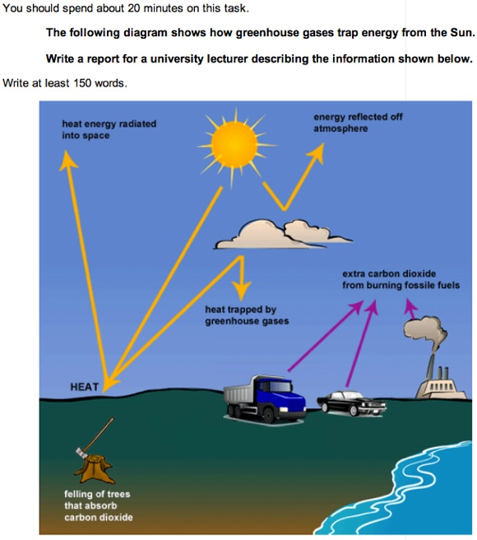

**Task #1**

Energy from the Sun **reaches** the Earth as heat. Some of this heat energy is **subsequently/then** radiated into space, while some of it is trapped by greenhouse gases in the atmosphere and reflected back to Earth. This is a natural process, but in recent **decades**, human activities have **led to** an increase in the **amounts** of greenhouse gases in the atmosphere which is now trapping too much heat.  
  
One of the main greenhouse gases is carbon dioxide, and extra quantities of this **are released/have been released** into the atmosphere **as a result of** burning fossil fuels as a source of energy in power stations, factories and homes. Exhaust gases from cars and lorries **result in/have resulted in** further emissions of carbon dioxide.  
  
Plants serve to remove some of the carbon dioxide from the atmosphere by absorbing it through their leaves. However, as large areas of forest **are (being) felled/have been felled** in the Amazon and elsewhere, **less** carbon dioxide is removed in this way.

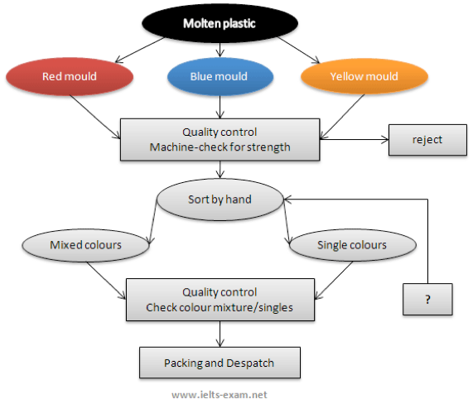

**Task #2**

There are four main stages in the production of plastic paper clips from this small factory. Two of these stages involve actual preparation of the clips, while the other two consist of quality control before the clips are sent out from the factory to the retailers to be sold to the public.  
  
To begin with, molten plastic is poured into three different moulds depending on the colour required; the colours are red, blue and yellow. Once these clips emerge from the moulds a quality control machine checks them for strength. Unsatisfactory clips are rejected. In the third stage in the process the clips are stored by hand into two groups, mixed and single colours. When this stage is complete the groups are checked a second time to ensure that the colour mixtures are divided correctly into single colours and mixed colour batches. Finally, the clips are packed and dispatched to the markets.

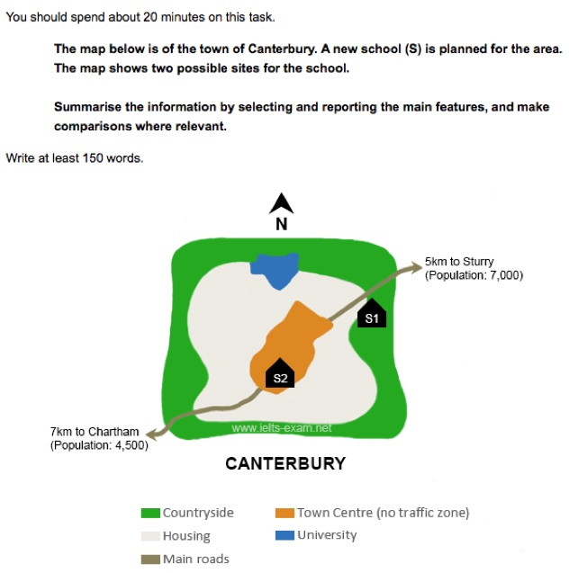

The map shows two proposed sites for a new school for the town of Canterbury and the surrounding area.  
  
The first site (S1) is situated in the countryside, to the north-east of the town centre. It is just outside the main housing area of the town and not far from the main road that links Sturry with Canterbury. It would therefore probably be in an ideal location for students coming from Sturry, which is only 5 kilometres away, and those who live on the east side of Canterbury. If there are students coming from Chartham, which is 7 kilometres to the south-west, they would be able to reach the school by taking the main road that runs south-west of Canterbury.  
  
The second site (S2) is located in the town centre itself. There are advantages of this: it makes it practically equidistant for students coming from either Sturry or Chartham. Moreover, it would presumably be relatively easy for students who live in the housing area around the town centre to reach the school. However, because of the no traffic zone in the town centre, no parent would be able to drive their child all the way to school. This may make travel arrangements difficult for some parents.