**PROJECT TITLE: Child Drone**

**NAME: Colin Cassidy DATE: 5/21/2015**

**WORK COMPLETED LAST WEEK**

The first task I was to look in to was the research of the breakout board, and the prototype expansion board and the GPIO. I was to establish what we had, what it can handle, and how you access it. The prototype expansion board allows us to stack and test specific functions and quickly and efficiently by having point soldering capability. I also decided to get physical weights of the components and assure that they were correct values given by the manufacturer.

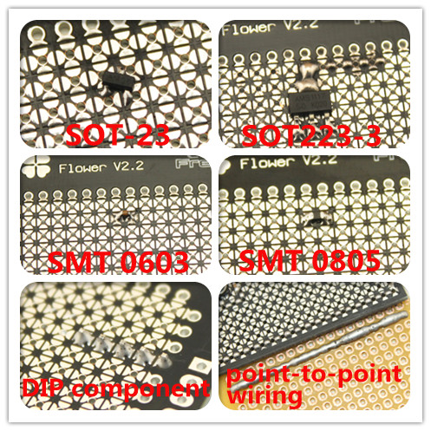

What is pictured above is the soldering ability of the prototype board using a flower design.

I also was to research what we could do with the breakout board and how we access it. It uses a standard breadboard so we have that option to configure it how we want and hook other components up to it.

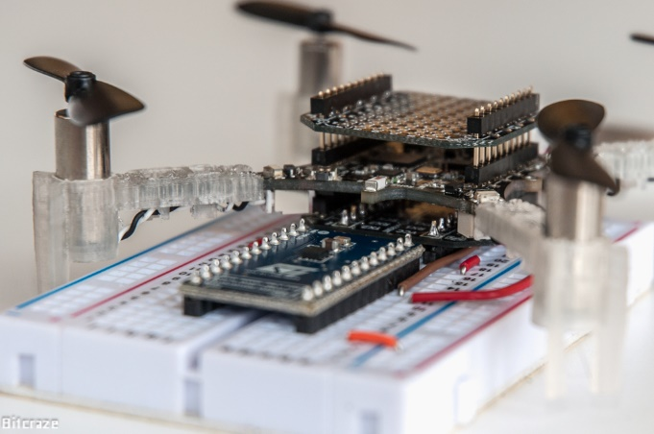

Im in the process of building a spread sheet with pin out and location and actions that should be available to the group

**WORK PLANNED FOR NEXT WEEK**

Next week I plan to work with Andrew to start designing a PCB and with Kim to make sure what we are doing is going to be within the constraints of the frame. I will bring it to a head to make sure that we need to get out propellers ordered and ready to go. So we can begin calculations for thrust.

**OPEN ISSUES**

Don’t have the propellers yet.

Have not meant with Andrew to see the schematic for the PCB

Not have a frame ready to go yet.

**DELIVERABLES AND MILESTONES**

|  |  |  |  |
| --- | --- | --- | --- |
| Task | Milestone | Planned | Actual |
| Thrust calculation | Get the parts ordered (propellers) | 5/29/15 |  |
| Confirm size of frame | Mount the drone to the frame for tweaks | 6/5/15 |  |
| PCB | Have the PCB fabricated and ready for tweaks | 6/5/15 |  |