Health Advice Group – App Prototype Feedback

Health Advice Group
Street Address – 72 GR Road
Town/city, postcode – TS 555 DH, Cleveland
Phone – 01642 4444266667
Email – healthadvice@Yahoo.com


Prototype Feedback Introduction - Plan

Technical Audience

The health advice group prototype and designs will be available on GitHub as a public repository and will be used as a place for feedback to be provided by technical users such as any minor/major issues and/or features that should be added. Accessing the repo will be trivial as a link can be shared for users and can also search for it on GitHub. A README file will be provided as it is commonly used for repos to give an introduction, documentation, and other aspects.

The public repo mentioned: FindlayProgramming/OCC-Mock-Final: OCC Mock Work (github.com)

Non-Technical Audience

For non-technical users, the prototype will be available through designs shown as well as a video of what the app includes, it will include non-technical language so the users can understand more easily on what is going on. The designs used to display the functionality of the app will be based of the C4 model as it allows for in-depth descriptions of systems as well as not being overwhelming to users.

The designs mentioned:

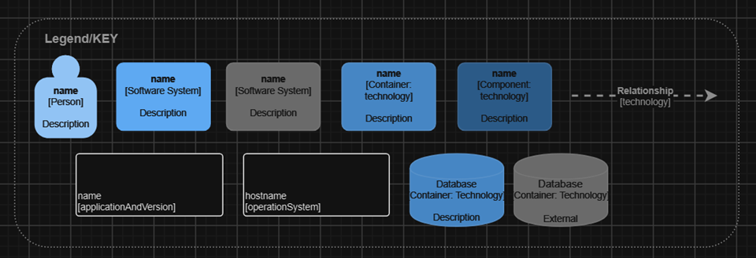

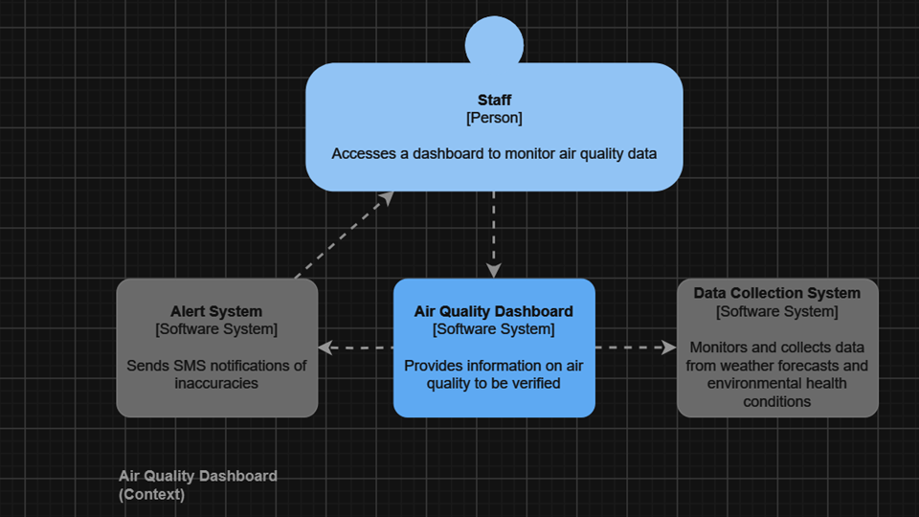

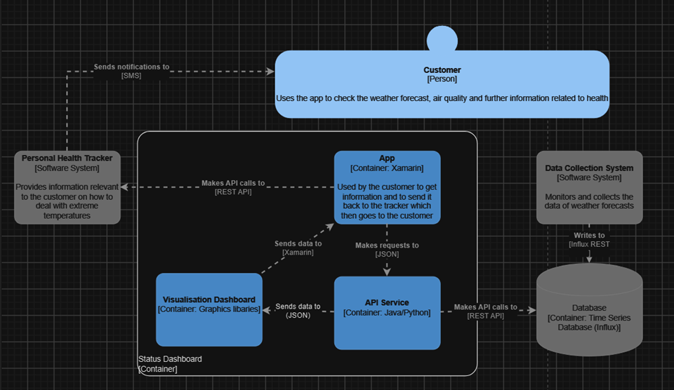

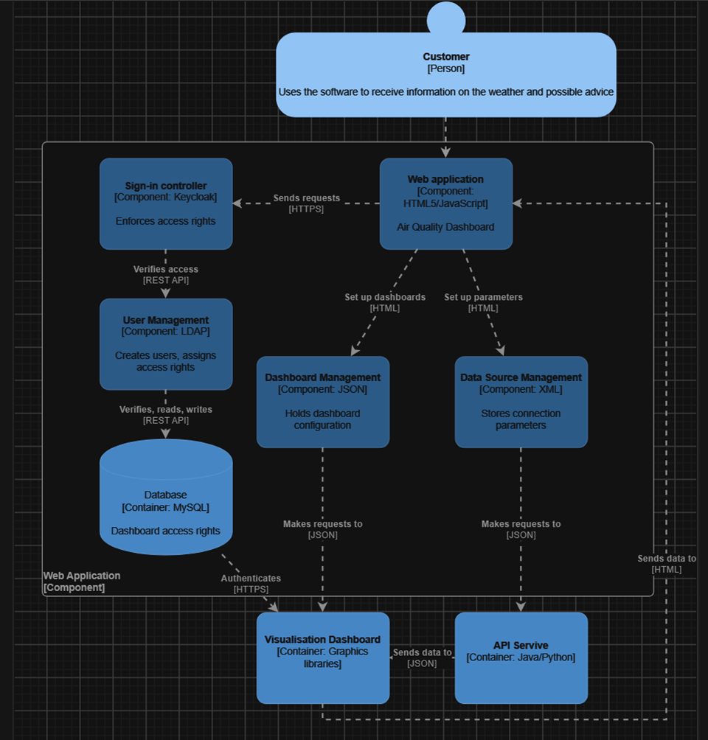

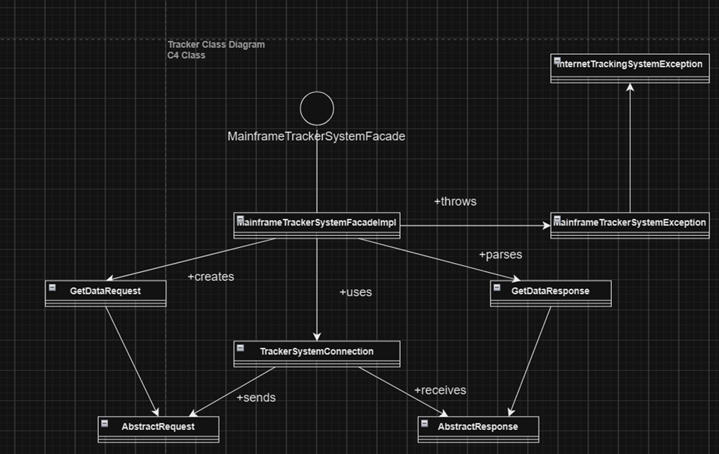

App Images:

Home-Page

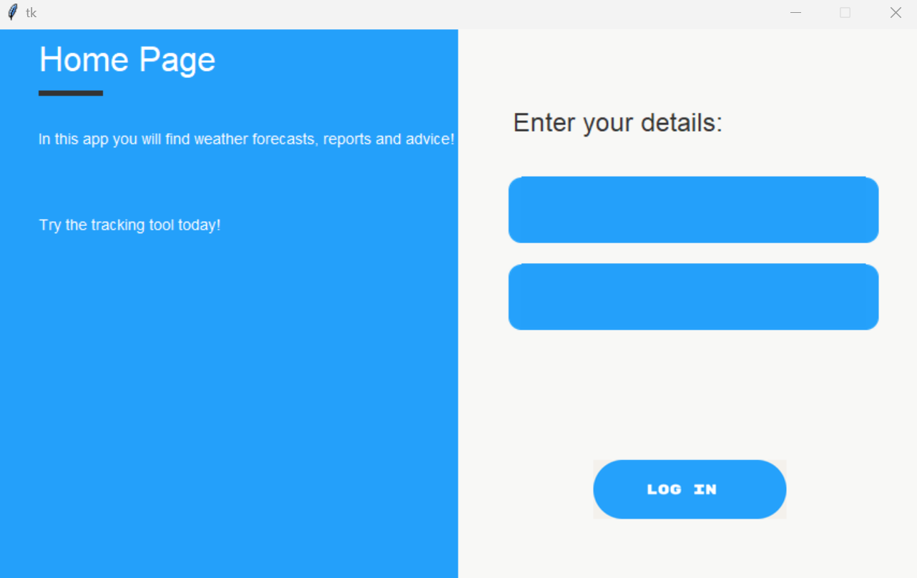

Dashboard

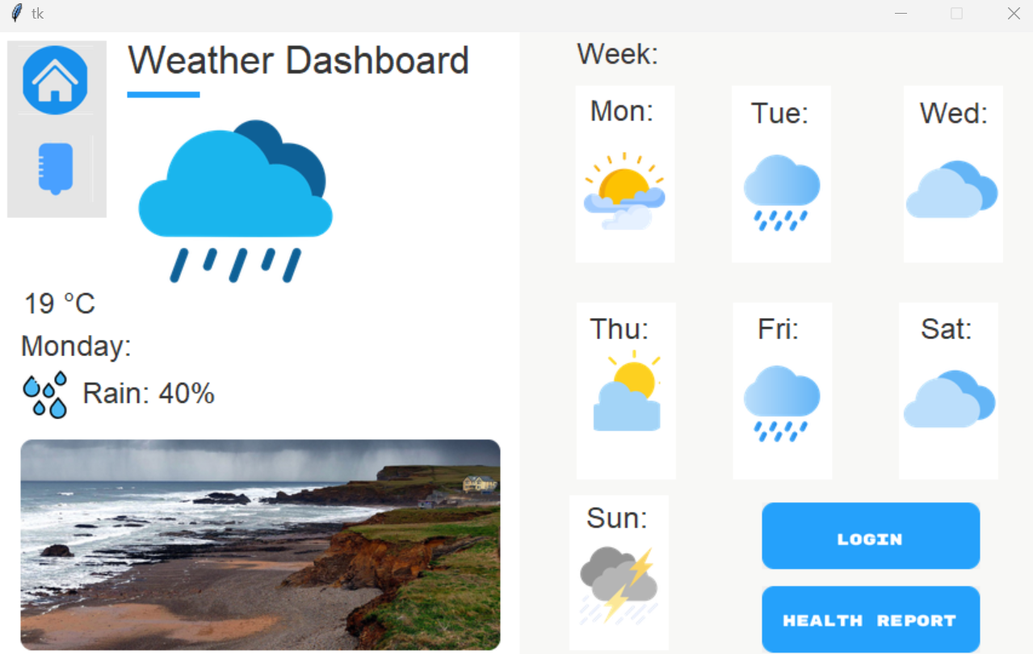

For both technical and non-technical users, I have added forms so they can provide feedback for the app as well as other aspects such as the database, there is also a section for users to provide information on anything that the app misses such as functionality or accessibility features for example.

The forms in question

Technical: Prototype Feedback - Technical Users - Google Forms

Non-technical: Prototype Feedback - Non-technical Users - Google Forms

Observations - Technical

Structured Observation – User Declan (Technical)

Category | Response | Comments
Functionality | Yes/No/N/A
Able to log-in | Yes
Able to go to the next window? | Yes
Positives? | Very neat login feature, clean look to it, easily navigable, clearly displayed all the features.
Negatives? | Is lacking some features such as air quality. | This was planned to be added but due to the lack of time available it could not happen. However, it would be trivial to add this in an update.
Features it should include? | Air quality, health reports.
Could it be simplified? | No
Any bugs encountered? | No
Conclusion | Simple, clean app that is missing some features. A good prototype.

Unstructured observation – User: Mark (Non-Technical)

Pain points of the observations:

- The design was met with a mixed response.
- User was unsure of the errors/bugs that would happen and how functionality may be improved.
- Not mobile friendly
- Lacks some features that should be included.

Please enter your name: Quin (student)(technical) Age: 18 | Answer the questions here:
Were you able to log-in? | Yes
Are the error messages easy to understand? | Yes
Were you able to receive a forecast? | Yes
Were you able to receive a customised forecast? | No
Were you able to access the health reports? | Links could include better content, needs work.
Were you able to access the advice page? | No
Is the advice relevant to the app? | N/A
Were you able to access the air quality feature? | No
Were you able to see data on the air quality? | N/A
How is the visual interface of the app? | Good, could use some work but overall is very clean.
How likely are you to recommend the app? | The app will need to include more features/updates for me to recommend it.
How would you compare this app to other weather apps? | This app includes a much simpler and cleaner design than other weather apps which is somewhat unique.
Do you believe that the app has improved compared to previous versions in its final build? | Yes, I do believe that the final build is an improvement over previous version/s.

How easy is it to navigate the app?

Hard
Difficult
Average
Easy
Very easy

How would you rate this app?

Bad
Not good
Average
Good
Great

What ways do you think the app could be improved?

“The app should include more features such as air quality, inputting temperature, dynamic content for users such as relevant health reports.”

Thanks for your feedback!

Please enter your name: Lily (student)(technical) | Answer the questions here:
Were you able to log-in? | Yes
Are the error messages easy to understand? | Yes
Were you able to receive a forecast? | Yes
Were you able to receive a customised forecast? | No
Were you able to access the health reports? | Yes, but the links could be improved upon.
Were you able to access the advice page? | No
Is the advice relevant to the app? | N/A
Were you able to access the air quality feature? | No
Were you able to see data on the air quality? | N/A
How is the visual interface of the app? | Decent, not boring to look at.
How likely are you to recommend the app? | Visually it could use some work and some features are missing so unfortunately unlikely.
How would you compare this app to other weather apps? | Most include more features but are less colourful in design.
Do you believe that the app has improved compared to previous versions in its final build? | Yes, the final build improves the design compared to previous ones and more features were added during that.

How easy is it to navigate the app?

Hard
Difficult
Average
Easy
Very easy

How would you rate this app?

Bad
Not good
Average
Good
Great
What ways do you think the app could be improved?

“Overall – Great prototype, especially if you implement the missing requirements. Those features really should be added to improve the user experience and give incentive to use the app.”

Thanks for your feedback!

Please enter your name: Ayomide (student)(technical) | Answer the questions here:
Were you able to log-in? | Yes
Are the error messages easy to understand? | Yes
Were you able to receive a forecast? | Yes
Were you able to receive a customised forecast? | No
Were you able to access the health reports? | Yes, but it provides generic information that may not be relevant to the user.
Were you able to access the advice page? | No
Is the advice relevant to the app? | N/A
Were you able to access the air quality feature? | No
Were you able to see data on the air quality? | N/A
How is the visual interface of the app? | Easy to understand and navigate as well as including a clean aesthetic.
How likely are you to recommend the app? | As the app is missing some features, it is unlikely. If those features are added, then I can recommend it.
How would you compare this app to other weather apps? | The design shown for this app is an improvement over others but lacks the features and information of them.
Do you believe that the app has improved compared to previous versions in its final build? | Yes, the final build dramatically improves the design of the app compared to previous versions.

How easy is it to navigate the app?

Hard
Difficult
Average
Easy
Very easy

How would you rate this app?

Bad
Not good
Average
Good
Great
What ways do you think the app could be improved?

“Very neat login feature, clean to look at, easy to navigate and displays most features However, it lacks some other features that the app would benefit from.”

Thanks for your feedback!

Please enter your name: Charlie (student)(technical) | Answer the questions here:
Were you able to log-in? | Yes
Are the error messages easy to understand? | Yes
Were you able to receive a forecast? | Yes
Were you able to receive a customised forecast? | No
Were you able to access the health reports? | Yes, but the information is very basic and unhelpful to users.
Were you able to access the advice page? | No
Is the advice relevant to the app? | N/A
Were you able to access the air quality feature? | No
Were you able to see data on the air quality? | N/A
How is the visual interface of the app? | Includes a clean design but lacks content that brings it down.
How likely are you to recommend the app? | It is very basic could include more features; each day shown should include links relevant to the day.
How would you compare this app to other weather apps? | The design aspect is great compared to other apps but again lacks the features and information of other apps.
Do you believe that the app has improved compared to previous versions in its final build? | Yes, the four previous versions shown lacked in features and design whereas the final build has improved upon both.

How easy is it to navigate the app?

Hard
Difficult
Average
Easy
Very easy

How would you rate this app?

Bad
Not good
Average
Good
Great

What ways do you think the app could be improved?

“One way I believe the app could be improved is if more features and content are added, I think the app follows conventions such as good use of white space. Adding more health reports personalised for users would be of great benefit to the app. Adding an advice window may also prove useful to users.”

Thanks for your feedback!

Please enter your name: Ahmed  (student)(technical) | Answer the questions here:
Were you able to log-in? | Yes
Are the error messages easy to understand? | Yes
Were you able to receive a forecast? | Yes
Were you able to access health reports? | Yes
What are your thoughts on the appearance of the site? | Basic but clean, includes most features.
What is your opinion on the site? | I appreciate the features available as well as the design but could include more content.
What is greatest benefit of the site? | The clean design and easy navigation.

How easy is it to navigate the app?

Hard
Difficult
Average
Easy
Very easy

How would you rate this app?

Bad
Not good
Average
Good
Great

Please enter your name: Christina (parent)(non-technical) | Answer the questions here:
Were you able to log-in? | Yes
Are the error messages easy to understand? | No, as a non-technical person it is difficult to understand.
Were you able to receive a forecast? | Yes
Were you able to receive a customised forecast? | No
Were you able to access the health reports? | Yes but it is very basic in terms of features however, it does provide a forecast that is easy to access and to keep track off.
Were you able to access the advice page? | No
Is the advice relevant to the app? | N/A
Were you able to access the air quality feature? | No
Were you able to see data on the air quality? | N/A
How is the visual interface of the app? | The visual interface is clean and is of great benefit to the app, a clean design can draw in new users while also not being intimidated.
How likely are you to recommend the app? | The design of the app is clean but lacks features that are arguably more important; I would not recommend at this time.
How would you compare this app to other weather apps? | The design is an improvement when compared to other weather apps but also it also lacks in features which bring it down compared to other apps.
Do you believe that the app has improved compared to previous versions in its final build? | Yes, there are more features on the app with more windows available and includes a cleaner design.

How easy is it to navigate the app?

Hard
Difficult
Average
Easy
Very easy

How would you rate this app?

Bad
Not good
Average
Good
Great

What ways do you think the app could be improved?

“To begin with, the app should include updates for features such as air quality and health advice. Another way to improve the app is possibly to clean or simplify the code by reusing pieces.”

Thanks for your feedback!

Code Review
One criticism of the code within the app was the lack of comments prevalent, this was especially significant as the code is available as a repo on GitHub, users would have access but would not know what to do with the code or what it does. It is important that comments be added as it makes code maintenance much easier as it points out to fellow developers what the code is supposed to do. I have previously fixed this by adding comments to unique code within the program/s and would explain what is being done and why it is important.

A part of the programs that work in the apps favour is how easy it is to communicate between different files (opening, reading, writing etc). For example, in the home page file, when an event triggers for a specific button it will open the dashboard file without issue.

The naming conventions I have chosen for the files and variables have previously been improved upon due to including a naming table for variables as well as selecting a name for files beforehand. The files have suitable name such as the home page being “Home-Page” and dashboard being named “Dashboard”. The database also includes a suitable name, that being “users.db”.

An issue that I had with the database is getting a server set up which would take a significant amount of time to implement, so it was suggested that I make a serverless database which achieved the results required.

Key thoughts of the feedback given:

- Able to log-in
- Easy to understand error messages for most users.
- Functioning forecast/dashboard.
- The design of the app is clean/neat.
- Information should be more relevant and be included for the days of the week.
- Can access all windows.
- Relevant advice should be provided.
- Would be a benefit if alerts are given when weather could affect health conditions.
- Air quality window needs to be added.
- The app meets most of the requirements in terms of functionality but needs to include more information and features.
- The final build has been improved compared to previous versions.
- Good use of whitespace and other conventions.
- An advice window could be included.

Follow up questions
Answer questions here: | Mark
Q1: Are there any other features that could be included? | An advice and health report window.
Q2: Are there other areas of the app that can be improved? | I believe the app could use some more colour and better use of some conventions.
Q3: How do you think the air quality window should be included? | A button or icon could be used which takes you to the air quality window, like the how the dashboard/home-page navigation works.
Q4: Should the account system be expanded upon? | Yes, as I believe it could help when making information more personalised for users.

Answer questions here: | Quin
Q1: Are there any other features that could be included? | A feature that allows users to input the temperature of their location and will give advice to the user.
Q2: Are there other areas of the app that can be improved? | A better use for conventions.
Q3: How do you think the air quality window should be included? | Implement a button or icon in the menu that leads to the air quality window.
Q4: Should the account system be expanded upon? | Yes, as that could also lead to other features such as adding a way to implement complaints or give more feedback.

Answer questions here: | Lily
Q1: Are there any other features that could be included? | Add the air quality window and inputs for users such as temperature.
Q2: Are there other areas of the app that can be improved? | A better use for conventions and colours.
Q3: How can the user experience be improved? | Improve the log-in system and allow for users to create accounts.

Answer questions here: | Charlie
Q1: How could the design of the forecast can be improved? | Add more colour to the different aspects of the window for it to look cleaner, doing so will highlight the different parts of the app.
Q2: How could the air quality and other features be implemented? | Each of the features can be added to different files which link to existing ones for example, how the home page links to the dashboard.
Q3: How do you think the code can be improved? | By reusing code in certain areas, reducing the time to build up the program as well as keeping it clean.

Answer questions here: | Ahmed
Q1: How could the design of the forecast can be improved? | Add more colour that could catch the eye of users and direct the user to important content.
Q2: How could the air quality and other features be implemented? | By adding more windows/files that connect to the other existing files these files will contain the missing features.
Q3: How do you think the code can be improved and improve conventions? | Reuse code, add comments and I would make sure to use white space in sufficient areas by following the existing conventions.

Colleague Feedback
Firstly, I asked various people including my colleagues as well as people outside of college to test the app and gather their feedback.

When asking for feedback, the main aspects I focused on where:

- The positives/what went well.
- The negatives/what the app could do better.

Thoughts of users:

- Able to access the home page.
- Able to log-in.
- Able to go to the dashboard page.
- Able to access health reports.
- Add air quality window as well as add/improve other features.
- Use visual representations such as graphs.
- Good visual design.
- Lacking widgets.
- Easy navigation.
- Unprofessional.
- Could use more colour.
- Could improve the use of whitespace.
My thoughts:

- Users can access all areas of the app2.
- Testers have found that there could be a better use of colours and images.
- Users have understood the error messages.
- Testers have found that the app meets most user requirements.
- Testers have found the app easy to navigate.
- Overall, the app has been met with mixed results, specifically when it comes to the features either saying that some are missing or are not implemented well. This can be easily fixed with updates however.

Analysis
(Pie chart)

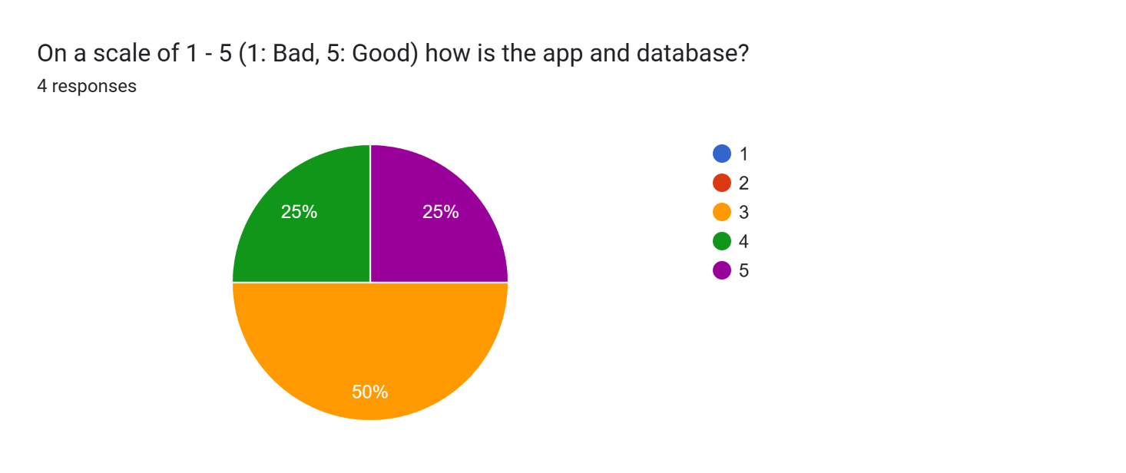

(data from forms)

(Yes = 1, No = 2)

(data from forms)

Bar Graph

(data from forms/observations)

Looking at the feedback received, several key points from the responses have been inferred.

Firstly, by analysing the first pie chart on app ratings, it can be gathered that the overall opinion of testers is that the site is mixed. Most testers have agreed that the design of the app is good but also that features are missing. The other pie chart shown for logging-in shows that there are no issues with the log-in function and were able to access the dashboard.

The biggest criticism of the application appears to be the lack of features available; this has been explained as to why the features were not included however, it is valid and should be adhered to. Another criticism was the use of conventions in the app such as whitespace which will also be considered.

Despite the criticisms, there were also positives mainly relevant to the design of the application and how simple it is for users to follow which is important as increases the user experience.

From observing the bar graph, it can also be seen that the application is easy to navigate which is another important feature for users as intimidating applications do not give a good impression and may waste the user’s time.

Overall, users found the application appealing visually but also lacking in some features which holds it back, if these features were to be implemented in an update, then it would drastically improve the app. However, it does not meet all the user’s requirements at the moment.

As suggested, the features can be added as another window for the application the same way the home page and dashboard have been implemented. The third window will also include visual representations of data to further improve the user experience, this will be done by adding a button.

Changes Needed | Solution
Add air quality and other features | The air quality as well as other features can easily be implemented by adding another window/file that links to the existing application.
Add graphs | Graphs will be added using buttons. Whenever the user requires a visual representation of data, they can click the button that is linked to the relevant page.
Current days for the forecast need to be more prominent | Links will be added to the relevant days for the forecast which can help users gain more relevant information.
Have alerts for when the weather effect health conditions | Add a feature to the app, that notifies the user of weather that will affect their health and give advice on how to prevent it. Will be available to turn on/off.
Some incorrect use of conventions | These can be handled by following convention standards, can be changed in an update.
Add an advice window | An advice window/file can be added to connect to the existing app.

Legal

Licenses have been mentioned in the repo provided as well as the assets used, it has been made sure that any assets used have been used do not require a license.

