**Schematics  
  
Plug board**

INPUT 26’b

CHANGE 26’b

OUTPUT 26’b

PLUGBOARD

**Rotor System**

ROTOR1

ROTOR2

ROTOR3

INPUT 26’b

INPUT 26’b

OUTPUT 26’b

INPUT 26’b

OUTPUT 26’b

OUTPUT 26’b

ROTATE

Writing_config

ROTATE

ROTATE

Writing_config

Writing_config

**Reflector**

INPUT 26’b

OUTPUT 26’b

REFLECTOR

**WHAT ARE WE TRYING TO EMULATE?**

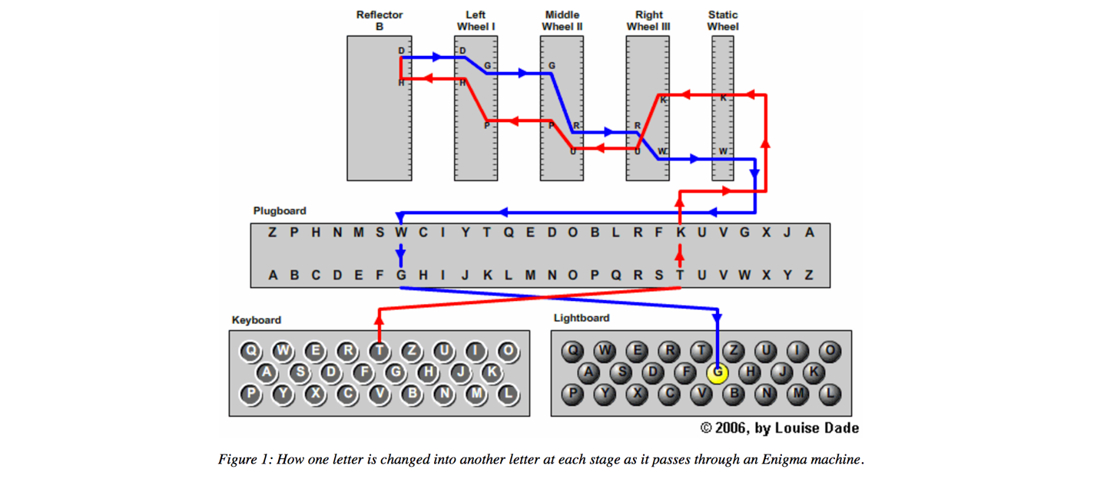

THIS WEEK

NEXT WEEK