GATalk Illustrated Quick Guide
Version: 0.18.1 Beta 2; updated: 2026-08-14
Interface languages: Simplified Chinese is the reference UI. English, Traditional Chinese, Japanese, and French are currently previews. This guide uses the English UI throughout.
This guide covers the common workflow in short steps. Button names follow the English UI.

1. Start
Purpose: open a platform or professional workbench from one home screen.
- Download the Windows x64 beta from GitHub Releases and extract the complete archive. Do not use Code → Download ZIP; that button downloads source code without a runnable EXE.
- Run GATalk/GATalk.exe; developers can run start_dev.cmd.
- Select a workbench. Recent projects appear below.
- Press Ctrl+Shift+H in any workbench to return Home.
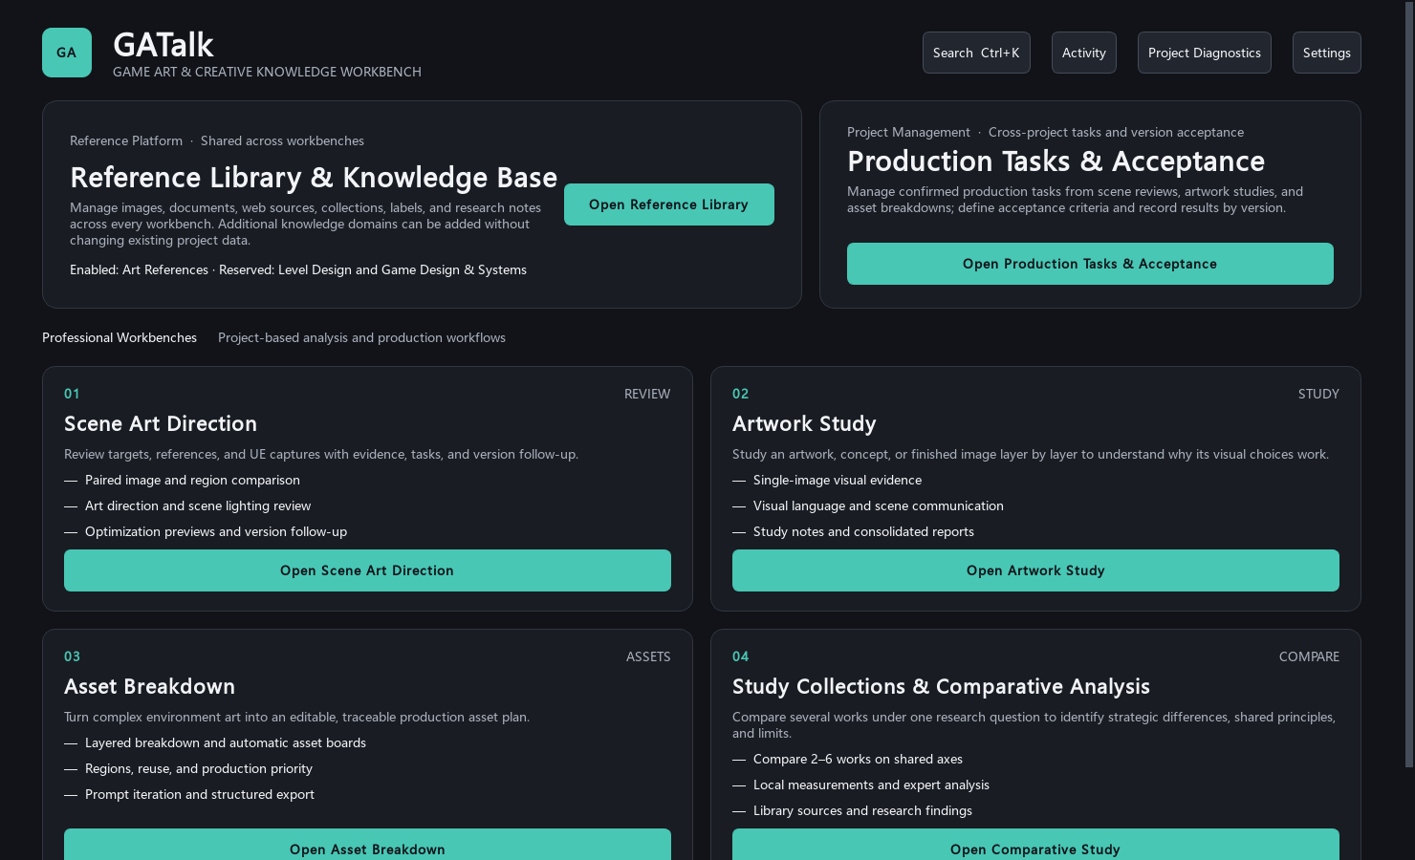
Workbench Home keeps platforms, professional workbenches, and recent projects together.
Result: GATalk preserves the current window size and maximized state. Imported images remain read-only, and nothing is uploaded automatically.
The beta is not code-signed. If Windows displays a protection warning, verify the archive SHA-256 on the Release page before continuing.

2. Global Settings
- Press Ctrl+,, or choose Settings > Global Settings.
- Select language, theme, font size, and UI density.
- Choose Apply to preview and OK to save.
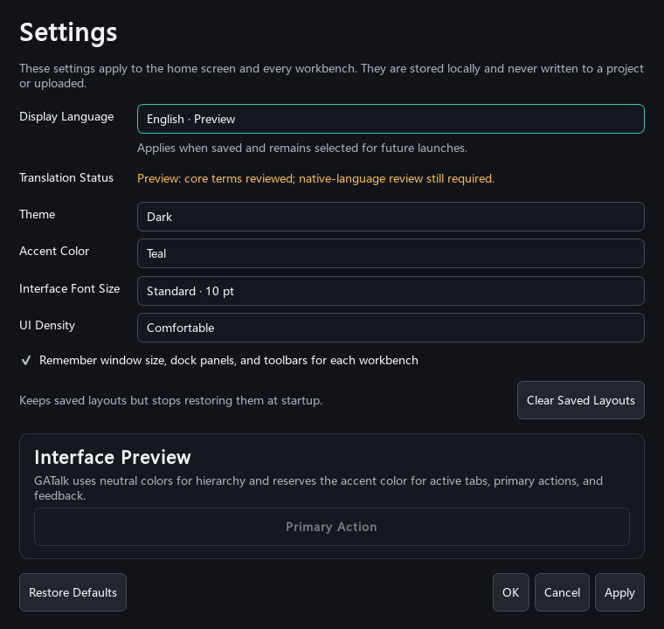
Global Settings manages language, appearance, density, and common behavior.
Saved settings remain active on the next launch. Language changes never rewrite project names, notes, or earlier AI results.
Shortcuts: Ctrl+K Search; Ctrl+Z Undo; Ctrl+Shift+Z Redo; Esc exit the current tool.

3. References & Knowledge Base
Purpose: store reusable images, articles, links, and project notes.
- Create or open a library.
- Create collections and import files, links, or notes.
- Add author, source, tags, and research notes, then save.
- Create a crop, translate selected text, or reference the item from a project.
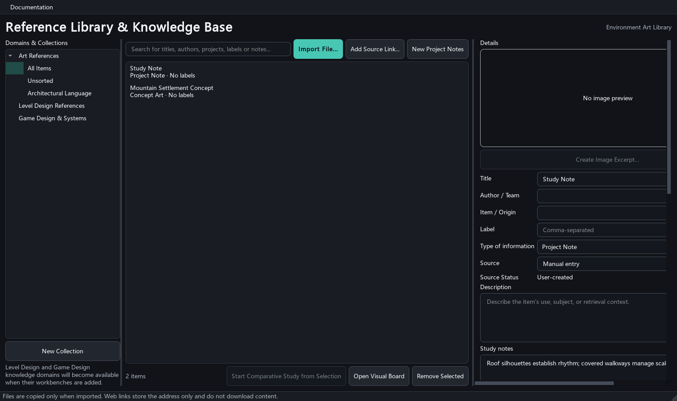
The library places collections on the left, items in the middle, and source details on the right.
Web links are stored but never fetched automatically. Translation and online analysis require explicit confirmation.

4. Artwork Study
Purpose: study composition, value, colour, light, space, and visual storytelling in one artwork.
- Create a study and import an image.
- Enter the research goal and known context; leave uncertain facts blank.
- Inspect Local Evidence, then explicitly start Expert Analysis.
- Record your own conclusions in Learning Notes.
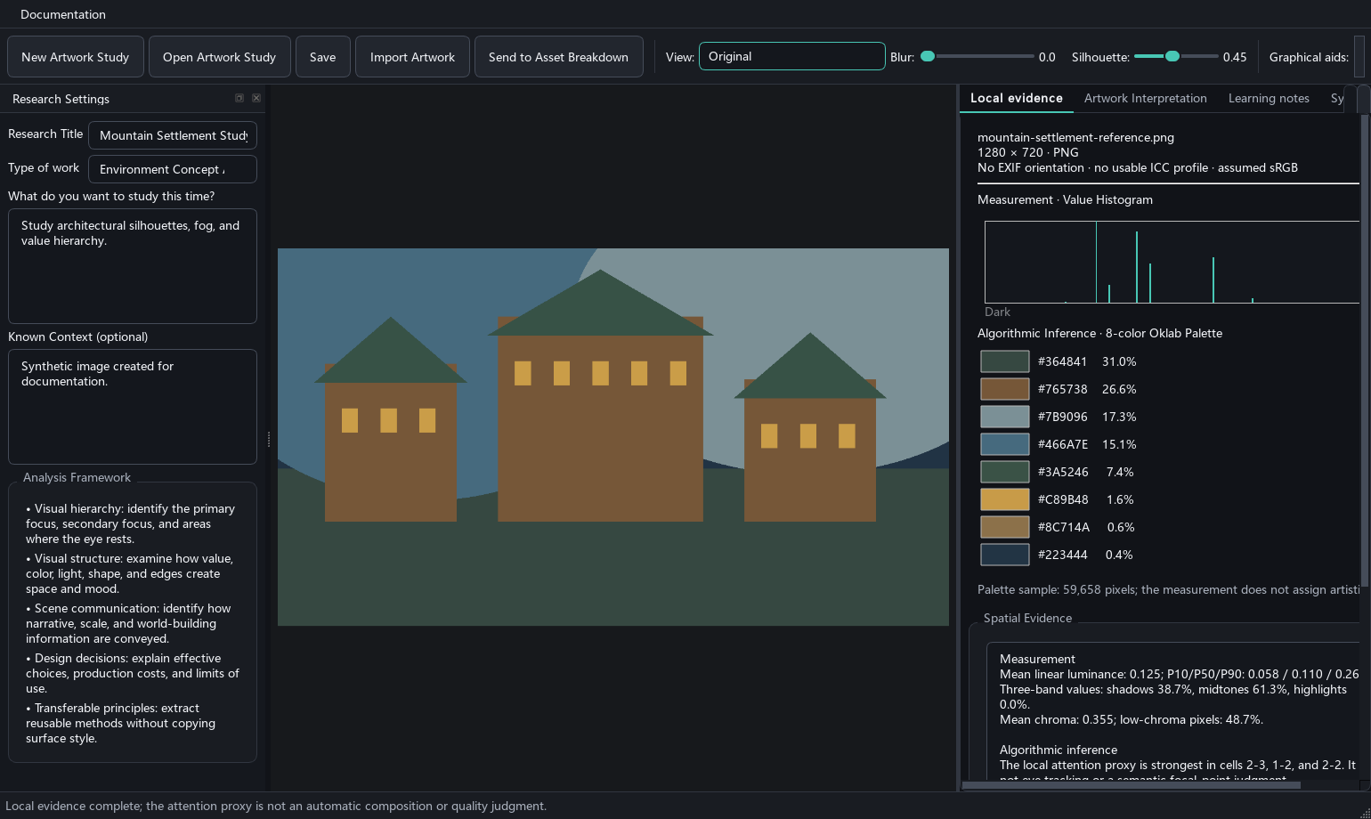
Artwork Study keeps the goal on the left, artwork in the centre, and evidence and notes on the right.
Local measurements and AI interpretation are stored separately.

5. Comparative Study
Purpose: compare two to six artworks under one research question.
- Create a study and import the artworks.
- Select axes such as composition, value, or colour organisation.
- Compare the images side by side and record shared patterns and key differences.
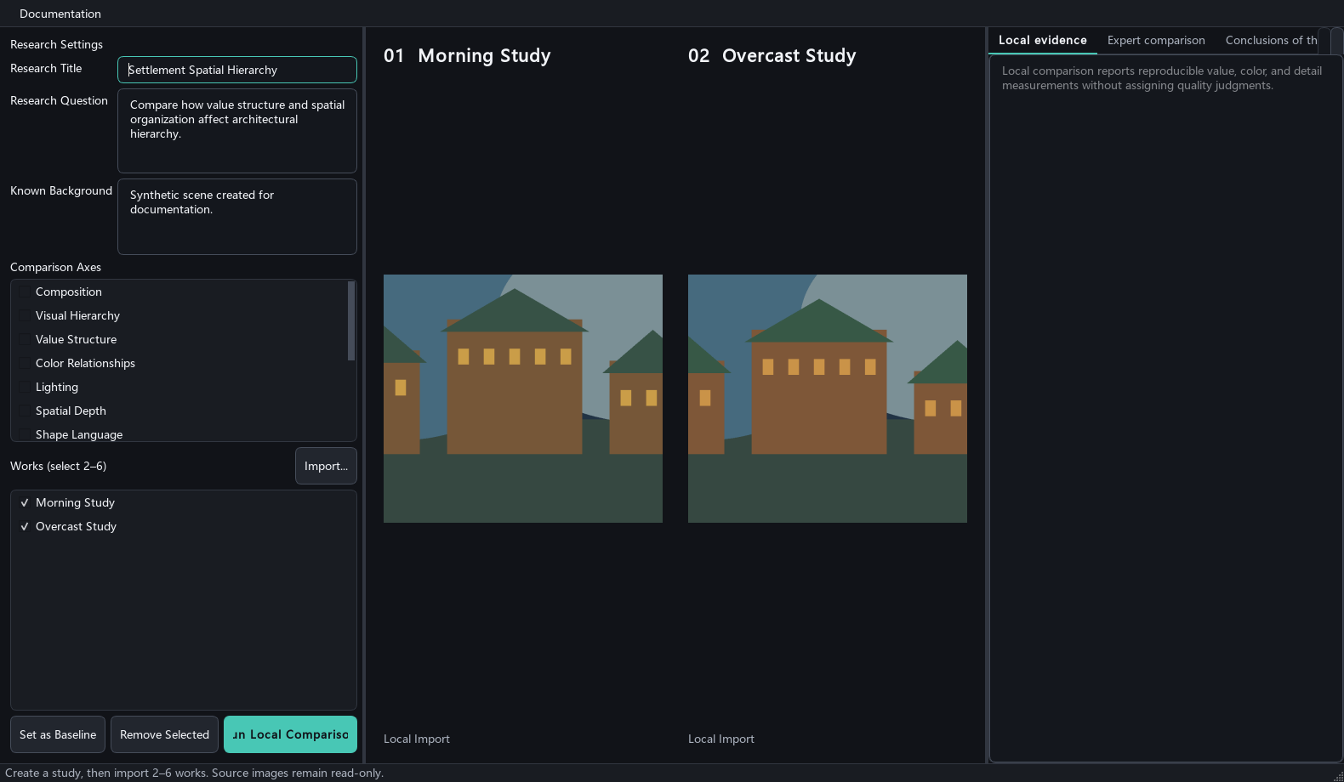
Comparative Study keeps images, research axes, and findings in one view.

6. Asset Breakdown
Purpose: turn complex concept art into an editable asset plan, generation prompts, and asset boards.
- Create a project and import the main artwork and optional references.
- Complete scene understanding, then select breakdown depth and production goal.
- Correct asset names, hierarchy, categories, and source regions.
- Generate only selected assets, or prepare prompts for an external image tool.
- Export the asset list, images, or board.
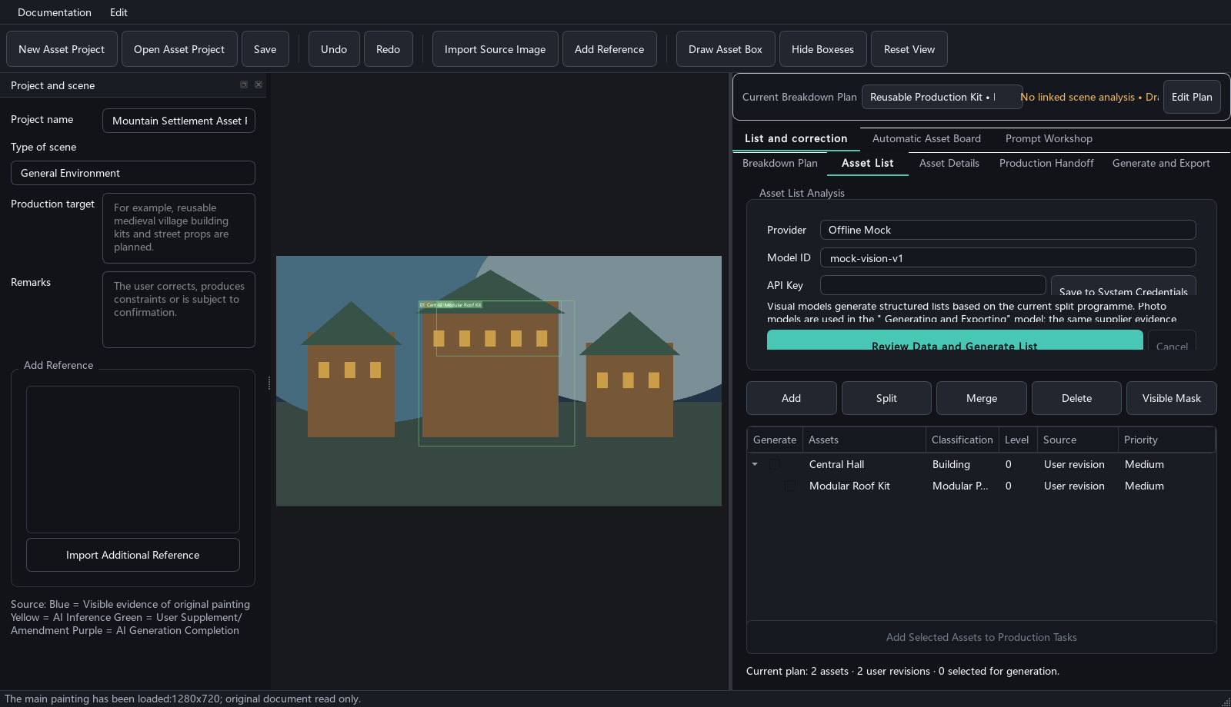
Asset Breakdown links source regions to an editable production hierarchy.
Visible evidence, AI inference, and generated completion are labelled separately. Generated images are concept aids, not production-ready models.

7. Scene Art Control
Purpose: compare production intent, reference art, and the current UE screenshot.
- Create a project and complete Production Intent.
- Create a Shot; import a reference and the current Version.
- Compare the canvases and inspect palette, value, and paired-region evidence.
- Review the send manifest before starting an AI review.
- Convert confirmed findings into tasks and verify them against a new Version.
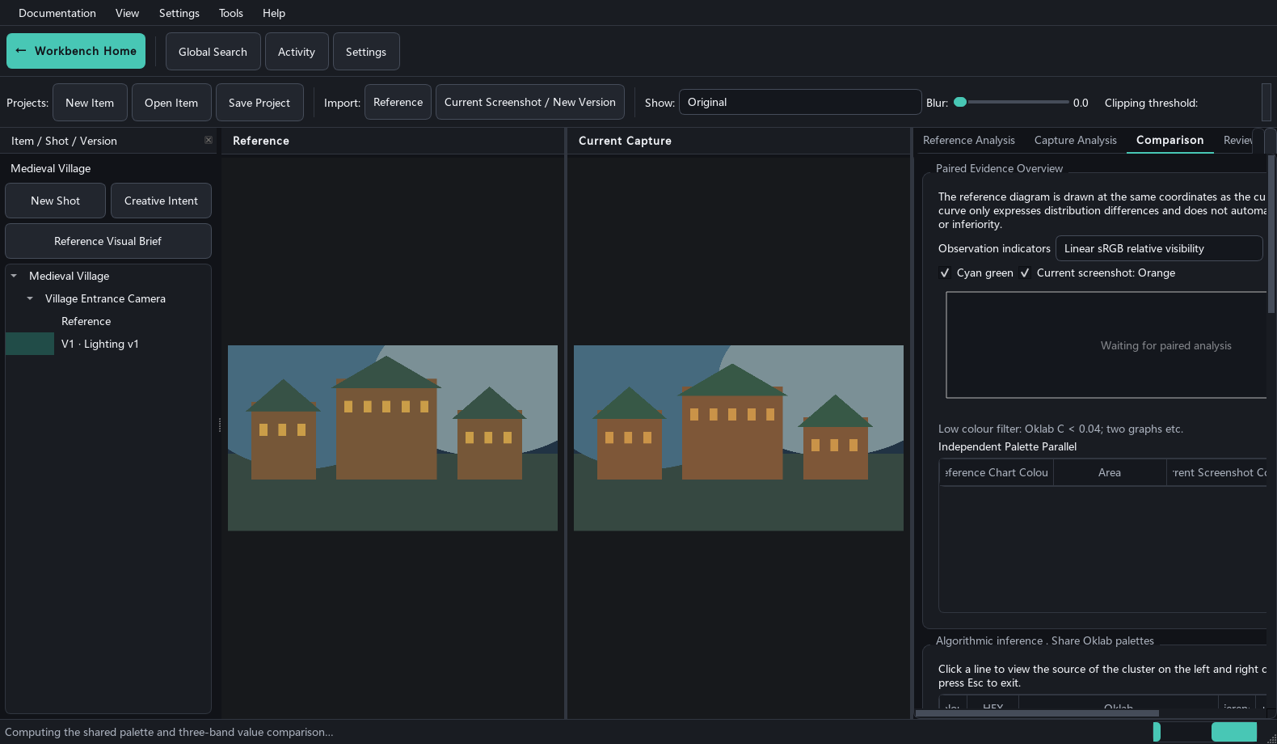
Scene Art Control combines project navigation, two canvases, and evidence analysis.
Projects restore the active Shot, Version, view, parameters, and analysis history.

8. Production Tasks & Acceptance
- Confirm a finding in its source workbench and create a task.
- Filter tasks by project, stage, priority, or status.
- Add acceptance criteria and record Passed, Failed, or Insufficient Evidence on a new version.
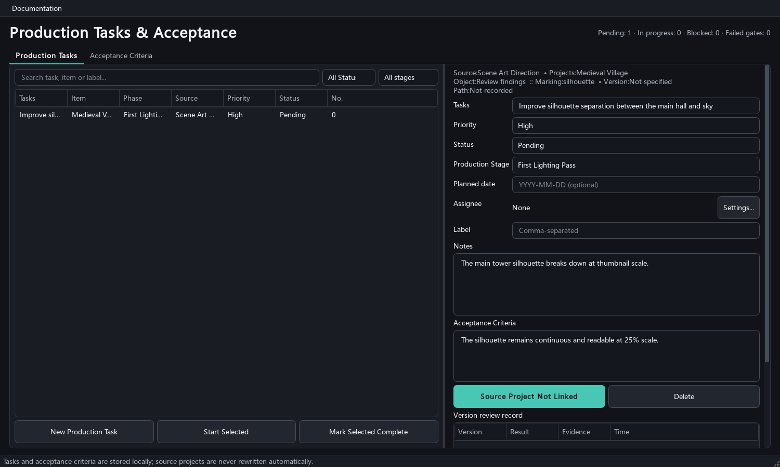
Production Tasks & Acceptance keeps tasks, sources, criteria, and gates together.
The centre stores cross-project indexes and acceptance records; it never rewrites source projects.

9. AI and safety
- Select a provider and model. API keys are stored only in Windows Credential Manager.
- Inspect images, fields, resolution, and expected calls before sending.
- For 401/403, check credentials and access; for 404, check the model ID; for 429, wait for quota; for 503, retry later.
- Offline Mock validates workflow and structure only. It is not a local vision model.
Without an API key, projects, measurements, regions, tasks, reports, and offline review packages remain available. Every network request requires a user action.

10. Report an issue
Purpose: provide a reproducible report without publishing private or commercial data.
- Confirm the defect in the latest GitHub beta and provide the version, Windows release, display scaling, and reproduction steps.
- Use a synthetic or redistributable image. Remove API keys, private paths, accounts, and project secrets.
- Use a GitHub Issue for ordinary defects. Use private vulnerability reporting for credential exposure, unsafe file access, or another security defect.
Result: maintainers receive a minimal reproduction, while public records remain safe to redistribute.

