

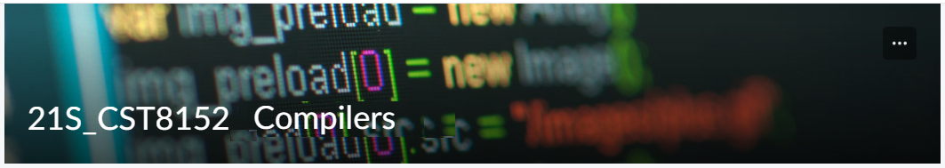

MODEL TASK FOR ASSIGNMENT 2.1 – Dublin

Team: Sean Wray - Id: 041036555
/ Byron Jones- Id: 040585687

- Note: This task is part of the Assignment 2 from Compilers Course. Any problem, contact your lab professor.

PART 1: RE – Regular Expression (1.5 mark)

Lexeme Classes: Define the classes to be used in your regular expression:

Answer:

(0) L: [A-Za-z] (Letters)
(1) D: [0-9] (Digits)
(2) C: $ (Dollar sign, for constants)
(3) Q: “” (Quotations for console output in print functions)
(4) U:_ (Underscore, used to indicate a method)
(5) N: \n (Next Line / break)
(6) F: <EOF> (End of file)
(7) R: : (Colon)
(8) O: [^LDCQEUR] (Other characters)

Define the RE to be used for: variables, literals and keywords:

Answer:
* Variables: VID = L[L | D ]*R //Example of a variable declaration: numapples:

Constant: CID= L[L | D ]*C //Example of a constant pi$

*Methods: MID = UU[ L | D ]*UU //Example of a function declaration: __MyMethod__

* Literals: Q[^Q]*Q //Example of a string literal “Hello!”
* Keywords: {and, for, if, not, or, while, print, String, integer, float, Character, Boolean, void, def}

PART 2: TD – Transition Diagram (1.5 marks)

Activity: Starting from the previous lexeme classes and obeying the RE, it is possible to define the automata for your language:

Answer (draw / copy image of the automata):

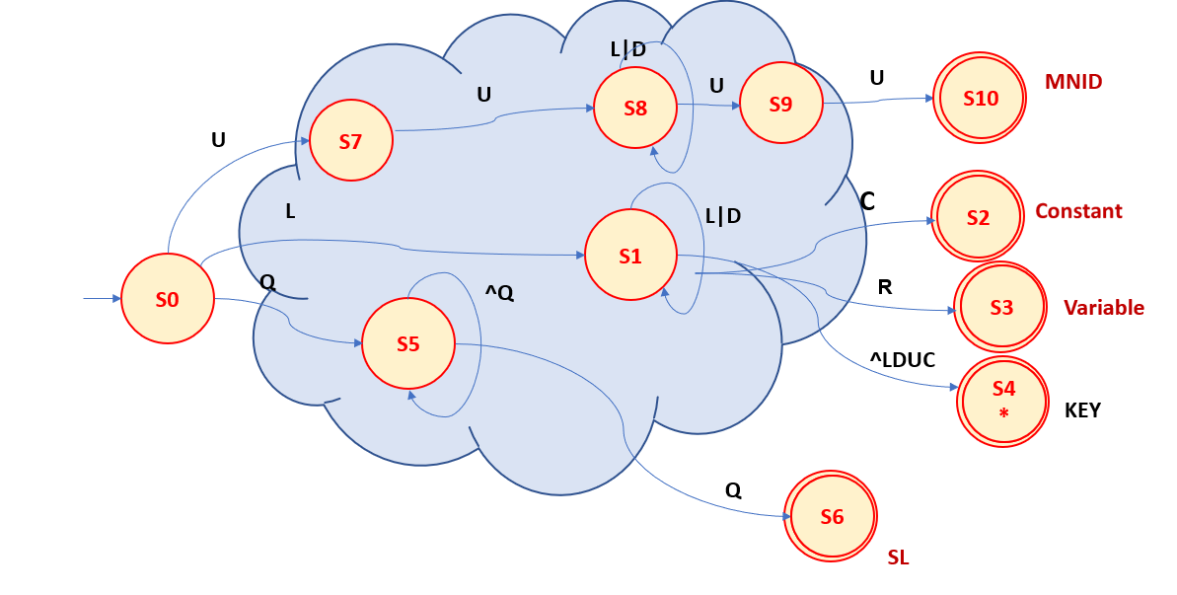

PART 3: TT – Transition Table (2 marks)
Answer (Transition Table):
Input | Input Symbol |  |  |  |  |  |  |  |  | Output
State \ Classes | 0 | 1 | 2 | 3 | 4 | 5 | 6 | 7 | 8 | Type
 | L(A-Z) | D(0-9) | C($) | Q(“) | U(_) | N(\n) | F(EOF) | R(:) | O | -
S0 | 1 | ESNR | ESNR | 5 | 4 | ESNR | ESNR | ESNR | ESNR | NOAS [0]
S1 | 1 | 1 | 2 | ESNR | 1 | ESNR | ESNR | 3 | 4 | NOAS [1]
S2 | FS | FS | FS | FS | FS | FS | FS | FS | FS | ASNR (Const) [2]
S3 | FS | FS | FS | FS | FS | FS | FS | FS | FS | Variable (VAR) [3]
S4 | 4 | 4 | 4 | 4 | 5 | 5 | 5 | 5 | 4 | ASNR (KEY) [4]
S5 | 5 | 5 | 5 | 6 | 5 | 5 | 5 | 5 | 5 | NOAS [5]
S6 | FS | FS | FS | FS | FS | FS | FS | FS | FS | ASNR (SL) [6]
S7 | ESNR | ESNR | ESNR | ESNR | 8 | ESNR | ESNR | ESNR | ESNR | NOAS [7]
S8 | 8 | 8 | ESNR | ESNR | 9 | ESNR | ESNR | ESNR | ESNR | NOAS [8]
S9 | ESNR | ESNR | ESNR | ESNR | 10 | ESNR | ESNR | ESNR | ESNR | NOAS [9]
S10 | FS | FS | FS | FS | FS | FS | FS | FS | FS | ASNR (MNID) [10]

Adapted from resources developed by Prof. Svillen Ranev (Algonquin College, 2019)

