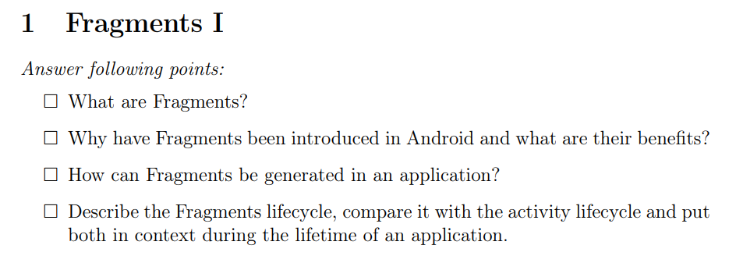

1. Fragments are modular UI components. A fragment defines and manages its own layout, has its own lifecycle, and can handle its own input events but they must be hosted by an activity or another fragment.
2. Mainly because of the various screen sizes of devices. Fragments provide modularity to applications.
3. Create Fragment Class -> Add via XML or in programmatically  
     
   Fragment:  
     
   XML:  
   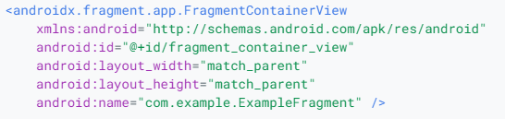  
   Program:  
   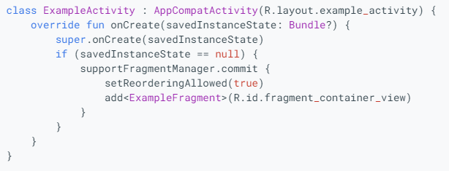
4. 