CypherComm: A Proof-of-Concept for Modular Amateur Radio Encryption

Caleb Carpenter
George Washington University
Washington D.C., United States
caleb.carpenter@gwu.edu

Nathan Ormsby
George Washington University
Washington D.C., United States
nathan.ormsby@gwu.edu

Suprit Patil
George Washington University
Washington D.C., United States supritshivshanthkumar.patil@gwu.edu

Vinayak Dubey
George Washington University
Washington D.C., United States
vinayak.dubey@gwu.edu

Abstract—Handheld radios, also known as “walkie-talkies”, two-way radios, or amateur radio, are a staple means of communication in areas where cell service is either unavailable, or too scarce to use effectively. That being said, these radios offer little, in terms of privacy and security. Generic, consumer-brand walkie-talkies don’t offer encryption, and very few offer “Privacy Codes” (which is just a work-around for actual encryption/obfuscation). CypherComm aims to remedy this by providing a proof-of-concept for real-time radio encryption. CypherComm is a modular add-on for hand-held radios and provides a basic level of encryption and obfuscation that prevents ordinary listeners from being able to understand your transmitted radio data.
Keywords—radio, walkie-talkie, encryption, obfuscation, analog data, radio encryption, transmitting, receiving, Teensy

Introduction
The concept for CypherComm came from looking at 2G encryption used by phones throughout the 2000’s. Originally, this project was going to be geared towards better protection for smartphones; however, due to the recent evolution of 5G networks, the need for another method of encryption is far less than it used to be. Thus, the transition to radio frequency encryption. Frequency encryption has been present for many years, and is hardly a new concept; however, it is not very present at the consumer level. Due to laws and regulations around the encryption of certain frequency spectrums (and thus the abundant number of agencies monitoring those spectrums for encrypted traffic), there has been little progress made in the realm of consumer-available walkie-talkie encryption. Several standards currently exist, including some obfuscation techniques such as “frequency hopping” (discussed later) and Privacy Codes, though most off-the-shelf radios aren’t equipped with either of those, much less full encryption. CypherComm’s purpose is to bring the privacy and security from encrypted transmissions into the public domain, while simultaneously keeping the cost at a reasonable level.
The general public has limited use for encrypted radio technology; however, there are still plenty of use-cases where privacy is of great value (such as in a crowded environment, where anyone with a radio may be able to hear your communications, or for truckers/travelers who require the ability to communicate between vehicles, but desire more privacy in doing so).

Project History
Very little exists, in terms of relatively similar projects. While the technology exists, it primarily exists at the military and law enforcement levels (naturally). The closest similar project is the thesis of a Finnish graduate student^{[1]}. This graduate student took the same concept of 2 Teensys connected to one PC, and used a One Time Password (OTP) as encryption between the two. The OTP was stored on a MicroSD card for each Teensy, and then audio data was passed from the PC to one Teensy, to the second Teensy (which it was directly connected to), and then back to the PC, decrypted.
While similar in concept, the project only encrypts and decrypts digital data, which, unfortunately, does not resolve our primary challenge (receiving and decrypting analog data).

Setup

Hardware required
This project makes use of four Teensy 4.0 microcontrollers, along with four Teensy 4.0 audio shields. Two electret condenser microphones are also required, for transmission of real-time voice data. If no microphones are used, audio data can be transmitted via the MicroUSB cable that powers the setup. Two open-ended male 2.5mm are needed as well, to connect the radio output to the audio shield line-in input pins.

Software Required
This project makes use of the Arduino IDE, as well as several packages, including the external board manager “https://www.pjrc.com/teensy/package_teensy_index.json”, which needs to be copied and pasted into the “Additional boards manager URLs” text box in “File > Preferences”, for Windows (for MacOS, click “Arduino IDE > Settings”).
This paper does not go into the specific install or setup of the software mentioned above.
Each Teensy microcontroller needs to be soldered onto an audio shield using male pins and female headers, respectively. The microcontroller, if it didn’t come with male pins, needs them soldered facing down, away from the central processor. After this, each audio shield needs a 14-pin female header on each side of the board, soldered facing up (on the same side as the audio jack). Following soldering, the microcontroller and audio shields should fit together snuggly. The MicroUSB port should be facing the same direction as the 3.5mm audio jack on the audio shield. After soldering the audio shield and Teensy connections together, the 2.5mm male cable needs to be soldered onto the audio shield. When the audio jack is in the bottom-left corner, the input pins are the bottom two, of the set of four, in the top-middle section of the audio shield. Take the open end of the 2.5mm cable and solder the two appropriate input wires to their left and right holes (typically, the white wire is the right side). Finally, take the two electret condenser microphones and solder them to the other two audio shield pairs (so one pair has the 2.5mm cables, the other has the microphones). The pins for the condenser mic are on the opposite side of the built-in SD card reader.
By the end of the hardware setup process, you should have four microcontroller-audio shield pairs, soldered together using male pins and female headers. Two of those pairs should both contain 2.5mm male audio cables soldered to the input pins on their respective audio shields, and then the other two pairs should contain condenser mics soldered to the appropriate pins on the audio shields.

Overview of the Process
CypherComm’s functionality follows the principle of “input, transmit, receive, output”. Following the hardware and software setup, connect two Teensys to your PC, via MicroUSB. One Teensy should be a Transmitter (contain a condenser mic), and the other should be a Receiver (contain a 2.5mm cable). The Transmitter (Tx) board needs to be attached to the radio input slot using a 3.5mm audio cable connected from the jack on the audio shield to the radio. The Receiver (Rx) board needs to be attached to the radio output slot using the soldered 2.5mm male cable.
Flash the Tx board and Rx board with the “Scrambler.ino” and “Descrambler.ino” Arduino sketches, respectively. These two sketches contain the foundation for the transmission and reception of data. Following the flashes, you can play audio on your PC, and hold the Push-To-Talk (PTT) button on the Tx board’s radio (the radio connected via audio jack). Leave the Rx board’s radio (radio connected via 2.5mm) unplugged to hear the non-decrypted data (you can change the encryption settings in Scrambler.ino to change if the data is encrypted at all, or if it’s encrypted and decrypted on the Tx side, before transmitting (both options result in clear-text audio data being transmitted, and being understandable, even by the non-decrypting side).

The Cypher Process
The encryption of the actual digital audio data takes place in Scrambler.ino. The encryption occurs using a pseudo-random seeded “buffer scramble”. This pseudo-random scramble takes a key as input, and outputs a series of random numbers (hence the seed). This seed is then used to “swap” packets in the buffer, thereby “scrambling” them, so that the audio data is sent out garbled. The function “scrambleBlockInBuffer” takes care of this scrambling process. Using the Arduino.h library, scrambleBlockInBuffer calls “randomSeed(key)”, initializing a pseudo-random sequence of numbers using a key. By ensuring the Tx and Rx sides of the process contain matching keys, we can ensure that audio data is encoded and decoded in a meaningful way. On the reverse side, “descrambleBlockInBuffer” is the function that takes the buffer and ensures that the pseudo-randomly scrambled data is returned to proper order, and then can be outputted.

However, these two scrambling methods aren’t the only capable scrambling functions in the program. Scrambler.ino also comes equipped with “scrambleBlockInBuffer”, which essentially flips every sample in the buffer, thus reversing the audio frequency. Take a song, for example: when the song was played with “scrambleBlockInBuffer”, the audio came out extremely garbled, with a lot of static surrounding it. If you combine that with “descrambleBlockInBuffer”, then you have restored audio. However, if you replace both with “scrambleBlockInBuffer”, then the outputted clear-text audio actually does sound reversed, which is quite interesting. The song tested was Frozen’s “Let It Go”, sung by Idina Menzel. The results were equally peculiar and hilarious. For every high note, we received a low note, and vice versa. Dubbed “Demon Elsa”, this is the current working demo for CypherComm. Demon Elsa represents a small piece of the obfuscation and encryption goal for this project. While not the final end state that was desired, Demon Elsa adequately proves the proof-of-concept capabilities for consumer-available radio obfuscation.

Challenges
A large portion of the challenges encountered during this project arise from the format of the audio data, at the various stages. In example, when audio is passed into the Tx Teensy via MicroUSB, the audio is in a digital format. This makes the audio extremely easy to work with, in terms of encryption and obfuscation. In fact, the demo part of this project that uses “scrambleBlockInBuffer” actually encrypts and decrypts digital data, as opposed to analog. This makes playback of data much easier, as no change has occurred.
When the audio from the Tx Teensy is passed out the 3.5mm jack to the radio, the data is converted to an analog signal over a carrier wave, and then transmitted to the waiting radio. The Rx Teensy then receives the analog audio data from the input pins and attempts to run decryption against those packets. Naturally, decryption against raw analog data is impossible, given the “noise” that exists in the data and the transformation. Thus, Nathan Ormsby came up with the idea of “fence posts”. These “fence posts” represent blocks of audio data, both digital and analog, by marking them with extremely wide-range frequency “jumps” (reaching over 10k MHz). These jumps allow us to track the audio packets on the analog (receiver) side of things, and thus decrypt that packets much more easily.

Solutions and Future Work
Put simply, our primary challenge arose from how the encrypted digital data was received and decrypted, after being transmitted over an analog connection (the radio waves, and then teensy line pins). As stated before, Nathan Ormsby’s implementation of these “fence posts” can be seen below. In essence, a large “fence post signal” is sent, every N audio blocks, thereby ensuring that the analog signal on the other side has a demarcation for where to start decrypting. Aside from the Demon Elsa work that was done (which is obfuscated, but still understandable), this represents the largest portion of our “future work”. We will be continuing to develop this idea of fence posts to further fine-tune the decryption process on the other side, so that we can send AND receive the audio, effectively, after it’s been scrambled.
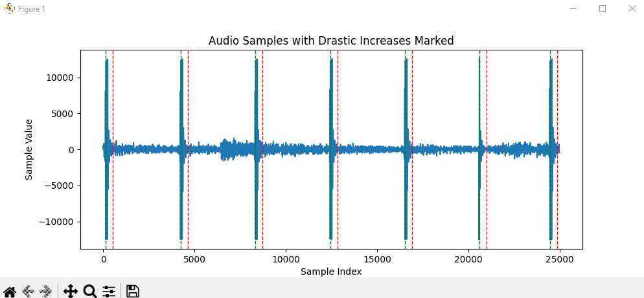
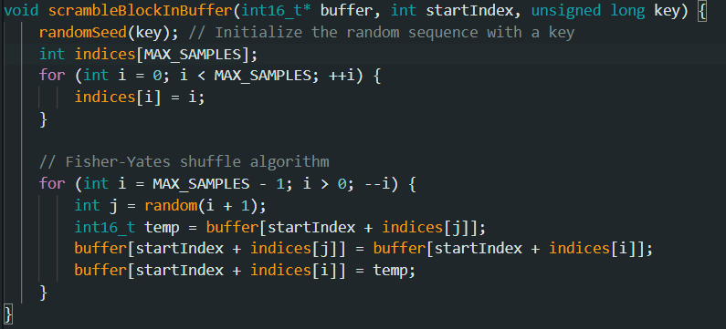

References
- Nevalainen Ari, “Open source OTP voice encryption in microcontroller“ Jyvaskylan ammattikorkeakoulu. JAMK University of Applied, 2019. (references)

