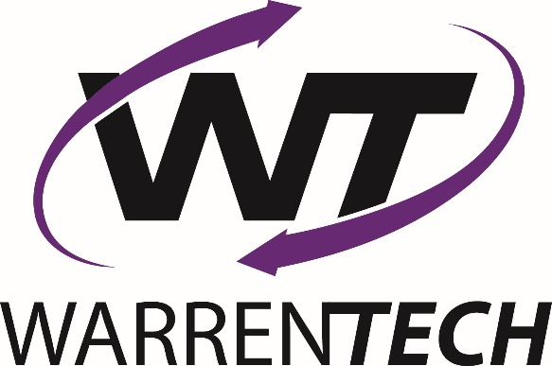

**Out of Class Assignment for Monday, 11-14-16**

The world of technology is rapidly changing! Datacenters are buildings that have raised floors with power, air, and humidity conditioning and special fire suppression systems. Datacenters have massive power consumption needs, and must be secured from outside intruders (both virtually, and physically). Datacenters require special racks in which the servers are placed and networked together. Datacenters need to be operational at all times, even during prolonged power outages.

The old datacenter (of just 5 – 10 years ago) is now virtualized. (See example pictures.)

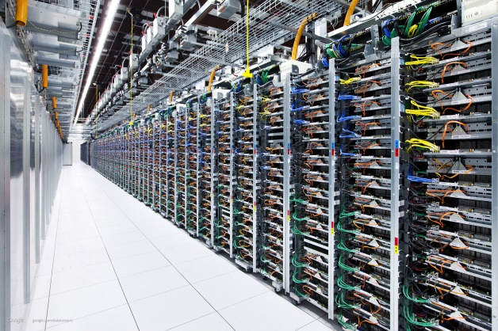 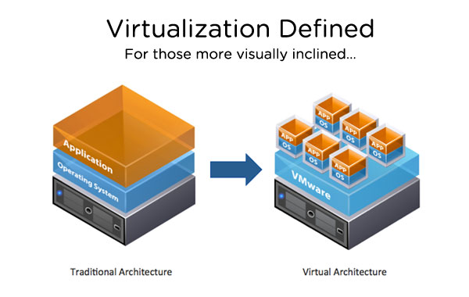

Google Datacenter Virtualization example

At one time, only one server in a datacenter was used with one application. (In times past it was difficult to get two servers to “talk” to each other, but load balancing, and clustered server software fixed that problem). When load balancing and clustered server software came about, it was possible to join multiple single servers together for faster response time to users.

Thanks to their wonderful virtualization software, a company called VMWare has become a huge Information Technology (IT) industry asset, one that most organizations could not live without. So strong was VMWare’s entrance into IT that Microsoft felt compelled to come out with its own Hyper-V server product.

**The Big Question**

So…now with cloud computing becoming so ubiquitous, my question to you is this: What’s the next step in the evolutionary chain for datacenters?

Do you imagine a hybridized datacenter in which most of the servers are hosted by another company (such as Amazon Web Services (AWS)), Microsoft Azure, Google Cloud Services, et al, but the company keeps a handful of specialty servers on hand? Or the opposite: Companies keep most of their datacenter server operations in-house, but outsource less non-critical applications?

Do you suppose there are companies that will outsource *all* of their datacenter operations? Or do you imagine that companies will develop their own in-house cloud operations, and if so, what do you think would be the advantage to that?

Here’s your assignment:

1. Do some research to find out what technical professionals and so-called “C-band” managers such as Chief Technical Officers (CTO) think about this issue?
2. Once you have done your research and compiled what you believe to be the correct narrative, write me a 3 – 5 page “whitepaper” talking about your findings. Imagine that I am your Chief Information Officer (CIO), and I’ve asked you to do this research work for me so that I know how to properly position our organization for the future.
   1. What are the risks? Provide me a **risk analysis summary** of *all* options.
   2. What re the benefits? Provide me a **benefit analysis** of all options.
   3. What are the costs? Provide me a **basic budget** for a 1,000 server datacenter infrastructure.
   4. How to I handle fault tolerance and data recovery if my cloud solution fails? Or do cloud solutions fail? Write me a **fault tolerance and data recovery** section, talking about the options.
3. The paper should have the following formatting elements associated with it:
   1. Spacing: 1.5
   2. Font: Arial or other sans serif font
   3. Font size: 13
   4. Paper title: 18 point, bolded
   5. Paper sections: 16 point, bolded
   6. Page numbers: bottom right-hand side, starting with page one on page one
   7. Student information: Bottom left-hand side in a footer: three lines: (1) Student name, (2) Class and section (e.g. AM or PM), (3) Date written
   8. Graphics: one or two *small* graphics are acceptable
   9. *Do NOT* simply cut and paste paragraphs into your paper. I can *easily* detect that ploy. Instead, write what you think the paragraph is saying in *your own words*. I want to know what you think, *not* what people on the web think.
4. The paper needs to be *professionally* written. Papers that are not spell-checked will be given a zero grade. Hand-written papers will NOT be accepted!
5. Papers in which it is clear that students have simply cut and pasted information from Internet pages or other sources will be given a zero grade.
6. The paper is due *uploaded in Jeffco Schoology* by end of day (3:45 PM), 11-15-16. Papers submitted later than that will be given a zero grade.