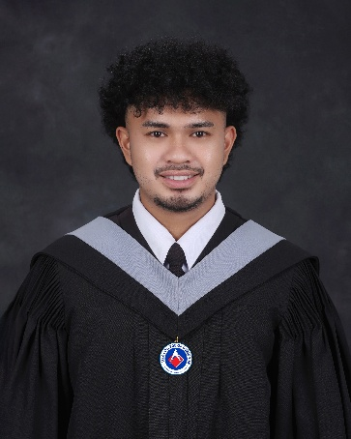

RENIE MONTERO JAVIER JR.
Address: P4 Poblaction Valencia City Bukidnon
Contact Number: 09639152549
E-mail :javierrenren1@gmail.com
Date of Birth: January 31, 20002 Place of Birth: Valencia City Bukidnon (Philippines)
Gender: Male
Country of Citizenship: Philippines Country of Residence: Philippines

CAREER OBJECTIVE:
A highly motivated and versatile Information Technology graduate seeking a role where I can utilize my full-stack development, mobile applications, and technical troubleshooting skills. Committed to continuous learning and contributing innovative solutions to a globally competitive company.
EDUCATION
Institution Name: ACLC COLLEGE OF BUKIDNON (Philippines)
Location: Hagkol, Valencia City, Bukidnon (Philippines) Institution Start Date: June 2022- June 2026
Field of Study: Bachelor of Science in Information Technology
Honors: Cum Laude
Consistent Dean’s Lister (1st Year – 4th Year / 2022 – 2026)

CAPSTONE/THESIS PROJECT
AI-Powered Facial Health Assessment and Dermatologist Recommendation System
Solo Full-Stack & AI Developer | June 2025 – March 2026

WORK EXPERIENCES Position  View Editor  OJT  Full-Stack Developer  Full-Stack Developer |  | Company/Institution  LPZ  Premium Quality Work Solutions Corp.  Agrivet Supply Corp.  Bulahan Clans. |  | Date  Jan 2023 – March 2023  Feb 2026- April 2026  May 2026 – June 2026  Feb 2026 – April 2026
TRAININGS AND SEMINARS  Stress Management and Human Rights Education  HACKATHONS & TRAININGS |  |  | Seminar on Technology  Participant & Developer | Local Tech Hackathon – Robinsons Valencia
SKILLS/ QUALIFICATIONS
Web Development (Frontend & Backend): React, HTML5, CSS, Tailwind CSS, JavaScript, TypeScript, PHP, Java, Python, NestJS, Node.js
Databases: PostgreSQL, MySQL
Mobile & Desktop Development: React, Laravel, NestJS React Native, Android Studio (Java), NetBeans (Java)
UI/UX & Graphic Design: Figma, Canva, Adobe Photoshop
Video Editing: Adobe Premiere Pro, CapCut
IT Support & Hardware: Computer Systems Servicing, Hardware/Software Troubleshooting, System Reformatting, Data Entry
Productivity: Microsoft Office Applications (Word, Excel, PowerPoint)
Languages: English, Bisaya, Tagalog

REFERENCES

Name | Position/ Company | Contact No.
Catherine Uy | Officer Documentation | 09668927691

