ATM App Use Case

Document Information

|  |  |
| --- | --- |
| **Document Title** | Manage Funds |
| **Document Owner** | Aaron Wright |
| **Version** | 1.0 |
| **Status** | Final |
| **Date** | 03/09/2020 |

1. Brief Description

The purpose of this application is to allow an authenticated user to be able to move fund into and out of there bank account.

1. Actors

The following roles and systems are involved in the ATM App Use Case:

* Users
* Bank accounts
* Authentication Servers

1. Pre-Conditions

The following conditions must be met before the ATM App can perform its function.

* System must be powered on.
* Pin pad and card reader must be functioning properly
* System must be securely connected to the Authentication and bank account servers via a VPN tunnel.

1. Basic Flow

The Happy path of the ATM app.

1. The customer is prompted to insert bank card.
2. The user is prompted to enter a pin number.
3. The authentication server verifies the user.
4. The user is prompted to select an account to interact with.
5. The user is asked whether they are withdrawing or depositing.
6. The user is prompted to enter the amount.
7. The desired function is performed.
8. The card is ejected.
9. Alternate/Exception Flows

1a – The system is not powered on.

1b – The system must be powered on.

1c – The connection to the VPN must be established.

2a – The Customer is not validated, causing the card to be ejected.

3a – The transaction can be cancelled at any time, causing the bank card to be ejected.

4a – If a withdrawal amount is selected that exceeds the available fund the user is prompted to enter a valid amount

4b – If a withdrawal amount is repeatedly selected that exceeds the available fund the transaction is aborted, and the card is ejected.

5a – The user is given the option to cancel at any time during the transaction, causing the card to be ejected.

6a – The user goes to long without any input.

6b – The card is run through an internal shredded to protect the customers account.

1. Post Conditions

The following conditions must be met in order for the ATM app’s function ends.

* The user selects quit.
* The user allows the system to time out by not giving input for an extended period of time.

1. Supplemental Requirements

The application will need to have functionality added in the future to allow for it to be implemented on ITMs. This would allow for customer to get cashiers checks and other services that require a teller at the ITM.

1. Visual Model

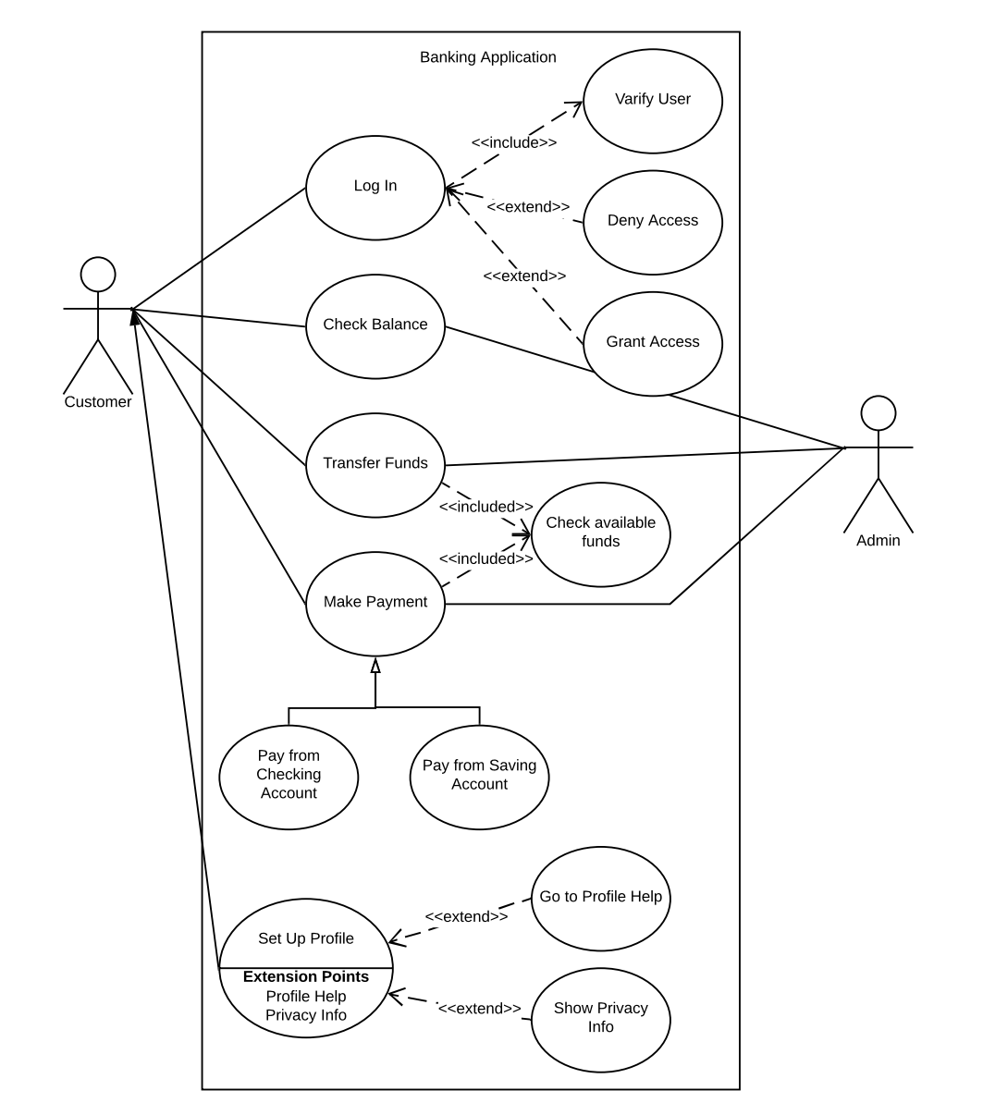

Revision History

|  |  |  |  |  |
| --- | --- | --- | --- | --- |
| V. | Date | Author | Description | Status |
| 1.0 | 03/09/2020 | Aaron Wright | Use case Details fully entered. | Final |
|  |  |  |  |  |