FIRST Tech Challenge

ATLAS FTC AI Assistant: Website and LLM
Functional Specification
Please note: Items in [brackets] are placeholders the team still needs to fill in. Items marked "Issue" are open decisions; each has a proposed resolution that should be confirmed at the next team review.
Feature Information
Feature Name | Atlas
Area | Team software project: rules assistant website + language model
Related Features | Engineering Calculators, Parts Advisor, FRC Mode (planned), Admin Dashboard
Requirements Specs | Project Schedule (Nov–Jan); Website ↔ Model API Contract (to be written, Nov)
Document Location | GitHub - Writerfrighter/Atlas: A chatbot & resource library for FIRST teams · GitHub
Spec Status | Initial Draft

Contact Information
Website Lead | Siddharth Vasudeva
LLM Lead | Avijit Dube
Design | Steven Zhou
Mentor / Advisor | Chad Magendaz

Related Documents
Game Manuals | FTC Game Manual Part 1 and Part 2, current season (official FIRST website)
Official Q&A | FTC Game Q&A system (official FIRST website)
Planning Documents | Project Schedule (Website + LLM columns, Nov–Jan); Pitch deck; bi-weekly progress decks
Design Specifications | [Figma / wireframe link]
Test Specifications | eval/ftc_rules_v1.jsonl (see Section 3.12)

Author | Date | Version | Comments
Avijit Dube | 03-Nov-26 | 0.1 | Initial draft covering website and LLM
Website team | 06-Nov-26 | 0.2 | Checked all the website parts against the real site, fixed what was wrong, marked what's planned, and put in new screenshots

Table of Contents
1 Feature Description 4
1.1 Behavioral Specification 4
1.2 UI Description 8
1.3 API and Interfaces 14
2 Integration Issues 15
2.1 Manageability 15
2.2 Security Impact 15
2.3 Setup Requirements 16
2.4 Hardware/Environmental Requirements 17
2.5 Source File Impact 17
3 Project Information 18
3.1 Work List 18
3.2 Data Model Impact (Firestore) 19
3.3 Performance 20
3.4 Localization/Globalization Issues 20
3.5 Accessibility Issues 20
3.6 Compatibility 21
3.7 Backup 21
3.8 Reliability Issues 21
3.9 URL Requirements 21
3.10 Supportability 22
3.11 User Assistance Issues 22
3.12 Test Plan and Quality Targets 22
3.13 Key Feature Interactions 23
4 Boneyard 23
4.1 Hybrid Retrieval 23
4.2 Cloud-Hosted Model 23
4.3 Fine-Tuning 23
4.4 Robot Photo and CAD Questions 23
4.5 Other Channels 23
4.6 Additional Languages 23

Functional Specification
FTC AI Assistant: Website and LLM

1 Feature Description

1.1 Behavioral Specification
The FTC AI Assistant is a web-based chatbot that answers questions from FIRST Tech Challenge teams about the current season's competition rules and helps with the engineering side of building a robot. A team member signs in, types a question in plain language ("Can our robot extend past the field perimeter?", "What gear ratio do I need for 5 ft/s?"), and receives a short, direct answer that cites the exact manual section, Q&A post, or update it came from.
Teams today answer rules questions by searching two long PDF manuals, the official Q&A, and team updates by hand, and the answer often depends on rules spread across several sections. The assistant shortens that search to seconds while always pointing back to the official source, so a team can verify the answer before relying on it at an event.
The project has two parts, built by two sub-teams that meet at a single API boundary (Section 1.3):
- Website (our team): the React web app, login and sign up, the chat page, saved chat history, dark/light mode, the Q&A page with admin editing, and the Firebase backend that stores everything. Later it will also pass messages to the model.
- LLM (model team): the model server running on a team PC, the BM25 retrieval index / RAG over the knowledge sources, the calculator tools, and the prompts that turn retrieved text into a cited answer.
We built the website first so it works on its own with a placeholder reply instead of the real model. That way neither team has to wait on the other. Right now the chat page shows a "Demo mode" badge, and we connect it to the real model server once the LLM team is ready. Figure 1 shows how all the pieces connect.
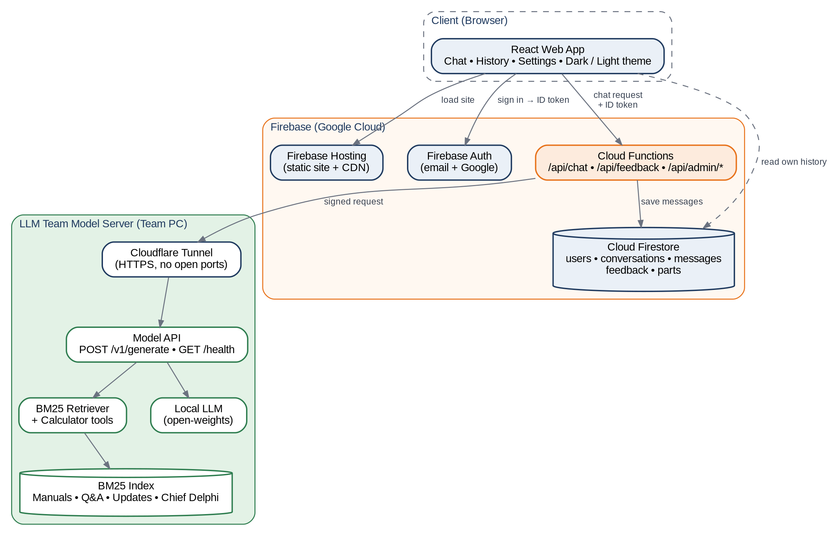
Figure 1: System architecture

1.1.1 Goals and Non-Goals
Goals | Non-Goals (for beta)
Accurate answers to rules questions with a citation on every rules answer  Answers in under ~10 seconds on typical questions  Engineering help: gear ratios, speeds, torque, part selection  Clean, simple interface that works on phones at events  Easy switch to a second competition (FRC) later | Replacing the official Q&A or acting as an official ruling  Image or CAD upload ("look at my robot")  Training a model from scratch  Native mobile apps  Languages other than English

1.1.2 Users
User | Typical needs | What matters most
Student team member | Quick rule checks while designing or practicing: "Is this legal?" | Speed, plain language, works on a phone
Rookie team | Understanding the game, scoring, and inspection from scratch | Explanations, starter questions, no jargon
Admin (our team) | Add, edit and delete Q&A entries (works now); later review bad answers and manage beta invites | Simple Q&A editor, feedback queue (planned)

1.1.3 Core Capabilities
Capability | Description | Pri
Rules Q&A | Answers questions about the game manuals, Q&A, and updates using retrieved source text only | 1
Source citations | Every rules answer lists the sources it used, labeled by type, with a snippet and link | 1
Conversation memory | Follow-up questions use the last few turns of the conversation for context | 1
Engineering calculators | Gear ratio, drivetrain speed, arm torque, and lift calculations computed in code | 2
Parts Advisor | Recommends parts from a curated catalog based on the user's requirements | 2
Design ideas | General mechanism brainstorming (intakes, slides, arms), clearly labeled as suggestions | 3
FRC mode | Same assistant over FRC sources, selected from a competition switcher | 3

1.1.4 Knowledge Sources
The assistant only answers rule questions from the sources below. Each source has an authority level; when two sources disagree, the higher-authority, newer source wins, and the answer reflects that.
Source | Format | Authority | Refresh | Notes
Game Manual Part 1 | PDF | Official (1) | Each new version | Robot rules, inspection, event structure
Game Manual Part 2 | PDF | Official (1) | Each new version | Season-specific game rules and scoring
Official Q&A | Web posts | Official (1) | Weekly during season | Clarifies manual rules; newer than manual
Team / Coach Updates | Email/web | Official (2) | As published | Manual changes and announcements
Chief Delphi threads | Forum posts | Community (3) | Monthly | Labeled "Community, unofficial"; mainly FRC
Parts catalog | Firestore | Curated | Each season | Vendor specs entered/verified by our team

1.1.5 Answer Pipeline
When a user sends a message, the model server processes it in the stages shown in Figure 2. An intent router decides whether the question needs rules retrieval, a calculator, a parts lookup, or a mix of these.
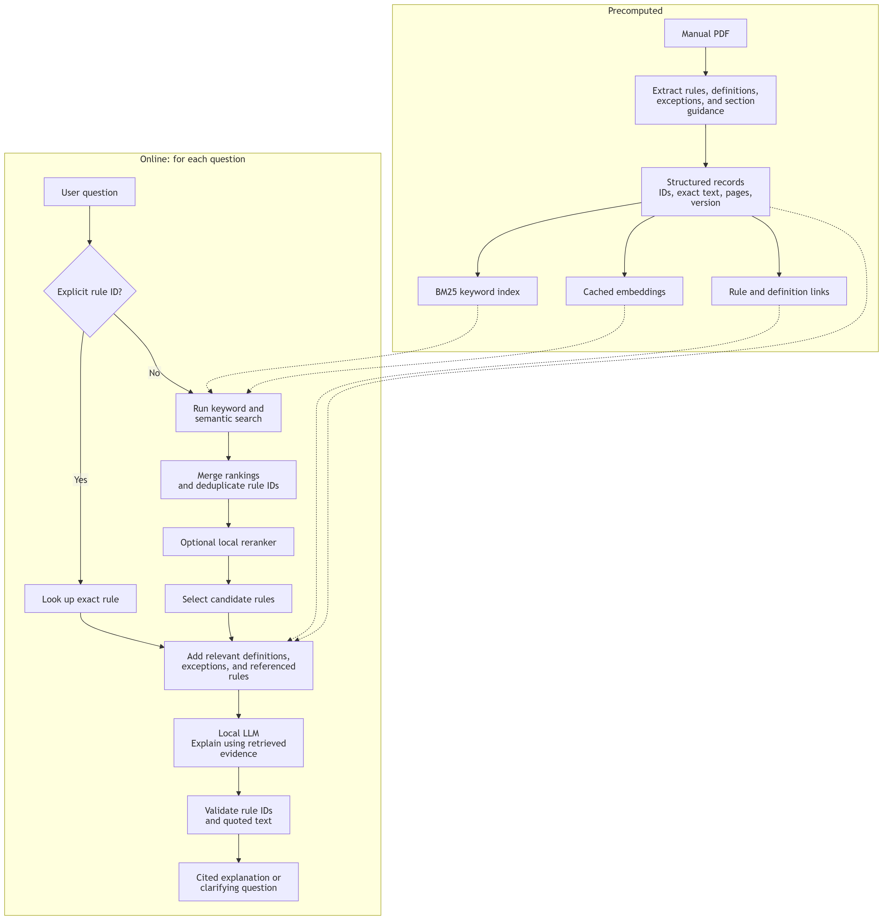
Figure 2: Answer pipeline on the model server
Stage | Behavior
Normalize & expand | Lowercases, fixes common misspellings, and adds FTC synonyms so keyword search finds paraphrased questions (for example, "how tall" → "height, sizing, starting configuration").
Intent router | Classifies the question as rules, calculation, parts, design, or off-topic. A question can trigger more than one path (for example, "Is this motor legal and how fast will it go?").
BM25 retrieval | Returns the top 8 chunks for the active competition and season. Chunks keep their rule ID, section, page, and source type.
Authority re-rank | Moves official sources above community sources and newer Q&A/updates above older manual text on the same rule.
Prompt assembly | Builds the prompt within a fixed token budget: system instructions, retrieved sources, recent conversation turns, and the question.
Generation | The LLM writes the answer and streams it token by token.
Citation check | Verifies every rule ID in the answer exists in the retrieved sources. Unknown rule IDs are removed, and the answer is flagged in logs.

Answering policies. These rules are built into the system prompt and checked in testing:
- Rule: Answers come only from retrieved sources. If no retrieved source addresses the question, the assistant says it could not find it in the manuals and suggests asking the official Q&A instead of guessing.
- Answers lead with the direct answer in one or two sentences, then details, then sources.
- When sources conflict, the answer names both and states which one is newer or more authoritative.
- Community content is never presented as a ruling.
- Off-topic questions get a short, friendly redirect to what the assistant can help with.

1.1.6 Data Ingestion
Sources are converted into a searchable index by an ingestion script that the LLM team runs (Figure 3). The index is rebuilt whenever a new manual version, Q&A batch, or update is published.
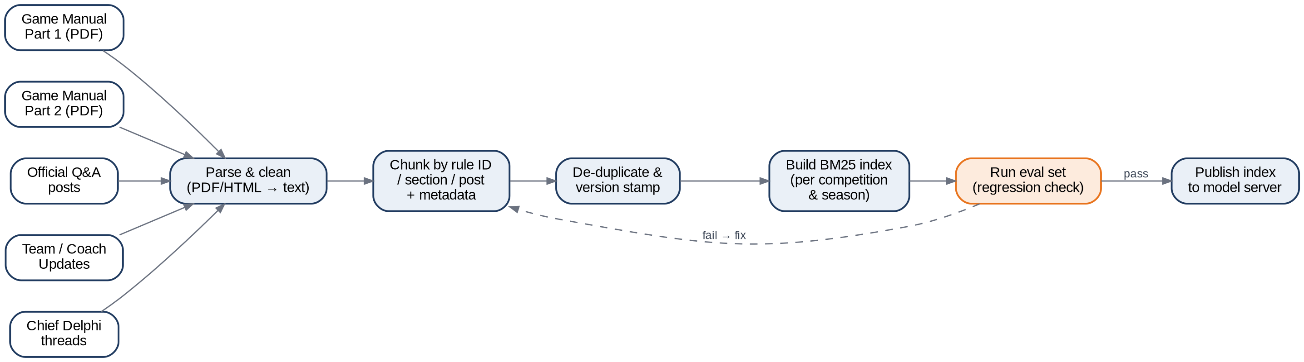
Figure 3: Ingestion pipeline from raw sources to a published BM25 index
- Chunking: manuals are split at rule boundaries so one chunk holds one rule (with its ID, for example, a robot rule or game rule number) plus its section title. Q&A posts are a single chunk per question-answer pair. Long sections are split with a small overlap.
- Metadata per chunk: competition, season, sourceType, title, ruleId, section, page, url, publishedAt, version.
- Versioning: each index build gets a version string (for example, ftc-2026-v3). The model server reports the active version, and every saved answer records the version that produced it.
- User notice: when a new manual version is indexed, the website shows a dismissible banner: "Updated with Game Manual [version], [date]."

1.1.7 Usage Policies and Limits
Policy | Beta value | Behavior when reached
Message length | 2,000 characters | The message box won't let you type past 2,000 characters
Rate limit per user | 30 messages / hour, 200 / day (planned) | Not built yet. Needs the Cloud Function. Will show a friendly message with the time until reset
Conversation context sent to model | Last 6 turns | Right now the site sends the whole chat; the Cloud Function will cut it to the last 6. Older turns stay on screen either way
History retention | Until the user deletes it | Users can delete one chat at a time from the sidebar. Deleting all data in Settings is planned
Account access | Open sign-up for now; invite code planned | Anyone can make an account right now. The invite code box gets added to sign-up before beta
Request timeout | 45 seconds (planned) | Not built yet. Will keep the partial answer and show "Retry"

1.2 UI Description
The site is built around the chat page, and everything else is one click away from the navbar at the top. Figure 4 shows every page on the site right now and who can get to it.
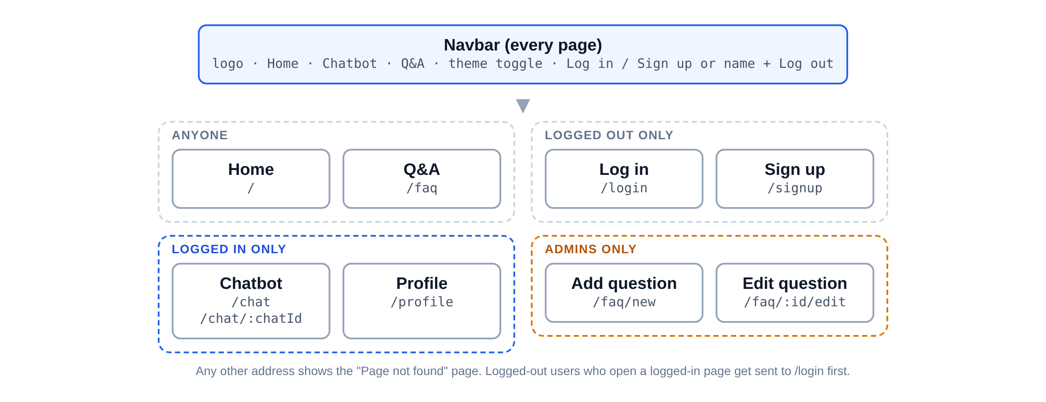
Figure 4: Site navigation map (all the pages that exist right now)
Top usability goals for beta:
- A first-time user can get to an answer fast: type a question in the box on the home page, sign up, and the chat opens with that question already sent. A new chat also shows two example questions you can just click.
- Users can tell where an answer came from (source chips under each answer, planned for when the model is connected).
- The site works on a phone: every button is at least 44 px tall, and the chat history turns into a slide-out menu on small screens.
- Both themes are easy to read and should meet contrast guidelines.
- Errors say what happened in plain words (a small pop-up at the top of the screen), and the user never gets a blank page. If Firebase isn't set up yet, a setup screen shows instead of a broken site.

1.2.1 Landing Page
The home page (/) is public, so anyone can see it, logged in or not. The top has a question box: you type a question, hit "Ask Atlas", and it opens the chat with your question already sent. If you're logged out it makes you log in or sign up first and then takes you there. Next to the box is a sample conversation so people can see what the chat looks like before signing up. Below that are "What you can ask about" (Game Rules, Scoring, Registration and Resources), "How a question gets answered", and a section about our team. The footer has our team info, links to official FTC resources, and the line "Not affiliated with or endorsed by FIRST." Logged-in users can still visit the home page; it doesn't send them away. Figure 5 shows the home page.
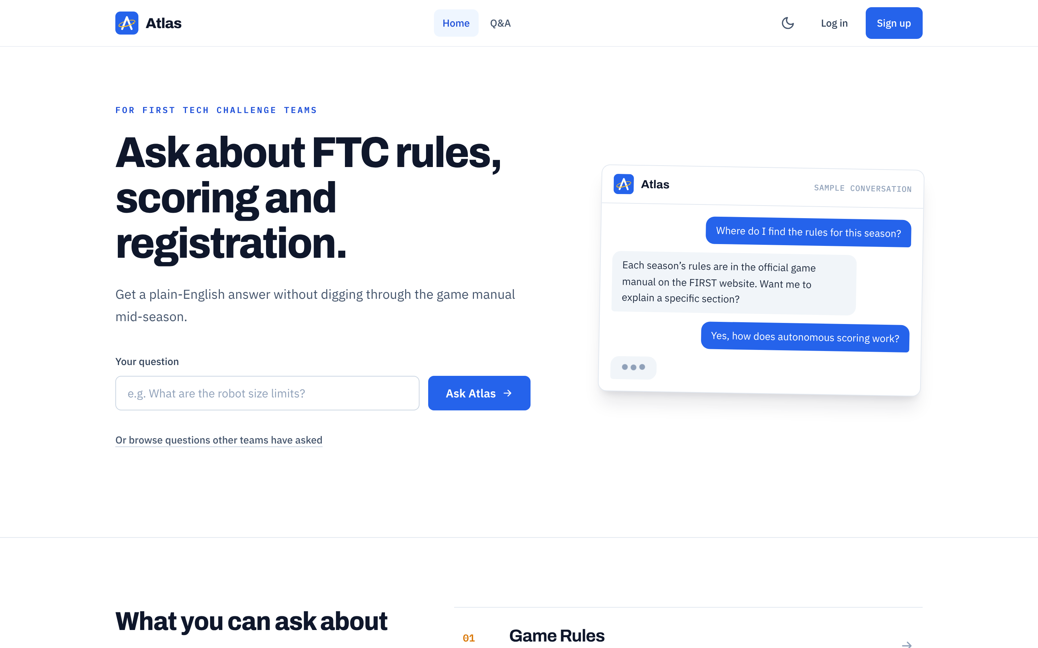
Figure 5: Home page, logged out (light theme)

1.2.2 Sign-in and Sign-up
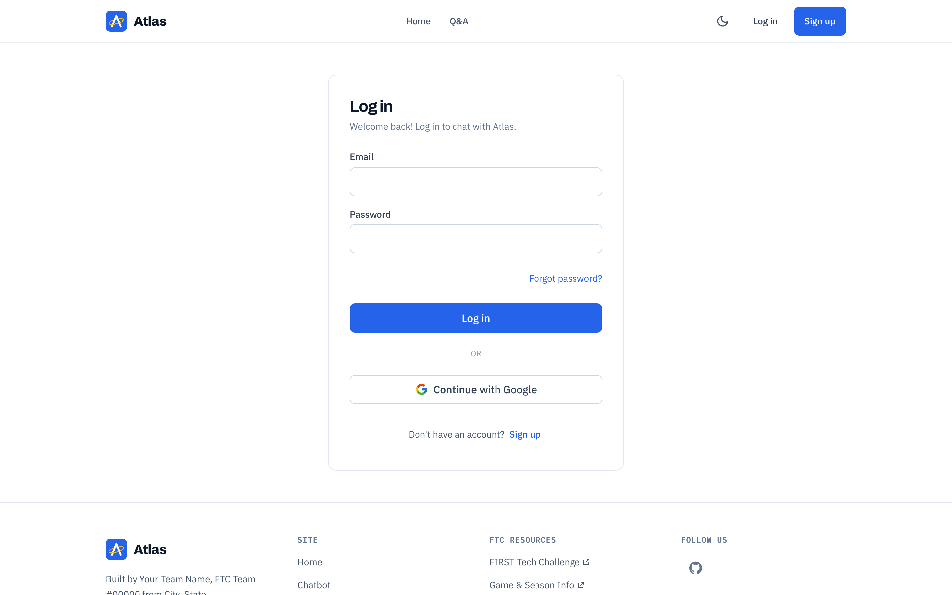
Figure 6: Log in page (light theme)
Login uses Firebase Authentication with two options: Google sign-in and email/password. The Log in and Sign up pages are only for logged-out users. If you're already logged in, they send you to the chat.
Action | Result
Continue with Google | Opens the Google pop-up. The first time someone signs in, we make their profile in Firestore using their Google name. Asking for a beta invite code here is planned, not built yet.
Log in with email | Both boxes have to be filled in. A wrong email or password shows "Incorrect email or password." so it doesn't say which one was wrong.
Create account | Name, email, password (at least 6 characters) and confirm password. If the passwords don't match, it tells you before sending anything. Planned for beta: invite code, age check, and email verification.
Forgot password | Type your email, then click "Forgot password?" and Firebase sends a reset email. Right now, if there's no account, it says "No account found with that email." We plan to change it to always say "If an account exists, we sent a link" so people can't check which emails are signed up.
Log out | The "Log out" button is in the navbar. It takes you to the home page first and then logs you out. Your theme choice stays saved on the device.

1.2.3 Chat Window
The chat page (/chat) is where logged-in users ask questions. Figure 7 shows it in light mode with numbered callouts, and Figure 8 shows the same page in dark mode. The replies in the screenshots are placeholders because the model isn't connected yet. That's what the "Demo mode" badge means.
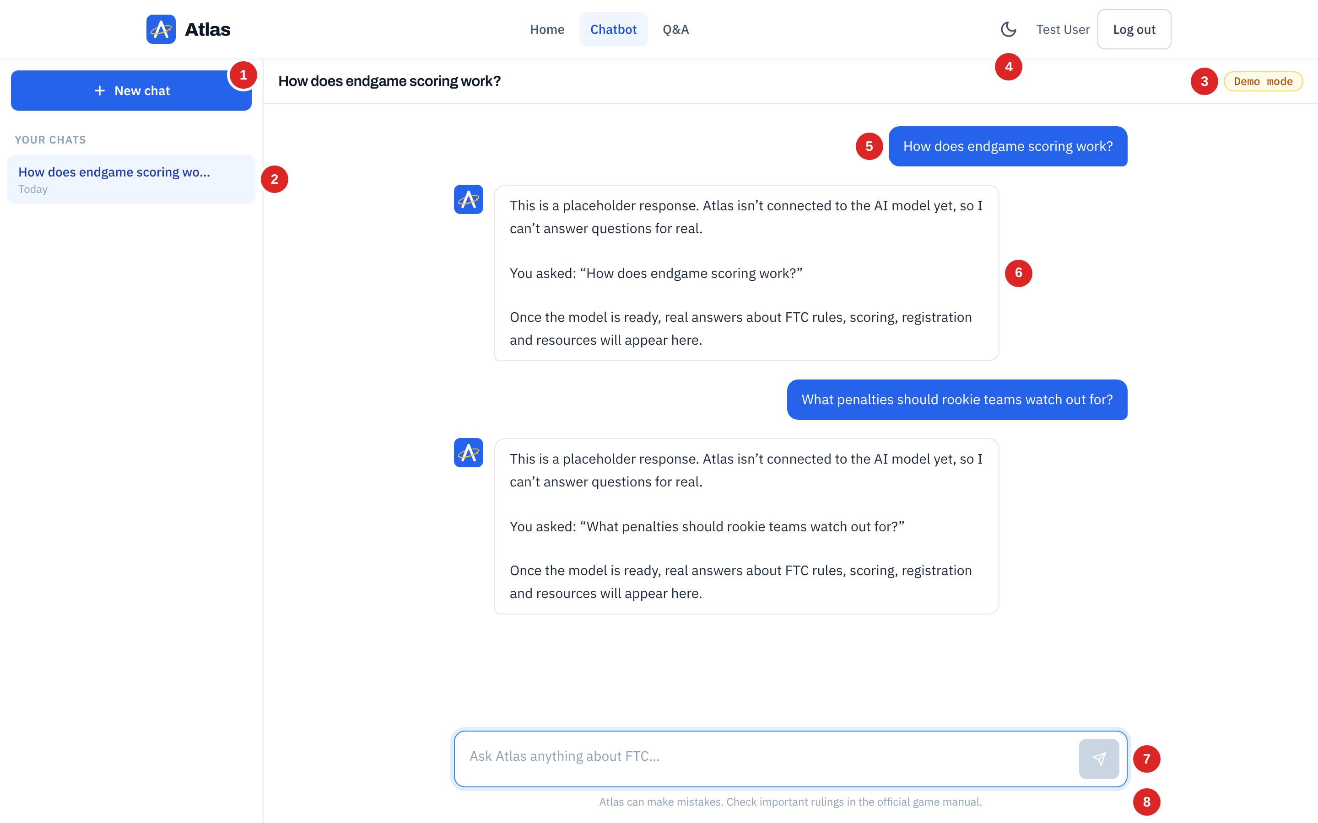
Figure 7: Chat page, light theme (callouts explained below)
# | Element | Behavior
1 | New chat | Opens a fresh empty chat. The chat doesn't get saved until you send the first message, so you don't end up with a bunch of empty chats.
2 | Saved chats | Every chat is listed under "Your chats", newest first, with "Today", "Yesterday" or the date. Click one to open it. The trash can button deletes it (it asks first).
3 | Demo mode badge | Shows while the site isn't connected to the model, so nobody thinks the placeholder replies are real answers. It goes away by itself once VITE_AI_API_URL is set.
4 | Theme toggle | Switches light/dark right away (Section 1.2.5). It's in the navbar, so it works on every page.
5 | Your message | Blue bubble on the right. Long messages wrap and line breaks are kept.
6 | Atlas's reply | White bubble on the left with the Atlas logo. While you wait, three "typing" dots show.
7 | Message box | Enter sends, Shift+Enter makes a new line. The box grows as you type. The send button is grayed out when the box is empty or Atlas is still replying.
8 | Disclaimer | "Atlas can make mistakes. Check important rulings in the official game manual." Always shows under the message box.

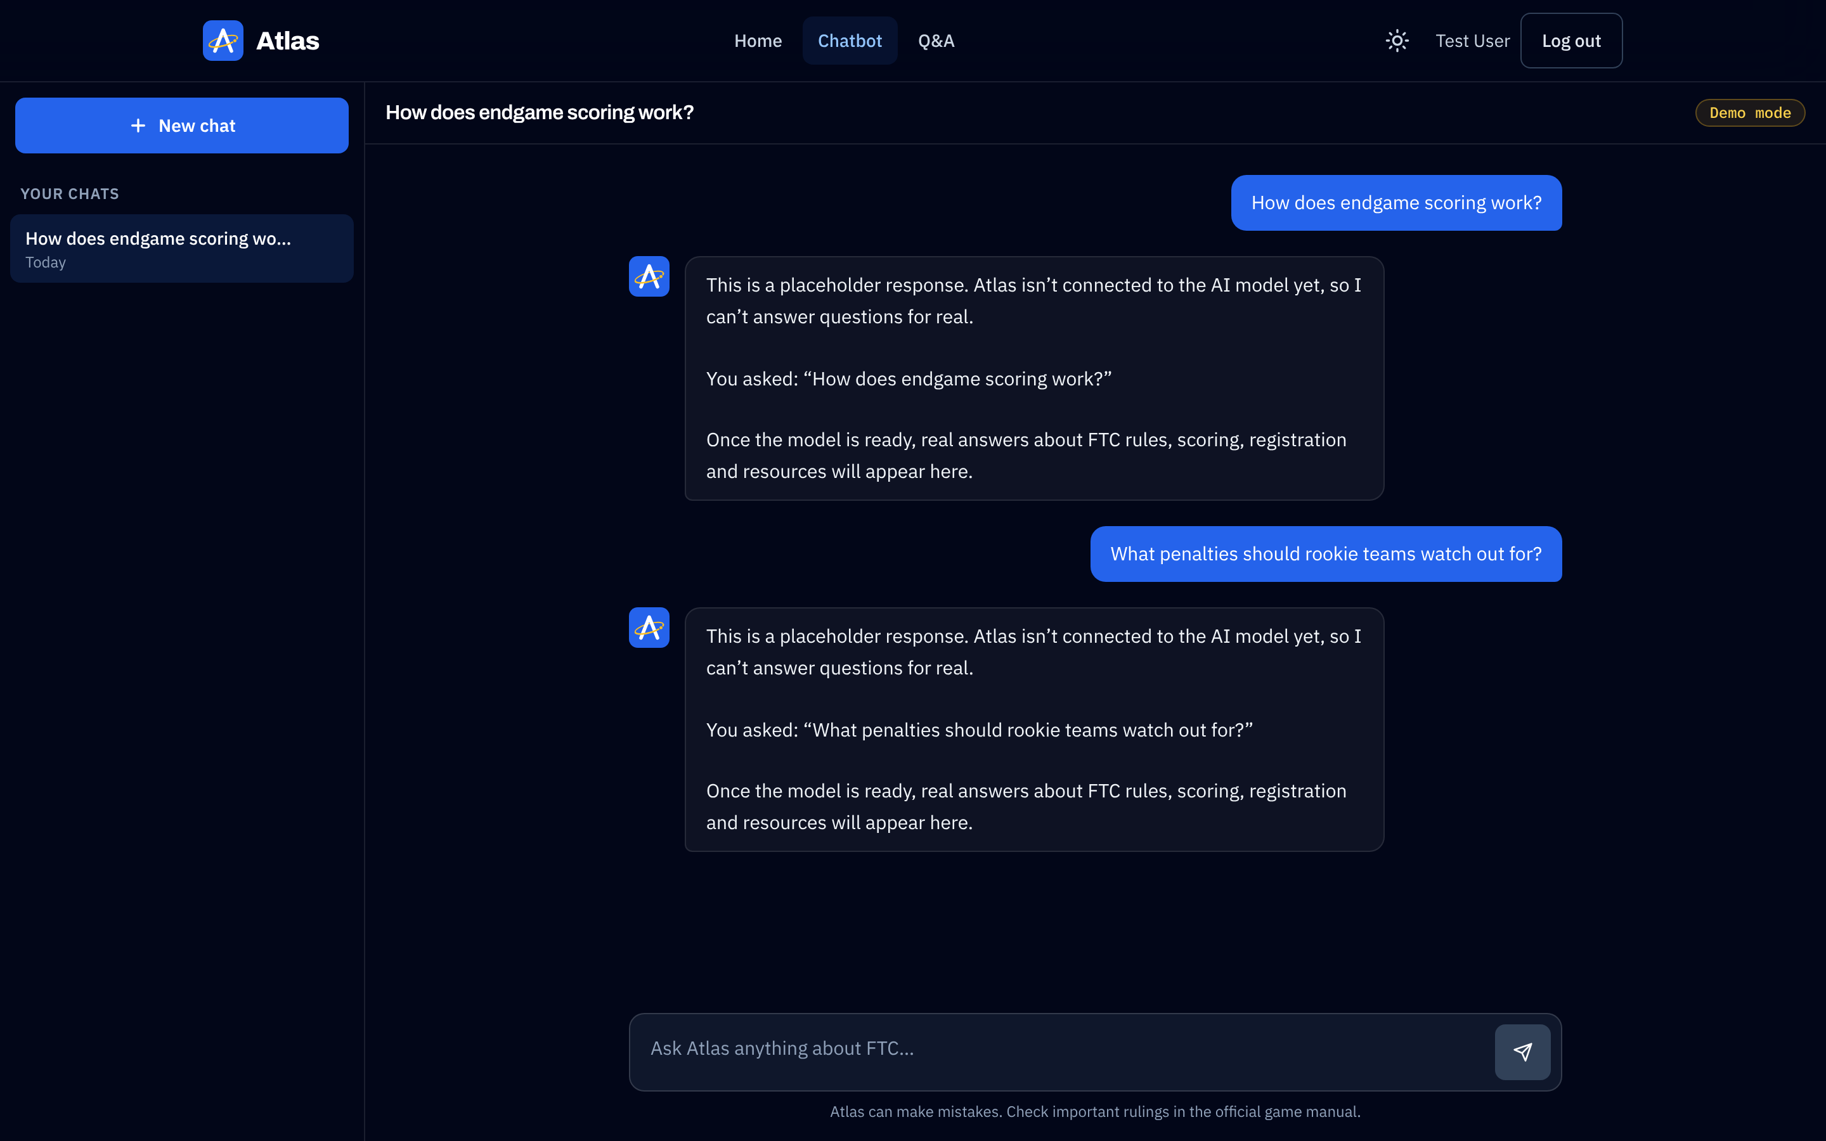
Figure 8: Chat page, dark theme
Streaming (planned). Right now the whole reply shows up at once after the typing dots. Once the model is connected through the Cloud Function, we want the answer to show up word by word, with source chips at the end and a Stop button.
Empty state. A new chat says "Hi [first name], how can I help?" and shows two example questions: "What are the robot size limits?" and "How are points scored during autonomous?" Clicking one sends it. We cut it down from four to two so the screen isn't a wall of buttons.
Formatting. Replies show as plain text right now (line breaks are kept). Markdown (bold, lists, tables) and calculator result tables are planned for when real answers come in.

1.2.4 Conversation History
- Chats are listed in the left sidebar under "Your chats", newest first. Each one shows "Today", "Yesterday", or a short date like "Sep 28". Grouping them into Today / Previous 7 days / Older is planned.
- A new chat gets its title from the first question (cut off at 40 characters). You can delete a chat with the trash can button, and it asks you to confirm first. Renaming chats isn't built yet.
- Planned: chats from a past season will show a "Season ended: answers may be outdated" label.
- On screens narrower than 1024 px, the sidebar turns into a slide-out drawer. You open it with the menu button next to the chat title.

1.2.5 Theme (Dark / Light Mode)
The first time you visit, the site matches your device's light/dark setting. Clicking the moon/sun button in the navbar switches it right away and saves it in the browser. If you're logged in, it also saves it to your Firestore profile (preferences.theme) so it follows you to other devices. All the colors are set once in src/index.css, and we only use three: Atlas blue, slate grays, and amber for small highlights. No gradients.
Token | Light | Dark | Used for
background | #FFFFFF | #020617 | Page background
border | #E2E8F0 | white at 10% | Card and sidebar borders (we use borders, not shadows)
text | #0F172A | #F1F5F9 | Body text
muted | #64748B | #94A3B8 | Hints, dates, small labels
brand (Atlas blue) | #2563EB | #2563EB (links #93C5FD) | Buttons, links, your chat bubble
accent (amber) | #B45309 | #FCD34D | Demo mode badge, step numbers, notes

1.2.6 Profile and Settings
There isn't a separate Settings page yet. Right now the Profile page (/profile, you get there by clicking your name in the navbar) shows your name, email, the date you joined, your theme, and your User ID with a Copy button (admins need this, see Section 1.2.7). Admins also get an "Admin" badge. The theme toggle in the navbar is the only setting so far. Figure 9 shows the Profile page, and the table below is what we still want to add.
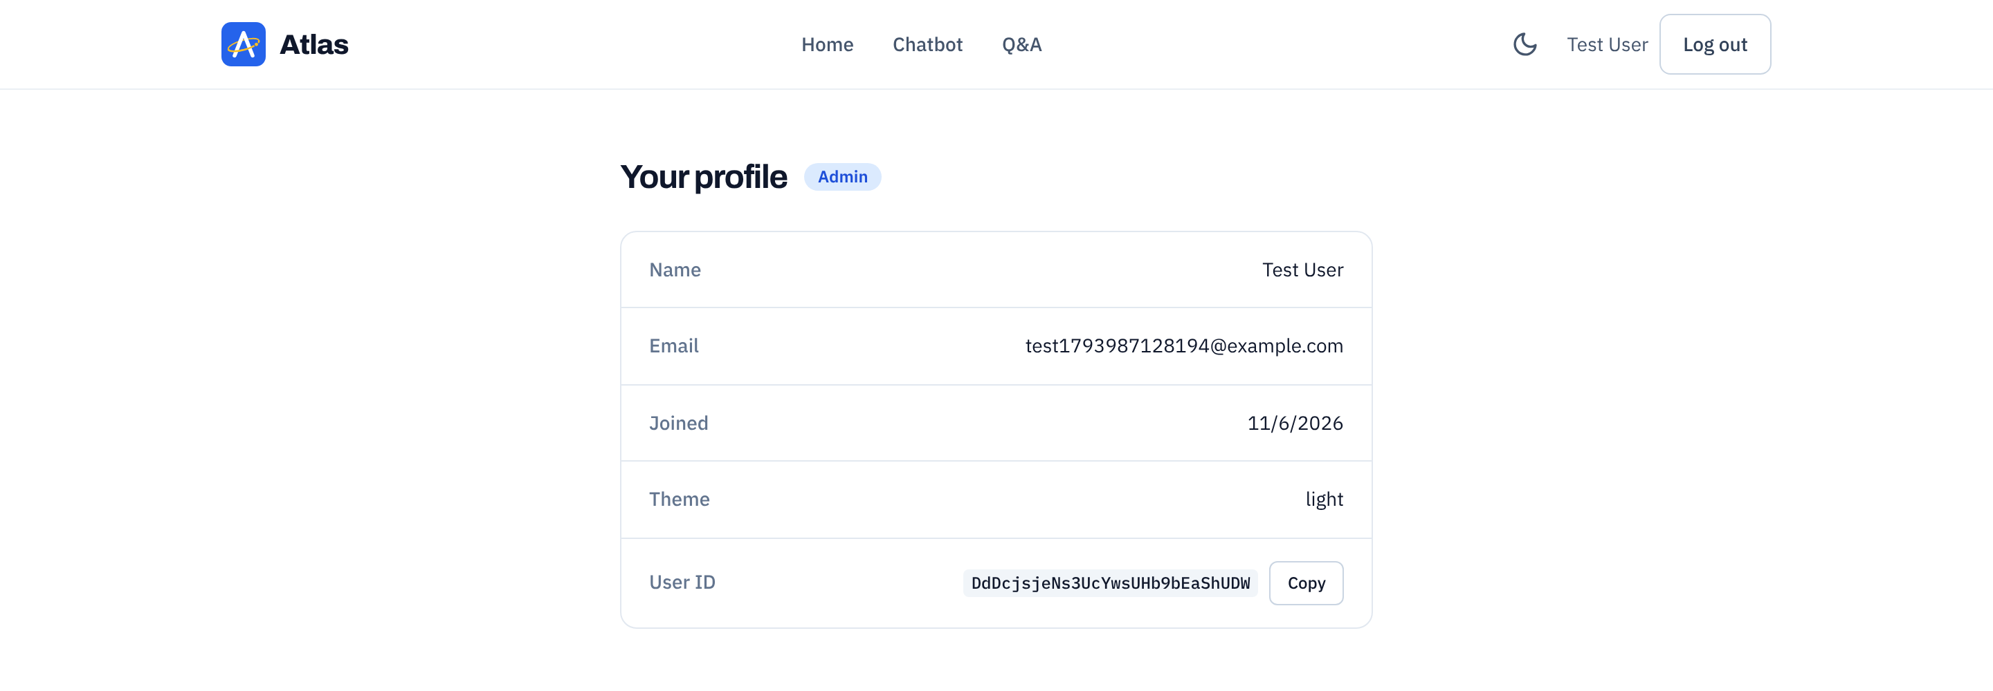
Figure 9: Profile page for an admin account
Section | Options
Profile | Now: shows name, email, joined date, theme and User ID. Planned: change display name and password (email can't be changed for Google accounts).
Appearance | Now: light/dark toggle in the navbar. Planned: System / Light / Dark choice and a text size option (Normal / Large).
Assistant | Planned: default competition and season; show/hide community sources.
Data | Now: delete one chat at a time from the chat sidebar. Planned: delete all chats, download my data (JSON), and delete account.

1.2.7 Admin Tools
Right now admins can add, edit and delete Q&A entries (see Section 1.2.10). Someone becomes an admin when their User ID is added to the admins collection in the Firebase Console. There's no way to do that from the website. Admin checks happen in the Firestore security rules, not just by hiding buttons, so a normal user can't change the Q&A even if they mess with the page. The full Admin Dashboard below is planned for beta:
- Feedback queue: all thumbs-down answers with the question, answer, sources, and comment. Admins mark items as reviewed and tag the cause (retrieval miss, wrong answer, formatting).
- Usage: daily active users, messages per day, median response time, model server uptime.
- Beta access: create invite codes with a use limit and expiry.
- Parts catalog: add, edit, and verify catalog entries.
- Index status: active index version and last build date (re-indexing itself is run by the LLM team).

1.2.8 Error Handling
Condition | Message shown | Recovery
Atlas can't reply (any error) | "Atlas couldn't reply. Please try again." | Your message is already saved in the chat, so you can just send it again
Wrong email or password | "Incorrect email or password." | Try again, or use "Forgot password?"
Too many login tries | "Too many attempts. Please wait a moment and try again." | Wait a bit and try again
No network | "Network error. Check your internet connection." | Reconnect and try again
Firebase not set up (developers) | Setup screen: "Almost there: connect Firebase" | Add the Firebase keys to .env.local and restart the dev server
Wrong address or deleted chat | "Page not found" page. A link to a deleted chat just opens a new chat | Button back to the home page
Planned once the Cloud Function is added: a "model offline" banner that disables the input, a timeout message with a Retry button, a rate limit countdown, a "Please sign in again" redirect when a session expires, and error IDs that match the server logs.

1.2.9 Help, About, and Disclaimer
There isn't a separate Help page yet. The home page explains what you can ask about, how a question gets answered, and who our team is. The disclaimer "Atlas can make mistakes. Check important rulings in the official game manual." is always under the chat box, and the footer says we're not affiliated with FIRST. Planned: a Help page that explains source chips and how to report a bad answer, and an About section with the index version and the full disclaimer: "Not an official FIRST resource. Answers may be wrong; verify important rulings in the official Q&A."

1.2.10 Q&A Page
The Q&A page (/faq) is a list of common FTC questions with answers our team writes. Anyone can see it without logging in. It has a search box, category buttons (All, Game Rules, Scoring, Registration, Resources), and you click a question to open its answer. Answers can have a source link, and links in the answer are clickable. At the bottom, "Didn't find your answer?" sends you to the chatbot. Admins also see "Add question", "Edit" and "Delete". The add/edit form checks the question (up to 300 characters), the answer (up to 5,000), the category, and the source link, and the Firestore rules check the same limits. Figure 10 shows the page while logged in as an admin.
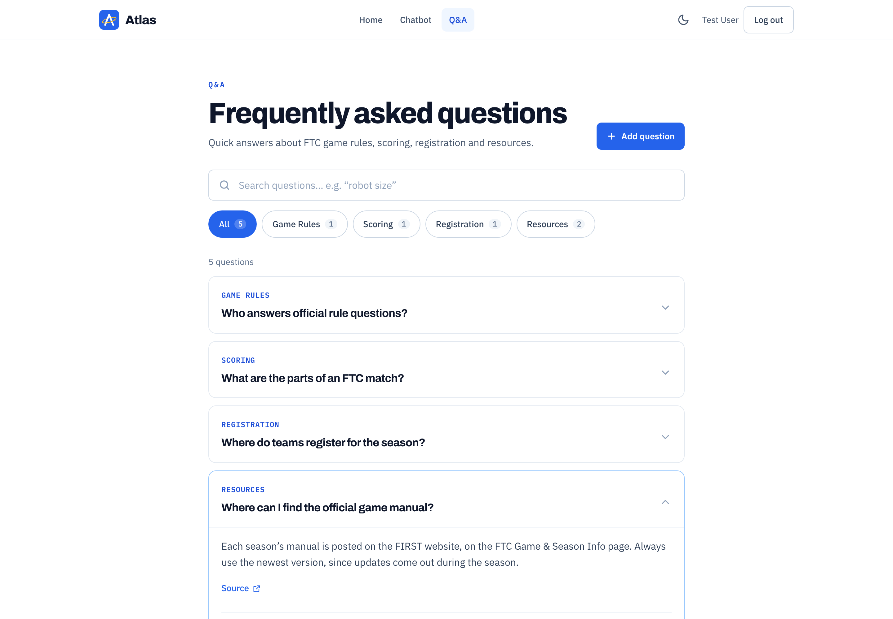
Figure 10: Q&A page, logged in as an admin

1.3 API and Interfaces
There are two interfaces: the public website API (browser → Cloud Functions) and the internal model API (Cloud Functions → model server). The browser should never talk to the model server directly (Figure 1). Figure 11 shows one complete chat request. None of the Cloud Function part is built yet. Right now the website calls getAIResponse() in src/api/getAIResponse.js, which gives a placeholder reply. When VITE_AI_API_URL is set, it sends POST { message, history } and expects { reply } back, so the Cloud Function either takes that shape or we update that one file to match it.
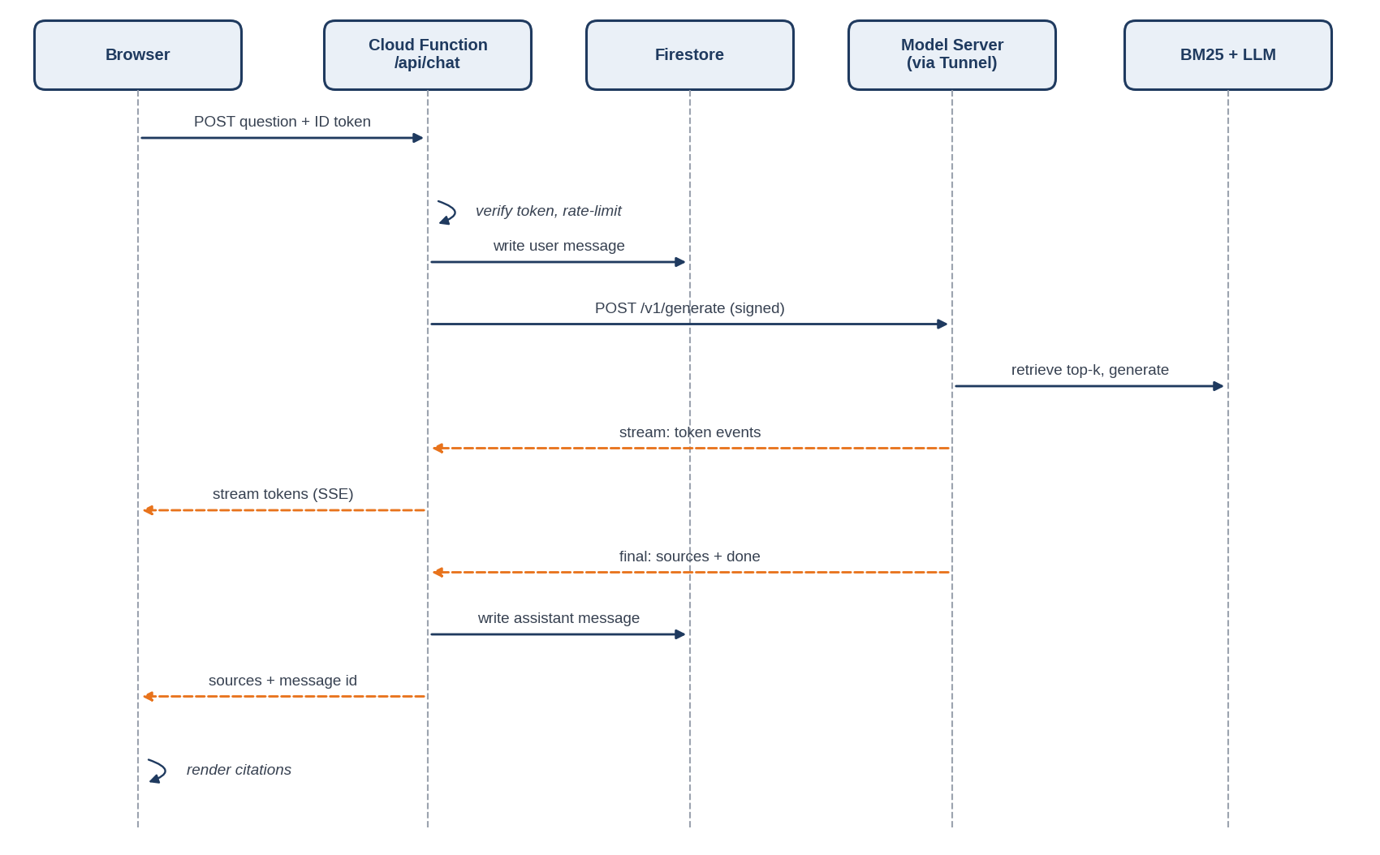
Figure 11: Sequence of a chat request (planned)

2 Integration Issues

2.1 Manageability
- Website: we keep an eye on it in the Firebase console (Authentication users, Firestore data and usage, and Hosting once we deploy). Cloud Functions logs and errors will show up there too once we add functions.
- Model server: a scheduled Cloud Function calls /health every 5 minutes and records uptime. Two failures in a row set a modelStatus = offline flag that the website reads to show the offline banner, and the LLM team is notified (Discord webhook or email).
- Configuration (planned): rate limits, timeouts, and the active season will live in one Firestore config document so they can be changed without a redeploy.
- Deploys: right now we deploy by hand with npm run build and firebase deploy --only hosting. Planned: every push to main deploys the website and functions through GitHub Actions, and pull requests get a Firebase preview link.

2.2 Security Impact
Risk | Mitigation
Model server exposed to the internet. | Cloudflare Tunnel (no open router ports) + Cloudflare Access service token + shared secret; only the Cloud Function holds the credentials.
API keys in the browser | No secret keys in the frontend code. The Firebase web config goes in .env.local, which is git-ignored (those keys are OK to be public; the security rules are what protect the data). Model secrets will go in Firebase Functions secrets / GitHub Actions secrets only
Users reading others' chats | Firestore rules only let a user read and write their own users/{uid} document and the chats and messages under it (Section 2.2.1)
Abuse and runaway cost | Now: 2,000 character message limit, and only admins can write to the Q&A. Planned: invite-only beta, per-user rate limits, Firebase App Check, billing budget alert
Prompt injection from imported text | Imported posts are treated as quoted data in the prompt; system instructions tell the model to ignore instructions inside sources; community sources are lowest priority.
Account takeover | Firebase Auth handles passwords, and the login error doesn't say if the email or the password was wrong. Planned: email verification and a reset message that doesn't reveal which emails exist

2.2.1 Security Context
Role | Can do
Signed-out visitor | View the home page and the Q&A page; log in or sign up
Logged-in user | Chat; see, open and delete own chats; view own profile; theme saved to profile. Planned: rename chats, send feedback, settings
Admin | Everything a user can, plus add, edit and delete Q&A entries. Planned: feedback queue, invites, parts catalog, usage stats
Cloud Function (service, planned) | Write assistant messages for users; call the model server; read config. Right now the user's browser saves both the question and the reply

match /users/{userId} {
allow read, write: if request.auth != null && request.auth.uid == userId;
match /chats/{chatId=**} { // chats AND their messages
allow read, write: if request.auth != null && request.auth.uid == userId;
}
}
match /faqs/{faqId} { allow read: if true;
allow create, update: if isAdmin() && isValidFaq(request.resource.data); allow delete: if isAdmin(); }
match /admins/{uid} { allow read: if isSignedIn() && request.auth.uid == uid; allow write: if false; }
// isAdmin() = signed in AND admins/{uid} exists. Full file: firestore.rules

2.3 Setup Requirements
Component | Requirements
Website | Node.js 20.19+ or 22+, React 19 + Vite + JavaScript (we went with JavaScript, not TypeScript), Tailwind CSS v4, Firebase JS SDK, Firebase CLI (for deploying, plus the optional local emulators, which need Java)
Cloud Functions | Node.js LTS, TypeScript, Firebase Functions (2nd gen)
Model server | Python 3.11+, model runtime chosen by LLM team, BM25 library, Cloudflare Tunnel client (cloudflared)
CI/CD | Planned: GitHub Actions workflows for lint, deploy, and eval. Right now we run npm run lint (oxlint) by hand

Secret / setting | Stored in | Used by
Firebase web config (VITE_FIREBASE_* keys) and VITE_AI_API_URL | .env.local on each person's computer (git-ignored; the Firebase keys are public by design, not secret) | Website
MODEL_URL, MODEL_SHARED_SECRET | Firebase Functions secrets | Cloud Function
CF_ACCESS_CLIENT_ID / SECRET | Firebase Functions secrets | Cloud Function → Tunnel
FIREBASE_SERVICE_ACCOUNT | GitHub Actions secrets | Deploy workflow (planned)

2.3.1 Component Isolation
The website and model server are deployed separately. The website already works without the model: if VITE_AI_API_URL isn't set, getAIResponse() gives a placeholder reply and the chat shows "Demo mode", which is how we've been building and demoing it. It can also run against the Firebase emulators (VITE_USE_FIREBASE_EMULATORS=true) so you don't even need the real Firebase project. The model server can be tested with the CLI without the website. They only depend on the API contract in Section 1.3.

2.4 Hardware/Environmental Requirements

2.4.1 Model Host PC
- Dedicated PC with a GPU sized for the chosen model (the LLM team confirms VRAM needs), wired Ethernet, and sleep and automatic restarts for updates disabled during beta hours.

2.4.2 Performance Targets
Metric | Target (beta) | Owner
Time to first token | ≤ 2.5 s median, ≤ 5 s 95th percentile | LLM
Complete answer | ≤ 12 s 95th percentile | LLM
Page load (first view, 4G phone) | ≤ 2.5 s largest contentful paint | Website
History sidebar load | ≤ 1 s for 50 conversations | Website
Model server uptime during beta hours | ≥ 95% | LLM

2.4.3 Network Bandwidth
Chat messages are tiny (a few kilobytes), so the site works on event Wi-Fi and phone data. Right now the website bundle is about 266 KB gzipped (886 KB before compression), which is under our 300 KB goal. The fonts (Archivo, IBM Plex Sans and IBM Plex Mono) load from Google Fonts for now; moving them to the same origin is planned.

2.5 Source File Impact
Right now the website lives in its own GitHub repository and the LLM team has theirs. The plan is to put both halves in one repository (monorepo) so the rules and eval set stay in sync:
ftc-assistant/
├─ web/ React + Vite app (src/pages, components, firebase, hooks, api)
├─ functions/ (planned) Cloud Functions: chat, feedback, admin, health check
├─ firestore.rules Security rules
├─ firebase.json
├─ model-server/ LLM team: api/, retrieval/, calculators/, prompts/
├─ ingestion/ Parsers, chunkers, build_index.py
├─ data/ Raw sources (manual PDFs) and parts seed data
├─ eval/ Question sets and reports
├─ docs/ This spec, API contract
└─ .github/workflows/ lint.yml, deploy-web.yml, eval.yml

Branch rules: main is protected and requires one review. Website and LLM teams work in their own folders, so changes rarely conflict.

3 Project Information

3.1 Work List
Priority 1 items are required for beta. Priority 2 items are planned for beta if time allows. Priority 3 items can slip past beta.
Area | Pri | Description | Owner | Target
Setup | 1 | GitHub repo and Firebase project (done); Hosting deploy via GitHub Actions (not yet) | Web | Nov
 | 1 | Write and agree on API contract (Section 1.3) | Both | Nov
UI | 1 | Chat page on the placeholder getAIResponse() (done; streaming not yet) | Web | Nov
 | 1 | Dark/light theme with tokens and saving (done) | Web | Nov
 | 2 | Landing page (done) | Web | Nov
 | 2 | Q&A page with search, categories, and admin add/edit/delete (added, done) | Web | Nov
Auth | 1 | Firebase Auth (Google + email) and protected routes (done); invite codes (not yet) | Web | Nov
Model | 1 | Switch retrieval to BM25; consistent low response times | LLM | Nov
 | 2 | PC optimizations (model runtime, quantization, batching) | LLM | Nov
 | 1 | Increase token budget; deeper reasoning without slower answers | LLM | Dec
Integration | 1 | Cloud Function relay to model server via tunnel; streaming | Both | Dec
 | 1 | Health check, offline banner, timeouts, retry (not started) | Web | Dec
Data | 1 | Chats and messages in Firestore with security rules; history sidebar (done early) | Web | Dec
 | 1 | Feedback buttons and admin feedback queue (not started) | Web | Dec
 | 1 | Rate limiting and App Check (not started) | Web | Dec
Knowledge | 1 | Import official Q&A and Team/Coach Updates | LLM | Jan
 | 2 | Import Chief Delphi (after terms check) | LLM | Jan
 | 1 | Source citation chips with expandable snippets | Web | Jan
Tools | 2 | Engineering calculators | LLM | Jan
 | 2 | Parts catalog (50–100 parts) and Parts Advisor | Both | Jan
FRC | 3 | Competition switcher + FRC data copy | Both | Jan
Quality | 1 | Eval set (100+ questions) and regression run on each index build | Both | Dec–Jan
Beta | 1 | Settings, help page, beta invites to a small group of teams (not started) | Web | Jan

3.1.1 Schedule
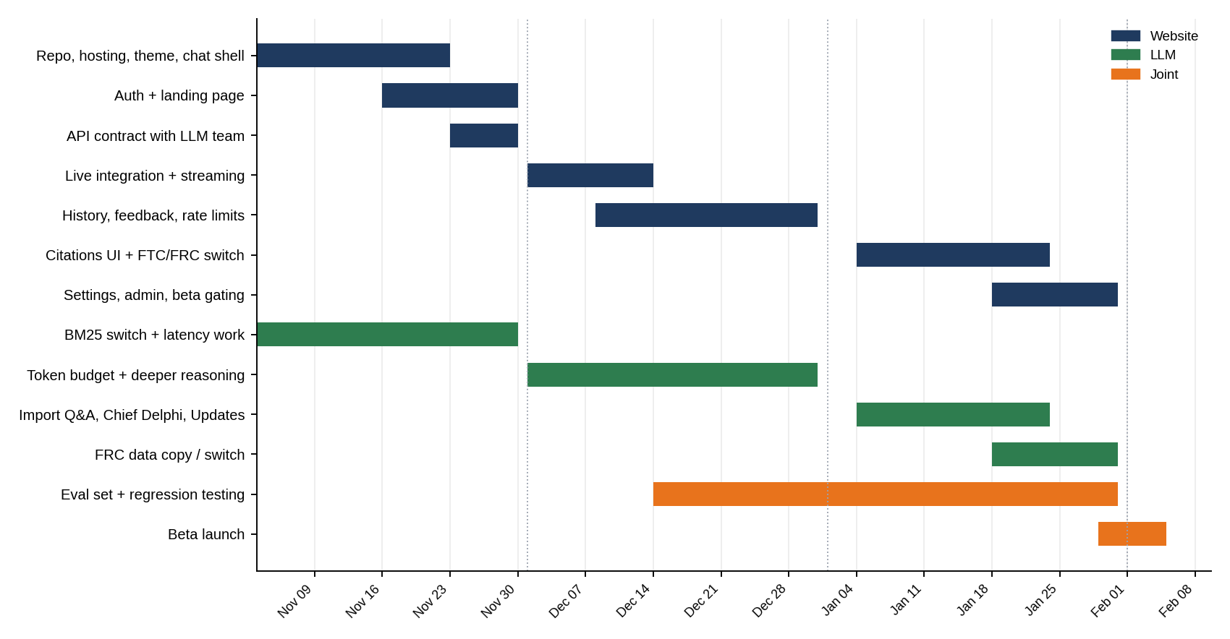
Figure 12: Project timeline, November through beta launch
Month | LLM | Website
Nov | Consistent low response times  Look into PC optimizations  Switch frameworks to BM25 | Repo and Firebase project ✓ (GitHub Actions deploy not yet)  Theme system and dark/light mode ✓  Chat UI on placeholder replies ✓  Firebase Auth sign-in and protected routes ✓  Landing page, mobile pass ✓  Q&A page with admin editing ✓ (added)  API contract with LLM team
Dec | Increase token count  Deeper reasoning without compromising response time  Initial website integration | Connect to real model through Cloud Function + tunnel  Streaming, stop, timeouts, retry  Firestore history with security rules ✓ (done early)  Feedback buttons, rate limiting, App Check
Jan | Finish website integration  Import Q&A + Chief Delphi + Coach Updates  Copy data → FRC, easy switch | Finalize integration, bug fixes from eval  Source citation chips  FTC/FRC switcher  Settings, admin, invites, beta launch

3.2 Data Model Impact (Firestore)
The website keeps its data in Cloud Firestore. Figure 13 shows the collections that are actually in use right now. The index itself lives on the model server, not in Firestore.
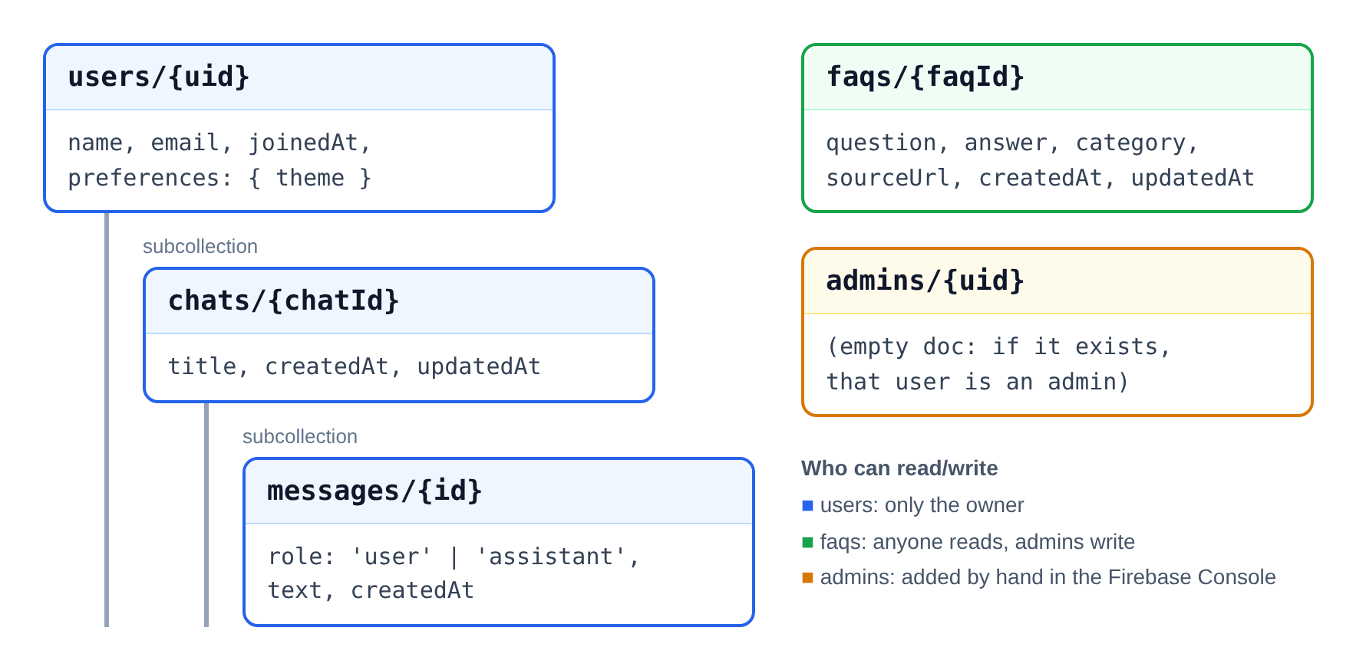
Figure 13: Firestore collections in use now
Collection | Purpose | Written by
users/{uid} | Profile: name, email, joinedAt, theme preference | User (own doc only)
users/{uid}/chats/{chatId} | One chat: title, createdAt, updatedAt | User
users/{uid}/chats/{chatId}/messages/{id} | Each message: role (user or assistant), text, createdAt | User's browser for now (planned: Cloud Function only, plus sources, latency and index version)
faqs/{faqId} | Q&A entries: question, answer, category, sourceUrl | Admin
admins/{uid} | Empty doc; if it exists, that user is an admin | Added by hand in the Firebase Console
feedback, parts, inviteCodes, config (planned) | Feedback, parts catalog, beta invite codes, rate limits and model status | Cloud Function / Admin

3.3 Performance
- BM25 index is held in memory on the model server; retrieval should take well under 100 ms.
- Identical questions within the same index version may be served from a short-lived cache to save GPU time (Priority 3).
- Only the last 6 turns are sent to the model, which keeps prompts small and answers fast as chats get long. (The Cloud Function will do the cutting; right now the website sends the whole chat.)
- The history sidebar loads all of a user's chats with a live Firestore listener, newest first. Loading 30 at a time with more on scroll is planned if lists get long.

3.4 Localization/Globalization Issues
English only for beta. Right now the UI text is written right in the components; moving it all into one strings file is planned so translation is possible later. Dates use the user's browser locale. Calculators accept both imperial and metric units, since FTC teams use both.

3.5 Accessibility Issues
- Both themes are meant to meet WCAG 2.1 AA contrast (4.5:1 for body text). We still need to run a full contrast check.
- The site can be used with just a keyboard (Enter sends in the chat, and buttons and links are real buttons and links), and focus should always be visible.
- Icon-only buttons (send, theme, menu, delete) have labels for screen readers. Planned: when streaming is added, answers get read out once they're done, not word by word.
- Buttons are at least 44 px tall so they're easy to tap. Planned: respect "reduce motion" settings and add a text size option in Settings.
- The Q&A categories and the Demo mode badge use text, not just color. Source chips (planned) will too.

3.6 Compatibility

3.6.1 Browser and Device Compatibility
Should work on the latest two versions of Chrome, Edge, Firefox, and Safari on desktop, plus Safari on iOS and Chrome on Android. So far we've mostly tested in Chrome. The smallest supported width is 360 px.

3.6.2 Season Compatibility
Every conversation and index is tagged with competition and season. When a new season starts, the new index becomes the default, old conversations stay readable with a "Season ended" label, and old indexes can be kept for reference. Moving to a new season should need only new source files and a config change.

3.6.3 Competition Compatibility (FRC)
Competition-specific settings (name, seasons, starter questions, source list, branding color) are stored in a single config file per competition. Adding FRC means adding a config file and an FRC index; no UI code changes should be needed.

3.7 Backup
- Source files and the parts seed are in GitHub, so the index can always be rebuilt from scratch.
- Firestore: scheduled weekly export to Cloud Storage (Blaze plan) or a manual export script before every major change.
- Each index build is kept by version on the model server, so a bad build can be rolled back by switching versions.

3.8 Reliability Issues
- If the model server is down, the site still loads and users can still read their old chats. (The offline banner is planned.)
- User messages are saved to Firestore before asking for a reply, so nothing typed is lost if the reply fails. This already works.
- The Cloud Function retries once on a connection error, never on a timeout (to avoid running the same question twice).
- Firebase Hosting keeps previous releases; a bad deploy can be rolled back in the console in under a minute.

3.9 URL Requirements
- Site address: the default Firebase address (atlas-b1d1c.web.app) once we deploy; a custom domain can be connected later. Right now we run it locally at http://localhost:5173 with npm run dev.
- Source links point to the official FIRST pages for manuals, Q&A, and updates, and to original Chief Delphi threads for community content.

3.10 Supportability

3.10.1 Logging/Eventing
- Each request gets a request ID logged by the Cloud Function and the model server, so one failed answer can be traced end to end.
- Logged: timestamps, latency, index version, retrieved chunk IDs, error codes. Message text is stored only in the user's own conversation, not in analytics.
- Planned: Firebase Analytics to track page views and feature use (new chat, feedback, theme change) without message content. It isn't added yet.

3.10.2 Error Messages
Right now errors show as short pop-up messages in plain words (see Section 1.2.8). Planned: every error follows that table (what happened and what to do) and unexpected failures get an error ID.

3.10.3 Diagnostic Tools
Planned: the Admin Dashboard will show model status, index version, response times, and the feedback queue. For now we use the Firebase console. The LLM team can replay any logged request ID through the CLI to reproduce an answer.

3.10.4 Recovery from Corruption or Error Conditions
Bad index: roll back to the previous version. Bad deploy: roll back in Firebase Hosting. Corrupted user data: restore from the latest Firestore export.

3.11 User Assistance Issues
Right now the home page, the Q&A page, and the two example questions in a new chat are the main help for users. Planned: a Help page, plus a one-page "How to test" guide and a feedback form link for beta testers. The disclaimer under the chat box and the "check the official manual" advice are part of user help and must not be removed.

3.12 Test Plan and Quality Targets
Quality is measured with a fixed eval set of real questions with known correct answers and source rules, built jointly by both teams and grown from real beta questions.
Metric | Beta target
Eval set size | 100+ questions across robot rules, game rules, scoring, inspection, and events
Correct answers | ≥ 90%
Answers with at least one correct citation | ≥ 95% of rules answers
Made-up rule IDs | 0
"Not in the manual" questions correctly declined | ≥ 90%
Calculator results | 100% match against hand-checked values

- Website tests: right now we test by hand (sign up, log in, chat, delete, theme, Q&A editing) using the Firebase emulators, plus npm run lint. Planned: component tests for chat, auth, and theme; one end-to-end test of sign-in → ask → answer → feedback against the mock model; and security rules tests with the Firebase emulator.
- Beta feedback loop: thumbs-down answers are reviewed weekly; confirmed failures are added to the eval set so they cannot come back.

3.13 Key Feature Interactions
- Parts Advisor ↔ Rules: part recommendations always include a legality check against current robot rules.
- Calculators ↔ Parts catalog: calculators can use catalog specs (for example, motor free speed) and say which part they used.
- Competition switcher ↔ Everything: competition and season select the index, starter questions, parts subset, and history labels.
- Manual updates ↔ History: older answers record their index version, so users can see an answer came from an earlier manual version.

4 Boneyard
Ideas considered but out of scope for beta. Kept here so they are not lost.

4.1 Hybrid Retrieval
Combine BM25 with embedding search so paraphrased questions find the right rules even without shared keywords. Worth revisiting if retrieval misses stay high after the synonym list.

4.2 Cloud-Hosted Model
Move the model off the team PC onto a cloud GPU or a hosted model API to improve uptime at events. Trade-off: monthly cost versus reliability.

4.3 Fine-Tuning
Fine-tune a model on FTC question-and-answer style once a large set of reviewed Q&A pairs is available. Retrieval would still supply the facts; fine-tuning would only improve tone and format.

4.4 Robot Photo and CAD Questions
Let users upload a photo or CAD screenshot and ask "Is this legal?" or "How can I improve this intake?"

4.5 Other Channels
A Discord bot for team servers, a progressive web app for offline reading of saved answers at events, and team workspaces where a whole team shares conversations.

4.6 Additional Languages
Spanish and other languages for international teams, translating the interface first and answers second.

