**Project Concept:**

A web-based scheduling system is required to ease hiring and management of work-study students each semester. This is to ease the laborious and cumbersome task of managing this process by hand, and to create a more standardized method for processing work study students.

The following image shows a mock-up of the main interface that would be developed. The most important part of this is the timetable that would be represent the total number of available hours for a particular location for the weeks in the semester. Following that is a tab that provides a link to a similar calendar but for each of the 5 locations. Further below are tabs that would help summarize the total number of hours each of the work-study students is working for a week at a particular location.

We also intend to show in lighter colors, the availability of other work-study students if the area is not already covered by another student’s work schedule, and also provide a summary for each student to know if they are meeting their grant’s requirements.

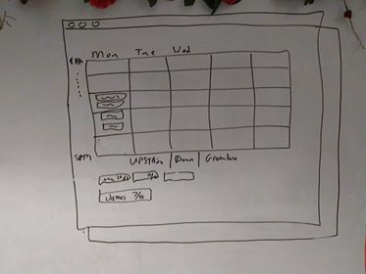

**Tweet: “**A web-based, user-centric scheduling system to ease hiring and management of work-study students each semester**”**