Chapter 1

1,What is the main difference between TCP and UDP?

TCP 是面向连接的，而UDP 是一种数据报服务。

2,What are two reasons for using layered protocols?

答：通过协议分层可以把设计问题划分成较小的易于处理的片段。分层意味着某一层的协议的改变不会影响高层或低层的协议。

3,What is the principal difference between connectionless communication and connection-oriented communication?

答：主要的区别有两条。

其一：面向连接通信分为三个阶段，第一是建立连接，在此阶段，发出一个建立连接的请求。只有在连接成功建立之后，才能开始数据传输，这是第二阶段。接着，当数据传输完毕，必须释放连接。而无连接通信没有这么多阶段，它直接进行数据传输。

其二：面向连接的通信具有数据的保序性， 而无连接的通信不能保证接收数据的顺序与发送数据的顺序一致。

4,What does ''negotiation'' mean when discussing network protocols? Give an example.

答：协商就是要让双方就在通信期间将使用的某些参数或数值达成一致。最大分组长度就是一个例子。

5,List two advantages and two disadvantages of having international standards for network protocols.

优点1：如果每个人都使用标准，那么每个人都可以与其他任何人交流；优点2：广泛使用标准将导致规模经济，比如生产大规模集成电路芯片。缺点1：为了取得标准化所需要的政治妥协经常会导致差的标准；缺点2：一旦标准被广泛采用了，要对它再做改变就会非常困难，即使发现了新的更好的技术或方法，也难以替换。

Chapter 2

1,Television channels are 6 MHz wide. How many bits/sec can be sent if four-level digital signals are used? Assume a noiseless channel.

**3. 答：**采样频率12MHz，每次采样2bit，总的数据率为24Mbps。

2,If a binary signal is sent over a 3-kHz channel whose signal-to-noise ratio is 20 dB, what is the maximum achievable data rate?

**答：**信噪比为20 dB 即 *S/N* = 100.由于 log2101≈6.658，由香农定理，该信道的信道容量为3log2(1+100) =19.98kbps。

又根据乃奎斯特定理，发送二进制信号的3kHz 信道的最大数据传输速率为

2*3 log22=6 kbps。

所以可以取得的最大数据传输速率为6kbps。

3,Is an oil pipeline a simplex system, a half-duplex system, a full-duplex system, or none of the above?

4,Why has the PCM sampling time been set at 125 µsec?

**答：**125的采样时间对应于每秒8000 次采样。一个典型的电话通道为4kHz。根据奈奎斯特定理，为获取一个4kHz 的通道中的全部信息需要每秒8000 次的采样频率。

5,What is the essential difference between message switching and packet switching?

Chapter 3

1，The following character encoding is used in a data link protocol: A: 01000111; B: 11100011; FLAG: 01111110; ESC: 11100000 Show the bit sequence transmitted (in binary) for the four-character frame: A B ESC FLAG when each of the following framing methods are used by Starting and ending flag bytes, with bit stuffing.

**2.** The solution is

(a) 00000100 01000111 11100011 11100000 01111110

(b) 01111110 01000111 11100011 11100000 11100000 11100000 01111110

01111110

(c) 01111110 01000111 110100011 111000000 011111010 01111110

2，What is the remainder obtained by dividing x7 + x5 + 1 by the generator polynomial x3 + 1?

**14. 答：**如所列的除式，所得的余数为x2+x+1。

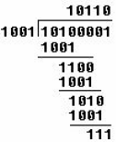*.*

3，A channel has a bit rate of 4 kbps and a propagation delay of 20 msec. For what range of frame sizes does stop-and-wait give an efficiency of at least 50 percent?

**答：**当发送一帧的时间等于信道的传播延迟的2 倍时，信道的利用率为50%。或者说，当发送一帧的时间等于来回路程的传播延迟时，效率将是50%。而在帧长满足发送时间大于延迟的两倍时，效率将会高于50%。

现在发送速率为4Mb/s，发送一位需要0.25。



只有在帧长不小于160kb 时，停等协议的效率才会至少达到50%。

4，Frames of 1000 bits are sent over a 1-Mbps channel using a geostationary satellite whose propagation time from the earth is 270 msec. Acknowledgements are always piggybacked onto data frames. The headers are very short. Three-bit sequence numbers are used. What is the maximum achievable channel utilization for

1. Stop-and-wait.
2. Protocol 5.
3. Protocol 6.

**答：**对应三种协议的窗口大小值分别是1、7 和4。

使用卫星信道端到端的典型传输延迟是270ms，以1Mb/s 发送，1000bit 长的帧的发送时间为1ms。我们用t=0 表示传输开始的时间，那么在t=1ms 时，第一帧发送完毕；t=271ms时，第一帧完全到达接收方；t=272ms，对第一帧的确认帧发送完毕；t=542ms，带有确认的帧完全到达发送方。因此一个发送周期为542ms。如果在542ms 内可以发送k 个帧，由于每一个帧的发送时间为1ms，则信道利用率为k/542，因此：

（a） k=1，最大信道利用率=1/542=0.18%

（b） k=7，最大信道利用率=7/542=1.29%

（c） k=4，最大信道利用率=4/542=0.74%

Chapter 4

1，What is the baud rate of the standard 10-Mbps Ethernet?

**答：**以太网使用曼彻斯特编码，这就意味着发送的每一位都有两个信号周期。标准以太网的数据率为10Mb/s，因此波特率是数据率的两倍，即20MBaud。

2，Sketch the Manchester encoding for the bit stream: 0001110101.

The signal is a square wave with two values, high (H) and low (L). The pattern is LHLHLHHLHLHLLHHLLHHL.

3，Sketch the differential Manchester encoding for the bit stream of the previous problem. Assume the line is initially in the low state.

The pattern this time is HLHLHLLHHLLHLHHLHLLH.

4，Consider building a CSMA/CD network running at 1 Gbps over a 1-km cable with no repeaters. The signal speed in the cable is 200,000 km/sec. What is the minimum frame size?

**答：**对于1km 电缆，单程传播时间为1/200000 =5×10-6 s，即5，来回路程传播时间为2t =10。为了能够按照CSMA/CD 工作，最小帧的发射时间不能小于10。以1Gb/s 速率工作，10可以发送的比特数等于：



因此，最小帧是10 000 bit 或1250 字节长。

5，An IP packet to be transmitted by Ethernet is 60 bytes long, including all its headers. If LLC is not in use, is padding needed in the Ethernet frame, and if so, how many bytes?

**答案22.** The minimum Ethernet frame is 64 bytes, including both addresses in the Ethernet frame header, the type/length field, and the checksum. Since the header fields occupy 18 bytes and the packet is 60 bytes, the total frame size is 78 bytes, which exceeds the 64-byte minimum. Therefore, no padding is used.

6，Ethernet frames must be at least 64 bytes long to ensure that the transmitter is still going in the event of a collision at the far end of the cable. Fast Ethernet has the same 64-byte minimum frame size but can get the bits out ten times faster. How is it possible to maintain the same minimum frame size?

答案：The maximum wire length in fast Ethernet is 1/10 as long as in Ethernet.

7，Some books quote the maximum size of an Ethernet frame as 1518 bytes instead of 1500 bytes. Are they wrong? Explain your answer.

答案：The payload is 1500 bytes, but when the destination address, source address,

type/length, and checksum fields are counted too, the total is indeed 1518.

Chapter 5

1，Give three examples of protocol parameters that might be negotiated when a connection is set up.

答案：在连接建立的时候可能要协商窗口的大小、最大分组尺寸和超时值

2，Consider the subnet of Fig. 1. Distance vector routing is used, and the following vectors have just come in to router *C*: from *B*: (5, 0, 8, 12, 6, 2); from *D*: (16, 12, 6, 0, 9, 10); and from *E*: (7, 6, 3, 9, 0, 4). The measured delays to *B*, *D*, and *E*, are 6, 3, and 5, respectively. What is *C*'s new routing table? Give both the outgoing line to use and the expected delay.

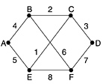

Fig. 1

**答：**通过B 给出（11，6，14，18，12，8）

通过D 给出（19，15，9，3，12，13）

通过E 给出（12，11，8，14，5，9）

取到达每一目的地的最小值（C 除外）得到：（11，6，0，3，5，8）

输出线路是：（B，B，-，D，E，B）

3， A large number of consecutive IP address are available starting at 198.16.0.0. Suppose that four organizations, *A*, *B*, *C*, and *D*, request 4000, 2000, 4000, and 8000 addresses, respectively, and in that order. For each of these, give the first IP address assigned, the last IP address assigned, and the mask in the *w.x.y.z*/*s* notation.

答案：To start with, all the requests are rounded up to a power of two. The starting address, ending address, and mask are as follows: A: 198.16.0.0 –198.16.15.255 written as 198.16.0.0/20

B: 198.16.16.0 – 198.23.15.255 written as 198.16.16.0/21

C: 198.16.32.0 – 198.47.15.255 written as 198.16.32.0/20

D: 198.16.64.0 – 198.95.15.255 written as 198.16.64.0/19

4， A router has just received the following new IP addresses: 57.6.96.0/21, 57.6.104.0/21, 57.6.112.0/21, and 57.6.120.0/21. If all of them use the same outgoing line, can they be aggregated? If so, to what? If not, why not?

答案：They can be aggregated to 57.6.96/19.

5，The set of IP addresses from 29.18.0.0 to 19.18.128.255 has been aggregated to 29.18.0.0/17. However, there is a gap of 1024 unassigned addresses from 29.18.60.0 to 29.18.63.255 that are now suddenly assigned to a host using a different outgoing line. Is it now necessary to split up the aggregate address into its constituent blocks, add the new block to the table, and then see if any reaggregation is possible? If not, what can be done instead?

1. The initial threshold of the TCP is 10 KB. How big will the window be if the ten four transmission bursts are all successful? Assume the maximum segment size is 2KB.

2. The receive window is 16 KB and the initial threshold of the TCP is 10 KB. How big will the window be if the ten four transmission bursts are all successful? Assume the maximum segment size is 2KB.

3. The initial threshold of the TCP is 10 KB, and the Time Out occurs when the congestion window arise to 12 KB. Please give the values of congestion windows from 1st to 10th . Assume the maximum segment size is 2KB.

4. Suppose that the TCP congestion window is set to 18 KB and a timeout occurs. How big will the window be if the next four transmission bursts are all successful? Assume that the maximum segment size is 1 KB.

5. Assume that the receive window is 24KB and the maximum segment size is 1KB. Initially, threshold is set to 14KB. Then a timeout occurs when the TCP congestion window is equal to 20KB. And suppose that next transmissions are successful, how much is the TCP congestion window in 15th transmission (Started from the initialization)?

2 4 8 10 12 2 4 6

6，如果收到一个IP包，其头部的十六进制描述为: **4600 009c 02f3 4000 4011 635f c0a8 0a64 3a3f 0eb7**, 回答以下问题（IP头部结构见尾页）:

1. TTL是多少？
2. 源IP，目的IP各为多少？ （点分十进制表示）
3. 该包的头部长度和数据域长度各是多少字节?
4. 该数据包是否是最后一个数据包（0表示最后一个分片，1表示还有分片）？该数据包是否允许再分片（0表示可以分片，1表示不可以分片）？

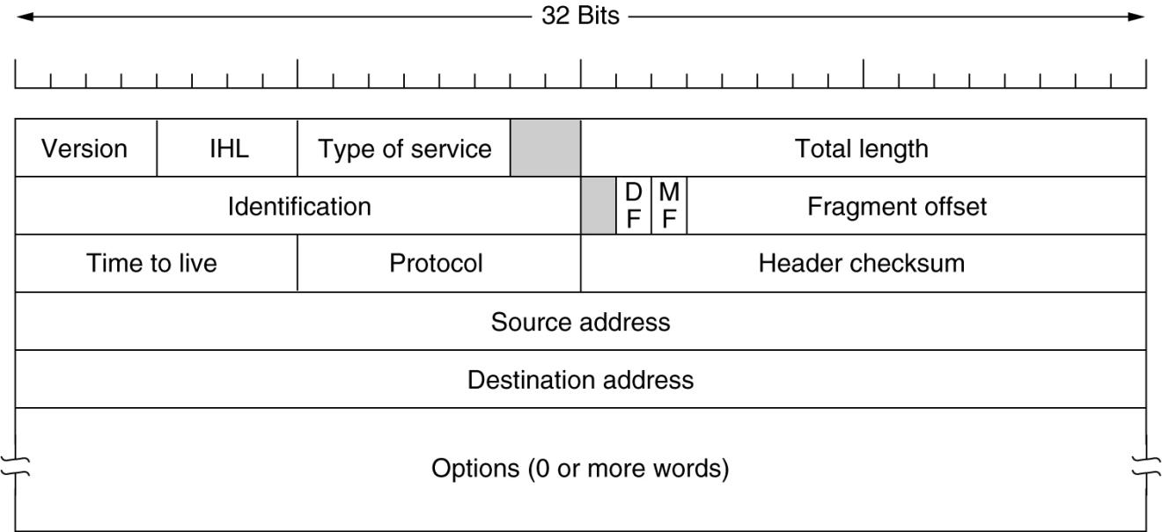IP包头部格式

Chapter 6

1, Why does UDP exist? Would it not have been enough to just let user processes send raw IP packets?

2, Consider the effect of using slow start on a line with a 10-msec round-trip time and no congestion. The receive window is 24 KB and the maximum segment size is 2 KB. How long does it take before the first full window can be sent?

**答：**按照慢启动算法，经过10、20、30、40ms 后拥塞窗口大小分别为4、8、16、32，所以在40ms 后将按照min{24，32}=24KB 发送数据。

3, Suppose that the TCP congestion window is set to 18 KB and a timeout occurs. How big will the window be if the next four transmission bursts are all successful? Assume that the maximum segment size is 1 KB.

**答：**由于发生了超时，下一次传输将是1 个最大报文段，然后是2 个、4 个、8 个最大报文段，所以在4 次突发量传输后，拥塞窗口将是8K 字节。

4, If the TCP round-trip time, RTT, is currently 30 msec and the following acknowledgements come in after 26, 32, and 24 msec, respectively, what is the new RTT estimate using the Jacobson algorithm? Use a = 0.9.

5，如果收到一个TCP报文段，其头部的十六进制描述为: **0459 0050 0001 11D9 0000 2710 7010 0800 1363 0000** , 回答以下问题（TCP结构见尾页）:

（1）源端口号是多少（十进制）?

（2）该报文段的发送方希望收到的下一个字节序号为（十进制）?

（3）该报文段的发送方下次最多能收到多少字节数据?

（4）该报文段的目的服务器提供的是__________服务。

1. WEB B. SMTP C. POP3 D. DNS

（5）此报文段的头部长度为多少字节？

Chapter 7

1，Many business computers have three distinct and worldwide unique identifiers. What are they?

2，DNS uses UDP instead of TCP. If a DNS packet is lost, there is no automatic recovery. Does this cause a problem, and if so, how is it solved?

1. 基本术语（50个）
2. 各个层次的协议分析

The data flow was captured (捕获) and listed blow in hexadecimal（十六进制）, context of the data includes Ethernet frame header, IP header and transport layer segment, according to the information answer the following questions.

0x0000 00 04 61 8f b1 f8 00 1a a9 7d e4 1e 08 00 45 00

0x0010 02 31 63 23 40 00 35 06 a4 25 da 12 67 26 ca c1

0x0020 30 84 1e 1d 04 23 c7 6d dd e6 94 c8 fb 83 50 18

0x0030 06 c0 17 a9 00 00 ……

1. What is the source MAC address ? 00 04 61 8f b1 f8 00 1a a9 7d e4 1e 08 00 45 00

答：00 1a a9 7d e4 1e

2. What is the length of IP packet?

45 00

0x0010 02 31 63 23 40 00 35 06 a4 25 da 12 67 26 ca c1

0x0020 30 84 1e 1d 04 23 c7 6d dd e6 94 c8 fb 83 50 18

0x0030 06 c0 17 a9 00 00 ……

答：0x0231=561

1. What is the source address and destination address in the network layer?

A: Source address: 0xda 12 67 26 = 218.18.103.38

Destination address: 0xca c1 30 84 = 202.193.48.132

1. Is this a TCP or UDP protocol in the transport layer?

A: IP包中Protocol字段的值为：06 ，所以为TCP

1. What is the source port?

A: Source port: 0x1e 1d= 7709

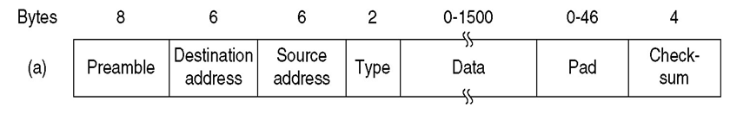

（注：以上捕获的数据中无preamble）

