Evan Trout
EECS 563
Socket Programming Exercise

#Evan Trout, Socket Programming TCP Client
#Submitted 09/25/18
from socket import *
serverPort = ''
serverName = ''
serverName = raw_input("Please enter a valid server address: ")
while (len(serverPort) < 4):
serverPort = raw_input("Please enter a valid port of at least 4 digits: ")
serverPort = int(serverPort)
clientSocket = socket(AF_INET, SOCK_STREAM)
clientSocket.connect((serverName, serverPort))
while True:
sentence = raw_input('Input lowercase sentence:')
clientSocket.send(sentence.encode())
modifiedSentence = clientSocket.recv(1024)
print 'From server: ', modifiedSentence.decode()
clientSocket.close()

#Evan Trout, Socket Programming TCP Server
#Submitted 09/25/18
from socket import *
serverPort = ''
while (len(serverPort) < 4):
serverPort = raw_input("Please enter a valid port of at least 4 digits: ")
serverPort = int(serverPort)
serverSocket = socket(AF_INET, SOCK_STREAM)
serverSocket.bind(('', serverPort))
serverSocket.listen(1)
print('The server is ready to receive')
connectionSocket, addr = serverSocket.accept()
while True:
sentence = connectionSocket.recv(1024).decode()
print sentence
capitalizedSentence = sentence.upper()
connectionSocket.send(capitalizedSentence.encode())
connectionSocket.close()
#Evan Trout, Socket Programming UDP Client
#Submitted 09/25/18
from socket import *
serverPort = ''
serverName = ''
serverName = raw_input("Please enter a valid server address: ")
while (len(serverPort) < 4):
serverPort = raw_input("Please enter a valid port of at least 4 digits: ")
serverPort = int(serverPort)
clientSocket = socket(AF_INET, SOCK_DGRAM)
while True:
message = raw_input('Input lowercase sentence:')
clientSocket.sendto(message.encode(), (serverName, serverPort))
modifiedMessage, serverAddress = clientSocket.recvfrom(2048)
print(modifiedMessage.decode())
clientSocket.close()

#Evan Trout, Socket Programming UDP Server
#Submitted 09/25/18
from socket import *
serverPort = ''
while (len(serverPort) < 4):
serverPort = raw_input("Please enter a valid port of at least 4 digits: ")
serverPort = int(serverPort)
serverSocket = socket(AF_INET, SOCK_DGRAM)
serverSocket.bind(('', serverPort))
print("The server is ready to receive")
while True:
message, clientAddress = serverSocket.recvfrom(2048)
print message
modifiedMessage = message.decode().upper()
serverSocket.sendto(modifiedMessage.encode(), clientAddress)
TCP Client

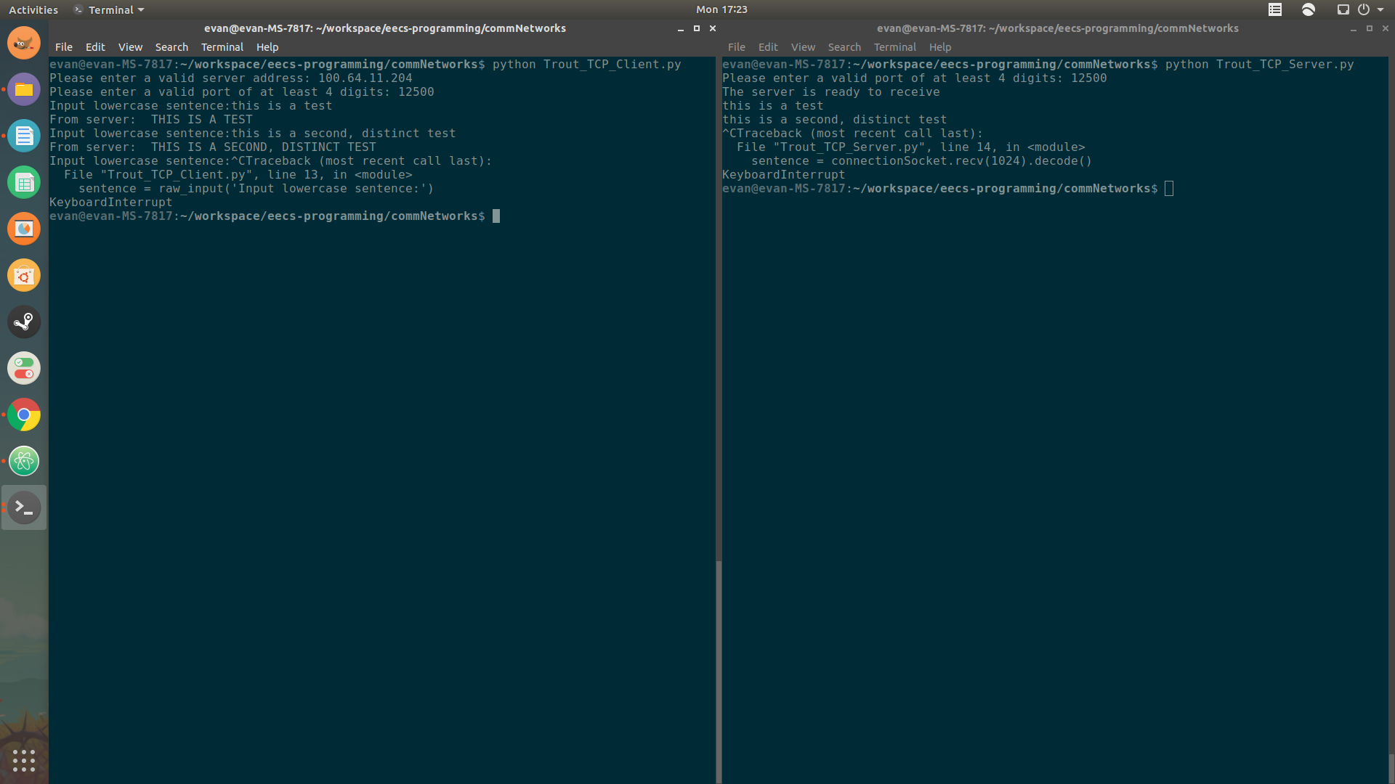
TCP Server

UDP Client
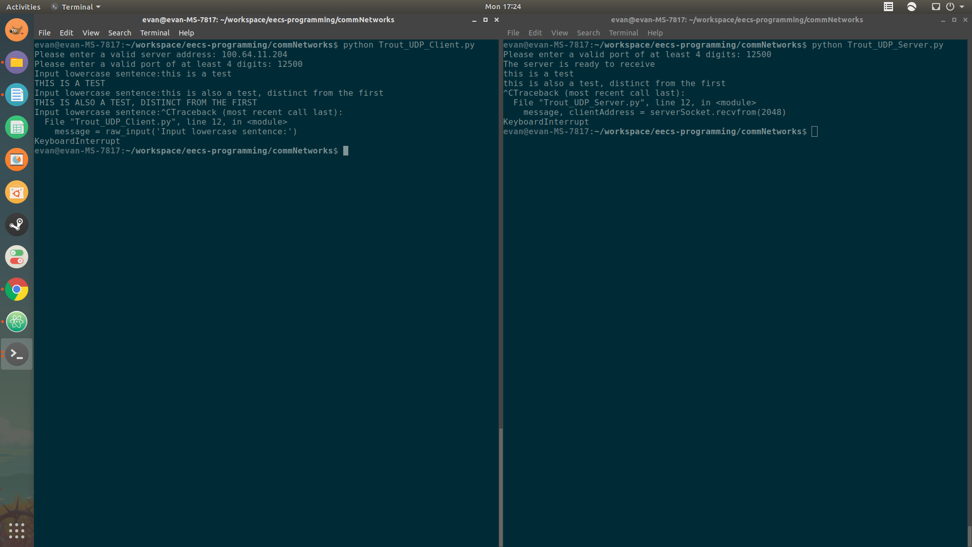

UDP Server

Example Applications - TCP
- Email (SMTP, POP/IMAP)
  - Primarily uses port 25 for SMTP and ports 110 and 143 for POP and IMAP
- The Web (HTTP)
  - Uses port 80
Example Applications - UDP
- Domain Name System (DNS)
  - Uses port 53
- Voice over IP (VoIP)
  - Usually 5060 or 5004 but varies based on provider

UDP servers only need one socket because the one socket can simply remain open and accept any incoming packets of data for the server. In contrast, TCP needs two sockets - the welcoming socket, which receives the client’s connection request and handles the three-way handshake, and a connection socket, which is opened after the successful three-way handshake and handles all data received and sent to the client.

A TCP server would need one connection socket for each of its n total connected clients, as well as the one welcoming socket, for a total of n+1 sockets.

