**Year-End Proposal: A digital guide: Navigating the post-COVID world**

**Project Team:**

|  |  |
| --- | --- |
| Group Leader | Ryan Chin Jian Hwa 4SK1 D3968 |
| Assistant Leader | Ooi Rui Zhe 4SA1 D3963 |
| - | - |

**Introduction:**

2020 is a special year for everyone around the world, as we are struck with a pandemic, COVID-19, that forced us to cope with new norms in order to survive. In line with the digital age and the Hackathon challenge organised this year, a digital guide in form of a website has been created to help people understand the new norms from the comfort of their own homes.

**Aims:**

* To spread awareness about new living norms.
* Encourage interactivity to ease absorption of information.

**Equipments / Tools needed:**

* Web Browser
* Internet Access
* Electronic devices

**Materials needed:**

* -

**Risk involved:**

* Power shortage

**Time involved:**

|  |  |  |
| --- | --- | --- |
| Content | Week One | Week Two |
| Planning/Discussion |  |  |
| Coding/Production |  |  |
| Evaluation |  |  |

**EXPLANATION:**

A website with information regarding the new norms in a post-COVID world is created and organised to spread awareness and information to the mass, as due to quarantines around the world, the greatest and easiest source of information would be from the Internet, or more specifically, a website. Even people who are less adept with electronic devices would at least be able to access and gain some insight from a website. However, with the abundant source of information out there, there are still users who fail to remember these important information. Therefore, this digital guide aims to ease the absorption of information by users through interactive little minigames and interesting display of information so that users will find it easier to understand. This includes a simulation which puts the user in different situations and test how they would act in said situation to educate them on proper behaviours in the situations, a short quiz about the new norms, and a time-bound minigame involving COVID-19 articles. With this, the website will be able to server as an effective guide for people navigating the post-COVID world.

**3D Sketches / 2D Sketches:**

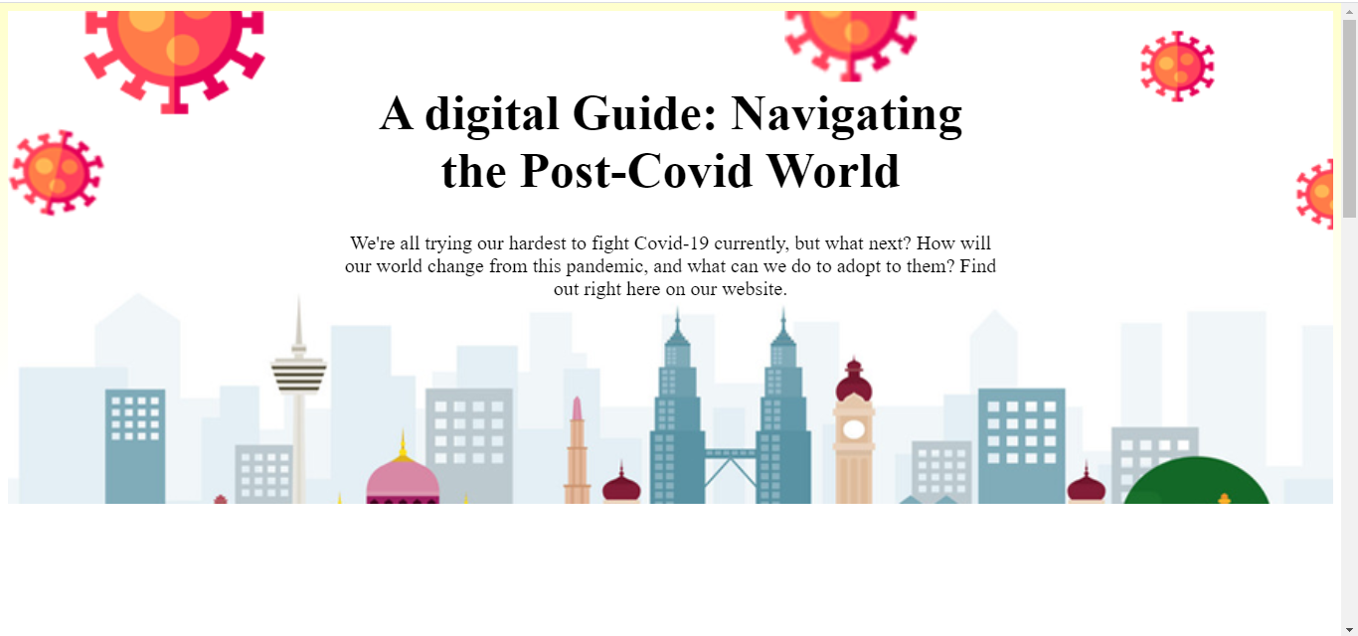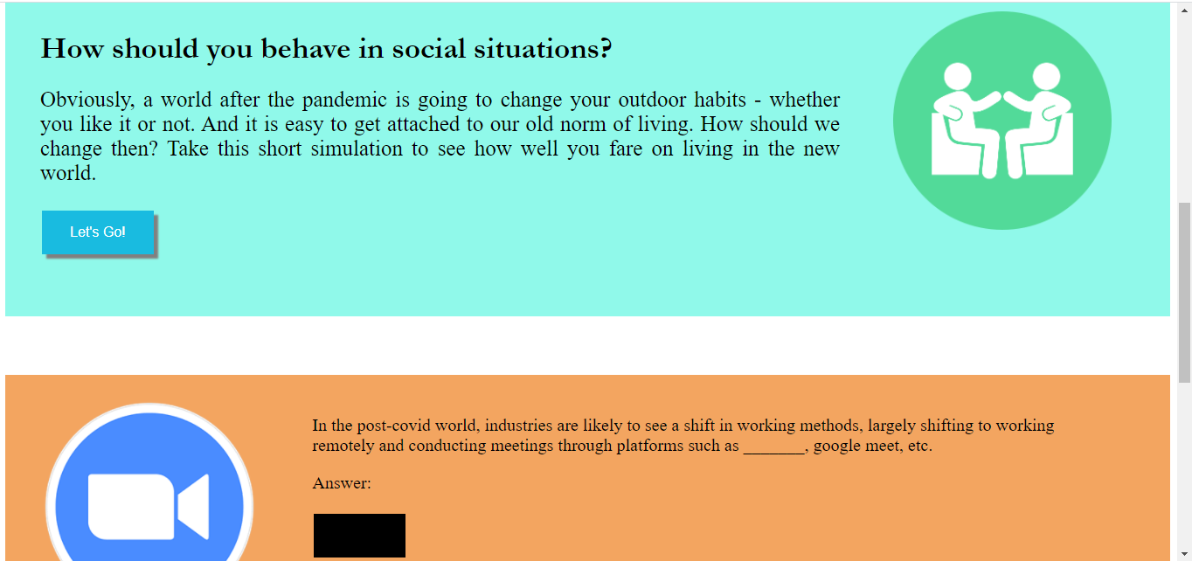

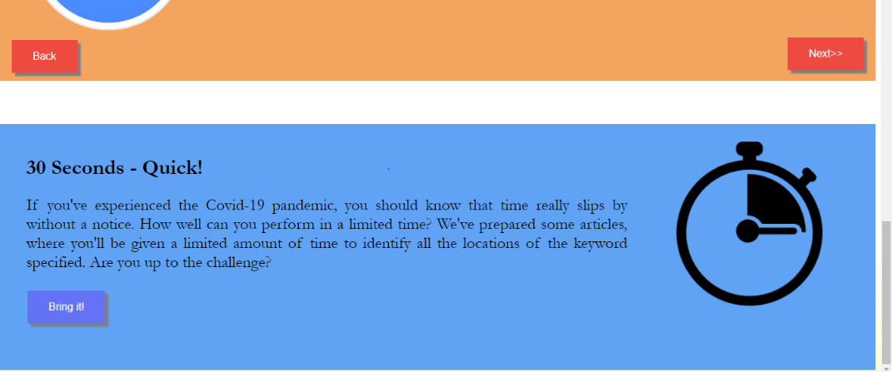

**Project Budget:**

|  |  |  |  |
| --- | --- | --- | --- |
| **Debit** | | **Credit** | |
| Content | RM | Content | RM |
|  | - |  | - |
| Total | - |  | - |

|  |
| --- |
| **Approved** |
| **Rejected** |

Acknowledged by,

**{NAME}**

Committee

i-CreatorZ Club

Prepared by,

**Ryan Chin Jian Hwa**

Group Leader

By,

**Teh Ai Wah**

Teacher Advisor

i-CreatorZ Club