**DECIBEL/DUST - BUSTER**

**[dB/D.B.]**

**An Application Designed to Determine Workplace Safety Conditions**

**Principle Terms: NXP, FRDM-K64F, FRDM-KW41Z, SPL Meter, Particle Concentration Sensor, 802.15.4, Bluetooth V2.0, Mbed OS, Kinetis Design Studio**

**Link to PowerPoint Presentation of This Paper:** <https://www.amazon.com/clouddrive/share/BCalwD4anHnYH1vJgd4UA89iFGwhb8RJD5RBAffIJL4>

**Link to Video Presentation of the [dB/D.B.]:**

<https://www.amazon.com/clouddrive/share/hoQ7Wdm0PsDwUEx17wJEuHigsUrUcwgNzZpLeb9HFqo>

**Authors:**

**William Singleton**

**Matthew Vice**

**Shozaf Zaidi**

**ECE 53301 – Wireless and Multimedia Computing**

**Indiana University Purdue University – Indianapolis**

**420 University Blvd, Indianapolis, IN 46202**

**Fall 2018**

**Title 1**

**Table of Contents 2**

**Abstract 3**

**Introduction 4**

**Materials & Methods 5-15**

**Protocols 5**

**Software Requirements 5-6**

**Hardware Requirements 6-11**

**System Design & Implementation 11-15**

**Steps to Run Mbed OS and KDS Code 15-16**

**Results 17-20**

**Conclusion 21**

**Acknowledgements 22**

**References 23**

**ABSTRACT**

In 1970, the Occupational Safety and Health Administration (OSHA) was established to regulate workplace safety conditions. OSHA established that a workplace should not expose workers to 90 dBA SPL for more than 8 hours and should not have more than 50 μg/m3 of dust accumulated for more than 8 hours. Because it is difficult for workplaces to measure such quantities, we developed a system that could notify users when workplace conditions exceeded these limits. We established an end device that features the dust sensor and an SPL sensor, with data flowing through the FRDM K64F development board. At the end device, an LCD display indicates when these limits are exceeded and displays a red color when the limit is exceeded and a green color when the limits are not reached. The system also communicates with the user’s mobile device via Bluetooth 2.0 to incorporate and island time feature to provide the user an alternative tropical color scheme for the LCD. The end device wirelessly communicates via a KW41Z to a remote KW41Z via 802.15.4 protocol to transmit sound and dust data. As the data arrives at the KW41Z, it is passed onto another K64F where it then enters the cloud logging system (ATT M2X) via Ethernet cable and the computer Wi-Fi. For the future, we hope to develop a better data logging system with more efficient data transfer between devices, and we hope to develop a more economical system.

**1. INTRODUCTION**

During the times of the Industrial Revolution, workplace conditions were dangerous to workers. Not only were people working endless hours, but the safety concerns of the workplace were numerous. Among these safety concerns was the long-term exposure of workers to loud sounds and lots of dust accumulation. As expected, these workplace conditions resulted in chronic auditory and respiratory health problems for those exposed to them. In 1970, Congress developed the Occupational Safety and Health Administration (OSHA) to enforce workplace safety rules.

OSHA has developed a set of standards for a variety of workplace conditions. For example, OSHA has limited workplaces to exposing workers to 90 dBA sound levels for only 8 hours. For each additional 5 dBA of sound, the time of exposure is cut in half. That is, at 95 dBA SPL, workplaces can only expose workers to these sounds for 4 hours. At 100 dBA SPL, workers can only be exposed to these conditions for 2 hours [1].

Similarly, OSHA has defined a set of standard for dust accumulation at the workplace over a certain area. Since dust can cause respiratory problems and allergies, there is an upper threshold for respirable dust over a given volume, and there is a threshold for total dust in a specific volume. That is, workplaces can only have 5 mg of respirable dust per m3, and workplaces should have no more than 15 mg/m3 of total dust at any given time. However, workers should not be exposed to more than 50 μg/m3 of dust over an 8-hour day [2].

Many workplaces do not have the means to determine if they are violating these workplace conditions. The purpose of this write-up is to utilize a variety of communications protocols (802.15.4, Bluetooth, etc.) to develop a dust and sound pressure level (SPL) sensor to detect sounds exceeding 90 dBA SPL and dust concentrations exceeding 50 μg/m3 to notify workplaces that they are violating the specified workplace conditions.

**2. MATERIALS & METHODS**

**2.1 Protocols**

Bluetooth V2.0 [3]

Nearly a decade after the introduction of Bluetooth, Bluetooth v2.0 was introduced in 2004 and is currently the most popular variant of Bluetooth. This technology introduced an optional Enhanced Data Rate (EDR) capability to the traditional basic rate capability, which in turn enhanced the traditional data rate by 300% to 3 Mbps. This standard is used to operate the “Island Time” feature of our device by communicating between the user’s mobile device and the FRDM K64F Development Board.

802.15.4 [4]

Defined in 2003 and currently maintained by the IEEE 802.15 working group, 802.15.4 represents a technical standard the provides the lower network layers for WPANs. The standard requires reduced communication speeds between devices within approximately a 10-meter range and is aimed at reducing costs seen in competing standards. The standard defines the lower network layers of the standard OSI protocol stack: the physical and medium access control (MAC) layers. The standard allowed for communication between the two FRDM KW41Z Development Boards. With any additional devices, the protocol would allow for the establishment of a wireless mesh network.

**2.2 Software Requirements**

Tera Term VT

Tera Term VT was used for visualizing data picked up from the audio and dust particle sensors and passed through the KW41Z and K64F development boards. In other words, this software was used to collect results and identify the functionality of our product.

Mbed OS [5]

Acting as an interface between application code and embedded devices, the Mbed Operating System works to translate programming language into a sort of functionality for the hardware. Specifically, the Mbed OS was used to upload commands to the FRDM K64F Development Board for device functionality. This OS utilizes an application programming interface (API) by allowing users to access predefined commands and subroutines to simplify the software implementation of such products.

KDS Integrated Development Environment [6]

This integrated development environment (IDE) was designed particularly for Freescale Kinetis microcontrollers so that users can use Assembly, C, and C++ language to compile various software designs. The environment follows an Eclipse Luna 4.4 Framework. The IDE was used to program the two KW41Z development boards.

Matlab R2018a

Matlab was used for simple post processing of results. The Tera Term Log feature was utilized to bring data into the Matlab command window, where it was then filtered to provide plots of SPL and dust particle concentrations as a function of time.

IUPUIECE

The IUPUIECE Android Application was used as a communication interface between the user’s mobile device and the K64F development board. It was used to implement an “Island Time” feature into the LCD to provide an alternative, tropical color scheme to the LCD display (as opposed to the traditional red or green display).

**2.3 Hardware Requirements**

FRDM K64F Development Board [7]

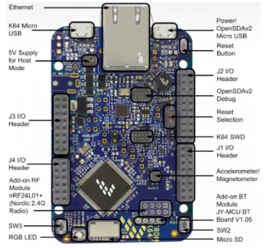

Figure 1 –The K64F Development Board.

This project required the use of two K64F development boards. One served as an end device that connected to the SPL and dust sensors, the LCD, the end-side KW41Z, and the HC06 Bluetooth module, while the other connected to the receiving KW41Z and to the cloud via Ethernet. The specifications for the development board are as follows:

* **Power Efficient MCU**: up to 120 MHz, 1024 kB Flash, 256 kB RAM
* **Peripherals**: 16 Channel DMA Controller, Low leakage wake-up, Low-Power modes
* **Clocks**: 3 Internal Reference Clocks, PLL & FL, 2 Crystal Inputs
* **Components**: LED (red, green, blue), 2 buttons, accelerometer and magnetometer
* **Power Supply Options**: USB Debug/Target 5V, 5-9V Vin, 5V Power input, 3.3V Coin

FRDM KW41Z Development Board [8]

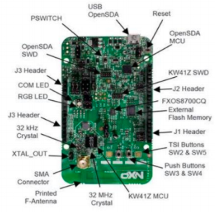

Figure 2 –The KW41Z Development Board.

This project required the use of two KW41Z development boards which communicated with one another over 802.15.4 wireless protocol and communicated with the K64F development boards via UART thru receiving and transmitting connections. The specifications for the development board are as follows:

* **Power Efficient MCU**: up to 48 MHz, 512 kB Flash, 128 kB RAM
* **Radio**: 2.4 GHz BLE 4.2, 802.15.4 compliance, dual-PAN support
* **Clocks**: 26 and 32 MHz for BLE, 32 kHz Crystal Oscillator, 32 MHz for 802.15.4
* **Low Power Consumption**: 6.8 mA Rx Current, 6.1 mA Tx current, 182 nA LPM
* **Voltage Range**: 0.9 V to 4.2 V

HC06: Bluetooth Slave [9]

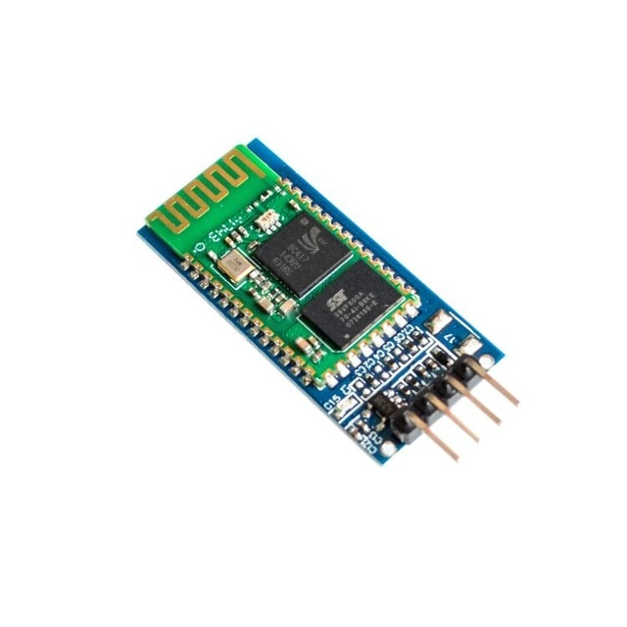

Figure 3 – The HC06 Bluetooth Slave Module.

The HC06 Bluetooth module was used to communicate between the user’s mobile device and the K64F to control the color scheme options on the LCD. The specifications are as follows:

* **MCU**: -80 dBm sensitivity, 2.4 GHz antenna, 2 to 3 Mbps EDR module, 8Mb Flash
* **Low Power**: operates between 3.1 to 4.2 V, 30 to 40 mA pairing current, 8 mA communication current
* **Storage Range**: -40 to -85 C

Sharp GP2Y1010AU0F Compact Optical Dust Sensor [10]



Figure 4 –Circuit Diagram and Physical diagram of the Optical Dust Sensor.

The dust sensor was utilized to determine when dust in the room exceeded 50 μg/m3 (the specified OSHA standard for workplace safety). The sensor communicated with the end device K64F which further communicated with the remaining development boards to log data to the cloud. As dust levels reached this threshold, the LCD display indicated a warning. The specifications include -0.3 to 7V supply voltage, -10 to 65 C operating temperature, 20 mA LED terminal current, and 20 mA consumption current.

Analog Devices ADMP401 Omnidirectional Microphone [11]



Figure 5 –The SPL Microphone Sensor.

This microphone was utilized to measure sound pressure level of an area. As SPL exceeded 90 dB in a room, the microphone notified the K64F which further communicated with the remaining development boards to log data to the cloud. The LCD display indicated a warning in turn. The specifications include a 62-dBA signal-to-noise ratio, a 60 Hz to 15 kHz frequency response band, 1.5 to 3.3 V power supply, and 160 dB SPL maximum detection limit.

Hitachi HD4478U Dot Matrix Liquid Crystal Display Controller/Driver [12]

The LCD was used to provide indications to the user of real-time SPL and dust concentration conditions. It followed a Red and Green display feature to indicate whether the sound and/or dust levels were too high or optimal, respectively. It also included the capability to display a tropical purple (too high SPL or dust concentration) or a tropical cyan (acceptable SPL or dust concentration) color scheme. The specifications include 2.7 to 5.5 V operation, 3 to 11 V driver power, 2 MHz MPU bus interface, 4 or 8 bit MPU interface, and 240 character fonts.

Passive Peripheral Components

The passive components utilized in this product include three transistors that control the output color of the LCD display (Red and green tropical cyan and tropical purple). Different output states from the K64F ground the transistors to the chassis to complete the circuit. Additional components include three 16 kΩ resistors for each of the transistors, a 150 Ω resistor for the dust sensor, a 220 μF capacitor for the dust sensor, and a 10 kΩ potentiometer for the LCD.

**2.4 System Design & Implementation**

Hardware Setup

The overview of the dust/sound sensor system is displayed in Figure 6.



Figure 6 –System Overview of the Dust/SPL detector.

The connection diagram of the system is represented by Figure 7.

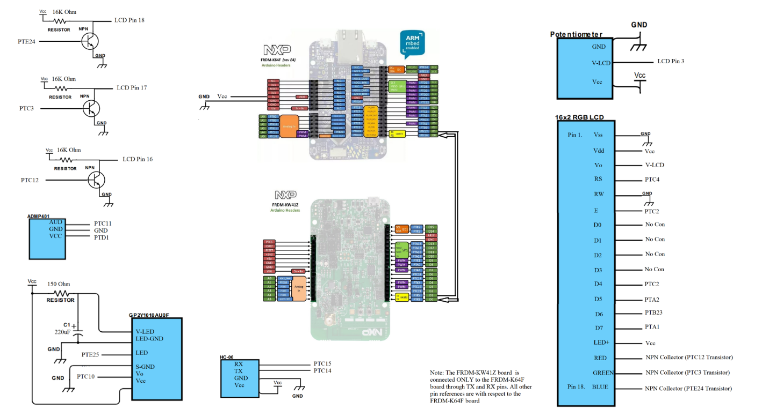

Figure 7 –Connection Diagram of our system.

Finally, the actual system setup is represented in Figure 8.

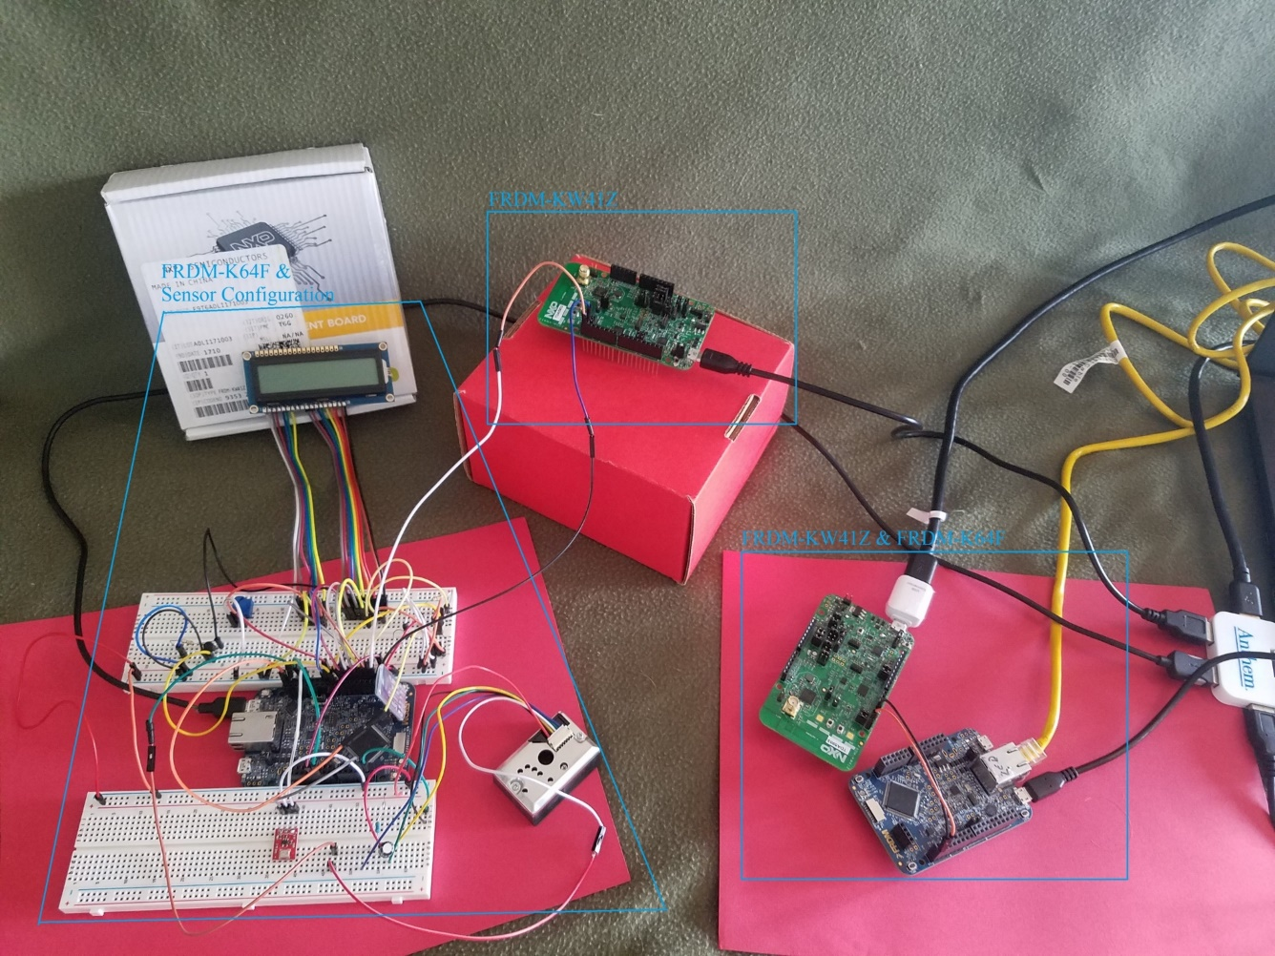

Figure 8 –Overall System configuration.

As the end device of the system, one K64F is setup and has pin connections with the peripherals of our system. In other words, the LCD display screen, the HC06, and the SPL sensor are connected to the K64F. The K64F is also connected via Rx and Tx to the first KW41Z development board over the UART protocol.

The KW41Z then transmits data wireless over 802.15.4 to an adjacent KW41Z, which in turn communicates with the second K64F via Tx and Rx pinouts. This final K64F is then connected to the internet of the computer via WiFi, and data is transmitted to the cloud server, ATT M2X, which logs data with a time stamp. Each K64F is connected to the computer and data is read in real time via Tera Term VT to ensure data is being transmitted properly.

Both KW41Z boards are programmed via Kinetis Design Studio IDE, and the K64F boards are programmed with Mbed OS. The HC06 Bluetooth slave communicates with the user’s mobile device via the android application “IUPUIECE” to change the color scheme of the LCD display.

Finally, the three transistors – PTC12, PTC3, PTC24 (red, green, and blue, respectively) – detect state changes in the end device K64F, and if dust concentrations exceed 50 μg/m3 or SPL exceeds 90 dB SPL, the PTC12 is shunted to ground to cause the LCD background to display red. Similarly, below these levels, the PTC3 is shunted to ground to display the green light. In the “Island Time” color scheme, PTC24 is constantly shunted to ground to display a blue light, and when the sensors exceed the defined thresholds, the red display is superimposed on top of the blue display, resulting in a tropical purple color. Otherwise, the green LCD is superimposed on the blue color to yield a tropical cyan color.

Steps to Run Mbed OS and KDS Code

All of the necessary source code for this project can be found on: https://github.com/Wssingle/Hello. This is a Github account. The files used are MSN_802.15.4_End_Device.cpp, MSN_802.15.4_Device_Coordinator.cpp, End_Sensor_Device_V2.cpp, and 802RecieverV2.cpp. The End_Sensor_Device_V2.cpp code is to be loaded onto the FRDM-K64F end sensor device, by turning it into a binary file using the Mbed OS website. Next, the 802RecieverV2.cpp is to be loaded onto the FRDM-K64F connected to the Ethernet bridge. This is to be done using the Mbed OS to turn the file into a binary file which is then loaded onto the board as done previously. The source code for the FRDM-KW41Z end device: MSN_802.15.4_End_Device.cpp, is to be downloaded from Github, along with the source code for the FRDM-KW41Z coordinator device: MSN_802.15.4_Device_Coordinator.cpp. After downloading these files, it is necessary to use the Kinetis Connectivity Project Cloner in order to clone the msn_end_device and msn_coordinator projects. After doing so, the App.c files of these clones will be replaced with the MSN_802.15.4_End_Device.cpp, and MSN_802.15.4_Device_Coordinator.cpp codes. After which, a JLink debugger will be used to load the code onto the FRDM-KW41Z boards. The boards are now loaded with the necessary software.

**3. RESULTS**

To develop a basis for the SPL meter to run, it was important to ensure that it provided accurate results. Since a quiet room with light chatter is expected to have an SPL of about 60 dBA, the SPL was measured in a quiet room. Figure 9 displays the SPL of this quiet room over time.



Figure 9 –The SPL readings from a quiet room with little chatter.

Because SPL oscillates around 64 dBA, it was determined that the sensor was properly working. To test that it was able to measure sounds above 90 dBA, a user whistled into the microphone after a period of silence. Simultaneously, another user measured the reaction of the LCD display and determined that the LCD did indeed turn red at SPL exceeding 90 dBA. The data sample for the whistling experiment is displayed in Figure 10.



Figure 10 –SPL measurements from a quiet room while whistling on the microphone SPL sensor.

Similarly, the dust concentration was measured in the dust sensor. We first measured a baseline for dust concentration in the room. This data is displayed in Figure 11.



Figure 11 – Baseline dust particle measurement in the room.

A pencil was then used to overload the sensor with “dust”, and the results were logged via Tera Term VT and brought into Matlab. While the pencil was held into the sensor, the dust sensor was overloaded at a constant rate to 0.8 mg/m3 as seen in Figure 12.



Figure 12 – Dust Particle measurements after the insertion of a pencil in the optical sensor path.

**4. CONCLUSION**

In conclusion, we were able to demonstrate that we could develop a workplace safety device that could continually monitor SPLs and dust concentrations. Using protocols like Bluetooth 2.0 and 802.15.4 we were able to develop a complete edge-to-cloud IOT solution for workplace hazard monitoring. In the future, we hope to improve this device by adding a filter to remove some voltage transients from the SPL sensor, improve the receiving frequency of the K64F, and become more economical by switching to an I2C bus for LCD communication. Additionally, we can add additional wireless capabilities to the system by using an ATT Wireless shield and eliminating the Ethernet. We would also like to improve the SPL calculation algorithms by pursuing an averaging method as opposed to the instantaneous method. Ultimately, it will be preferable to switch to thread protocol to form a mesh network of hazard monitors, all of which are capable of sending data to the cloud via a border router. This solution is predicated on the assumption that the workplace will have an 802.11 transceiver or something similar which we believe to be an eminently reasonable assumption. In addition, we would like to implement an RTOS on our end sensor device to ensure the strict timing deadlines necessary for hazard monitoring are met. Finally, we would like to keep the K64F to KW41Z configuration as it is. We believe that the K64F should be solely responsible for accumulating, processing, and finally communicating state information. This will offload the KW41Z which will be responsible for radio transmission and network maintenance only. These developments will push us closer to our goal of a universal workplace hazard monitor. All in all, our system satisfies the user needs and is a useful tool for workplaces to invest in.

**5. ACKNOWLEDGEMENTS**

We would like to thank the Electrical and Computer Engineering Department of IUPUI for providing us with the facilities and the resources needed to complete this project. Additionally, we would like to thank our Teaching Assistants, namely: Dewant Katare, Akash Gaikwad, and Durvesh Pathak, for the continuous support and assistance they provided us to resolve many of our issues for this project. Finally, we would like to thank Dr. Mohamed El-Sharkawy for the knowledge and background he provided us to complete this project.

**References**

[1] <https://www.osha.gov/SLTC/noisehearingconservation/>

[2] <https://www.osha.gov/dsg/annotated-pels/tablez-1.html>

[3] https://whatis.techtarget.com/definition/Bluetooth-20EDR

[4] <https://www.radio-electronics.com/info/wireless/ieee-802-15-4/wireless-standard-technology.php>

[5] <https://www.mbed.com/en/platform/mbed-os/>

[6] <https://www.nxp.com/support/developer-resources/evaluation-and-development-boards/freedom-development-boards/mcu-boards/kinetis-design-studio-integrated-development-environment-ide:KDS_IDE>

[7] <https://os.mbed.com/platforms/FRDM-K64F/>

[8] <https://www.nxp.com/products/processors-and-microcontrollers/arm-based-processors-and-mcus/kinetis-cortex-m-mcus/w-serieswireless-conn.m0-plus-m4/freedom-development-kit-for-kinetis-kw41z-31z-21z-mcus:FRDM-KW41Z>

[9] <https://www.olimex.com/Products/Components/RF/BLUETOOTH-SERIAL-HC-06/resources/hc06.pdf>

[10] <https://www.digikey.com/en/datasheets/sharpsocle-technology/sharpsocle-technology-gp2y1010au0f>

[11] <https://www.analog.com/media/en/technical-documentation/obsolete-data-sheets/ADMP401.pdf>

[12] <https://cdn-shop.adafruit.com/datasheets/HD44780.pdf>